SouthWest University, RongChang Campus, Veterinary student training workshop 30th October – 5th November 2011

Partners:
Jeanne Marchig International Centre for Animal Welfare Education, University of Edinburgh
Veterinary Faculty, Rongchang campus, Southwest University
Animals Asia Foundation

Aim:
To demonstrate an integrated approach to animal welfare science, veterinary ethics and clinical skills training through the use of animal alternative models

Learning objectives:

At the end of the course students should:

- Understand introductory concepts of animal welfare science
- Understand their responsibilities to animal welfare as a clinical veterinarian
- Demonstrate basic competencies in
  - Continuous interrupted suture patterns with either multifilament or monofilament material
  - Tying of a square knot, a surgeons knot and a square or surgeon’s knot at depth
  - Intravenous cannula (catheter) placement
  - Blood sampling
  - Laryngeal intubation

Report
The Southwest University is one of China’s leading Veterinary Schools, with strong ties to the Chi institute, a leading Traditional Chinese Veterinary Medicine (TCVM) provider http://www.tcvm.com/

I’d like to commend the SouthWest University for its desire to develop and promote alternatives to animals in teaching, and especially the Dean Madam Liu, and the head of TCVM Professor Ma, who encouraged and facilitated our visit.

As part of this collaborative project 236 final year veterinary students attended 3 hours of core lectures on animal welfare science and their responsibilities as veterinary surgeons delivered by Heather Bacon of the University of Edinburgh, plus a 2 hour training workshop on basic clinical skills (skills training was delivered to a maximum of 36 students at a time).

Skills training was delivered by veterinarians Heather Bacon of the University of Edinburgh and Monica Bando of the Animals Asia Foundation, assisted by Lisa Yang and Wen Yen of the Animals Asia Foundation. Clinical skills training focused on the importance of clinical competency to improve the experience of the patient and reduce stress in a clinical setting. As all training was delivered using non-animal models, we discussed the importance of reducing, refining and replacing animal use in education where possible, and that as veterinarians, it is important that we take responsibility for animal welfare and for not causing unnecessary suffering in our own training.

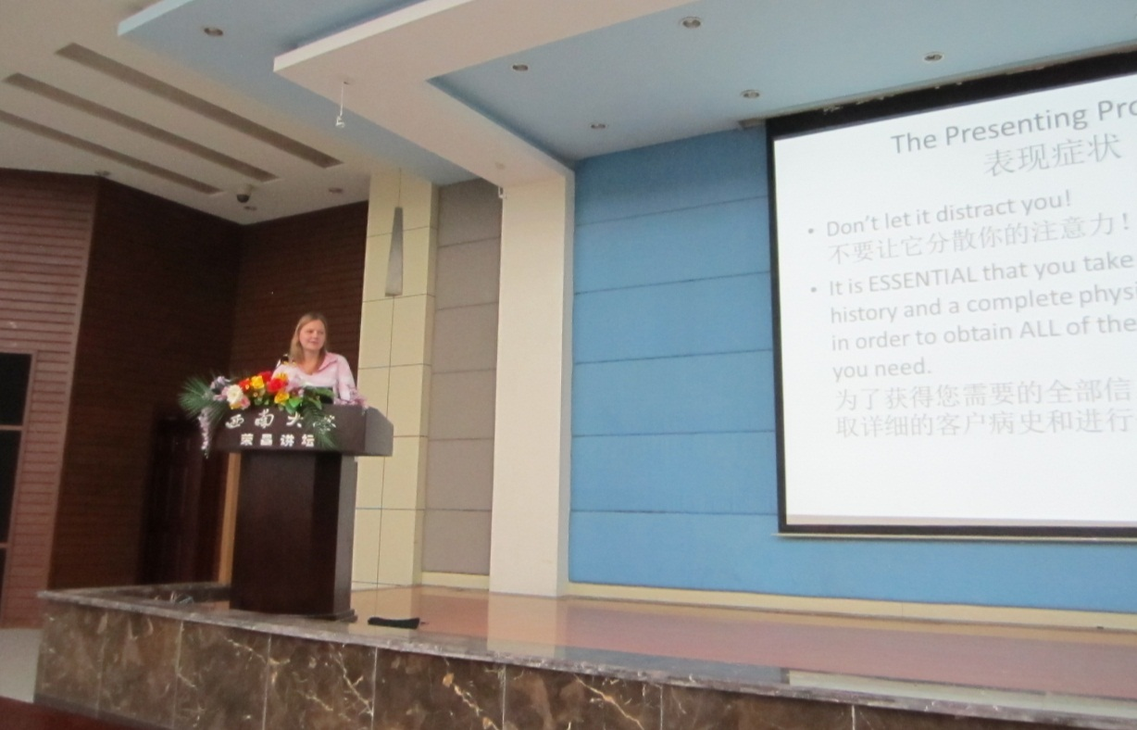
Fig 1: The Programme began with three hours of lecturesdelivered by Dr Heather Bacon covering basic principles of welfare and clinical care

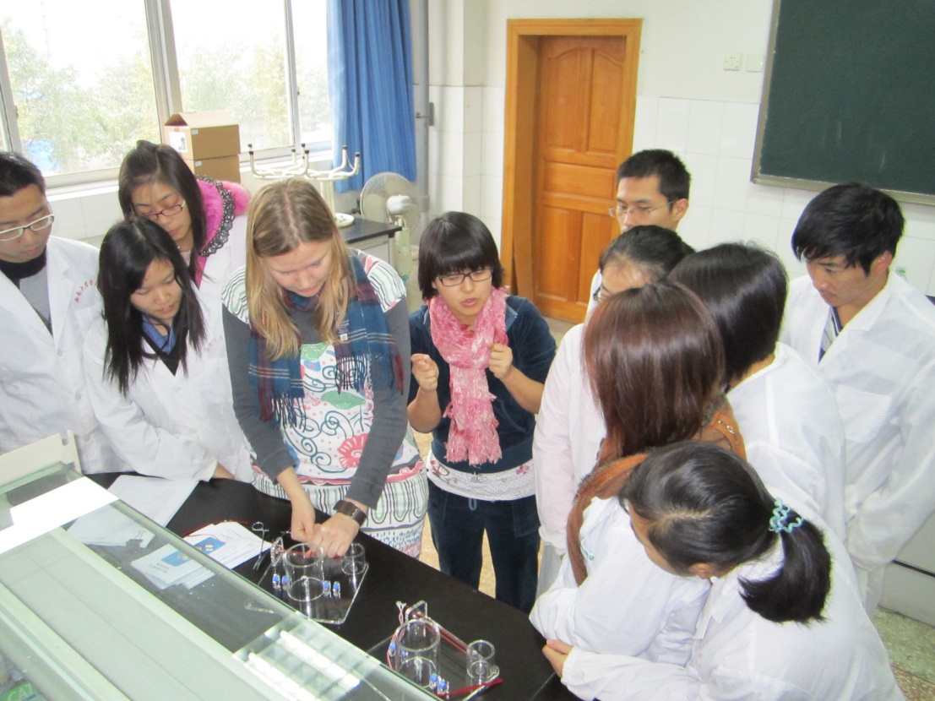
Fig 2: Demonstrations and thorough guidance on each practical skill were given at the beginning of each session
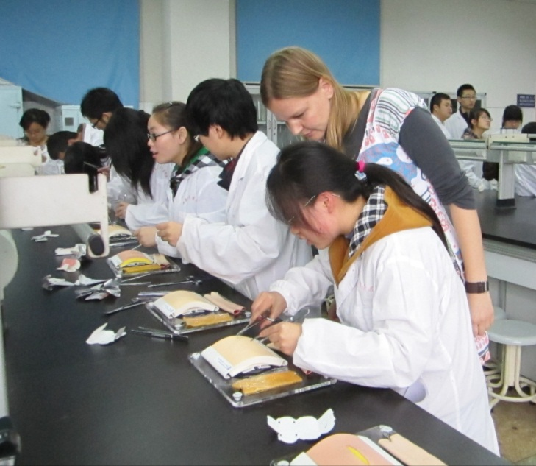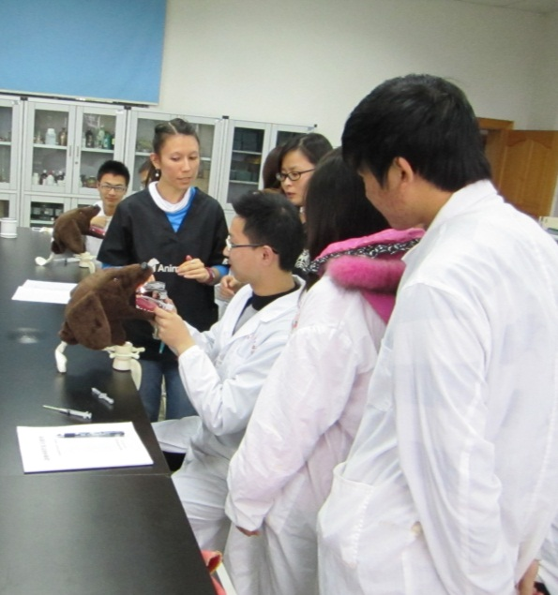
Fig 3: Students were given time to practice each skills with guidance and support from Dr Heather Bacon, Dr Monica Bando, Lisa Yang and Wen Yan

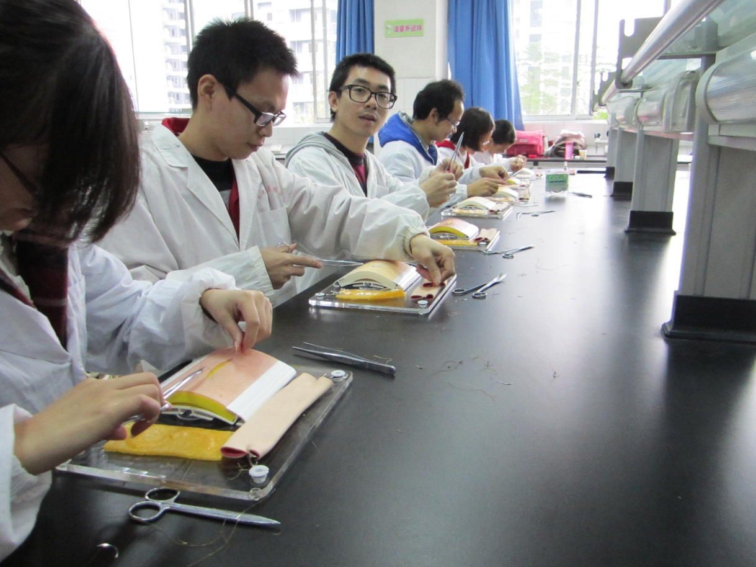
Fig 4: Students practice suturing on artificial tissues
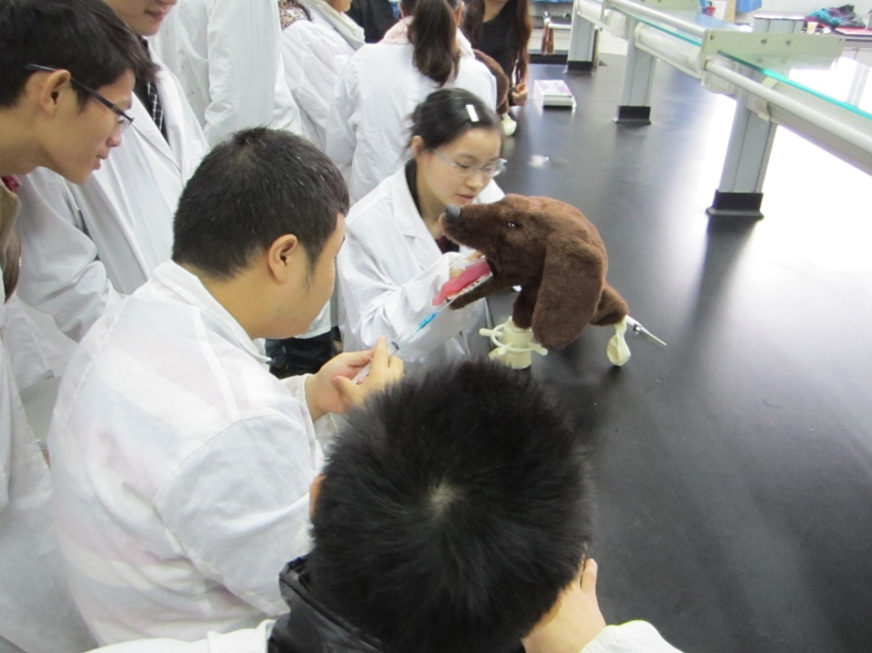
Fig 5: Students place an endotracheal tub and learn how to cuff it appropriately

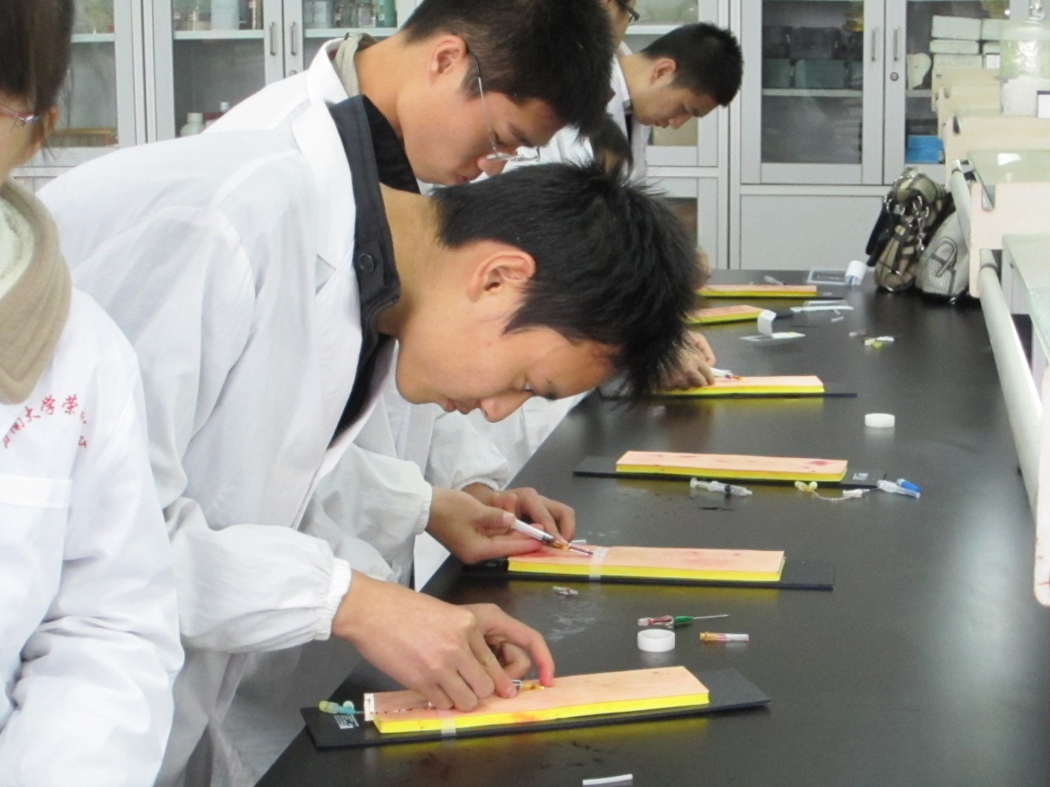
Fig 6: Students practice blood sampling and cannula placement

Comments and observations:

This was an extremely useful visit in developing our own understanding of and interest in the delivery of veterinary education in China. We learned of several interesting factors which may complicate the development of veterinary education. For example, many students on the degree are placed there after failing other unrelated courses – contrary to most other countries in the world, the veterinary degree may be seen as an ‘easy option’ or a ‘drop-out’ degree, meaning that with some exceptions, students on the course may be less motivated or able to complete the degree to the standard that we would anticipate.

Despite this, the students were generally very engaged, interested and a pleasure to teach. Most students seemed Interested in developing both academically and professionally.

Knowledge of preclinical topics such as anatomy or physiology was very limited amongst the final year students. We discussed that performing medicine or surgery without this theoretical knowledge was similar to driving a car without a road map – students were bound to get lost! It is important that a strong pre-clinical foundation underpins the delivery of any clinical training.

There was some concern that we were delivering too much information or information to a standard that was too detailed. This was difficult to reconcile as we would estimate the information delivered to be at the level of a preclinical veterinary undergraduate in the UK or USA, and would therefore hope that a final year student would be capable of assimilating this. We had a number of students who repeated the sessions with us 2, 3 or 4 times in an effort to gain as much information as they could from us, and in general we were very encouraged by the staff and student’s positivity.

Summary
The Southwest University is developing unique international partnerships in an effort to accelerate veterinary education in China and is to be commended for its work. We hope that this programme was useful in demonstrating alternative learning methodologies and in highlighting some areas which may require further attention from the faculty. In particular we would hope to see the development of clinical training practical sessions using non-animal models, where students can safely develop their clinical skills.

