Women students at the University of Edinburgh
A guide to the Centre for Research Collections’ sources for research

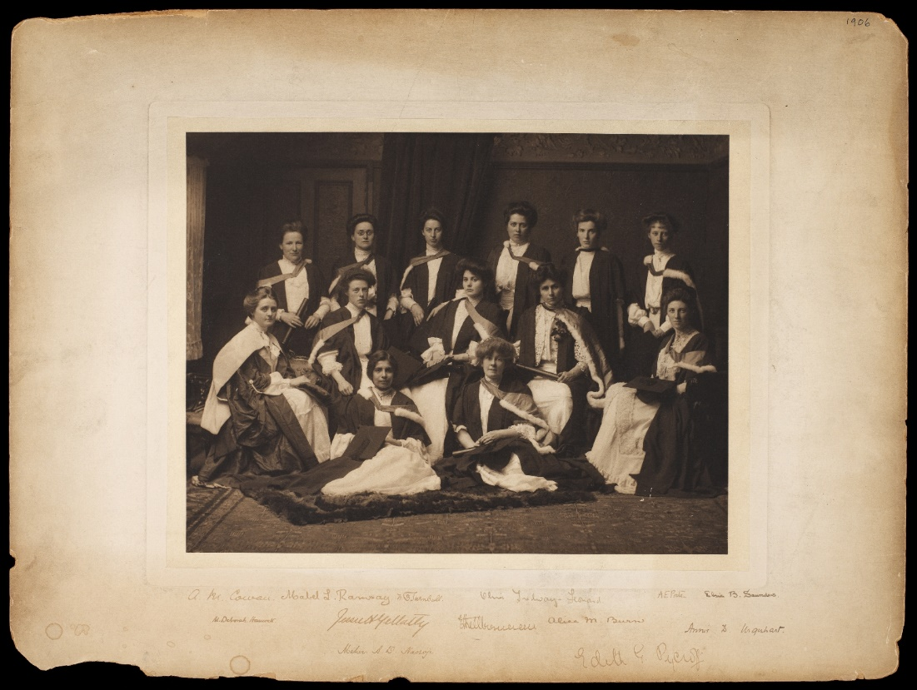
1906 female medical graduates (EUA CA1)
For more information on the identity of these women, see our blog post here

Introduction

Women were formally admitted to the University of Edinburgh in 1892, following the Universities (Scotland) Act of 1889. Prior to this there were no female graduates of the University, with the sole possible exception of James Barry (c.1789-1865). James Barry graduated with an MD from Edinburgh in 1812 and had a successful career as a military surgeon. After Barry’s death the woman who prepared the body for burial claimed that Barry was biologically female. Historians and biographers have since identified James Barry with Irish-born Margaret Ann Bulkley.

Nationwide campaigning for women’s entrance into Scottish universities began in earnest in the mid-nineteenth century. In Edinburgh this took two main forms: a direct attempt to enter the University by matriculating (enrolling) in the Faculty of Medicine by a small group of women known as the Edinburgh Seven; and the more circumspect campaigning work of the Edinburgh Association for the University Education of Women.

In 1869 Sophia Louisa Jex-Blake (1840-1912) and four other women applied to enter Edinburgh University’s Faculty of Medicine, the first women to make an open attempt to do so in the University’s history. The following year they were joined by two other women and came to be known collectively as the Edinburgh Seven. However, although the women had been allowed to matriculate, they faced other barriers to study: they had to arrange their own classes, were charged higher fees than their fellow male students and excluded from clinical placements at the Royal Infirmary, and faced hostility and abuse from students and lecturers. Finally, in January 1872 the University Court decided that women medical students would not be awarded degrees. This decision was confirmed by the Court of Session, which ruled in 1873 that the University had never been empowered to accept female students. The University’s women medical students were effectively expelled.

A more successful campaign was waged by the Edinburgh Ladies' Educational Association (ELEA), which was founded by Mary Crudelius (1839-1877) in 1867 and known from 1877 onwards as Edinburgh Association for University Education of Women (EAUEW). The Association’s stated aim was not to bring women into the professional sphere of medicine, but to cultivate and improve the female mind through its series of lectures. They attracted the support of several University lecturers who taught lectures to its members, helping to forge links between the Association and the University. These links are reflected in the fact that by 1877 the Rules and Calendar of the Association were being printed in the University Calendar, along with the names of recipients of the Association’s Certificate in Arts for Women which had been established in 1874.

In 1892 women were formally admitted to Edinburgh University. They were taught on the same terms as men and, except for the Faculty of Medicine, studied in co-educational classes. The first eight official female graduates of Edinburgh University graduated MA in 1893; all eight had studied classes with the EAUEW and these classes were deemed to count towards the degree requirements.

From 1892 onwards, the sources for researching women students are largely the same as those for researching male students (see the ‘Students at the University of Edinburgh’ research guide). However, women were not admitted to the Faculty of Medicine until 1916, and prior to that had to study at either the Edinburgh School of Medicine for Women (founded by Sophia Jex-Blake in 1886) or the rival Edinburgh College of Medicine for Women (founded 1889).

Even when men and women were taught together, full integration of women into student life was still some way off, and women students had their own accommodation and societies well into the 20th century. Masson Hall of Residence - named after Professor David Mather Masson (1822-1907) a prominent supporter of the EAUEW - was opened in 1897 as women-only accommodation by the EAUEW, which had turned its attention to the welfare of female students after 1892. Additionally, the Edinburgh Association for the Provision of Hostels for Women Students provided accommodation at East Suffolk Road from 1916 onwards.

Another area where male and female students were kept separate was the University Unions. The constitution of Edinburgh University Union forbade admission of women, and consequently Edinburgh University Women’s Union was founded in 1905. From 1964 this was known as the Chambers Street Union (after the premises it occupied), and in 1973 it finally merged with Edinburgh University Union to become part of the Edinburgh University Students’ Association (EUSA).

By 1914 over a thousand women had graduated from the University of Edinburgh. The percentage of women students steadily increased from the 1960s onwards until 1998 when, as a result of the merger of Moray House Institute of Education with the University, women constituted more than 50% of the student body for the first time in the history of the University.

The Centre for Research Collection (CRC)’s archives contain many collections relating to our women students, and these are listed below. It includes the papers of some of our notable female students and graduates, and this can be complemented by referring to our list of Women in archives.

Collections relating to women students in the CRC archives

James Barry
- Matriculation album, 1809-1812 EUA IN1/ADS/STA/2
- Signature in the laureation album (medical graduates), 1812 EUA IN1/ADS/STA/1/2
- Four copies of Barry's 1812 MD thesis 'De merocele' are at Att.83.7.15/4, Att.83.7.16/2, Att.87.5.21/14 and Duncan.56/2

The Edinburgh Seven
- Matriculation album, 1869-1872 EUA IN1/ADS/STA/2
- First matriculations, 1869-1872 EUA IN1/ADS/STA/4
- University of Edinburgh v. Jex-Blake, 1872-1875 EUA IN1/ACU/A2/11
- Material relating to the legal dispute between the Edinburgh Seven and Edinburgh University, 1872 EUA IN1/GOV/CRT/LEC

Sophia Jex-Blake
- Chemistry class registration book, 1858-1873 EUA IN1/ACU/C2/5
- Chemistry class examination book, 1866-1873 EUA IN1/ACU/C2/12
- Papers of Sophia Jex-Blake, 1855-1894 Coll-384
- Bruntsfield Hospital and Elsie Inglis Memorial Maternity Hospital, 1879-1989 Lothian Health Services Archive, LHB8-LHB8A
- Two legal documents in favour of Sophia Jex-Blake, 1884-1890 Coll-1553
- Correspondence between Sophia Jex-Blake and Miss E. Hamilton about amendments to the constitution of the EAUEW, 1871-1878 Coll-42/5/7
- Correspondence between Sophia Jex-Blake and geologist Sir Archibald Geikie, 1865-1899 Coll-74/12/7
- Files relating to a memorial for Jex-Blake in architect Sir Robert Stoddart Lorimer's papers, 1901-1949 Coll-27 (Gen.1963/44)

Isabel Thorne (member of the Edinburgh Seven)
- Diary of Isabel Thorne, 1887 Coll-1175

Edinburgh Association for the University Education of Women (EAUEW)
- Papers of the EAUEW, 1867-1974 Coll-42
- Material relating to the winding up of the EAUEW, 1871-1973 Coll-1419
- Rules and Calendar of the EAUEW, plus recipients of the Certificate in Arts for Women, are listed in the Edinburgh University Calendar, 1877-1893 EUA IN1/PUB/1

Accommodation
- Records of Masson Hall of Residence, 1893-1967 EUA GD58
- Papers related to Masson Hall in the papers of Warden of Masson Hall Marjorie Rackstraw, 1920s-1959 Coll-705/1
- Masson Hall Endowment Committee, 1970-1989 EUA IN1/ADS/SEC/CRR [AB 01 AG 01 AA]
- Masson Hall correspondence, 1990-1991 EUA IN1/ADS/SEC/CRR [AB 01 AG 01]
- Masson Hall correspondence, 1994 EUA IN1/ADS/SEC/CRR [AB 01 AG 01, Vol.2]
- Masson Hall papers, 1995 EUA IN1/ADS/SEC/CRR [AB 01 AG 01, Vol.3]
- East Suffolk Road hostels, 1974-1991 EUA IN1/ADS/SEC/CRR [AB 01 AB]

Women's societies
- Records of Edinburgh University Women’s Club (Edinburgh University Tea Club), 1920-1995 EUA GD6
- Edinburgh University Women’s Athletic Club, 1920s-1970s EUA GD32
- Records of the Edinburgh Women’s Medical Society, 1913-1952 EUA GD18
- Scottish Eastern Association, Medical Women’s Federation, 1915-2012 Lothian Health Services Archive, GD51

Papers of individual female students and graduates
- Papers relating to Anne Jane Anderson, one of the University’s first female medical students, 1866-1979 Coll-1835/14
- Papers of Susan Anderson Binnie (MB, ChB 1921), one of the first female medical students allowed to study alongside men, 1913-1922 Coll-1052
- Papers of Catherine R. Borland (MA 1905), author of a catalogue of Edinburgh University Library’s Western medieval manuscripts, 1911-1916 Coll-241
- Papers of Anne Dollar Davies, former medical student at the University of Edinburgh, c.1920-1990 Coll-1976
- Material relating to Helen Millar Lowe, one of the first female chartered accountants in Scotland, 1919-1930 Coll-1247
- Papers of Katherine Cameron MacArthur (MA 1929) educator and headmistress at Columba’s School for Girls, Kilmacolm, 1923-1943 Coll-890
- Papers of Jessie McLaren MacGregor (MB, CM 1896), one of the University’s first two female medical graduates, 1863-1906 Lothian Health Services Archive, GD1-53
- Papers of Alisa Giles Maxwell (MA 1948), student of Economics, 1938-1948 Coll-892
- Papers of Dr. Asta Winifred Russell Moller (MA 1920), who researched the history of the coal industry, 1916-1981 Coll-1832
- Papers of Annie Hutton Numbers (MA 1918, BSc 1920, PhD 1926), chemist and teacher, Coll-649
- Papers of Eleanor Anne Ormerod (LLD 1900), first woman to receive an honorary doctorate from Edinburgh University, 1889-1900 Coll-334
- Papers of Flora Philip (MA 1893), one of the University’s first eight female graduates, 1889-1943 Coll-1672
- Photographs of Frances Helen Simson (MA 1893), one of the University’s first eight female graduates, 19th-20th century Coll-1983
- Lecture notes of Patricia Townsend, student at the University of Edinburgh in the 1970s, 1974-1977 Coll-1859
- Papers of Everitt Young (MA 1932), teacher who emigrated to South Africa, 1931-1951 Coll-1071

Related material elsewhere

- Reports of the Edinburgh School of Medicine for Women are held by the National Library of Scotland (vols 1-2, 1886-1890) and the University of Glasgow Archive (vol.1, 1886-1888 and 1895)
- The only way: Magazine of the Edinburgh University Women’s Suffrage Society, no.1, 1909 is held at the LSE Library

Accessing the collections

Digitised records and online databases
- Our repository for digitised theses, Edinburgh Research Archive (ERA) includes James Barry's 1812 MD thesis and Elizabeth G.K. Hewat's 1933 PhD thesis (first woman to graduate BD from Edinburgh in 1926, and first female Divinity doctoral graduate 1934)
- Selected items relating to Edinburgh Seven members Sophia Jex-Blake, Isabel Thorne, Edith Pechey, Matilda Chaplin, Helen Evans and Mary Anderson have been digitised and added to our Image Collections website
- Selected issues of the Edinburgh University Calendar have been digitised
- Our Historical Alumni online database has indexes for recipients of the Women's Certificates in Arts, 1876-1894, for entries in the Register of Extra-Academical Students, 1887-1922, and for female medical graduates for the time period 1896-1900

Accessing physical records in person
Most student records have not been digitised. To arrange an appointment to view records in person at the CRC, please email HeritageCollections@ed.ac.uk or phone 0131 650 8379. Where in-person visits are not possible, CRC staff can undertake research into specified individuals on your behalf, or arrange for specific records to be digitised for you.

Please note that the Data Protection Act and GDPR apply to records containing personal information about living (or potentially living) individuals, and therefore access to student records less than 75 years old is conditional.

Enquiries about Lothian Health Service Archive records should be directed to lhsa@ed.ac.uk

