Unidesk Survey for EdHelp, 6th June-8th August 2022
102 respondents from 1984 Surveyed

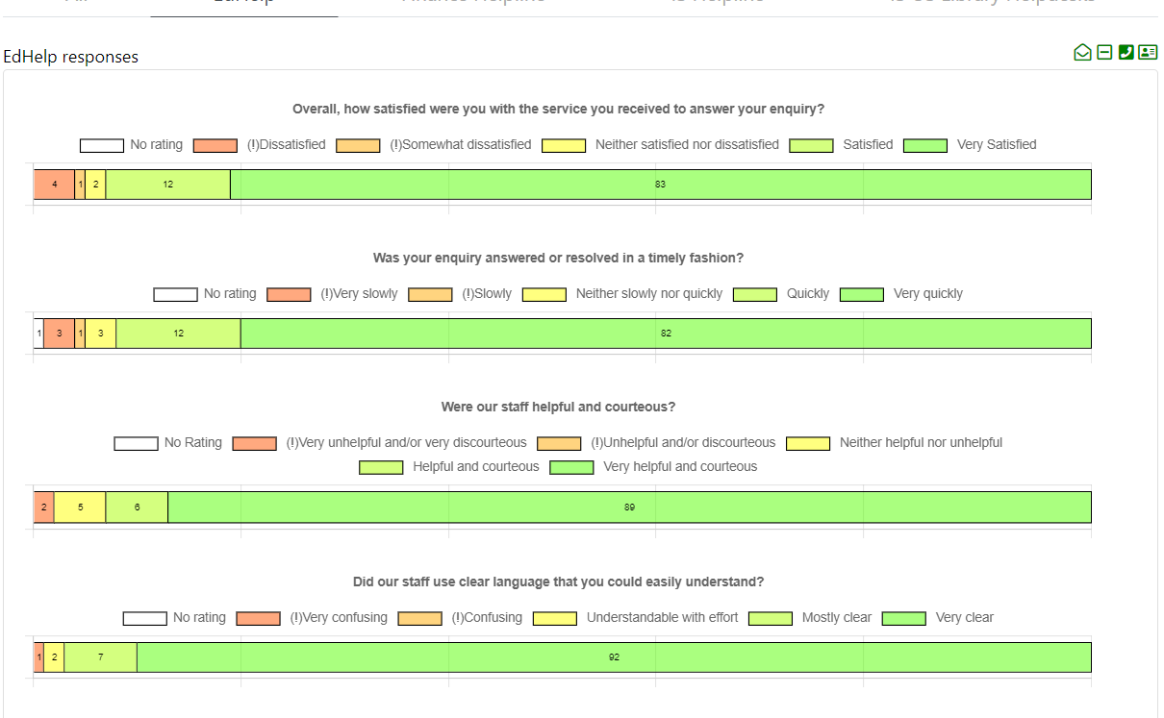
EDHELP SATISFACTION OVER THIS PERIOD-93% (92% FOR HELPDESKS), AND IMPROVED FROM 85% IN APRIL-MAY PERIOD 2022.

