*Instructions - delete text in between the *…* as appropriate*
Researcher Living Lab project proposal - *insert general title of project area*
Key SRS contact for this project (name, role, email)

Academic Supervisor or lead academic contact (name, email, school and course programme, if different to student)

Description of the paper
This paper is in essence a template for a potential dissertation Living Lab project that a researcher would like to propose. The question and research is intended to inform and/or make recommendations to the SRS Department’s work areas. It should also align with one or more of the Sustainable Development Goals (see below for more context).
Once you have completed this form, please email it to the SRS Project Coordinator for Living Labs and the Sustainable Development Goals Vanessa.McCorquole@ed.ac.uk.

Draft research question
*Insert text in bold. Aim for roughly a one line question.*

Background
*Provide some background to the project by providing some web links to relevant university webpages and include where available, some university web links to its strategy or an SRS strategy that is in line with this project. Be clear about what data set provision you have found or are hoping to ask SRS colleagues for. Please note, not all data is something that is stored with SRS, so researchers may have to liaise with other university colleagues to acquire data e.g. energy use, procurement.
Refer to which SDGs this project is intending to work towards. Use the table further into this document to indicate the main SDG this project is relevant for and up to 3 SDG sub-themes that this project works towards. Aim to write this background section in everyday language so that colleagues working in different disciplines, languages and abilities to your own can easily grasp the size and scope of the project.*

Objectives
*Examples are provided, these can be edited partly or completely*
- Identify and highlight key SDG issues related to *insert text* to highlight the problem.
- Identify and assess alternative solutions in relation to *insert text*
- Assess the practical implications of *insert text*. Will there be any significant cost or operational implications?
- Make recommendations to the University regarding any options recommended within the project.
- Identify how the project or recommendations could be replicable across other universities around the globe e.g. the Global South, to ensure solutions are deliverable where they are needed most/in the shortest amount of time.
The project should aim to do the following:
It describes a problem, an opportunity, or a barrier
It doesn’t predict the solution
It catches people’s attention
It is persistent and difficult to crack
If it were solved, we would see the difference
We would be able to measure a solution’s impact
We have evidence that it is a real challenge.

Data set provision
Research data may be available from the publically available Data Library found here:
https://www.ed.ac.uk/sustainability/what-we-do/research/initiatives/the-university-as-a-living-lab/data
Or you may have some data from elsewhere at the university e.g. in your school. Use the table below to state where and what type of data you are going to use in your research. If you have a methodology, state this too.

Data needed for this project (delete as appropriate) | Data sets available from and contact information (delete as appropriate)
*e.g. Carbon reporting, staff survey, purchase etc* | *Insert a website or contact name and email*
*Surveys* | *To be completed as part of the project*

Outputs
Your dissertation will be your own piece of research and you will decide what you think the results show and draw your own conclusions. The project will need to be shared with colleagues so that we try to make operations changes based on your recommendations. Please tell us in the table below, what type of output you might like to complete during or at the end of your project. This can be your opportunity to try something new and add a new skill when you are applying for jobs or future courses.
Output format | Insert not applicable or Yes (with further detail)
Presentation to a number of stakeholders
Mixed media resource for reuse
Report with operational recommendations
Resources for staff/student behaviour change
Resources for staff/student training
*Other, please specify*

Transformational change with the SDGs
The Sustainable Development Goals showcase 17 things humanity must do to ensure peace and prosperity for people and the planet, now and into the future.
*Use the table below to mark which main SDG this project is relevant for and up to 3 SDG sub-themes that this project works towards. You can insert n/a or leave the space blank where an SDG does not apply*
The information in this table was obtained with permission from the UN sustainable goals website, www.un.org/sustainabledevelopment/sustainable-development-goals
The Sustainable Development Goals for 2030, with a brief description of it’s intention with an example action that can be taken to meet that goal. | Briefly describe the project’s link to the main SDG it works towards and up to three SDG sub-themes.
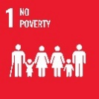
Donate what you don’t use. Economic growth must be inclusive to provide sustainable jobs and promote equality. More than 700 million people still live in extreme poverty.
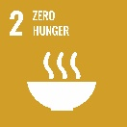
Waste less food and support local farmers. A third of the world’s food is wasted, yet 821 million people are undernourished. The food and agriculture sector offers key solutions for development, and is central for hunger and poverty eradication.
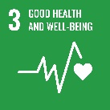
Vaccinate your family. Vaccinations resulted in an 80% drop in measles deaths between 2000 and 2017. Ensuring healthy lives and promoting the well-being for all at all ages is essential to sustainable development.
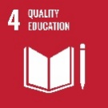
Help educate the children in your community.
617 million children and adolescents lack minimum proficiency in reading and mathematics. Obtaining a quality education is the foundation of improving people’s lives and sustainable development.
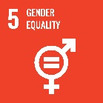
Empower women and children and ensure their equal rights. One in three women has experienced physical and/or sexual violence. Gender equality is not only a fundamental human right, but a necessary foundation for peaceful, prosperous and sustainable world.
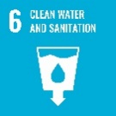
Avoid wasting water. Water scarcity affects more than 40% of the world’s population. Clean, accessible water for all is an essential part of the world we want to live in.
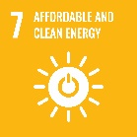
Use only energy-efficient appliances and light bulbs. Three billion people still lack clean cooking fuels and technologies. Energy is central to nearly every major challenge and opportunity.
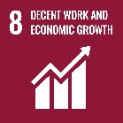
Create job opportunities for youth.
One-fifth of young people are not in education, employment or training. Sustainable economic growth will require societies to create the conditions that allow people to have quality jobs.
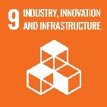
Fund projects that provide basic infrastructure.
Roads, water, sanitation and electricity remain scarce in many developing countries. Investments in infrastructure are crucial to achieving sustainable development.
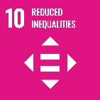
Support the marginalised and disadvantaged.
The poorest 40% of the population earn less than 25% of global income. To reduce inequalities, policies should be universal in principle paying attention to the needs of disadvantaged and marginalised populations.
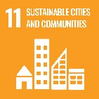
Bike, walk or use public transportation.
Nine out of ten urban residents breathe polluted air. There needs to be a future in which cities provide opportunities for all, with access to basic services, energy, housing, transportation and more.
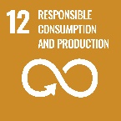
Recycle paper, plastic, glass and aluminium.
By 2050, the equivalent of almost three planets could be required to sustain current lifestyles. It’s about doing more and better with less and decoupling economic growth from environmental degradation.
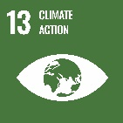
Act now to stop global warming.
Global emissions of carbon dioxide (CO₂) have increased by almost 50% since 1990. Climate change is a global challenge that affects everyone, everywhere.
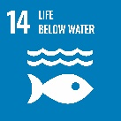
Avoid plastic bags to keep oceans clean.
Over three billion people depend on marine and coastal biodiversity for their livelihoods. Careful management of this essential global resource is a key feature of a sustainable future.
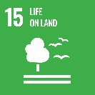
Plant a tree and help protect the environment.
Forests are home to more than 80% of all terrestrial species of animals, plants and insects. Sustainably manage forests, combat desertification, halt and reverse land degradation, halt biodiversity loss.
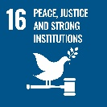
Stand up for human rights.
Access to justice for all, and building effective, accountable institutions at all levels. In 2018, the number of people fleeing war, persecution and conflict exceeded 70 million.
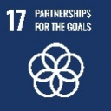
Lobby your government to boost development financing.
Revitalise the global partnership for sustainable development. Achieving the SDGs could open up US$12 trillion of market opportunities and create 380 million new jobs by 2030.

The University of Edinburgh Strategy 2030
Strategy 2030 can be found here:
www.ed.ac.uk/about/strategy-2030

The Social and Civic Responsibility Delivery Plan
To deliver Social and Civic Responsibility at the University of Edinburgh, we have chosen three strategic objectives and one cross-cutting theme.
The Social and Civic Responsibility Delivery Plan can be found here and in a summary box below:
www.ed.ac.uk/files/atoms/files/social_and_civic_responsibility_delivery_plan_2020.pdf

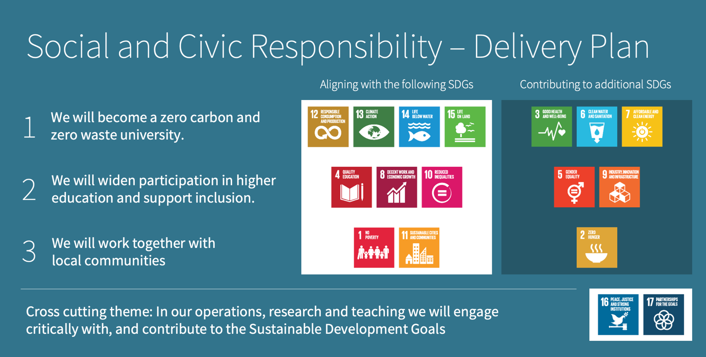

*Use the table below to mark which Social and Civic Responsibility 2030 objectives this project is relevant for how this project works towards those objectives.*
Social and Civic Responsibility Delivery Plan – Objectives and one cross-cutting theme | Briefly describe the project’s link to the objectives, how it is relevant and how this project works towards those objectives.
We will become a zero carbon and
zero waste university - Increasing opportunities and raising aspirations by making education and employment an achievable goal for more people in Scotland and globally.
We will widen participation in higher education and support inclusion - Increasing opportunities and raising aspirations by making education and employment an achievable goal for more people in Scotland and globally.
We will work together with local communities - to contribute to improve the lives of people across the Edinburgh City Region and beyond.
Cross cutting theme: In our operations, research and teaching we will engage critically with, and contribute to the Sustainable Development Goals - including the promotion, protection and respect for human rights.

