University of Edinburgh’s Careers Service

Targeting Email Service
To book a targeted email service simply complete our booking form on MyCareerHub.
Our targeted email service allows you to reach out to a specific group of students for whom your opportunity is particularly relevant. This service allows you to select very specific groups of students that you may be trying to reach.
To send a targeted email to select of students simply:
- Upload your opportunity to MyCareerHub or complete our events publicity form
- Write a clear, concise email, maximum of 500 words. Remember to include a powerful subject line to capture student’s attention and save this as a word document
- Complete a targeted email booking form:
- Provide your contact details
- Select your target discipline(s) – which subject areas you wish to target
- Within the chosen discipline(s), select your target level (year of study)
- Add any further comments about your target groups
- Upload your email wording as a word document
- If you would like to include a picture or a logo upload this
- Specify the date that you would prefer the email to be sent
- Provide your billing information
On receipt of your form, we will check your opportunity or event in on MyCareerHub, identify your target students, collate the email, and send it out within three working days for your prefer date.
Following the sending of your email you will be sent an invoice or online payment instruction.

Top Tips for making your email effective:
- Send more emails to few groups of students, so that you can tailor and be more specific in your messaging to the cohorts of students
- Get alumni from the University of Edinburgh or from that discipline to write the email, or include a case study
- Keep the message short and sweet. Use the PASS model.
Purpose – what is the desired outcome?
Action – what action do you want the reader to take and what is the deadline or time frame. You can consider subheadings.
Supporting – Have you given the reader all the information they need to take the action?
Subject – Clarify and summarise the message and the target audience in the subject
- Add your logo. Use your email as an opportunity to build your brand further with our students.
- Personalise the email to make it relevant and valuable to the right audience

Cost and selections
The cost for our targeted email service is £35 + VAT per subject area, per year group. The maximum number of selections is 15 for a paid targeted email and 5 for a free targeted email.
On the form, subject areas are split up by College and also have subtext to further explain the type of degrees offered within each School.
You can see an example of this below:
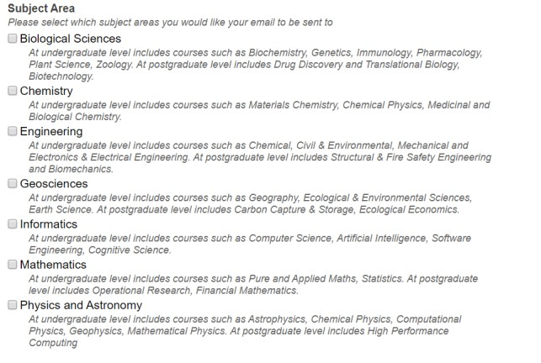
For each of the subject areas you can select from the below year groups. For example:
Biological Sciences
• 1st Year Undergraduates
• 2nd Year Undergraduates
• 3rd Year - Penultimate Year Undergraduates
• 4th Year - Final Year Undergraduates and Post Graduate Taught
• Post Graduates Research students such as PhD students
Physics and Astronomy
• 1st Year Undergraduates
• 2nd Year Undergraduates
• 3rd Year Undergraduates
• 4th Year - Penultimate Year Undergraduates
• 5th Year - Final Year Undergraduates and Post Graduate Taught
• Post Graduates Research students such as PhD students
Some of our subject areas contain an extra year. This breakdown is included in the targeted email order form.

Sample Email
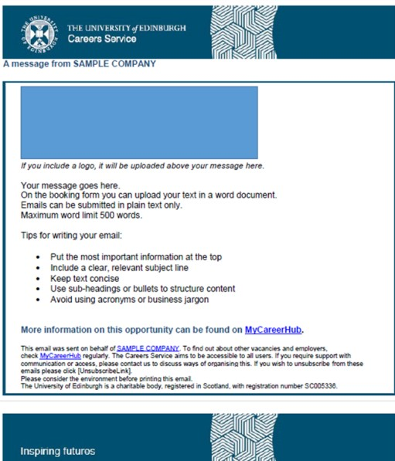
To request this document in an alternative format, please contact the Employer Team (employers@ed.ac.uk)

