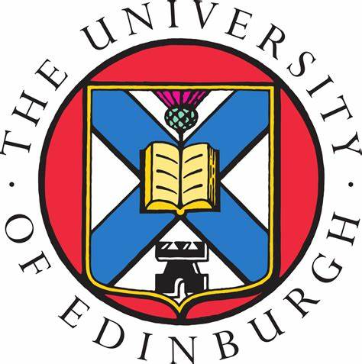 | The University of Edinburgh  College of Medicine and Veterinary Medicine

PReDICTED GRADES REQUEST FORM
SOUTH AFRICA – NSC (NATIONAL SENIOR CERTIFICATE)/IEB (INDEPENDENT EXAM BOARD)

Please complete this form electronically where possible

Name of Applicant:
UCAS Personal ID Number:
School Name & Address:

Subjects |  | Predicted Grades (0-10 OR %)
Subject
Subject
Subject
Subject
Subject
Subject
Subject
Subject
Subject
Subject

English Level

Teacher’s Name: | Teacher’s Signature: | Date:

