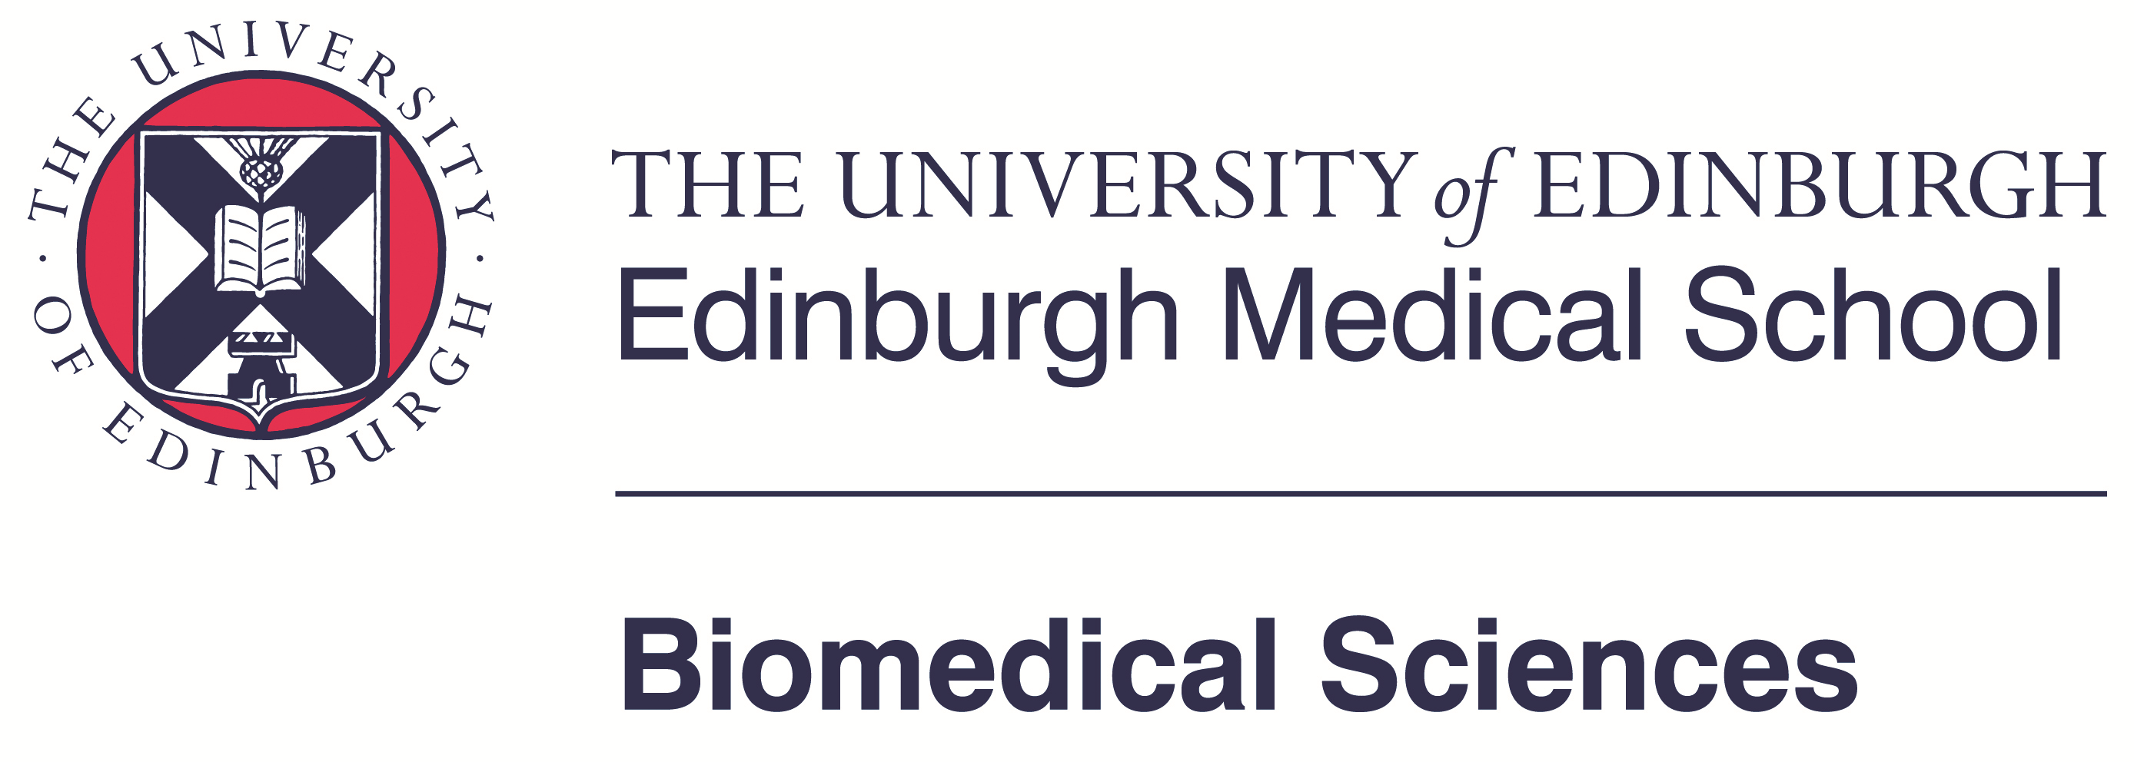

This is an application form for the 2021 School of Biomedical Sciences International Masters Scholarship for Integrative Neuroscience. If successful this scholarship would pay the Additional Programme Costs for the MSc by Research Integrative Neuroscience (currently £3000; note that programme fees still have to be paid!) for overseas students from a country on the DAC list of official development assistance (ODA) recipients. You may find a list of countries here: http://www.oecd.org/dac/stats/daclist.htm

Please return completed form to the programme administrator neuroscience.MSc@ed.ac.uk

The deadline for applications is 30 June 2021 and you will be notified if you are successful or unsuccessful by 30 July 2021.

What is your full name and address?

What is your country of residence?

Is your country on the DAC list of official development assistance (ODA) recipients?

Are you self-funded?

Do you receive any other monies for your studies either from your home country or the University of Edinburgh?

Do you suffer from financial hardship and/or have family responsibilities (e.g. accompanying children) that would make you particularly benefit from the waiver? Please make a case of no more than 0.5 A4 pages in length and attach documentation where appropriate.

Signature ______________________________________________

Date _____________________________________

