THE BHF REA3 CALL FOR FUNDING APPLICATIONS – 2022
About REA3  Our research is driven through 3 pillars of research excellence that focus on specific research questions central to their field of study with clear interconnectivities through methodologies, technologies and approaches across these areas. Our pillars are closely aligned with 2 major cross-cutting themes. Our overarching aim is to improve human cardiovascular health through Research Translation into Improved Diagnosis, Risk Stratification and Novel Interventions. | 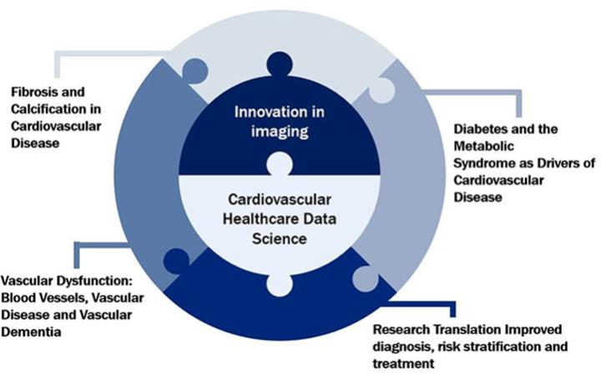
All applications must relate to the pillars and cross-cutting themes as part of REA3. Further information can be found on our website: BHF Centre of Research Excellence | The University of Edinburgh

ABOUT THE CALL

There are 2 funding opportunities: an open call for small projects up to £25K and a call for larger projects (up to £100K) addressing one of our 2022 challenges.
Small Projects – up to £25K
Small projects will relate to one or more pillars and themes in REA3 and will demonstrate a clear research outcome in the near term. Expected benefits would include a clear route to high impact publication or further substantive funding.
REA3 Challenge Projects – up to £100K
Applications should address one or more of the following challenges in relation to the REA3 pillars and cross-cutting themes:
- Connecting experimental and data science
- Defining approaches to broader engagement of all patients in research (patient data)
- Leveraging substantial additional external funding towards integration of data science with vascular and neurovascular science and/or industrial translation
- Establishing cross-disciplinary infrastructure (not equipment)
- Establishing strategic partnerships across REA3 priorities

HOW TO APPLY
Application forms should be emailed to Gillian Joyce: Gillian.Joyce@ed.ac.uk
CLOSING DATE: MONDAY 16 MAY 5.00pm
ELIGIBILITY:
Applications with clear links to REA3 priorities will be welcomed from University of Edinburgh staff. Postdoctoral researchers may be lead applicant on translational applications. External collaborations are welcome, but the lead applicant must be a University of Edinburgh member of staff. Applications seeking to attract matched DRI funding must include a DRI programme or project lead.
TYPICAL VALUE AND DURATION OF AWARDS:
The type and scope of awards will vary and funding will be flexible. Awards are expected to last between 6 and 12 months. The maximum duration of an award is 18 months from the date of award. All projects must be completed by the end of the REA3 funding – 31 March 2024
SELECTION PROCESS:
At least three independent reviewers will provide an assessment of each pump priming proposal, for both small and challenge projects. The most competitive proposals (REA3 Challenge projects only) will then be assessed by at least two external reviewers (REA3 External Advisory Board). The final funding decision for all projects will be made at a meeting of the REA3 Project Executive. Applications which exceed the word limits or fail to provide the requested information will be rejected.
EQUALITY & DIVERSITY
Names will be redacted from applications sent to external reviewers. Data on submissions and success rates will be gathered for reporting on equality and diversity.
FEEDBACK
All applicants will receive feedback on their submissions within one month of the submission deadline.
EVALUATION
Each funded application will be assigned a REA3 PI to monitor the project and report on progress to the REA3 executive. Projects can be discontinued at the discretion of the executive if they are not progressing sufficiently well.
Contacts
If you have a question regarding your eligibility to submit, or any other aspect of the content of your application, please contact Catriona Anderson: c.a.anderson@ed.ac.uk
To submit your application, please email the application form to Gillian Joyce: Gillian.Joyce@ed.ac.uk

British Heart Foundation Centre for Research Excellence
2022 – FUNDING CALL
APPLICATION FOR AWARD
1. Name of Centre
2. Lead applicant
3. Contact email address
4. Title of request for funding
5. For evaluation purposes please indicate whether your application is for the training element, a small project (25K max) or a strategic project (100K max) and which pillars and cross-cutting themes your application relates to:
Small Funded project (up to £25K)
Strategic project (up to £100K)
Pillars |  |  | Cross-cutting Themes
Diabetes and the Metabolic Syndrome as Drivers of Cardiovascular Disease |  |  | Innovation in Imaging
Fibrosis and Calcification in Cardiovascular Disease |  |  | Cardiovascular Healthcare Data Science
Vascular Dysfunction: Blood Vessels, Vascular Disease and Vascular Dementia |  |  | Translation/  commercialisation
6. Sum requested (BHF awards do not include fEC) |  |  | £
7. Nature of funding request (1-4 lines)
8. Case for funding:
i) The scientific case (max. 600 words, including references)
ii) Justification for what is requested:
- Small Funded projects (maximum 200 words)
- Strategic Funded projects (maximum 1000 words)
iii) How long are the funds requested for - max.18 months (1 line)
iv) Proposed start and end dates (1 line)
9. Relevance to REA 3 pillars and cross-cutting themes (max. 250 words)
10. Exit strategy i.e. strategy for making the transition from REA3 funding to longer term funding, or other mechanisms of sustainability, including relevant application and other deadlines (max. 250 words)
11. Key performance indicators What will be your indicators of success and when do you expect each of these to be achieved? (max. 100 words)
12. Will award funds be used to conduct research involving the use of animals and/or
clinical trials?
13. Breakdown of costs. Cost precisely what is needed (e.g. salaries, equipment, other support, etc.) Do not include fEC as this will not be funded.
No. | Item details |  | Estimated amount | Non-salary items items: quote received? Yes/No
1
2
3
4
5
Total
14. Funding received or promised from other sources. Please provide details including relevant dates. The REA3 Executive is keen to maximise leverage on investments.
16. Short cv(s) (max. 2 x A4 pages per person)
Please paste in below short CVs of applicants. These should include research papers since
Jan. 2014 and current grants.

