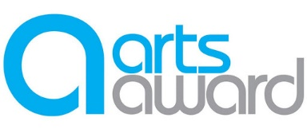
Capturing Lives in 2020: Oral History Activity
Interviewee Information Sheet and Consent Form
About the Capturing Lives Project
The ‘Capturing Lives in Scotland’s Communities’ project is about using art as a way to capture what our lives look like in 2020 in different parts of Scotland. So far we’ve used photography and landscape painting as a way to do this. This week, we’re looking at oral histories.
What is an oral history?
Oral history is the recording of people’s memories, experiences and opinions which are usually held in archives, where they will be able to be listened to in the future.
About this activity
This week we’ve asked participants to interview someone they know – a friend or family member – to find out about an aspect of their lives that they might not have known much about before. This could be about memories of school, of work, of important historical events or reflections on more recent events such as life in 2020.
The interview doesn’t have to be long – 10 minutes will do – and if you don’t feel comfortable being recorded you can opt to have the participant write down a summary of your discussion instead.
How will the recording be used
Usually we ask participants to upload their work to the channel in their teams so their other group members can see it. We will ask you to select below if you consent to the recording of your interview being uploaded to Microsoft Teams and/or to a written quote from it being used on our social media accounts. If you’d rather not have your recording uploaded to Teams, its not problem at all, we’ll ask the participants to write about their reflections of the interview instead.
Interviewer’s Name:
Interviewee’s Name:
Date of Interview:
I consent to the recording of my interview being uploaded onto Microsoft Teams:
YES / NO (Please delete accordingly)
I consent to a written quote from my recording being used on the UMIS social media accounts:
YES / NO (Please delete accordingly)
I consent to a sound clip from my recording being used on the UMIS social media accounts:
YES / NO (Please delete accordingly)

