APPLICATION FORM

Postgraduate Certificate in Leadership and Learning: Core Processes
Autumn 2022 Intake

Session | Title | First Name(s) |  |  |  | Initials | Surname |  |  |  | Date of Birth |  |  | No. of years teaching
2021-2022
School/Establishment/Service |  |  |  |  | Post Held |  |  |  | Employing Authority |  |  |  | GTC No  (Compulsory)
Home Address |  |  |  |  |  |  |  | Work Address
Postcode |  |  |  |  |  |  |  | Postcode
Home/Mobile Phone |  |  |  |  |  |  |  | Work Phone
Home Email Address |  |  |  |  |  |  |  | Work Email Address

Do you have a disability, which will require special arrangements to be made to allow full access to your chosen pathway of study? (Please give details).

As part of the application process, you are asked to reflect on and respond to the questions below:
- to help you determine the suitability of this programme to you and your CLPL
- to facilitate a screening process in the event that the programme is over-subscribed

Please do not exceed 250 words for any single response (each box will expand as you type).

NAME:
SCHOOL:
Please explain why you wish to undertake this particular Masters-level programme.
You might consider potential influence/impact on:
- you, your thinking and your practice
- learners with whom you work
- colleagues and/or wider school/education community

In what ways, if any, does this programme relate to your ongoing professional learning?

There will be a focus on understanding enquiry processes to support curriculum development. Please share your thoughts on how this might feature in your studies on this course:

Please outline any experience(s) you have had of practitioner enquiry and/or teacher leadership to date:
- as part of your ongoing practice in school, and/or cluster
- as part of any more formalised professional learning courses through your Local Authority, Regional Improvement Collaborative or with any national organisations

Thinking about you taking forward practitioner enquiry and/or teacher leadership within your own school context, please identify any key opportunities and challenges you anticipate encountering:
Potential opportunities | Potential challenges

Please provide details of previous relevant SCQF credits at Masters-level that you have achieved. This could include masters credits from your Initial Teacher Education PGDE or other relevant education related PG Certificate course. These may be eligible for Recognition of Prior Learning (RPL)/Advanced Standing. Normally, these should be within the last 5 years.
Course name and number of SCQF credits achieved | Institution of study and relevant dates

PLEASE SAVE THIS DOCUMENT WITH A UNIQUE FILENAME THAT INCLUDES YOUR FULL NAME [eg CPPGCert-ApplicantName]

Email the completed document to [ insert name and email of LA contact ] by 9.2.2022

SCQF Level 11 Professional Learning Opportunity
As part of study at Master’s level, participants will undertake professional enquiry, which will incorporate these key areas of Career-Long Professional Learning, from the National model of professional learning:
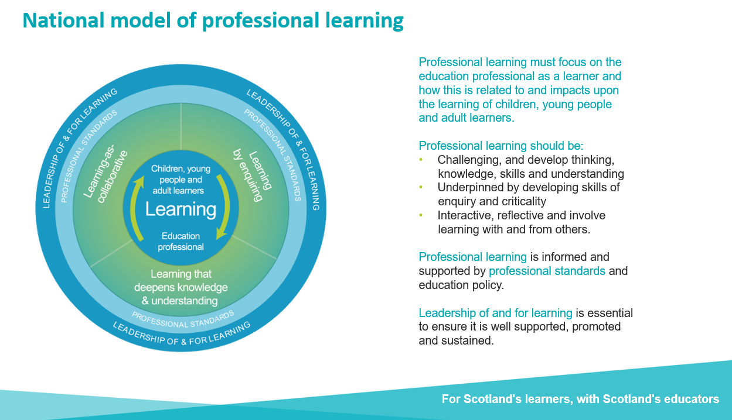

To address all areas, it is vital that participants engage in work-based learning which enables them to make meaningful connections across theory, research and practice. Applicants must be in a relevant post to enable them to participate in the full programme of learning.
The submission completed at the end of each course will enable participants to demonstrate engagement in SCQF Level 11 study. For this model of learning to work it is vital that participants both commit to undertaking all aspects of its design and have the endorsement of their Headteacher/Senior Leadership Team, who is supportive of the programme’s intentions, to enable access to the work-based components. Prospective applicants need to ensure that they have met with that member of the SLT before applying.

For Completion by the Applicant
I understand that by submitting this application form to my Local Authority that is part of the University of Edinburgh Teacher Education Partnership, I consent to my application form being shared with the University of Edinburgh where I would undertake the Masters-level learning. If successful with this initial application, I understand I will need to submit an additional electronic application form to the University of Edinburgh.
By accepting a funded place on this programme, I am also committing myself to:
- Paying the £650 participant contribution towards fees, the remaining amount (currently £3520) will be covered by the funding.
- completion of the recommended activities and intersessional tasks to enable full participation in all components
- attendance at and participation in all formal taught sessions and any related network activities
- completion of formative and summative assessment components
- completion of the courses within the prescribed timeframe

Name of Applicant | Role | Signed | Date

For Completion by a Member of the School’s SLT
Undertaking masters level professional learning is a significant commitment on the part of the individual. All courses on the MEd Leadership and Learning programme are practice-based and the learning and critical enquiry participants undertake should all be closely aligned to relevant aspects of practice, for both the individual and the context in which they work. Valued support can come in many forms, for example - recognising the significant study being undertaken; sustaining an open and ongoing dialogue with the individual about their learning; opportunities for time to support their study.
This year there will be a focus on understanding enquiry processes to support curriculum development.
I can confirm that the school is able to provide the necessary support and experiences to enable ........................................................................................... to undertake and complete this professional learning opportunity. As the SLT, I/we will support this applicant by ensuring they have appropriate opportunities to engage in the practice based elements of their study and they will have opportunity to share/discuss their learning, as appropriate.

My supporting statement for this applicant is below or attached.

Supporting Statement from SLT
Please explain why you support this member of staff to undertake this particular Masters-level programme. You might consider potential influence/impact on:
- the individual’s thinking and practice
- learners
- colleagues and/or wider school/education community

Name of SLT Member | Role | Signed | Date

