Own Work Declaration for take-home exams
This document gives instructions on how to set up an Own Work Declaration (OWD) which keeps the dropbox hidden unless the student has marked the OWD as reviewed.
If you haven’t already, create folder in your Assessments space in your Learn course site called ‘Take-home exam’ or similar. You’ll put all information about the exam, the own work declaration and the dropbox in this folder.

Adding the Own Work Declaration (OWD)

- Navigate to the course content area where you want to add the OWD form and exam submission drop-box.
- Click on Build Content then select File
- Click on the Browse Content Collection button
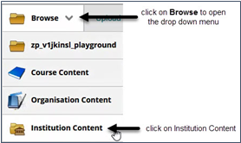
- In the pop-up window, hover over the Browse folder, then select Institution Content
- Click on the ‘Show all’ button near the bottom of the page.
- Use the radio button to select Own Work Declaration 2021-22(RemoteExamination).pdf file. This is a copy of the preferred wording for an OWD, as agreed by the Academic Contingency group (COVID-19).
- Click on Submit to go back to the Create File window.
- In the Name field type:
“Own work Declaration - open and read. By selecting 'Mark reviewed' you agree this is your own work”
- Select Submit.

Now add your exam drop-box in the same content area as the OWD. It does not matter whether you are using a Learn assignment drop-box or a Turnitin assignment drop-box.

Set up the dropbox to be hidden until the OWD has been reviewed

- Click on the action arrow beside the drop-box and select Adaptive Release from the drop-down menu.
- Scroll down to Review Status and select Browse
- A pop-up window appears with the folder structure for your course.
- Select the Own Work Declaration Form. The pop-up window closes.
- Select Submit.
- Click on OK in the pop-up window to confirm that review has been set up.
- The exam drop-box should now have Enabled: Adaptive Release under the title and the OWD form now has Enabled: Review under the title.
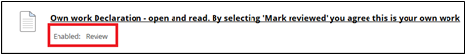
- Switch to Student View and you can check that the assignment is not visible until you have selected "Mark Reviewed". (Doing this will not affect it’s availability to students)

If you require this document in an alternative format, such as large print or a coloured background, please contact Karen Howie (Karen.Howie@ed.ac.uk)

