Learn - School Learn Support Role

This document covers the main tasks that can be carried out by staff with the School Learn Support (SLS) role in Learn. Once training has been completed, staff will receive additional permissions which will allow access to the System Administrator panel.

Contents
1) Search for Users within Learn 2
2) Search for Courses 2
3) Enrolling users onto a course 3
4) Quick Enrol yourself onto a course 4
5) Manual Courses Naming and Location conventions 4
6) Create a User playground 5
7) Creating a manual course (not registered in EUCLID) 6
8) Shared Course Arrangements 7
9) Batch enrolling users onto multiple courses 8
10) Applying a template to a course 9
11) Quick Enrol 10
12) Instructions for school staff with Quick Enrol privileges 12

1) Search for Users within Learn
You may need to search for a user to check their availability and view their enrolments across multiple courses. You will be able to search for users across the University.
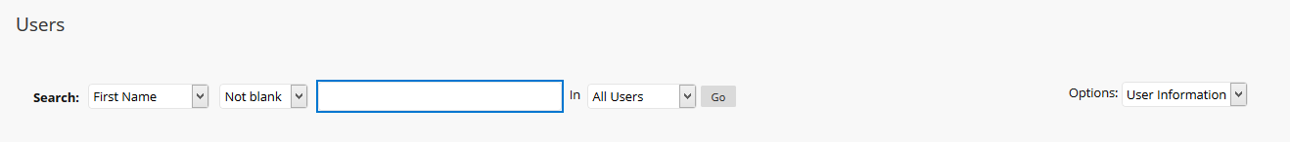
Selecting Users from the Admin Panel takes you to the window below:

This provides a number of filters and search options including searching by username, first name or last name, (from the drop-down menu) and user (system) role (from Options).
You can use “contains” to find partial matches to firstname or lastname if you don’t have an exact UUN.
Do not search for UUN “Not blank” which returns all enrolments and will take a very long time to run.
Do not use the “nodes” options, users are not generally associated with nodes.

Your search results will display a list of users. Any user that is no longer active in Learn will have a Red X next to their name.
You can access options and properties for the user by using the context menu next to their name details.

2) Search for Courses
Selecting Courses from the Administrator Panel takes you to the window below:
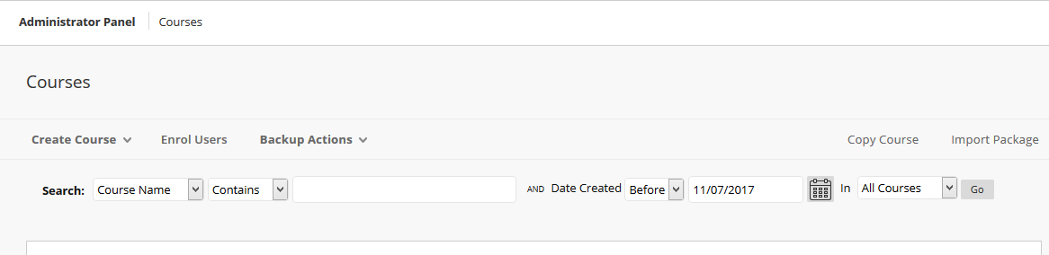
From this screen you can search for courses by Course Name or Course ID (i.e. EUCLID code)
You can filter in a number of ways.

Examples:
- If you have part of course name use “contains” in second field
- School - Replace “All Courses” selection in last field with “Select a Node” and use pop-up search window to find school by name - e.g. “Contains” “Divinity” and select the School of Divinity node.

From the courses window you can also enrol users singly or in a batch, create new courses, and create a course backup. See later sections of this document for instructions on these.
Searching for courses is also available to the Quick-Enrol role, and is the easiest way of accessing and quick-enrolling onto courses.

You are restricted to your school node only when searching for courses whereas when searching for users it is university wide.

3) Enrolling users onto a course
- Find the course (by course name, use contains - add part course name as above).
- Select the context menu next to ‘Course ID’.
- Select ‘Enrolments’ from drop down list.
- Click on ‘Enrol Users’
- Enter a single UUN or paste in a comma-separated list of UUNs.
(If one UUN is incorrect, the whole list fails.)
or
- Select browse to search for a single user (this gives options for search by first name or last name as well as UUN)
- Add ‘Role’ from drop down list, and submit.
- You will receive a “Success: Enrolment added for username” message.

Use caution when adding student users to a EUCLID-fed course. This should only be done in exceptional circumstances, (for example, if immediate access to a course is urgent), as the EUCLID feed will over-write any manual changes.
It is not possible to delete a user from a course as this action removes any work submitted by that student, anonymises discussion posts, and is irrecoverable.
Instead, make the student inactive by using the action menu next to the username and selecting “change user’s availability in course” and select “No” from the “Available” option.

4) Quick Enrol yourself onto a course
School Learn Support can add themselves to a course (only courses associated with the assigned school) to check it, add other users, or edit content.
You will be enrolled onto the course as an Instructor; this role has full view, edit permissions.
- Search for course as described above. e.g. course name, contains - add part course name.
- Click on Course ID - ignore the red “Access Denied” alert.
- Select Quick Enrol link in left-hand menu and click OK
- Course Management Panel will appear for course, allowing you to carry out the edits or other task required.
- To exit - select Quick Unenrol and click OK – ignore the Page unavailable error message.
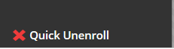

5) Manual Courses Naming and Location conventions
As the Learn School Support role you will be able to create manual and playground courses for your school. To help manage the large number of courses in the system you must follow the naming conventions as below and ensure the course is added to the correct school/node in Learn.
Courses are assigned to school\nodes to allow the School Learn Support role to manage them. Courses that aren’t assigned to the relevant school\node will not be able to be managed by the School Learn Support user.
Use the format for prefix, Course name as given and location (attach to node) as below:
Prefix | Type of course/section | Use / Node
zp_ | Playground sections (UUN) | For individual playgrounds - add to playground node.
ls_ | Shared courses - name as given by staff. | For manually-created target courses - add to school node
zu_ | Non-automated University courses - name as given by staff, include time period (AY, Sem) | Where enrolments do not come from EUCLID. Use school or department node as appropriate.

Note course ID’s cannot be changed once created.
Please note that the course prefix is lowercase. The course id does not contain spaces.
We recommend coming up with your own naming convention for identifying courses by name, academic session and semester.
Deprecated codes: previously, manual shared courses have been prefixed zs_ and some older non-EUCLID courses have been prefixed zx_. Ongoing instances of these courses will continue in the system, but please do not create any new courses using these codes.

6) Create a User playground
A user may request a playground directly via the IS Helpline, but this ability is also available to the School Learn Support role.
A playground course is one intended solely for testing features and functionality of a test course and is not intended for teaching or general enrolment.
- Select the System Admin tab.
- Select the Courses option, inside the Courses module.
- Select Create Course > New.
- General Information fill in the fields with the details below:
  - Course Name: ** zp_UUN**_playground
  - Course ID: ** zp_UUN**_playground
  - Description: (Leave this box blank)
- The subject area and discipline can be left as default.
- In Term, select ongoing from the drop down menu.
- Leave options Availability, Guest Access, Categories as they are.
- For Course View Options the default will be Original but you may select Ultra if this is required. Instructor is not recommended.
- For option 5 Institutional Hierarchy Nodes click on the Find node button and type “playground” in the search field. Select the check box for your School Playground node, and press submit. This closes the pop-up window.
- Leave the rest of the settings as they are.
- Select the Submit button to the bottom right of the window.
- Return to the Courses section as in 1 above.
- Search for the playground you have just created (course contains “uun”)
- Click on action arrow next to the course ID, select enrolments from the drop-down menu, and enrol the user as an Instructor in their playground.
- Apply the appropriate template to the course (see section 10 below).

7) Creating a manual course (not registered in EUCLID)
This can be used to create courses which do not take any data feed from EUCLID – for example, external courses, or training courses for staff or students. It can also be used to create a Shared (target) course for EUCLID-fed courses, e.g. for a programme-level grouping.
You will need details from the user of
- the exact name of the course,
- whether it is a copy of any pre-existing course(s),
- which year(s) and semester(s) it runs in, or if it is ongoing
- the school or other unit for course node
- the UUNs of Instructor(s) to enrol.
If the course is to be a target shared course, it MUST be given the prefix ls_. Otherwise use zu_
Please note ls_ is lowercase “LS_”

- Select the System Admin tab on the top left. Select the Courses option, in the Courses section.
- Select Create Course > New.
- General Information fill in the fields with the details below:
  - Course Name: ** Course Name** (as seen by students)
  - Course ID: ** zu_course_name_year** (shorten if necessary) or **ls_course_name_year**
  - Description: (Leave this box blank)
- Course IDs must be unique, so if you are running the same course in Semester 1 and 2 then you may also wish to add SEM1 or SEM 2 to the course ID.
- The subject area and discipline can be left as default.
- In Term, Select Academic year (e.g. 2018-2019), ongoing or relevant term, from the drop down menu.
- Availability – Yes
- For Course View Options the default will be Original but you may select Ultra if this is required. Instructor is not recommended.
- Guest Access - No
- For option 5 Institutional Hierarchy Nodes click on the “find node” button and find the relevant node, either school (type “school” in the search field then Go to get a list of schools) or other area (e.g. type “Institute” to find IAD). Check the relevant node and select submit. This closes the pop-up window.
Any manually created course that is not assigned to a node on creation will result in a ‘target does not exist’ error.

- Leave the rest of the settings as they are.
- Select the Submit button to the bottom right of the window.
- Return to the Courses section as in 1 above.
- Search for the course you have just created (course contains **coursename**)
- Click on action arrow next to the course ID, select enrolments from the drop-down menu, and enrol the user(s) requested as instructors.
- Apply the basic template to the course (see item 10 below), either the default or the school template requested.

8) Shared Course Arrangements
Shared course arrangements cannot be setup by the School Learn Support role. You can request a shared course request via the Learn Support Webpages using our web form.
If you are requesting multiple shared course arrangements, it is possible to send these through to us following a template spreadsheet. Once filled in this can be sent to IS Helpline for processing.
Removing a Shared Course Arrangement
In the event of a course no longer requiring the shared course arrangement to feed student enrolments it can be disabled. You can request a shared course is disabled using the Shared Course Request Form and indicating that the arrangement is to be disabled in the action drop-down selection. You can also send a request to the IS Helpline.

Please note: Removing a shared course arrangement will de-activate the EUCLID enrolments, however the students will still need to be made unavailable in the target course after the arrangement has been removed. It is not possible to delete students from courses, but they can have their status set to unavailable which will prevent them accessing the course again.

There is more information about how shared courses arrangements available from the Learn support webpages

9) Batch enrolling users onto multiple courses
We recommend using the EUCLID enrolment for managing student access to courses, and we consider EUCLID to be the golden copy for information about which courses students should have access to.
It is possible to bulk-enrol users into one or more courses as a single upload and executable action. This approach may be useful in the following scenarios:
- A new member of teaching staff that needs access to multiple courses
- Providing Staff Participant access to multiple courses
- The use of a manual course that requires multiple student enrolments
There is no bulk un-enrol, so take care when using this.
Because it is not possible to delete people from a course any unwanted enrolments will have to be set to unavailable manually.

Batch enrol cannot change an existing user’s role in the course.
Format for the bulk enrol upload file
- Create a csv file in Excel with one record on each row of the file.
- Each record must be in the following field order:
Course ID, Username, Course Role
(Do not have a title column for these names as it will not upload, have it look like the example below with no title column)
- Save as a .csv file.
- After you have created the CSV file go to:
- System Admin> Courses > Enrol Users> Browse> Upload csv file.
- Set the delimiter Type to Comma and Select Submit
Example: to enrol users as instructors on to course with id zp_course1
zp_course1 | psmyth | P
zp_course1 | khall | P
zp_course1 | rwa | P

Course Role Codes
Instructor Role | P
Student | S
Teaching Assistant | T
Staff Participant | SP
Class Only | A2

10) Applying a template to a course
In the majority of Schools all EUCLID created courses will have a template applied, so the instructions below will only apply to manually created courses.

Applying a template does not overwrite existing content, so if there is already some content in the course when a template is applied, duplicate content folders and menu items may be created. In this case it is necessary to go in and “tidy” the course by removing empty content folders and menu items.

Course Copy
If there is no template applied to a course, you can use the course copy tools to give your course the key content, structure, and settings from another course.
Before you start: You will need to know which template is to be applied, and the ID of the course to apply it to.

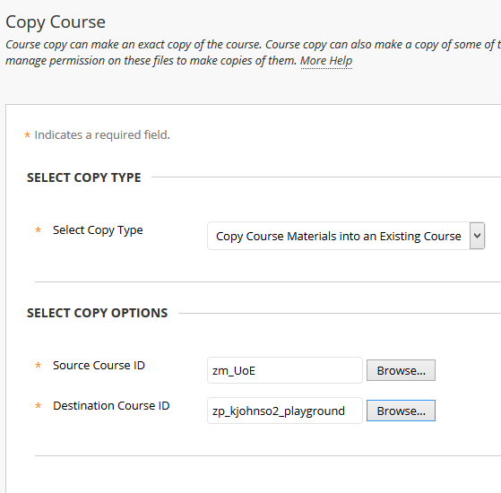
- Go to System Admin> Courses > Copy Course
- Select copy type: Copy course materials into Existing course
- Select Copy Options:
- Browse Source Course ID: Pop-up window opens.
- Search Course ID to find template
Select template and Submit. Pop-up window closes.
- Destination Course ID: Course ID type in or search for Destination course ID (as step 5 above).
- Select Submit. Copy options window opens.
- Select at least one item of content.
- Select Submit. You should see a “Success: Course copy action queued” message.
- An email confirmation is sent when the action is complete.

11) Quick Enrol
Learn School Supports can assign the Quick Enrol privilege to staff within their schools. The Quick Enrol privilege allows a staff member to enrol temporarily on any course within their school in order to see content, activity, or perform administrative tasks. They can subsequently un-enrol themselves from the course to avoid accumulating lengthy lists of courses. If the school has agreed, it is possible to bulk enrol a list of staff UUNs as a csv file.
Please note: Quick Enrol is an administrative privilege and membership in your school should be reviewed on a regular basis.
Quick Enrol grants people with Instructor access to any course in your school and has full edit and view permissions.

School Learn Support should not add users to the school\node with any other role than Quick Enrol.
IS monitor school\node roles and will remove other escalated roles
1. From the System Admin tab > Communities> Institutional Hierarchy
2. From the Hierarchy tree on the left hand pane, select the relevant School
3. The School name will then appear at the top of the main window. Business School is selected in the example in the image below.
4. Select the Administrators tab
5. From the Administrators tab select Add Administrator
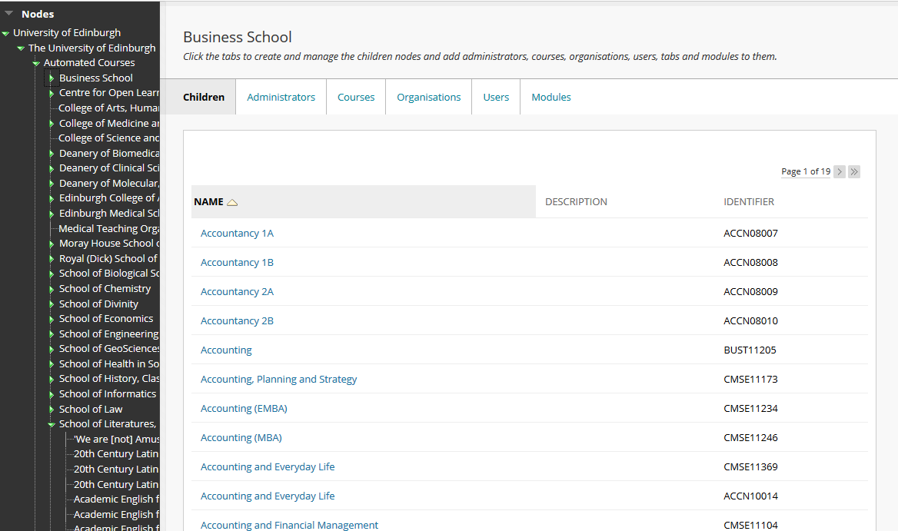
3. School name will appear here after selection from left pane
4. Select the Administrators tab
2. Select School from here

6. Enter the UUN into the username field. Multiple names can be entered if separated by a comma.
7. Select Quick Enrol from the role and move it to the selected items window.
8. Select Submit
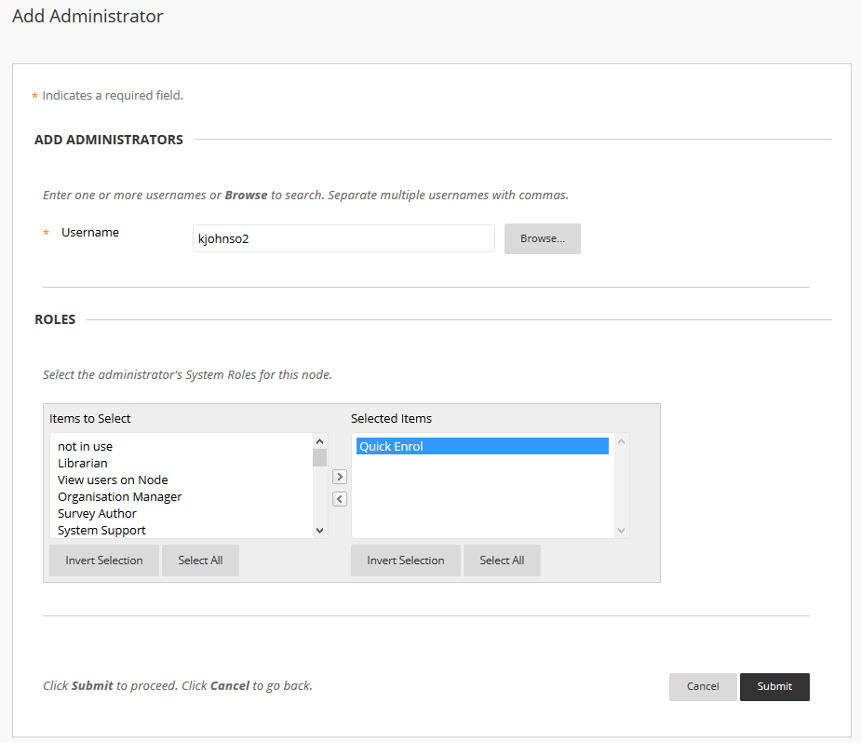
6. Enter UUNs in username field

7. Select Quick Enrol here
8. Submit

12) Instructions for school staff with Quick Enrol privileges
School staff who have been assigned Quick Enrol privileges, can access courses within their school through the Quick Enrol link.
How to search for courses:
Clicking on the Quick Enrol link will take users to an overview screen which contains a link to the course search page.
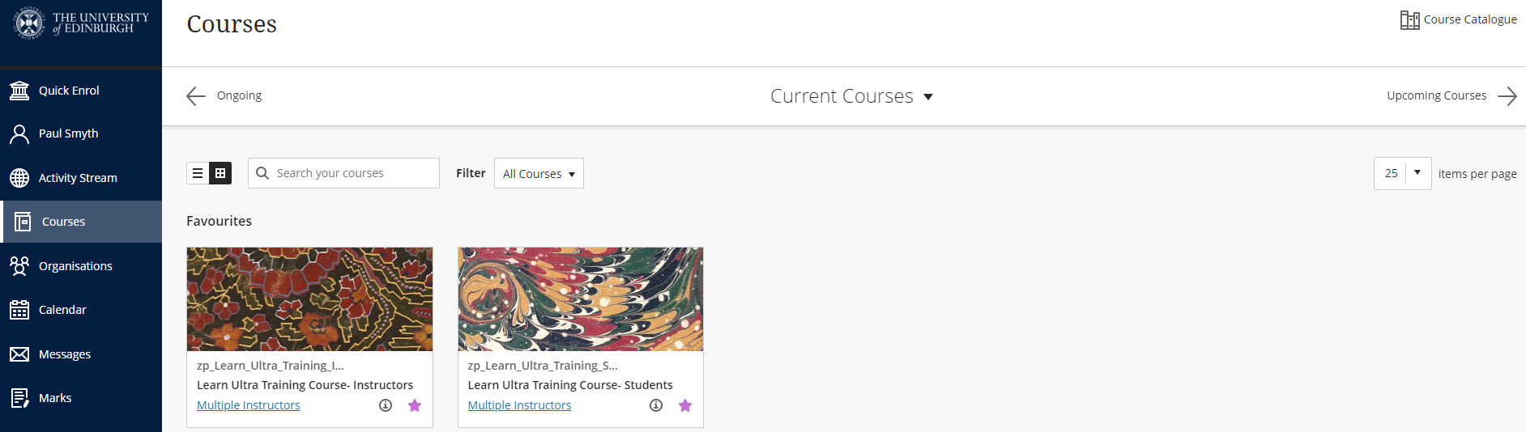
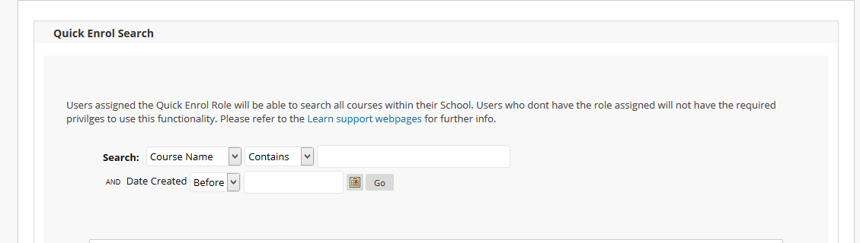
From this screen you can search for courses by course name, or Course ID (i.e. EUCLID code).
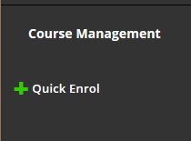
You can narrow your search by using the “date created” field, otherwise leave at the default and select “Go”.
- From the list of courses, select a Course ID > Open to enter the course.
- The Quick Enrol option can be found at the bottom of the left menu. Ignore the “Access denied” message at the top of the screen – you have not yet enrolled.
- Select OK when you see the pop-up message: ‘You will be given the role: Instructor. Proceed?’
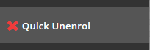
- You can now view the course as an Instructor, and carry out tasks such as enrolling others.
- When you no longer need to have access to the course, choose Quick Unenrol from the left hand menu to leave the course.

