Easter Bush Pathology

HISTOLOGY Request Form
Vet Practice & Clinician |  |  |  |  |  |  | Charge to
Sampling date/time |  |  |  |  | Previous lab no.s
Animal’s name  + I.D. number, if available |  |  |  |  | Owner’s name
Species |  |  | Breed |  |  | Sex |  |  | D.O.B.
Clinical history (primary complaint, duration of illness, additional findings/ancillary test results, etc.)
Drugs given
Lesion description (location, size, rate of development, etc.) |  | 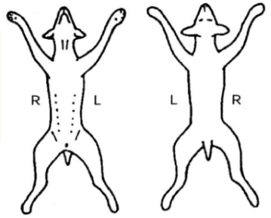
Clinical diagnosis (list of differentials) |  |  |  |  | Laboratory notes (for lab use only)

