EdHelp and Library Site Helpdesks Satisfaction for 8th August-15th September

Library Sites- 98% satisfaction during this period
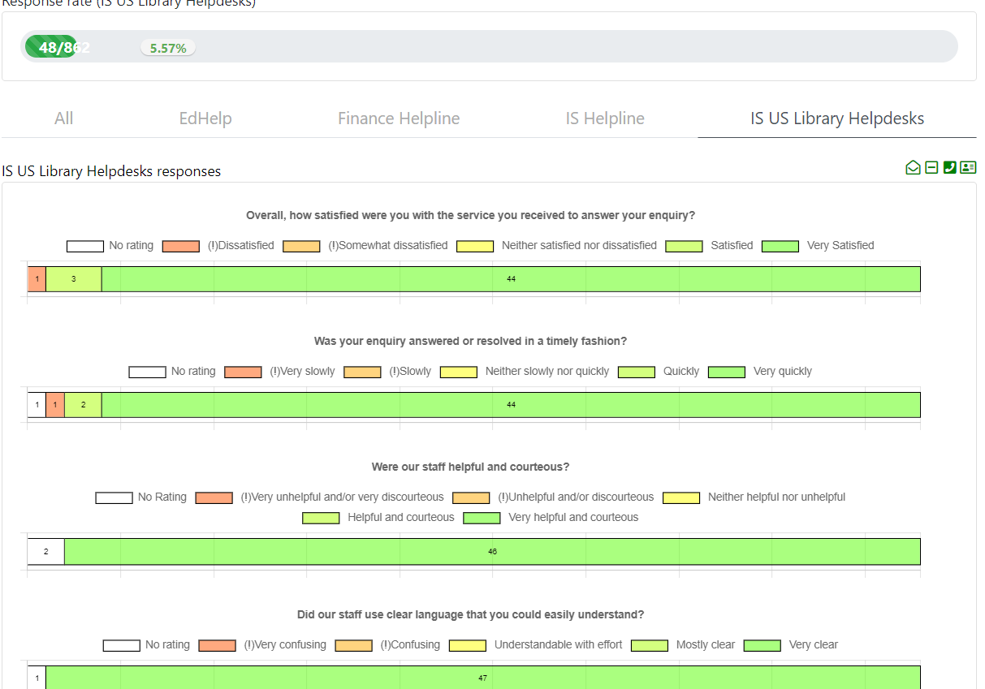

EdHelp-94% satisfaction during this period
