A Guide to Shared Parental Leave

Contents
Introduction 2
Glossary 2
End to End Process Map 3
Key Roles 4
Before you start 5
Policies 5
Subsidiaries 5
Recording 5
Step 1 – Notification of entitlement to take SPL 6
Step 2 – Booking Leave (continuous and discontinuous) 8
Step 3 – During SPL 10
Step 4 – Returning from SPL 12
Step 5 – Non-Return from SPL 13

Introduction
This guidance document has been written to support the end to end business process for Shared Parental Leave.
The guidance has been written by stage in the process with the key roles in mind. The responsibilities of a Line Manager and School or Department Administrator may vary between Colleges, Schools and Professional Service Group Departments. Line Managers should contact their local support team to understand the process and responsibilities within their own area.
For example, a School or Department Administrator could be performing tasks in the process of a Line Manager.

Glossary

P&M | People and Money
SPL | Shared Parental Leave
Curtail | when a mother/lead adopter gives notice to bring their maternity/adoption leave to an end early
SPLIT days | Keeping-in-touch days
ShPP | Statutory Shared Parental Pay

End to End Process Map
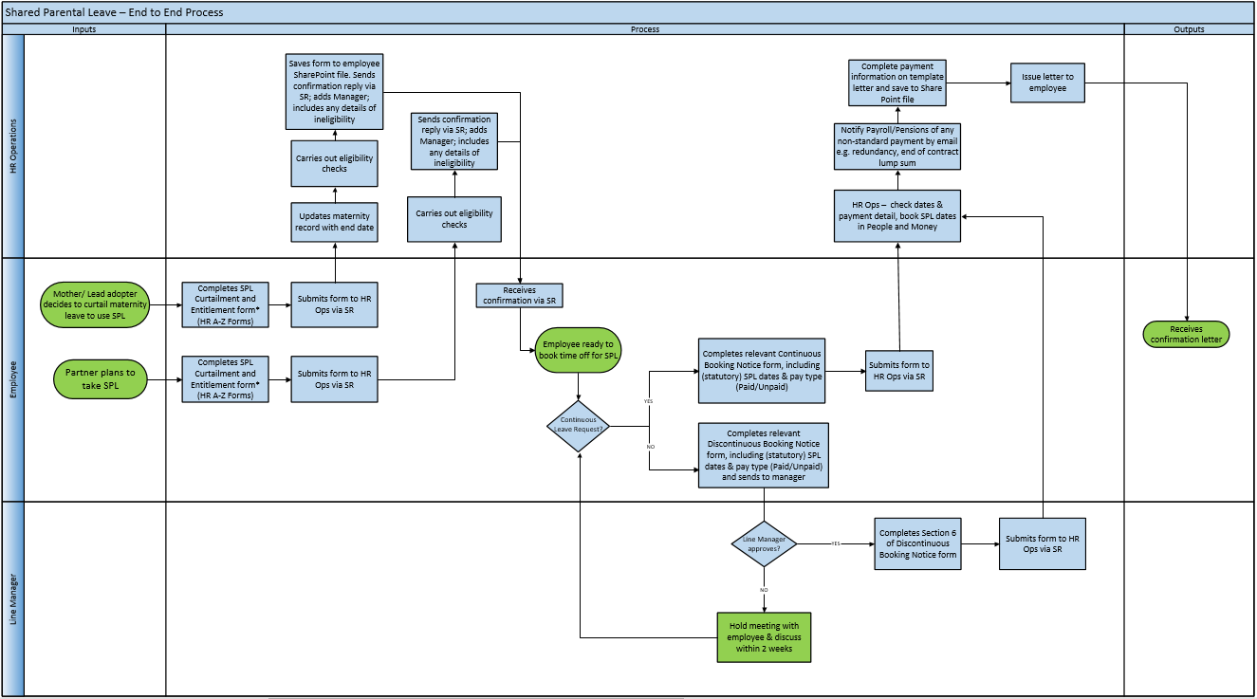

Key Roles
Role | Description
Mother/Lead Adopter | University of Edinburgh employee who is a Mother/Lead adopter who wishes to share their leave and/or pay with their partner to care for their child in the first year following their birth/placement for adoption. This role also applies to intended parents in a surrogacy arrangement.
Partner | University of Edinburgh employee who is a Partner/Father who wants to share leave with the mother/lead adopter of their child in the first year following their birth/placement for adoption. This role also applies to intended parents in a surrogacy arrangement.
Line Manager | All members of staff that have direct or matrix style management responsibilities for other members of university staff. Only direct line managers can record leave and not “dotted” line managers.
Directors of Professional Services or equivalent | Will have access to reports to see absence in the School/ Department.
School/Department Administrator (SDA) | Some areas will appoint a designated person within the School or Department to which absence can be reported to and recorded by. Will have access to reports to see sickness absence in the School/ Department.
HR systems | Auto generated reports will be produced by OTBI
HR Operations | HR Ops will receive forms, check eligibility, record Shared Parental Leave in People and Money and produce employee letters to confirm Shared Parental leave arrangements. Will liaise with payroll.
Payroll | Updating records for staff on long term sick
HR advisor | HR Advisors and Heads of HR supporting managers with employee relations issues.
Occupational Health (OH) professionals | The University’s Occupational Health Service professionals provide an independent, impartial and confidential service to benefit University employees and managers with regard to health concerns or issues. They assess referrals for ill health retirement according to the requirements for ill health retiral as indicated by the pension provider. They decide if support for ill health retirement can be given.

Before you start

Policies
Please read the University’s Shared Parental Leave policy, which applies to all employees of the University who wish to share leave and pay with their partner to care for their child in the first year following their birth/placement for adoption. The policy includes information regarding eligibility, entitlement and pay options.

Subsidiaries
Employees of subsidiary companies should refer to their own SPL Policy. Leave entitlement plans for colleagues in subsidiaries (Edinburgh Innovation, Edinburgh University Press and UoE Accomodation Ltd) have been built in the system.

Recording
When booking periods of SPL, employees should complete the Curtailment and Entitlement form and send to HR via Service Request with an indication of how much leave and pay they wish to take. HR Operations will check entitlements and respond to the employee. Employee sends the Booking Notice Form to HR to request the dates they wish to take SPL. HR Operations log the absence dates in People and Money and issue a letter to the employee. Payroll receive copy of letter and calculate pay.
SPL is requested at Person, not Assignment level, and so employees with multiple posts will only request each period of SPL once as the leave must start and end on the same date in every post.
Any existing absences, such as annual leave, that clash with the leave request must be deleted prior to processing the absence.

Work Schedules
Work schedules in People and Money are very important as they underpin the operation of other functions, such as the annual leave requesting and recording process. Every assignment must have a work schedule and these are normally discussed and agreed on appointment or when there is a change in working hours/pattern or a flexible working request has been made.
It is vital that the work schedule is maintained and is correct prior to the leave start date. The work schedule must be amended on return from leave if the employee wishes to change their working pattern. Further information is available within the Guidance to Work Schedules. Currently SDAs cannot see employees’ work schedules but the employee and the line manager can see the work schedule using the Team Schedule app.

Step 1 – Notification of entitlement to take SPL
Employees and managers should read the Shared Parental Leave Policy for information and guidance about each stage of leave.

Role\Process | Employee | Line Manager/SDA | HR Operations
Discuss with manager | Employees are encouraged to have an informal discussion about their plans to take SPL with their  manager as early as possible so they can plan ahead for their absence.
Ending Maternity/Adoption Leave and Notification of Entitlement (Mother/Lead Adopter only) | Before initiating SPL, the mother/lead adopter must give their employer notice that they are  curtailing their maternity/adoption leave and pay arrangements. The remaining leave and any  ShPP can then be shared.  To do this they must complete sections 1 and 2 of the SPL Curtailment and Entitlement form  If the employee plans to take SPL themselves, they should continue to complete the rest of the form and give an indication of how much leave and pay they plan to take and when.  The form should be submitted through a Service Request in P&M:  - raise an SR  - Click on Category  - Select Forms  - Select Interim Forms  - Select Shared Parental Leave  Employee Guide – How to request Shared Parental Leave | The line manager will be copied into the letter that HR operations send to the employee. | HR operations will check eligibility and send a letter to the employee, copying in the line manager, through the Service Request informing employee of next steps.
Notification of Entitlement (Partner only) | To initiate SPL, the partner must complete and submit the Curtailment and Entitlement form through People and Money with an indication of how much leave and pay they plan to take and when.  The form should be submitted through a Service Request in P&M:  - raise an SR  - Click on Category  - Select Forms  - Select Interim Forms  - Select Shared Parental Leave  Employee Guide – How to request Shared Parental Leave | The line manager will be copied into the letter that HR operations send to the employee. | HR operations will check eligibility and send a letter to the employee, copying in the line manager, through the Service Request, informing the employee of next steps.
Curtailment Cancellation | If the employee decides to cancel the curtailment of their maternity/adoption leave and pay, they must complete the Curtailment Cancellation Form. This must be done before they have returned to work (other than on agreed SPLIT days).  The form should be submitted through a Service Request in P&M:  - raise an SR  - Click on Category  - Select Forms  - Select Interim Forms  - Select Shared Parental Leave | The line manager will be copied into the letter that HR operations send to the employee. | HR operations will acknowledge receipt and notify the manager

Step 2 – Booking Leave (continuous and discontinuous)
Employees and managers should read the Shared Parental Leave Policy for information and guidance about each stage of leave.
Role\Process | Employee | Line Manager/SDA | HR Operations
Booking Leave | Once HR operations have confirmed entitlement, all periods of SPL must be requested by completing a Booking Notice Form and sending this to HR through a Service Request with the category ‘Interim Forms SPL’ in People and Money. The employee should remove any existing leave, for example annual leave, that will overlap with intended periods of SPL.  Employee Guide – How to Request, Cancel and Amend Annual Leave  Dates  Each period of leave will be booked separately, for example an employee may decide to take 3 separate periods of continuous leave.  If the Curtailment and Entitlement form was submitted before the actual date of birth/placement, and the expected date and actual date are different, the period of entitlement will change (i.e. the employee is entitled to take SPL up until the first anniversary of the child’s birth/placement). In this situation an employee should contact HR:  - raise an SR  - Click on Category  - Select Form  - Select Interim Forms  - Select Shared Parental Leave  - Explain in the comments field that the entitlement dates need to be amended and confirm the actual date of birth/placement  Type of Leave  There are two types of leave to choose from; continuous or discontinuous. Please read the Shared Parental Leave Policy to understand the difference. Continuous leave requests will automatically be granted. Discontinuous leave requests need to be approved by the manager. If the employee has more than one post at the University, they must notify the manager in each post that they intend to take SPL.  Pay Options  The employee must select which option they are choosing based on their entitlement and how they wish to be paid for this period of SPL.  Employee Guide – How to request Shared Parental Leave  The employee should confirm the SPL weeks already taken, by them and their partner, and the remaining weeks available. This will change every time they book leave. They can use the table below to help with the calculation. If the employee is not entitled to statutory pay, they should disregard the Statutory Pay column.  Leave Statutory Pay  - Total shared entitlement (weeks): 52 39  - Weeks already taken/booked by you and/or the person you are sharing leave with (this includes Maternity leave and previous SPL bookings):  - Remaining weeks available for SPL: 52 39 | If continuous leave is chosen, HR will acknowledge receipt and inform the manager. If discontinuous leave is chosen, the manager will need to approve or decline the request.  If the request cannot be approved, the manager must meet with the employee, within 2 weeks, to discuss the request and explore whether alternative arrangements can be agreed.  If the request is approved, the manager must approve the Booking Notice form in Section 6 and submit the form through a Service Request in P&M:  - raise an SR  - Click on Category  - Select Form  - Select Interim Forms  - Select Shared Parental Leave
Line manager responsibilities in P&M | If a line manager is going on leave, they should delegate their tasks for the duration of the absence to another colleague within their team.  The Line Manager can delegate approval to an individual SDA or to a nominated person.  P&M user guide - How to set up a delegation for a planned absence  Delegation applies to all approvals, both employment approvals and leave. Approvals delegated will go to one named person. | If the employee goes on SPL, before they have set up their delegation, the line manager can set up delegation on their behalf.  P&M user guide - How to set up your reportee's delegation during unplanned absence
Supporting Information
People and Money User Guides
Human Resources A-Z of Policies
Appendix I

Step 3 – During SPL
Employees and managers should read the Shared Parental Leave Policy for information and guidance about each stage of leave.
Role\Process | Employee | Line Manager/SDA | HR Operations
Keeping in touch days (SPLIT) | If an employee agrees to attend any SPLIT days, they will need to decide in advance whether they wish to be paid for the time, or accrue TOIL. If they choose to take TOIL, they must arrange with their manager when this will be taken. Ideally, this will be at the end of their leave and before they physically return to work. | Enter the SPLIT days into People and Money.  To submit the form, go into Help Desk and click on the Service Requests app. Go to the Forms heading and select KIT/SPLIT Days from the list. Complete the mandatory fields and click Save and Close to submit  P&M User Guide - How to raise and maintain a Service Request enquiry user guide.
Varying Booked Leave | Employees can vary booked leave provided they give 8 weeks’ notice. They must notify HR by completing the Varying/Cancelling Booked Shared Parental Leave form.  Employee Guide – How to request Shared Parental Leave | HR will acknowledge receipt and inform the manager. | HR ops will amend/cancel the booked leave.
Cancelling Booked Leave | Employees can cancel booked leave provided they give 8 weeks’ notice. They must notify HR by completing the Varying/Cancelling Booked Shared Parental Leave form. In the comments field they must add a note to explain if they will be rescheduling or if they have decided to opt out of SPL.  Employee Guide – How to request Shared Parental Leave | HR will acknowledge receipt and inform the manager. | HR ops will need to amend/cancel the booked leave.
Supporting information
Employee Guide – How to request Shared Parental Leave
P&M User Guide - How to raise and maintain a Service Request user guide

Step 4 Returning from SPL
Employees and managers should read the Shared Parental Leave Policy for information and guidance about each stage of leave.
Role\Process | Employee | Line Manager/SDA
Changing working pattern/work schedule/working hours | If an employee wishes to request a different pattern of work for their return to work following leave, they have the right to make a flexible working request.  Flexible Working Policy | Consider the flexible working request and follow the procedure in the Flexible Working Policy.  Update the employee’s work schedule, if necessary  Guide to Work Schedules
Other forms of leave (delaying the return) | If an employee wishes to delay their expected return date beyond their entitlement they may be able to request another type of leave. See the Shared Parental Leave Policy | Discuss the other types of leave available.
Carry over of annual leave | Ideally, holidays accrued during your leave should be taken at the end of the period of leave and before physically returning to work. | If the employee has accrued leave that they have not been able to take and therefore they need to carry over into the following year, their leave balance will require to be manually adjusted. SDAs can do this themselves and guidance on how to do this can be found in the user guide linked below. In areas where there is no SDA available to help with this, line managers can raise a service request to HR Operations who can do this.  P&M User Guide - How to adjust balances
Supporting Information
People and Money User Guides
Human Resources A-Z of Policies
Human Resources A-Z of Forms

Step 5 Non-Return from SPL
Employees and managers should read the Shared Parental Leave Policy for information and guidance about each stage of leave.
Role\Process | Employee | Line Manager | HR Operations
Redundancy | Should the role be placed ‘at risk’ of redundancy shortly before or during SPL, the employee will be given the same opportunities to engage with the consultation process as they would have had they been at work. If they are subsequently made redundant while on SPL, payment of any outstanding UESP/ShPP will be made by lump sum at the end of the employment. If they are made redundant prior to taking planned SPL, they will no longer be eligible for SPL. | Follow any necessary steps as outlined in End to End Process User Guide – Guide to Employment Separation | HR Ops will liaise with payroll and send a letter to the employee, where necessary.
Resignation | If an employee decides they won’t return to work, they must notify their manager as soon as possible. They must give notice of their resignation, in line with their Conditions of Employment.  If they opted to receive UEMP they will be told how much they need to repay, so that they can agree how this will be repaid before their employment ends. | Process the termination in People and Money.  P&M User Guide – How to process terminations  End to End Process User Guide – Guide to Employment Separation | HR operations will liaise with payroll and send a letter to the employee.
Supporting Information
People and Money User Guides
Human Resources A-Z of Policies

