EPSRC Impact Acceleration Account
UoE Partnership Development Call September 2023
Criteria and Guidance Notes

Application deadline: Friday 1 September 2023 at 12 noon. Submit to EPSRCIAA@ei.ed.ac.uk.

Table of contents
Table of contents 1
SUMMARY 1
SCOPE 2
What is a suitable partnership? 2
How mature is the partnership? 2
APPLICATION PROCESS 3
TERMS AND CONDITIONS 4
Strategic alignment, proposal themes and content 4
Partner organisations 4
Internal requirements 5
Proposal duration 5
PROPOSAL AND ACTIVITY COSTING 5
CONFLICTS OF INTEREST 6
AWARD CONDITIONS 6
SUBMISSION 6
Appendix 1: Using EPSRC IAA to develop partnerships 7
Appendix 2: Relationship maturity levels and their characteristics 8

SUMMARY
The EPSRC IAA seeks to support the University of Edinburgh’s ambition to increase its number of strategic partners in industry or government sectors. Funds are available to provide resources for engagement initiatives that will accelerate the development a relationship, which shows the signs of being long term, multidisciplinary and large scale, and has the potential to become more strategic (in the medium to long term).
Applicants are strongly encouraged to contact their School leadership, finance team and lead Business Development or Technology Transfer colleague at the earliest possible stage, to discuss the proposed projects and access necessary support.

SCOPE

What is a suitable partnership?
Some of the University’s partners are suitable for more strategic partnerships. Typically, these partnerships will be working towards a joint long-term strategy and will be recognised across different parts of the University. Partners that may be suitable for a more strategic engagement are characterised by:
- Having the ability to invest significant new sums into University activity (£m scale cash and in-kind), including via access to their supply chains and clients
- The ability and willingness to work in partnership to attract further significant investment (through for example, influencing Government and joint bidding)
- Deriving long-term value and synergy from a close strategic relationship with the University
- A need or identified opportunity and willingness to work across College/University disciplines
- Could credibly build the University partnership into their long-term ambition and strategy
In addition to direct investment, Figure 1 below highlights the range of activity a strategic partnership will influence.

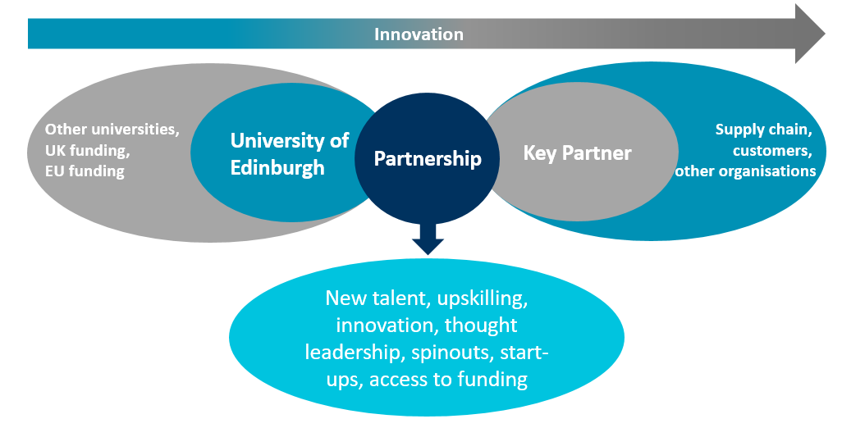Figure 1
Examples of the structure of previous partnership development projects can be found in Appendix 1.

How mature is the partnership?
The partnership development proposal should be appropriate to the maturity of the relationship. Figure 2 presents a model with different levels of maturity, depending on the extent of the ongoing relationship. Appendix 2 characterises the various levels in more detail. Business as usual typically reflects levels 1-3. The aim of the Partnership Development is to support academics, their industry partners, and BD staff to progress partnerships to become more mature and strategically significant.

Candidate relationships for this opportunity can be at any stage in terms of maturity levels, and the programme is not expected to result in the creation of partnerships at the highest level. The programme instead aims to support the acceleration of progress towards the next stage of maturity, e.g. developing a broad offer for a targeted partner, expanding an existing relationship across disciplines and/or the partner’s business areas, or joining up the strategy for relationships with multiple touchpoints and establishing longer term priorities.

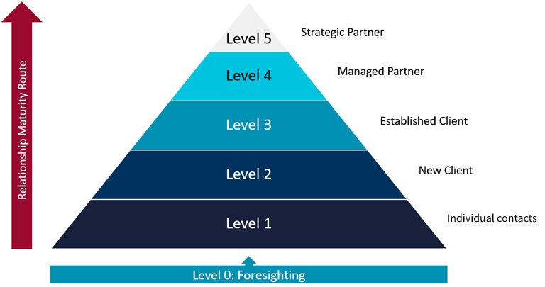Figure 2

APPLICATION PROCESS
The application process consists of two stages with an initial expression of interest to support the applicants’ internal engagement with relevant colleagues across the University.
- Expression of Interest by July 14 2023, complete the online form
- Full application deadline by 12 noon 1 Sep 2023, submit to EPSRCIAA@ei.ed.ac.uk
To apply, please complete the Expression of Interest using the online form by the deadline on 14 July. You will then be eligible to submit the Partnership Development application form to EPSRCIAA@ei.ed.ac.uk by 12:00 noon on Friday 1 September 2023.
The proposal will be evaluated by the University’s EPSRC IAA board comprising members from both scientific and commercial backgrounds. Applicants are urged to ensure that the proposal is written with clarity and a non-specialist audience in mind. The panel will meet by the end of September and outcomes are expected within two weeks of the review meeting.
The panel will particularly consider:
- Choice of partner organisation and its current relationship level (ref. Figure 2)
- Likelihood of moving the relationship up the maturity levels (ref. Figure 2)
- Willingness of partners to engage (including in-kind and cash support with higher expectations on matching for more mature partnerships)
- Proposal’s strategic vision and ambition
- Strategic benefit to the University of Edinburgh
- Level of current and potential touch points of the relationship across the University
- Existing or potential leverage of funds from, and alignment to, other impact or industry funding streams, e.g. Innovate UK (UKRI), ISCF
- Viability of the proposed activities
- Clarity of plan to achieve proposal aims
- Likelihood of achieving impact
- Potential reach and significance of impact (economic, social, and/or environmental)
Where consensus is not reached across the board, the final decision will be taken by the PI of the EPSRC IAA grant, Prof Andy Mount.

TERMS AND CONDITIONS
The EPSRC IAA is committed to equality of opportunity for all eligible applicants. The University has a long-standing commitment to equality, diversity, and inclusion and to promoting a positive culture which celebrates difference, challenges prejudice, and ensures fairness. Applications are encouraged from research-active staff at all career stages and from all disciplines within remit.
By applying to the call, applicants confirm that they are aware of and comply with the University guidelines on research integrity as well as commitments to equality, diversity and inclusion, and the University’s sustainability policy, including its travel guidelines.

Strategic alignment, proposal themes and content
- Overarching themes for the proposal must fall within an EPSRC theme
- Proposal(s) for collaborative projects and secondments must include details on underpinning research and its fit with the EPSRC remit
- The proposal should be focussed on the development and strengthening of a partner relationship with strategic potential
- The proposal should clearly articulate the potential strategic benefit of the relationship and outline which activities and engagement mechanisms will be utilised to achieve this
- The proposal should indicate any link to funding from other funding sources and outline how this could provide additional advantage
- The proposal should have a clear knowledge exchange or commercialisation focus with the short, medium and long-term anticipated impact clearly identified
Fundable activities that can be utilised to support the development and strengthening of the relationship are as follows:
- Workshops and events to develop propositions, joint plans and strategies
- Outward and inward secondments (typically partnership champions)
- Collaborative research projects
Eligible costs include staff time and consumables. Staff travel and subsistence for partner meetings and interactions (appropriately combined with virtual formats, in line with the University Sustainable Travel Policy) is also fundable.

Partner organisations
The proposal must justify the choice of partner organisation.
- Partner organisations can be based in the UK or overseas.
- The proposal should include a statement of support from the partner organisation demonstrating their commitment to the activities outlined in the proposal and the development of the partnership.
- The expectation is that partner organisations will have existing relationships with the University. There may be varying degrees to this, however, the application should demonstrate the added value of developing the partnership.

Internal requirements
- Applicants are required to follow School research application procedures when applying for this funding including costings.
- The proposal for funding must be created as an opportunity in the appropriate research management databases (including Worktribe and IRM) prior to or upon the proposal being submitted. No award can be made without this being documented.
- Applications must be endorsed and managed by the EI account team, or equivalent, at the lead School for the application.

Proposal duration
- The maximum duration for any proposal and its associated engagement activities is 12 months, although funding levels and duration should be appropriate to the activities and proportional to the added value.
- Activities must start by January 2023.

PROPOSAL AND ACTIVITY COSTING
Table 1 below provides guidance on the type of resources and engagement activities as well as the maximum amount of IAA funds that can be requested for each.
Resources | Funds available (up to)
Travel/accommodation/subsistence | £5,000
Meeting/workshop costs (e.g. catering) | £2,500
Events costs (e.g. room hire, catering) | £5,000
Collaborative projects | £60,000
Secondments | £60,000
Table 1
- A maximum of £100,000 can be requested per proposal
- IAA funds will only cover direct project costs. (Please refer to the EPSRC guidance on project costs for definitions.)
  - The activities in the proposal are to be costed on a full economic costing (fEC) basis and IAA funds requested for the permitted costs.
  - Permitted costs that IAA funds can be requested for are directly incurred costs and directly allocated costs except estate costs. Indirect costs cannot be funded.
- Projects are to be costed in Worktribe thus creating a Worktribe record.
- IAA funds will not support basic research
- Feasibility and proof of concept applications will not be supported
- IAA funds cannot be used for direct subsidising of commercial R&D
- Patent filing or similar costs associated directly to registering intellectual property rights will not be supported
- Equipment costs for projects are not normally supported. In exceptional circumstances where a clear case for why the project cannot go ahead without the equipment being provided, equipment cost requests up to a maximum of £10,000 will be considered by the board
- In addition to the cost rules summarised above, for all other costs standard EPSRC grant cost eligibility rules will apply.
- Final project costs must be reflected on financial systems no later than one month after project completion

CONFLICTS OF INTEREST
All applicants are required to recognise and disclose activities that might give rise to actual, perceived or potential conflicts of interest and to ensure that such conflicts are properly managed or avoided.

AWARD CONDITIONS
- To satisfy EPSRC requirements, applicants (BD and academic(s)) must report on progress, in terms of progress against milestones, output and spend, during the project at agreed intervals
- To satisfy EPSRC requirements, applicants must provide progress report(s) as well as final reports and, if requested, contribute to a case study upon completion of the project
- Further, applicants must provide and update information in ResearchFish for individual projects, where applicable
- Applications must be properly costed in Worktribe (with only direct costs allowed) and have received approval through their usual School procedures
- All project costs must be posted to the correct job code no later than one month after project completion. Failure to comply with this may result in being disqualified from submitting applications to future programmes and in the withdrawal of the unclaimed or full amount of the award.
- Any problems or issues that arise during the project must be highlighted immediately. This includes identified underspend in the project period; this is important as these funds need to be reallocated to prevent their loss to the University

SUBMISSION DETAILS
Expression of Interest | Deadline for applications | Panel meeting | Outcomes
14 July | 12noon Friday 1 September 2023 | Late September 2023 | Outcomes expected within 2 weeks of the panel meeting
Expressions of Interest are submitted by completing the online form.
All proposals must be submitted to EPSRCIAA@ei.ed.ac.uk and should contain:
- Overall proposal form with sections on each of the included activities
- Worktribe costing (excel sheet)
- Statement/letter of intent from the partner organisation

Appendix 1: Using EPSRC IAA to develop partnerships
Several partnership development projects with different component parts have been completed using the IAA funds. See two examples below based on projects from previous call rounds.

Example 1
This proposal includes three components: secondment, collaborative project, and regular meetings. The three components are designed to complement each other and form a coherent strategy for intensifying and expanding the collaboration with Company X. The three components fit together as follows: The 6-month collaborative project focusses on exploring topic A. It will bring in a university academic who has not worked with the company before and nucleate immediately a relationship with a division of the company with whom we have not yet collaborated.
The year-long, 1-day per week virtual secondment will enable us to scope out new opportunities to collaborate, within our research group, and in the wider College and University. Areas of strategic importance will be identified, by the secondee and communicated to EI and a wide academic audience at Edinburgh. These strategic areas will then be explored in detail by the company’s scientists and academics at Edinburgh during the scheduled quarterly meetings.
Component activities:
- Collaborative project 6 months
- 1 day per week virtual partnership champion secondment 12 months
- 4 quarterly meetings over 12 months

Example 2
The proposal first phase (months 1-3) is designed to define and qualify a set of topics of interest to Company Y and to agree a set of confidentiality terms. We will hold a meeting with the company to confirm the outline of the project followed by a workshop to define project scope and our respective obligations. Following engagement activities in month 2 we will establish, with support from legal services, an agreement to cover the company’s requirement and a partnership champion secondee to facilitate access and support interactions.
In the second phase (months 4-12) a partnership champion secondee with the necessary technical and commercial skills to be able to move between the two organisations will be appointed to optimise knowledge sharing between specialist joint teams, from Company Y & the university. The secondee will undertake an alignment exercise over 7 months. University and Business Development staff will help support four workshops and seminars to bring together experts from industry and academia to discuss the development of identified topics. The exercise will result in an overview document detailing joint teams, from the company & the university, together with a horizon scan document detailing relevant funding opportunities. By the end of the project, we will expect to have submitted at least 1 major funding application in support of the company’s ambitions and with a platform to establish the company as a managed partner.
Component activities:
- Meeting and a workshop to define and qualify a set of topics of interest to the company and to agree a set of confidentiality terms. (3 months)
- Recruitment of dedicated resource for alignment exercise. (2 months)
- Secondment performing alignment exercise with workshops and Horizon scanning for funding calls around identified topics. (7 months)
- 4 focused workshops around identified priority topics (6 months)

Appendix 2: Relationship maturity levels and their characteristics
Levels of Relationship Maturity - Development Stages

Level | Description | Measures of effectiveness (cumulative) | Typical Activity
Level 0 – Foresight | Companies are identified as suitable targets, but do not as yet have established contacts. | Target lists, IRM campaigns, events, records of initial introductions. | Opportunity analysis and scanning. Proposition development
Level 1 –  Individual contacts | Initial partnership exploration and discussions, assessment on whether both sides fit. | Exploratory meetings recorded, initial opportunities and needs explored, information exchanged (IRM). | Facilitating introductions and selling the University to potential partners.
Level 2 – New Client | Involvement is unlikely to be rigorous, but moving towards some form of agreement. Assessment of ambitions made. | Relationship begins to form Progress to NDA, MoU or contract.  Opportunities captured on IRM Low level investment likely/made. | Finalising contracts and agreements.
Level 3 – Established Client | Repeat business.  Agreement on likely interests and areas of mutual interest. Participation on larger work and bids (e.g. IUK, ISCF etc.).  Assessment of the long term opportunity to develop the relationship. | Relationship activity recorded on IRM. Communities of Interest start to appear and meetings held, Regular briefings and reviews of relationship, recorded on IRM. | Interactions with a number of academics. Some degree of stewardship required.
Level 4 – Managed Partner | Interest in various aspects of the University (not restricted to research),  Relationship is effectively managed.  Future aspirations are agreed and shared.  Account plan/road map is agreed. Activities are focussed on bigger opportunities and strengthening relationships. | Relationship documented in an account plan.  Interaction on a planned and managed basis.  Shared strategic objectives.  Communities of interest remit established.  Interchange of staff.  Allocation of resource mechanisms available to assist in prioritisation.  Joint bids submitted.  Productivity measured. | Agreed account plan, led by nominated account manager and involving interactions with academic groupings across the University. Dedicated stewardship required.
Level 5 – Strategic Partner | Relationships at this level focus on continually improving the productivity of the relationship. | Board-to-board (Executive, Vice-Chancellor) meetings.  Joint Programmes.  Joint investment in facilities.  Productivity actively managed.  Large-scale investment and bidding,  Influencing of Government and external funders.  Suite of activities to maintain strategic relationship put in place. | Managed via an agreed account plan, led by the nominated account manager, involving multiple University services and academic communities and large scale, complex, ambitious programmes/investments. CEO to Principal level engagement. High level of co-ordinated stewardship required.

