EPSRC Impact Acceleration Account
UoE Partnership Development Call September 2023
Application Form

PI DETAILS
Title
Name
Current position
School/department
Email
CO-PI/PDRA DETAILS
Title
Name
Current position
School/department
Email
BUSINESS DEVELOPMENT EXECUTIVE/MANAGER DETAILS
Name
Position
Email
PARTNER ORGANISATION DETAILS
Organisation name
Website
Core activities of partner/sector
Number of employees
UK presence
Associated contact name
Associated contact job title
Associated contact email
PROJECT DETAILS
Start date
End date
Any EPSRC grant(s) linked to this project (NOT REQUIRED | (title(s) and reference(s))
Worktribe reference
Please note that information provided may be used for EPSRC reporting

Partnership development details

- Describe the partner organisation, it’s key business areas and UK presence. (200 words)
- If established, provide details of the history of the relationship, including:
- any previous collaboration (including awards and direct funding)
- proven ability to fund UoE activity and attract investment from third parties (200 words)
- Does the organisation currently engage strategically (e.g. investments of £m scale) with any other HE institution? If so, please provide details, and highlight how a partnership with UoE will differ from existing investments/partnerships. (200 words)
- Describe the role and level of decision-making authority of your key contact in the partner organisation, and how will this project enable you to build more contacts within the partner organisation. (200 words)
- Describe the strategic potential of the partnership, including:
- the potential reach of the relationship across the University
- alignment of partners challenges with UoE research
- evidence that the partner is interested in growing the relationship. (300 words)

- Describe the research expertise and personnel to be involved in the partnership and
  - how this expertise is relevant or beneficial to the partner
  - how the proposal’s overarching theme(s) align with EPSRC’s themes. (300 words)
- Which level of maturity is the relationship currently at? (checkbox)

☐ Strategic partner  ☐ Managed partner  ☐ Established client  ☐ New client  ☐ Individual contacts | 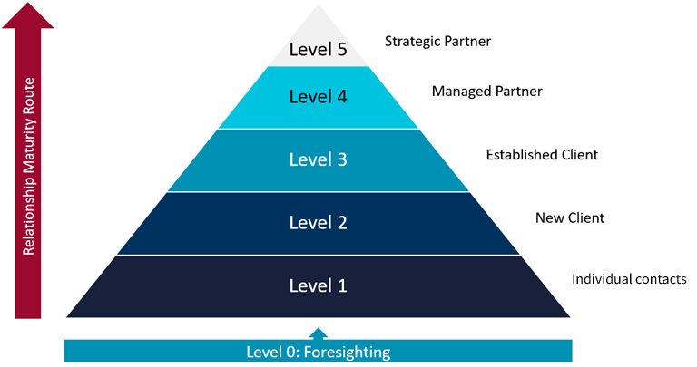

- Describe the purpose and main objectives of the proposal. (200 words)
- Describe the activities included in the proposal (i.e. workshop/event, secondment, collaborative project,) indicating how they align with one another. Where support for secondments and collaborative projects are requested, please complete sections with further details below. (300 words)
- List the activities to be carried out against timeframes.
No | Activities  -workshops/events  -secondments  -collaborative projects | Delivered in (MM/YY)

- Describe how these activities will contribute to the overall objectives of the proposal. (200 words)
ACCOUNT MANAGEMENT
The relevant Business Development Executive/Manager contact must fill in this question.
- Describe the steps that will be taken to ensure ongoing management and to continue to develop the relationship during and after the delivery of this project, including resources and involvement (UoE and EI Staff) required, coordination with the EI Strategic Partnerships Team, and considering other potential funding opportunities to utilise. (400 words)

Collaborative research project details
[delete if not applicable, if more than one please duplicate section]

PROJECT DETAILS
Project title
Start date
End date
Duration
- What is the rationale for the project? Explain the need/opportunity, the role of the partner organisation and your primary objectives. (200 words)
- Describe the underpinning research as supporting evidence for the project, and outline its fit with the EPSRC remit. (200 words, references acceptable)
- How will the project achieve its objectives? Please outline the work plan, key milestones for the route to impact, and associated timelines; and summarise in the table below. (200 words, not including table)
No | Activity/Milestone | Delivered in (MM/YY)

- What are the anticipated next steps after the project? Describe how you will use the project results going forward. (200 word limit)
- What impacts do you ultimately anticipate if your long-term plans are successful? What is the route to realising these impacts? If possible, please attempt to quantify potential impacts. (200 word limit)
- Describe how you will use the project and its results to continue to develop the relationship with the partner. (200 words)
- Responsible Innovation: How do you plan to understand the views of any stakeholders that could be affected by your innovation, i.e. what impacts may be seen as desirable or undesirable, and by whom? See also https://epsrc.ukri.org/research/framework/ (200 words)
- Please justify the resource requested, outlining responsibilities for delivering the project activities, with reference to the project plan above and funding table below. (200 word limit)
IP AND ACCOUNT MANAGEMENT
The relevant BD/TT contact must fill in this section.
- Where appropriate please describe the IP position, the strategy for Background and Foreground commercialisation and any issues to be considered (300 words maximum).

Secondment details
[delete if not applicable, if more than one please duplicate section]

SECONDEE DETAILS
Title
Name
Current position
School/department
Email
SECONDMENT DETAILS
Start date
End date
Duration
- What is the purpose of the secondment? Explain the need/opportunity, for the secondee and the partner organisation, and state the primary objectives of the secondment. (200 words)
- Describe the secondee’s relevant research expertise their skills and experience, how it will support the secondment and outline its fit with the EPSRC remit. (200 words, references acceptable)
- How will the objectives of the secondment be achieved? Please outline the secondee’s planned activities, key milestones for the route to impact, and associated timelines; and summarise in the table below. (200 words, not including table)
No | Activity/Milestone | Delivered in (MM/YY)

- What are the anticipated next steps after the secondment? Describe how you will use the project results going forward. (200 words)
- What impacts do you ultimately anticipate from the secondment? What is the route to realising these impacts? If possible, please attempt to quantify potential impacts. (200 words)
- Describe how you will use secondment and its results to continue to develop the relationship with the partner. (200 words).
- Responsible Innovation: How do you plan to understand the views of any stakeholders that could be affected by your joint activities with the partner organisation? See also: https://epsrc.ukri.org/research/framework/
- Please justify the resource requested, outlining responsibilities for delivering the project activities, with reference to the project plan above and funding table below. (200 word limit)
IP AND ACCOUNT MANAGEMENT
The relevant BD/TT contact must fill in this section.
- Where appropriate please describe the IP position, the strategy for Background and Foreground commercialisation and any issues to be considered (300 words maximum).

FUNDS REQUESTED
Resources required  (e.g. PI/PDRA staff time, consumables, travel costs etc.) | Purpose | Funds to be allocated to  (e.g. School of Engineering, Bayes Centre, EI etc.) | Total Cost (£) | Contribution
 |  |  |  | IAA | Company Cash | Company In Kind | Other Funder

