Client Feedback (Version 2)
University of Edinburgh Client Feedback: Easy Read version
Please ask someone to help you with this form, if you want – like a parent, carer or staff.
- How was it talking to Trainee Clinical Psychologist _________________________? (insert name)

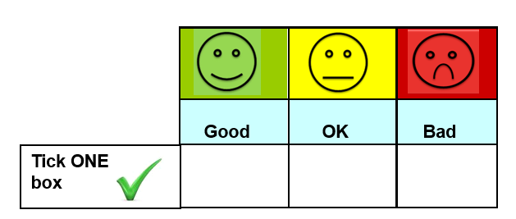

Can you say why? _____________________________________________________________

- Did Trainee Clinical Psychologist __________________________ (insert name) help you with your problems?

Can you say why? ____________________________________________________________

