ECA Parthenon Frieze Cast – East Frieze, Section VII
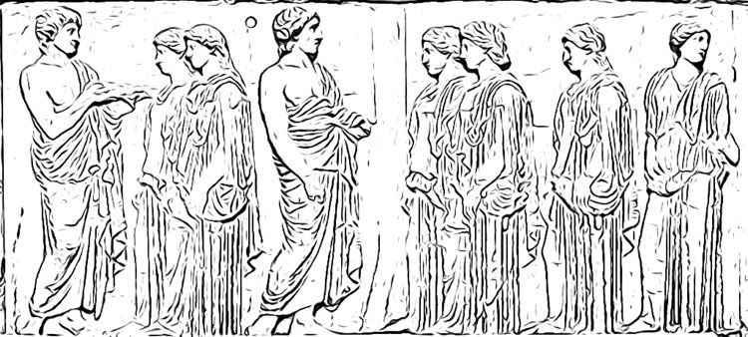
The originals of these panels decorated the walls of Athens’ Parthenon and were very colourful and were also complemented with metal attachments in the form of spears, swords, horse reins and other appropriate accessories, as an additional way of bringing them to life. Bring the panel below to life by adding colour and accessories of your own! We’d love to see your finished creations: Tweet them to us @EdinUniLocal.

