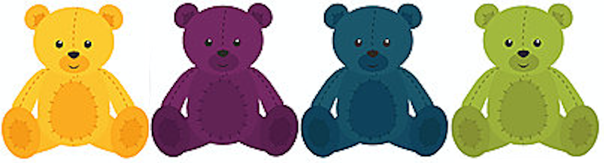
Information sheet for parents
Project title: Language learning study
Invitation to participate. Your child is invited to participate in a research study at the Wee Science Lab on how children learn new languages. This document explains our study, what your rights are, and what will be done with the data we collect. You should keep this page for your records.
What is the study about? When children learn languages naturalistically (for example, if they move to a country where a new language is spoken) they are generally very successful, and typically outperform adults in the same situation. There seem to be differences in the way adults and children learn languages, and the reasons for these differences are currently unknown. The aim of this study is to explore how children learn to classify words into different categories, such as humans and animals.
What will happen? If you agree for your child to participate, we will show your child simple images on a computer screen and teach them to describe these in a new language. Your child’s responses will be audio recorded. The study will last between 20–30 minutes. We will work with your child to make sure they enjoy the task. Your child will receive stickers as a thank you for participating.
Compensation. For your participation in this study you will receive a £5 voucher to a local cafe.
Risks and benefits. There are no known risks to participation in this study. There no tangible benefits to you or your child, however you will be making a contribution to our knowledge about language and how it is learned.

Confidentiality and use of data. All the information we collect during the course of the research will be processed in accordance with Data Protection Law. In order to safeguard your own and your child’s privacy, we will never share personal information (like names or dates of birth) with anyone outside the research team; if you agree and want to be contacted for future studies, we will add your contact details to our secure Wee Science participant database. Your child’s data will be referred to by a unique participant number rather than by name. We will store any personal data (e.g., audio/video recordings, signed forms) using the University of Edinburgh’s secure encrypted storage service or in a locked filing cabinet at the University of Edinburgh. The anonymised data collected during this study will be used for research purposes. With your permission, identifiable data such as recordings may also be used for research or teaching purposes, and may be shared with other researchers or with the general public (e.g., we may make it available through the world wide web, or use it in TV or radio broadcasts).
What are my data protection rights? The University of Edinburgh is a Data Controller for the information you provide. You have the right to access information held about you. Your right of access can be exercised in accordance Data Protection Law. You also have other rights including rights of correction, erasure and objection. For more details, including the right to lodge a complaint with the Information Commissioner’s Office, please visit www.ico.org.uk. Questions, comments and requests about your personal data can also be sent to the University Data Protection Officer at dpo@ed.ac.uk.
Voluntary participation and right to withdraw. We will ask your child’s permission before we begin the study, and we will make sure they understand that they can stop the study at any point. You may also choose to withdraw your child from the study at any time. Any data supplied up to that point will be deleted.
If you have any questions about what you’ve just read, please feel free to ask, or contact us later. You can contact us by email at [insert researcher contact info]. This project has been approved by the PPLS Ethics committee. If you have questions or comments regarding your own or your child’s rights as a participant, please contact the School Research Ethics Convenor at ppls.rec@ed.ac.uk.
Thank you for your help! Now please complete the consent form on the next page.
[insert name of researcher(s)]
Parental consent and agreement to data usage
Project title: Language learning study
PLEASE MARK EITHER ‘YES’ OR ‘NO’ FOR EVERY STATEMENT BELOW:
Consent for participation: | Yes | No
I consent to my child taking part in the above study, including recording my child’s voice/face.
Agreement to identifiable data usage requests: | Yes | No
I agree that recordings of my child’s voice/face can be shared with other researchers and used for teaching or research purposes (e.g., presentations and publications).
I agree that recordings of my child’s voice/face may be made publicly available for general use (e.g. used in radio or television broadcasts, or put on the world-wide web).
I agree to be contacted for future studies conducted in the Wee Science Lab. I understand that the contact information I provide will be securely stored in the Wee Science secure database and that it will not be shared with any third parties.

Caregiver’s name |  | Child’s name |  | Child’s date of birth
Caregiver’s signature |  | Caregiver’s relationship to child |  | Today’s date
Languages spoken + context (e.g., English – school, Basque – home)

If you agree to provide your contact details for future studies, please enter them here (email or tel.):

Unique participant code (researcher will complete)

