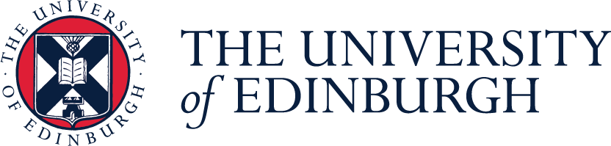

CSE Internship Summary Report
  - June to September 2019

Executive Summary
The College of Science and Engineering (CSE) is committed to helping the University achieve its Zero by 2040 Strategy targets. To understand its current level of engagement with sustainability, the CSE funded a student internship to map out participation in sustainability initiatives and calculate its annual carbon footprint. Using data provided by the CSE, Estates and the Department for Social Responsibility and Sustainability, the annual carbon footprint for 2018/2019 was calculated as 19,303 tCO₂e. Of this total, the majority of emissions arose from business travel and energy sources. Through interviews with all seven Schools in the College a clear, longstanding engagement with SRS topics has been confirmed, with many Schools contributing to the Sustainable Development goals in their teaching and research.
This report highlights the strengths and improvement areas of each School in the CSE, and opportunities for further engagement with SRS initiatives.

Key Recommendations
Following multiple interviews with key stakeholders and extensive research, a number of Key Recommendations are presented below, with detailed explanations provided in the accompanying Appendices.
No. | Policy recommendation | Rationale
1. | Encourage widespread participation in the Sustainability Awards | The Sustainability Awards provide a framework for Offices and Labs to tackle sustainability issues, and receive recognition for their efforts. The CSE has 12 Office and Lab teams currently, but would benefit from teams forming at a whole School and building level rather than small individual groups.
2. | Encourage staff and students to become Sustainability Champions | The newly formed Sustainability Champions Network provides staff and students opportunities to take action on sustainability issues in their area and develop their skills.
3. | Develop leading initiatives to reduce carbon emissions from Business Travel.  e.g. Policy mandating traveling to London by Train | Significant carbon reduction with targeted action as London is the number one destination for domestic flights at the University.
4. | Default Vegan/Vegetarian catering | Responsible and sustainable consumption and carbon reduction.
5. | Sustainability Induction for all Students and Staff | Raising awareness of the University’s commitments to Zero by 2040 and opportunities for staff and students to get involved.
6. | Departmental SRS strategy | Sharing of best practices and recognition of good efforts.

Project Overview
This project was based on a partnership between the College of Science and Engineering (CSE) and the Department of Social Responsibility and Sustainability (SRS). The project aimed to identify the key challenges and opportunities for the CSE to further reduce their environmental impact and contribute to the University’s Zero by 2040 target.
The goals of the CSE internship were to:
- Measure the carbon footprint (tonnes CO₂e) of the CSE in the areas of Business Travel, Waste and Energy, using available quantitative data.
- Through interviews with key stakeholders, map the engagement of the CSE with the SRS department by looking at initiatives in line with five target areas: Zero Carbon, Zero Waste, SRS in Supply Chains, Community Engagement and SRS in Learning, Teaching and Research. Then map these initiatives to the Sustainable Development Goals (SDGs).

Results (1) - Carbon Footprint

Total Carbon Footprint of the CSE
The carbon footprint of the CSE in the areas of Business Travel, Waste and Energy was 19,303 tCO₂e in 2018/2019, an average of 1.46 tCO₂e per capita for the staff and student population (Figure 1). This is equivalent to launching 4 space shuttles into space a year (Berners-Lee, 2019a). Table 1 compares the data for the CSE with that for the whole University, including per capita values.

Figure 1: The carbon footprint (tCO₂e) of the CSE in the areas of Business Travel, Waste and Energy.

Carbon Emissions from Energy, Waste and Travel
The total carbon footprint of the CSE is mainly comprised of the emissions arising from energy and business travel, with waste contributing 0.04%. Table 1 shows a breakdown of the carbon emissions and measured values, including both total and per capita values, for business travel, energy and waste.

Table 1. Total and per capita data from business travel, energy and waste data for the CSE and whole University for the year 2018/2019. Per capita averages were determined using the total population of staff and students in the CSE (13,179 headcount) and the University (53,920 headcount).
 |  | CSE |  | Whole University
 |  | Total | Per capita | Total | Per capita
Overall carbon footprint from Energy, Waste and Business Travel (tCO₂e) |  | 19303 | 1.46 | 78661 | 1.46
Energy | Carbon (tCO₂e) | 13030 | 0.99 | 59669 | 1.11
 | (MWh) | 67745 | 5.14 | 291212 | 5.40
Waste | Carbon (tCO₂e) | 7.27 | 0.00 | 225 | 0.00
 | (tonnes) | 340 | 0.0258 | 2993 | 0.0555
Business Travel (tCO₂e) |  | 6267 | 0.48 | 18767 | 0.35

Energy
There has been a steady decline in energy associated emissions since 2015/2016 with 13,030 tCO₂e being produced in 2018/2019. However, energy consumption has been variable over the same period, and in 2018/2019, accounted for 23% of the University’s total annual energy consumption (Estates Department, 2019).
Waste
The total weight of waste produced by the CSE in 2018/2019 was 340 tonnes. The current average of 25.8kg per person compares favourably to the University’s Waste Strategy target of reducing waste arising per person to 66kg.
Travel
Carbon emissions from CSE Business Travel have varied over the years with a large increase observed in 2018/2019 for all Schools, bar Physics. A total of 6,267 tCO₂e was emitted in 2018/2019, which cost the University £3,605,791 and is equivalent to 12 ha of deforestation (Berners-Lee, 2019b). The CSE also has 6 of the top 12 departments/schools which emit the most carbon emissions from business travel.
Caveats to the data
Energy and Waste data represents the Kings Buildings Campus only and excludes Schools in the central area (the School of Informatics and part of the School of Geosciences located in the Drummond building. Furthermore, the reported waste data only includes data for General, Glass, Mixed Recycling, Hazardous and Organic waste.
Business travel data takes into account all travel bookings via Key Travel and all travel claimed via eExpenses. This includes travel for purposes such as attending conferences, field work and commuting between campuses. It was not feasible to accurately source data from the CSE College Office alone and therefore, this was excluded in the analysis.

Business Travel Survey
Air travel accounts for 95% of the University’s travel emissions, and so a business travel survey was designed to better understand the nature and need for taking flights for business travel, and also questioned which emissions reduction strategies were most effective and favoured. The responses considered most effective and most favoured were a policy mandating travelling to London by train and rewards for those who travel sustainably (Figure 2).
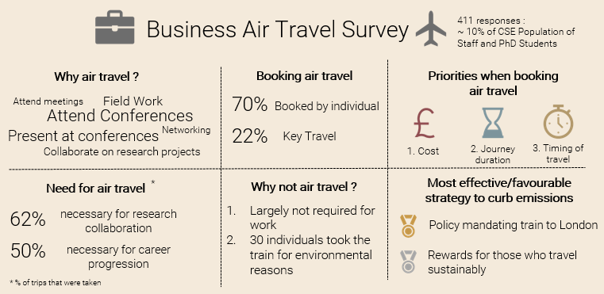
Figure 2: Summary findings of the Business Travel Survey.

Results (2) – Mapping CSE initiatives to five target areas
The chart below maps different initiatives being carried out within the CSE that are in line with five key target areas for the Department for SRS. These initiatives are just some of the highlights within each School, representing those with the most significant SRS impact or originality. Additionally, interviews with key stakeholders revealed a lack of awareness and recognition of the wide variety of SRS themed initiatives at the CSE, which highlights an area for improvement. An extensive list of all initiatives and the key contacts can be found in Appendix A.

References
Berners-Lee, M. (2019a). How Bad are Bananas? Pp.155
Berners-Lee, M. (2019b). How Bad are Bananas? Pp.154
Estates Department, Personal Communications, 3 Sept 2019

Key SRS target areas:
- Zero Carbon
- Zero Waste
- Sustainable Supply Chains
- Community Engagement
- Learning, Teaching and Research

Mapping CSE initiatives to SRS target areas

Actively involved in SCF projects
PC Reuse
Glove Recycling Scheme
Waste management
Book a Scientist
LEAPS
Some SRS courses and research themes
Department SRS Strategy and Committee
4 Student Experience Grants**

*As of 2018/2019 ** In 2018/2019
PC Reuse
Active WARP it user
Waste management
Primary Engineer
SWAP Access programme
Some SRS courses and research themes
4 Student Experience Grants**

Actively involved in SCF projects
Active WARP it user
Science Insights
4273π project
Many SRS courses and research themes
5 Sustainability Awards *
5 Student Experience Grants **
Living Lab projects e.g. Horsefall Labs energy monitoring

Actively involved in SCF projects
PC Reuse
Transitioning to Vegetarian ACE Events Catering
Geoscience Outreach
The Elevator Project
Many SRS courses and research themes
In the process of setting up a Sustainability Committee
Living Lab projects e.g. Case Studies in Sustainable Development

Business Travel Pilot
PC Reuse
Vegetarian ACE Events Catering
Math Circle
Funmaths Roadshow
School Beach Cleans

School of Geosciences
School of Mathematics
School of Engineering
School of Physics and Astronomy
School of Biology
Active WARP it user
Data Education for All
Living Lab projects e.g. City Sounds Project

Actively involved in SCF projects
PC Reuse
Active WARP it user
Waste management
Life Beyond Project
Particle Physics for Scottish Schools
REF 2021 Outreach Impact Cases

School of Informatics
School of Chemistry

Results (3) – Engagement Mapping to SDGs
The University and Students' Association have signed the Sustainable Development Goals Accord in 2017. Demonstrating the level of commitment to the SDGs Accord, CSE initiatives and projects that directly contribute to each of the 17 goals are mapped below.

Engagement Mapping to SDGs

Zero Carbon
SCF projects
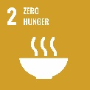
Business Travel Pilot
Sustainability Champions

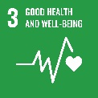
Zero Waste
Paperless exam boards and meetings
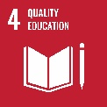
Waste management
Glove recycling scheme

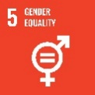
Sustainable Supply Chains
Warp It
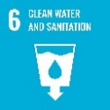
PC Reuse
Vegetarian Catering

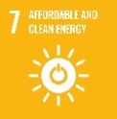
Community Engagement
Widening Participation
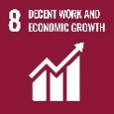
Edinburgh Science Festival
Science Insights
Life Beyond
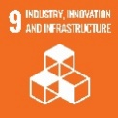
Particle Physics for Scottish Schools
REF2021 Outreach Impact Cases
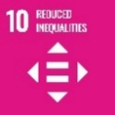
Primary Engineer
SWAP Access programme
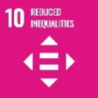
Book a Scientist
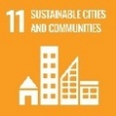
LEAPS
Math Circle
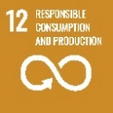
Math Inspiration
The Elevator Project
Data Education for All
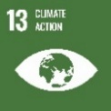
Learning, Teaching and Research
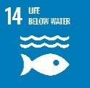
SRS Courses and Research themes
Sustainability Awards
Student Experience Grants
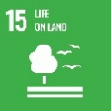
Geoscience Outreach
Living Lab Projects
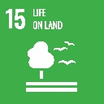
Sustainability Committee

