College of Medicine and Veterinary Medicine (CMVM), University of Edinburgh Public Engagement with Research Strategy

- Informed by CMVM community consultation.
- Accompanied by CMVM Public Engagement with Research Strategy Implementation Plan
- Relates to CMVM Outline Plan 2019 – 2022 Objective 5: To build and strengthen relationships between the university, the city and our communities.

Vision

Our vision is to build a CMVM community who can use public engagement to shape research that is responsive to the needs of society, to grow public trust in medical and veterinary innovation and to do more to improve the health and wellbeing of people and animals. We call this public engagement with research.

This means providing more people with more opportunities to engage in our world leading research. It also means working in ways that generate mutual benefit for our staff, students and wider society.

In the future we aim for our reputation for engagement to be as strong as our reputation for research. We will work towards a CMVM community who recognise that public engagement with research is a valuable part of research activity, are supported to develop their approaches and have the skills to deliver successful engagement.

1: What is public engagement with research?

Public engagement with research describes the many ways we can share CMVM research with new audiences and listen in response. It is a two-way process that enables change and has mutual benefit. High-quality engagement can enhance the impact of research. Engagement methods are influenced by the stage and nature of research activity.

In CMVM there are many ways we can use public engagement with research; to reveal knowledge, to inspire interest, to listen to new perspectives, to consult people with lived experience, to build trust in new technologies, to collaborate and to co-create research.

Why engage?
Public engagement can produce research that has greater impact, boost a scientist’s profile and enable access to new funding streams. It also has wider benefits for our staff and students as outlined below.

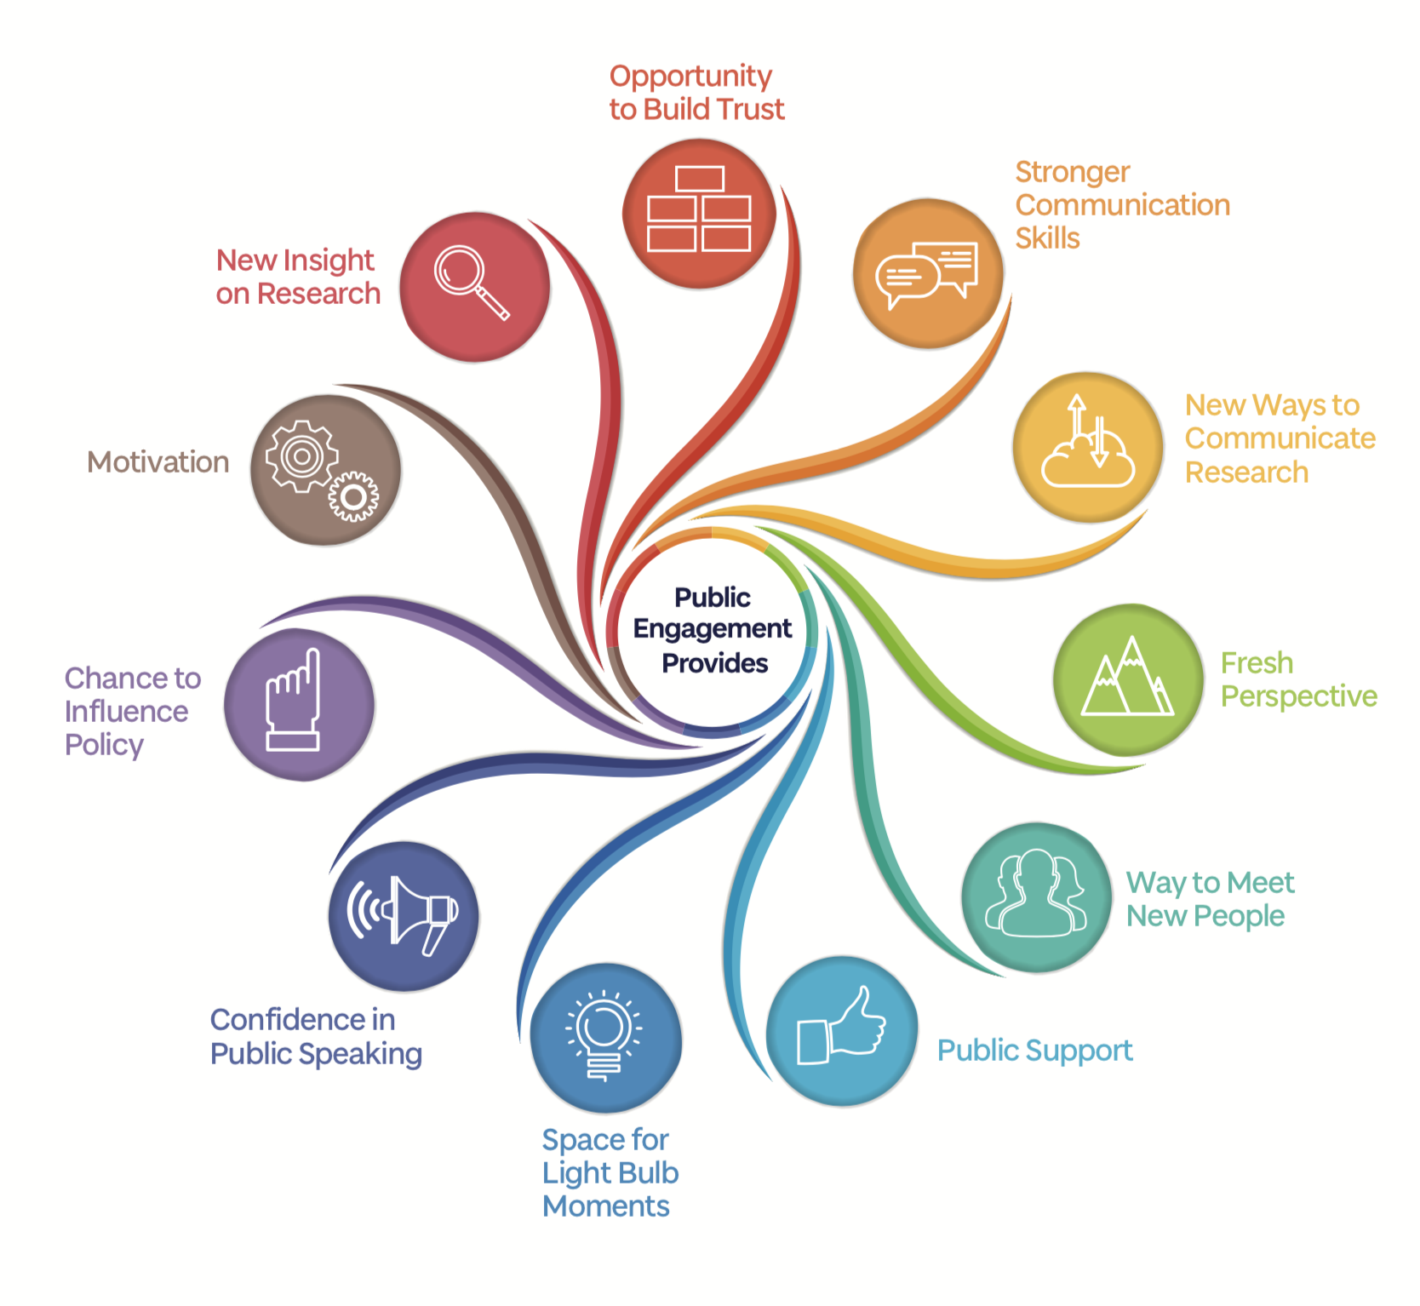
Image Credit: Hazel Lambert for Why Engage, School of Life Sciences, University of Dundee.

Who are we engaging with?
The potential audiences and stakeholders for public engagement with CMVM research are hugely diverse. Decision makers, patients or carers with lived experience, healthcare professionals, funders, politicians, school pupils, teachers, farmers, animal health professionals and others all have a potential interest in CMVM research priorities.

2: The CMVM approach to public engagement with research

Our ambition is to embed public engagement in the research life cycle with the aim of generating mutual benefit for the CMVM community and wider society.

In CMVM we will realise the University of Edinburgh’s objectives for public engagement with research using a simple aims and principles approach that serves to guide all engagement activity.

Our aims are to reveal, involve and embed underpinned by the principles of training, evaluation and partnership. This is the approach the whole CMVM community should adopt in development and delivery of engagement activity.

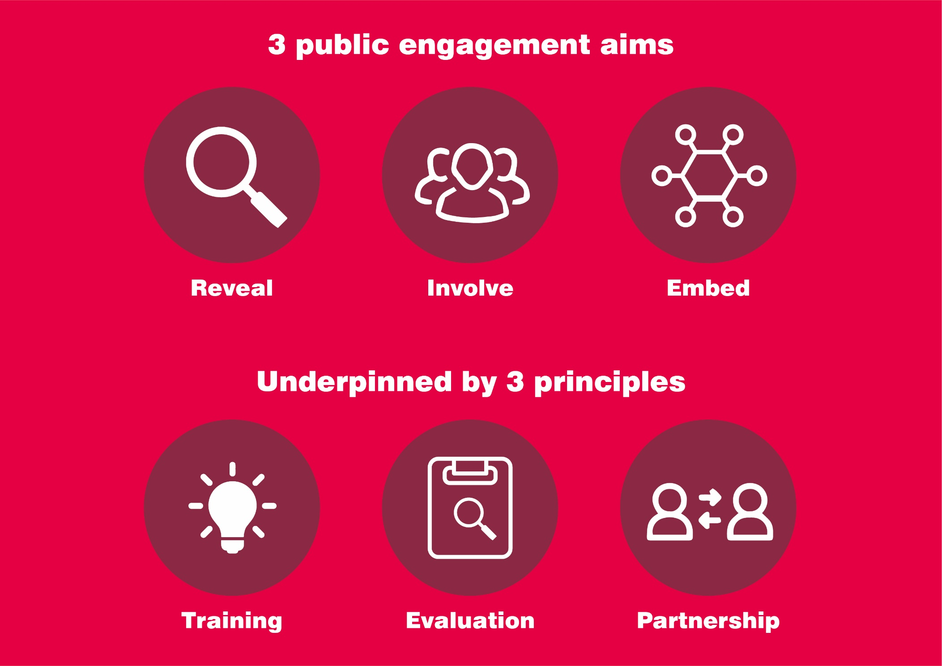

Reveal, Involve and Embed: CMVM’s Public Engagement with Research Aims

- Aim 1: Reveal. This aim is research-led.
This means sharing our research, where and how we conduct it, what we achieve and how it relates to other people’s lives.

How we will reveal: Through science festivals, public talks, fundraising events, research showcases, arts collaborations, digital storytelling, social media, podcasts, media relations, community events and collaborations, MOOCs, science shops and exhibitions.

- Aim 2: Involve. This aim is audience-led
This means always asking the people we are trying to reach how we can shape our messages and activities to meet their needs.

How we will involve: Invite participation in activity design, involve communities in co-design, invite patient perspective on research, create opportunities for idea generation based on lived experience.

- Aim 3: Embed. This aim is benefit-led.
This means making engagement a natural part of research activity. We know that taking part in public engagement has benefits for both researchers and external audiences.

How we will embed: By planning for budget and training to improve lay descriptions in grant applications, through inclusion in work allocation models, by recognising and rewarding time spent on engagement and through visible leadership.

Our public engagement aims are underpinned by three principles

- Training: to equip CMVM staff and students to engage and to support them in delivery.

When planning or preparing to deliver an engagement activity always consider what training is needed, for whom, when and where. Training opportunities should be linked to delivery and delivery shouldn’t take place without an offer of training for those who need it.

- Evaluation: to clarify aims, measure change, capture impact and improve our work.

Evaluation doesn’t have to be onerous. Built into a project from the outset and using methods that suit the participants it will reveal if an activity has met its aims. Making final evaluations available to others is a practical way to share learning within the CMVM community and improve engagement practice overall.

- Partnership: to include other voices, achieve shared aims and strengthen our engagement activities.

We will nurture and value partnerships with the organisations, communities and individuals who work with us to deliver or contribute to public engagement with research.

3: Implementation at CMVM level

The steps to achieve our public engagement with research aims and the University of Edinburgh’s objectives for public engagement with research are outlined in detail in the CMVM PE implementation plan.

A programme of work is proposed to raise awareness, strengthen networks, create opportunities, enable skill development and encourage the CMVM community to put our strategic approach into practice.

The CMVM Public Engagement with Research Manager will work alongside staff from the College of Science and Engineering and the College of Arts Humanities and Social Sciences toward shared goals in leadership, reward and recognition and working with diverse public audiences.

4: How will we know if this strategy has been successful?

Evaluation of the implementation plan is scheduled for 2022. Indicators of success are likely to include increased participation, partnership development and uptake of training in the CMVM community.

