Celebration Event Plan
At the University of Edinburgh we held a CMALT Celebration event annually. This an opportunity to bring the wider group together for informal networking and to celebrate the success of the group. November was a good time to hold this as you should know the results of the June (and some of the October) submission windows by then. At this event new CMALT holders receive University of Edinburgh Awards, travel mugs, as I wanted something to mark the participation in the U of E group. I like drinks cups as people can use them at work and they can start conversations about CMALT.

Date: Late November 3 to 5pm
Venue: The Raeburn Room (An historical university room with prestigious feel)
  - Guest List
    - CMALT Holders
    - CMALT Applicants
    - CMALT Supporters – Line Managers, Senior Managers, Administrative Support
  - Awards – these were handed out to staff as a mark of their participation in our cohort on successful certification.
(https://www.4imprint.co.uk/product/501966/Colour-Trim-Travel-Mug)
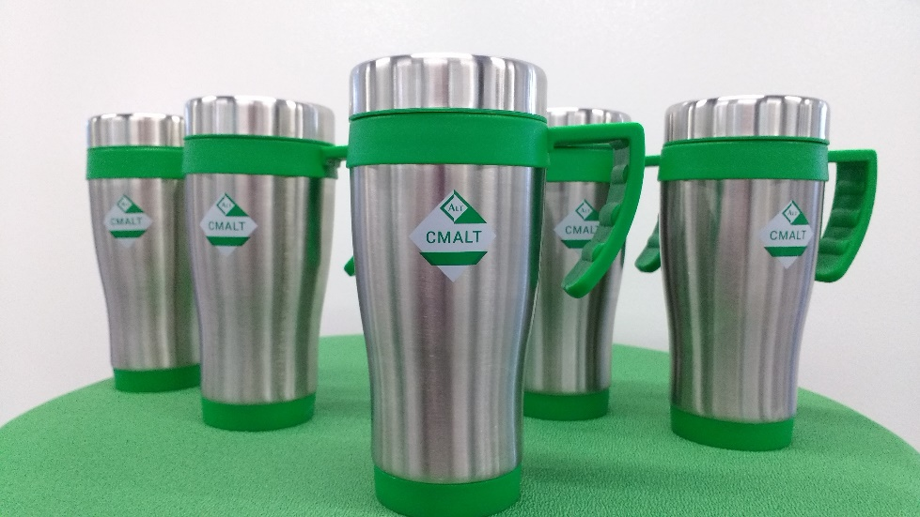
  - Invitations
    - Set up event booking for RSVPs
    - Invitation (Customise for each group) 6 weeks before
    - Send out reminders (2)
    - Keep an eye on the booking numbers
  - Catering – Wine, soft drinks and nibbles
  - Order cakes ( like to have these CMALT branded) – e.g https://www.thebrilliantbakers.co.uk/mini-logo-cakes/

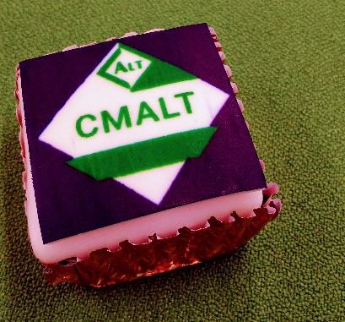

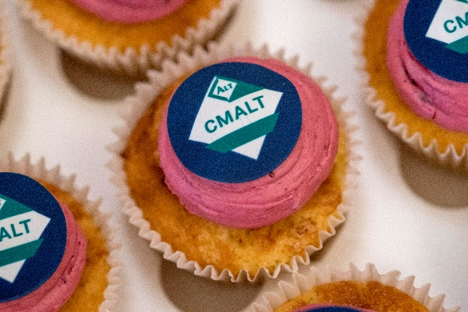

  - Speakers – Invite ALT staff, Senior Management from your institution to give short speeches during the event.
  - Music – background music and something to play this on
  - Photography
    - Book photographer
    - Think about the photos you want e.g. when receiving the award, groups etc.
    - Consider backdrop to photos
    - Permission to reuse, verbal or written
  - Print delegates List
  - Print Badges – CMALT Holders, Participants, Supporters
  - Social Media – Prepare a plan for Tweets on the day
  - Afterwards – publicise the CMALT Awards and publically congratulate winners. Consider blog post. University News item. Mailing list. Twitter or other social media.

