Careers Compass Notebook
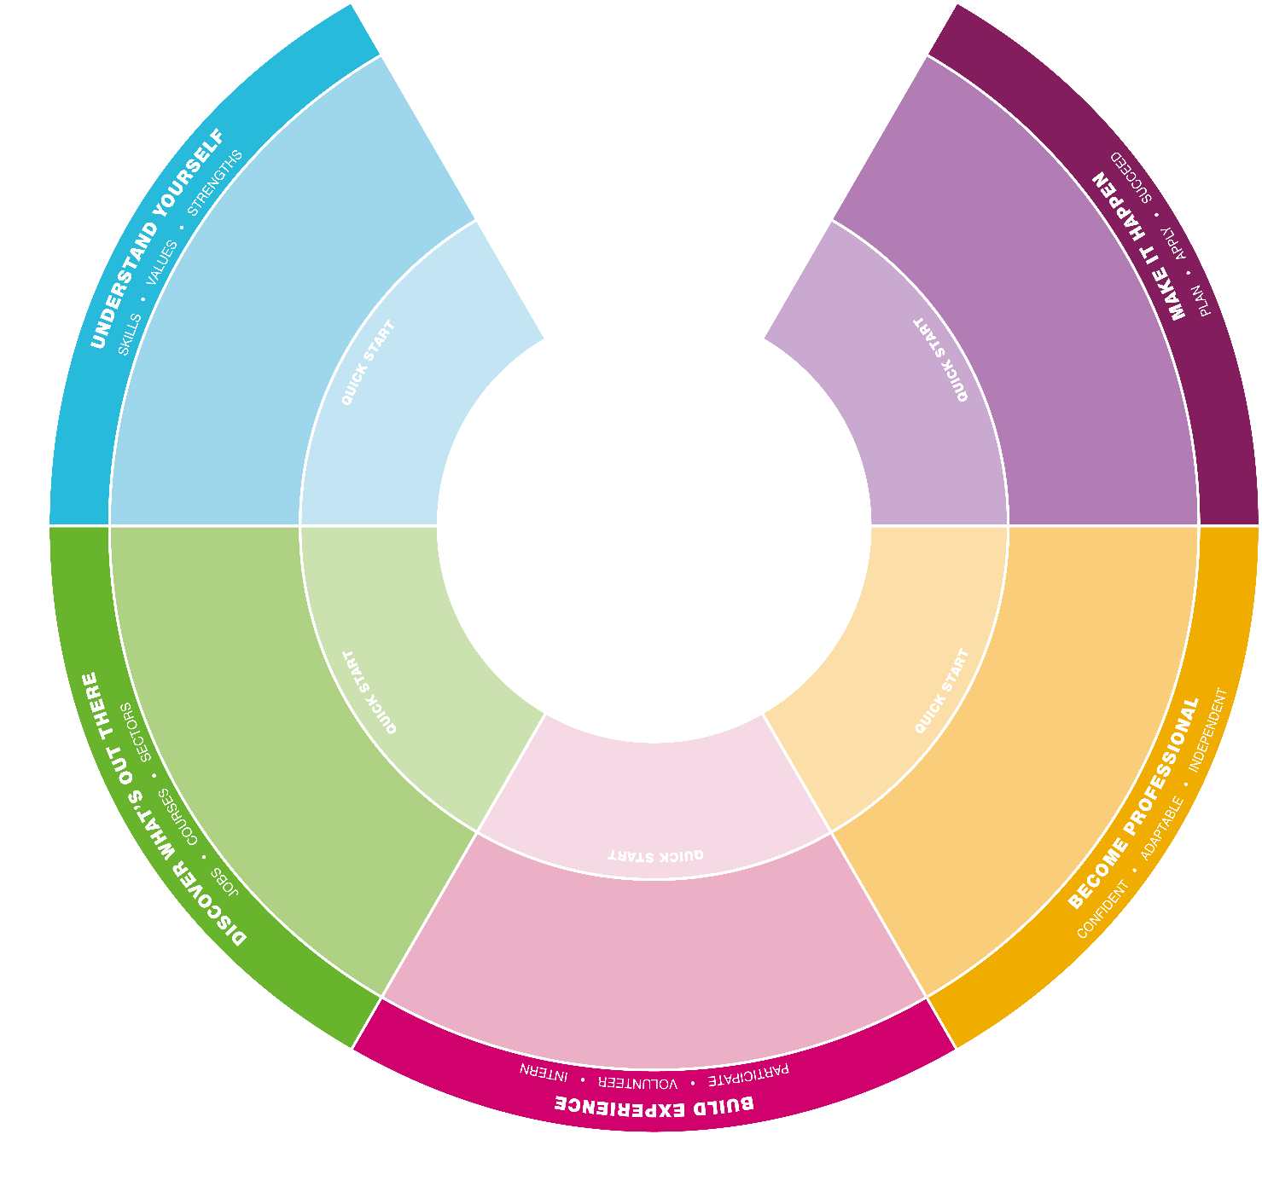
www.ed.ac.uk/careers/compass

Understand yourself: skills, values, strengths
Discover what’s out here: jobs, courses, sectors
Build experience: participate, volunteer, intern
Become professional: confident, adaptable, independent
Make it happen: plan, apply, succeed

What is it?

The Careers Compass can help you review what you've done, explore your options, plan next steps and chart progress along the way. It is designed to help you take small steps throughout your time at university.

Everything we offer is clearly linked to the Careers Compass so you can see where you are developing, identify possible gaps and plan your year ahead. It has five key elements:

• Understand yourself
• Discover what’s out there
• Build experience
• Become professional
• Make it happen

Why use it?

The Careers Compass is designed to work from any starting point. Whether you are in first year or final year, focussed or unsure, it can guide you with suggestions of what to do and when. Time is precious - use the Compass to help you make the most of it. You can build:

• Awareness of what you want, what you are good at and how to develop further.
• Awareness of options, sectors, employers and ways of working
• A range of experiences to develop valuable skills, insights and personal qualities
• Confidence in understanding what it takes to succeed
• Confidence in knowing how to find and create opportunities
• Confidence to make informed decisions and successful applications

How to use it

• Look at each segment of the Careers Compass online in the Student Guide and see our suggestions for actions to take at each stage “What to try” www.ed.ac.uk/careers/compass
• Really busy? Feeling under pressure? Just started thinking about it? Try the Quick start suggestions online to get you going
• Look at our events and resources to see what will help
• We also have the Careers Service Toolkits on Learn you can try, each one links to a segment of the Careers Compass.
• Use this notebook to record what you have done already, plan what you could do next and capture your notes or comments. The Reflectors toolkit is useful too www.ed.ac.uk/reflection/reflectors-toolkit
• Save the notebook in a folder or portfolio. PebblePad is a good option for recording achievements, learning records, personal goals and aspirations. It can be updated regularly, reviewed, shared and published online
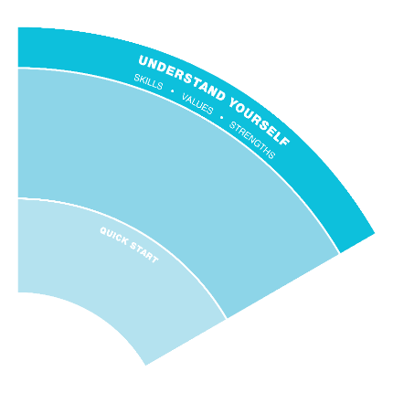 | Understand yourself: skills, values, strengths  By understanding yourself better you can identify what is important to you, what you enjoy and why. It also helps you work out what you are good at and what kind of role and environment might suit you. You’ll make much better applications as a result and you are more likely to find career fulfilment and satisfaction.
Looking back
Previous activities/experiences

What I learned or developed

Looking ahead
Plan a “What to try” action from the online Student Guide. These include a quick start suggestion

Plan an activity from the Understand yourself toolkit on Learn

Notes and comments

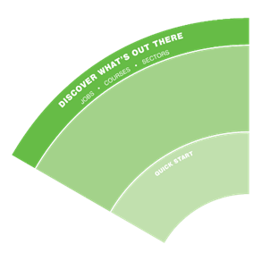 | Discover what’s out there: jobs, courses, sectors  Being curious and exploring different sectors, finding out about different roles, courses, employers and ways of working will help you work out what’s a good fit for you. This will help you narrow down the options and make decisions.
Looking back
Previous activities/experiences

What I learned or developed

Looking ahead
Plan a “What to try” action from the online Student Guide. These include a quick start suggestion

Plan an activity from the Discover what’s out there toolkit on Learn

Notes and comments

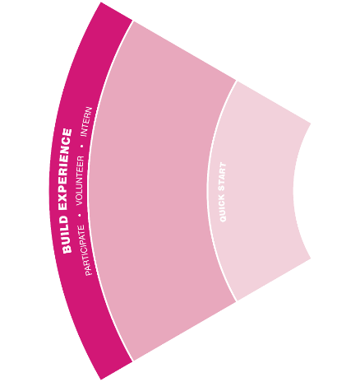 | Build experience: participate, volunteer, intern  Building experience can be everything from being a student rep to part-time work, volunteering in the community to being a School ambassador, informal summer work to doing an internship. Previous experience in an unrelated role, course placements, employer visits, family commitments, work-shadowing or virtual internships….it all counts.
Looking back
Previous activities/experiences

What I learned or developed

Looking ahead
Plan a “What to try” action from the online Student Guide. These include a quick start suggestion

Plan an activity from the Build experience toolkit on Learn

Notes and comments

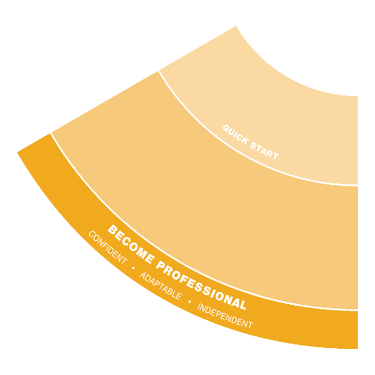 | Become professional: confident, adaptable, independent  Developing professional behaviours and mindsets is a gradual process. It includes being confident about email etiquette, building or extending networks, business awareness and being aware of your digital presence. Whatever stage you’re at – new graduate or mid-career, there are always ways to develop.
Looking back
Previous activities/experiences

What I learned or developed

Looking ahead
Plan a “What to try” action from the online Student Guide. These include a quick start suggestion

Plan an activity from the Become professional toolkit on Learn

Notes and comments

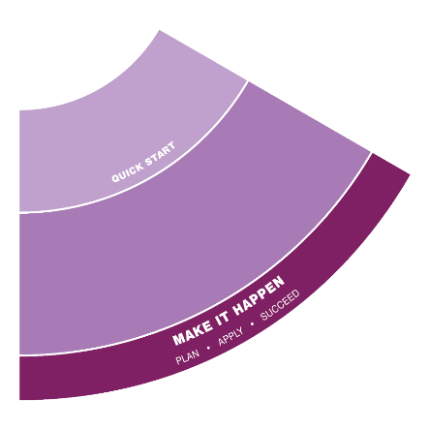 | Make it happen: plan, apply, succeed  You need a strategy to maximise your chances of success.  All the work you have completed across the different elements of the Careers Compass aspects will help everything come together. Making effective applications and positive impressions at interviews depends on how well you understand yourself and what you can offer, awareness of employer requirements and organisational culture and using resources to refine and enhance your applications. This is something you have a lot of control over.
Looking back
Previous activities/experiences

What I learned or developed

Looking ahead
Plan a “What to try” action from the online Student Guide. These include a quick start suggestion

Plan an activity from the Make it happen toolkit on Learn

Notes and comments

