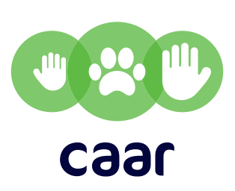
caar practitioner report 3: 2018
Children, adolescents and animals research

Dr Janine C Muldoon
Professor Joanne M Williams

Childhood cruelty to animals: what does it mean & who is at risk?

This report accompanies a reflective workshop organised by caar at the University of Edinburgh and funded by the Economic and Social Research Council (ESRC). It highlights key considerations for practitioners based on discussions within the workshop. For the research findings underpinning this report, please see research briefing 3.

Workshop resources:
https://www.ed.ac.uk/health/research/centres/cadp/child-animal-research/events/2018-workshops/workshop-3

Key considerations for practitioners working with children and/or animals

These considerations relate to two core aspects of practice: (1) understanding the nature and type of cruelty involved, and (2) intervening to prevent cruelty.

Understanding the nature of cruelty

- It is important to understand that unintentional cruelty and neglect are very different from intentional harm caused to animals. We need to intervene differently depending on the type of cruelty we are dealing with.
- Unintentional or accidental cruelty and neglect can result from children’s exploratory play activities, or a lack of knowledge of an animal’s welfare needs or capacity to feel pain and emotion.
- Intentional cruelty and neglect begins as young as 3 years of age, but is most common from the age of 6 years. It often links to adverse childhood experiences and abuse, and a trauma-informed approach is required when working with children.
- Children’s attitudes towards animal cruelty being acceptable, low compassion, low self-reported humane behaviour, poor attachment to pets, and a lack of belief that animals have minds are all risk factors for intentional cruelty to animals.

Intervening to prevent cruelty in practice

  - Childhood cruelty is a concern for many professionals and needs to be taken seriously rather than ignored.
  - Our evaluation research has revealed that programmes such as the Scottish SPCA’s ‘Prevention through Education’ are effective in enhancing knowledge of animal welfare, thereby decreasing risk of unintentional cruelty/neglect.
  - Animal welfare education should be carefully designed with child/age-appropriate activities to increase children’s knowledge of sentience, animal welfare needs and appropriate behaviour towards animals.
  - Longer-term animal-assisted interventions may have more impact on compassion, empathy/humane behaviour.
  - Educators can obtain advice as well as resources and educational materials from the Scottish Animal Welfare Education Forum.
- If you are concerned a child is harming an animal, please refer them to the ‘Animal Guardians’ (Scottish SPCA/University of Edinburgh) programme: https://www.scottishspca.org/media/14037853/animal-guardians-a5-information-pack-v5_editable.pdf

Connect with us
Website: https://www.ed.ac.uk/health/research/centres/cadp/child-animal-research
ChildAnimalResearch @ChildAnimals

