Procedure for booking British Sign Language (BSL)/English interpreters

Deaf people who are British Sign Language (BSL) users have a right to access public services through a BSL/English Interpreter and it is the responsibility of any public body to arrange for this.

Book a registered sign language interpreter as soon as you receive a request – regardless of how far in advance the assignment date is; interpreters are always in demand. Give as much information about the assignment, for example: date, time, location and context (meeting, interview, conference). For assignments longer than 30 minutes it is recommended that at least two interpreters are booked; this allows co-working and ensures the interpreter has sufficient breaks.

You can book a BSL/English interpreter directly – contact details can be found on:
- Scottish Register of Language Professionals with the Deaf Community (SRLPDC) – https://thescottishregister.co.uk
- National Registers of Communication Professionals working with Deaf and Deafblind People (NRCPD) - https://www.nrcpd.org.uk
The BSL/English interpreter’s registration profile may also be available to view which may support you in booking the most appropriate interpreter to work the assignment.

If it is difficult to book an interpreter directly, you can contact an interpreting agency who will source an interpreter for you. You will need to ask the University about which interpreting agencies are on the list of contractors.

Upon the interpreter’s arrival, you must ensure that the BSL/English interpreter is registered either through SRLPDC or NRCPD. Ask to check their badge, which may look like either of the following examples below:
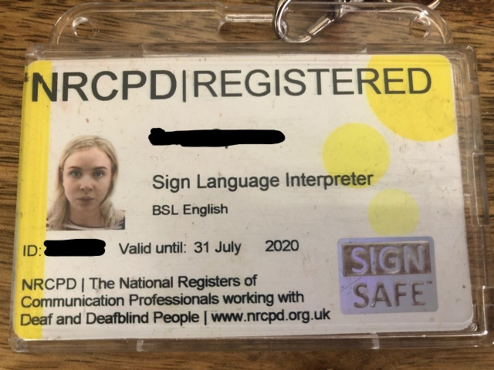
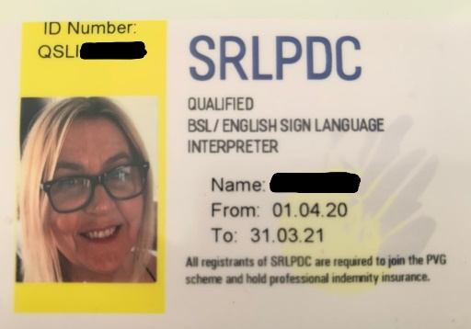

N.B.: the cards displayed above are for demonstration purposes; when asking to view the BSL/English interpreter’s badge it must be valid and not expired.

AUTHOR Alison Hendry, British Sign Language (BSL) Development Officer
DATE November 2021

If you require this in an alternative format please contact disability.service@ed.ac.uk

