Ballater Charitable Chiels Texas Scramble
Golf Tournament
in aid of the
Euan MacDonald Centre for MND Research
and various good causes in and around Ballater

Friday 23rd September 2022

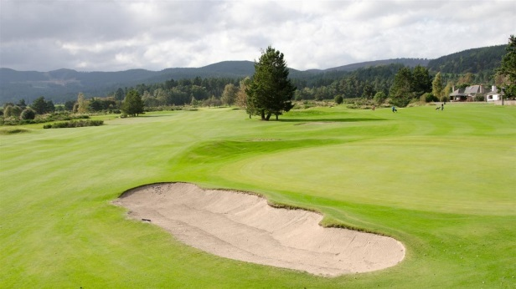

Ballater Charitable Chiels Texas Scramble Golf Tournament
This annual fundraiser was first organised by Sandy Barclay after he was diagnosed with MND. The Ballater Charitable Chiels joined forces with Sandy - and latterly his widow Lindsay - to host this fantastic fundraising event. Over a decade after Sandy’s inaugural Texas Scramble, the Ballater Charitable Chiels continue to organise this fantastic golf tournament in honour of Sandy and Lindsay. To date the Chiels have donated over £180,000 to the Euan MacDonald Centre for MND Research, and a similarly generous amount to community projects in and around Ballater.

Ballater Golf Club
This eighteen hole golf course is situated in one of the most beautiful parts of Upper Deeside. With glorious views and several holes close to the River Dee, golfers are sure to enjoy this lovely course.
The Ballater Charitable Chiels
The Charitable Chiels are local Ballater lads, who raise smiles and spirits with their community fundraising activities. As well as fundraising, the Chiels are also very ‘hands on’ in supporting their local community. They manage the Annual Bonfire and Fireworks Display, Village Christmas Lights, Village Play Park, and Ernie’s Bothy at Gelder Shiel, to name but a few.

The Euan MacDonald Centre for MND Research
The Euan MacDonald Centre conducts vital research into motor neuron disease (MND). Based at the University of Edinburgh, the Centre is a not-for profit, charitable network of over 200 researchers across Scotland. The aim of the Euan MacDonald Centre is to improve the lives of people with MND, and to make discoveries that will slow, stop and eventually reverse this devastating disease.

Ballater Golf Club proudly hosts the
Ballater Charitable Chiels Texas Scramble 2022
Friday 23rd September 2022

Only £50 per player (Team of four = £200)
Includes delicious hot buffet lunch

ENTRY FORM

Team name
Team Captain’s name
Captain’s phone number
Captain’s email address
Player 1 name and handicap
Player 2 name and handicap
Player 3 name and handicap
Player 4 name and handicap
1/10th combined handicap

Cheques should be made payable to Ballater Charitable Chiels - please jot down your team name on the back of your cheque. Alternatively, you can pay by bank transfer using the details below:

Bank account name | Ballater Charitable Chiels
Sort code | 80-05-51
Account number | 00107748
Reference | Please use your team name as your reference

Please send your completed entry form, along with your £200 team entry fee, to:
Andrew Thain
Event Organiser
3 Lochnagar Cottage
Royal Lochnagar Distillery
Ballater
Aberdeenshire AB35 5TB

If you have any questions, or would like more information, please contact Andrew. You can email him at Andy.Thain73@gmail.com or give him a call on 07752 532 864.

