Create auto-captions for your Collaborate recordings

Collaborate can automatically generate captions and a transcript of your session recordings.

Note: Auto-captioning is only available for recorded sessions; live auto-captioning in real time is not available in Collaborate. Also note that auto-captioning is currently only available for recordings in English.

How to generate auto-captions in Collaborate

Go to the list of recordings in your Learn or Moodle course

In a Learn Ultra course, click the ellipsis alongside Class Collaborate in the Details and Actions menu and select View all recordings.
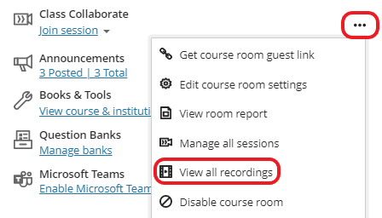

If your course is using the current/old version of Learn, or Moodle, access the Collaborate Ultra tool and then select Recordings from the burger menu.
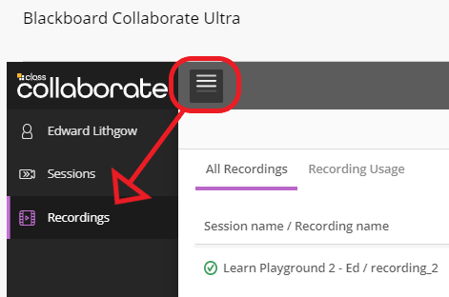

Enable and generate captions for the selected recording

Find the recording you would like to generate captions for and select Recording Settings from the Recording Options menu.
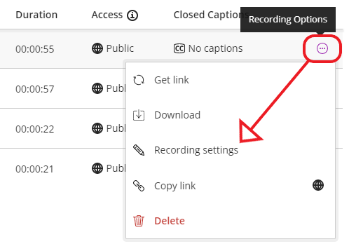

In the Recording Settings panel, toggle on Enable Captions, if not already selected. Then click Create auto-caption.
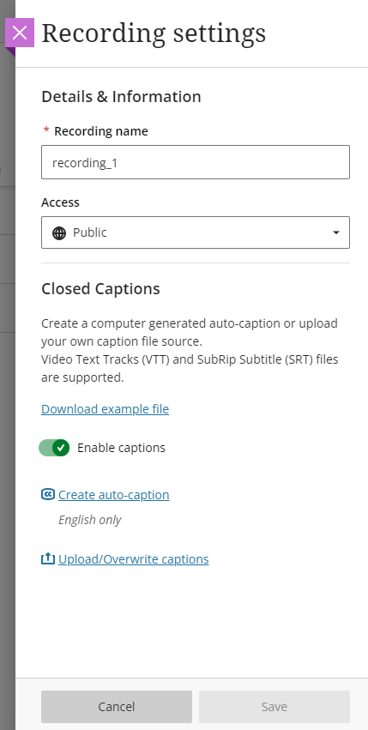
It may take time for the auto-captions to generate. You can leave the screen and come back later to view and share them.

After the captions are created, you’ll see that captions are available from the recording list. The captions will also immediately appear in the recording player for anyone who has access to the recording.

Editing captions

To improve or edit the auto-generated captions, click Download captions and open the downloaded .vtt file in a plain-text editor, such as Notepad on Windows, or Textedit on a Mac. When you have finished editing the captions, save the file, click Upload/Overwrite captions and select the .vtt file from the location you saved it.

