Assistive Technology loans for Staff – Miscellaneous Equipment
To request this document in an alternative format e.g. large print, Braille et. cetera please contact Jed Bajai via email at Jed.Bajai@ed.ac.uk
Miscellaneous Kit | Make and Model | Equipment Description | Serial Number
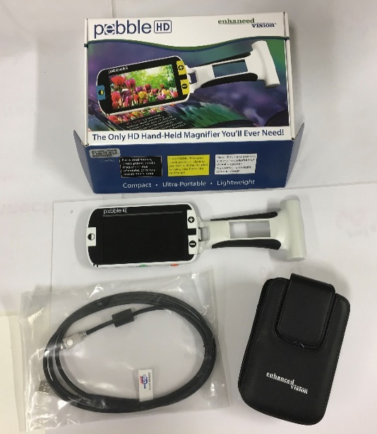 | Pebble HD Video Magnifier  Visual Aid | Accessories:  carrying pouch, AC charger / USB cable / separate stand  AC chargeable | S/N=P0901148
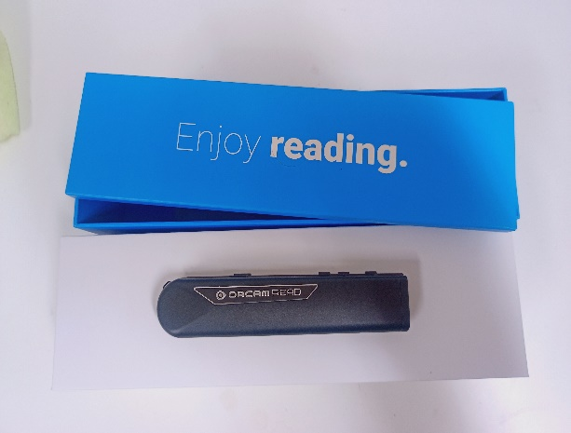 | Orcam Read – Visual Aid | OrCam Read  For People With Mild Vision Loss and Reading Fatigue  The ultimate way to read any printed or digital text,  Full Page Capture.  Laser Guidance.  Read Instantly.  Bright LED Light. | S/N=2122260468
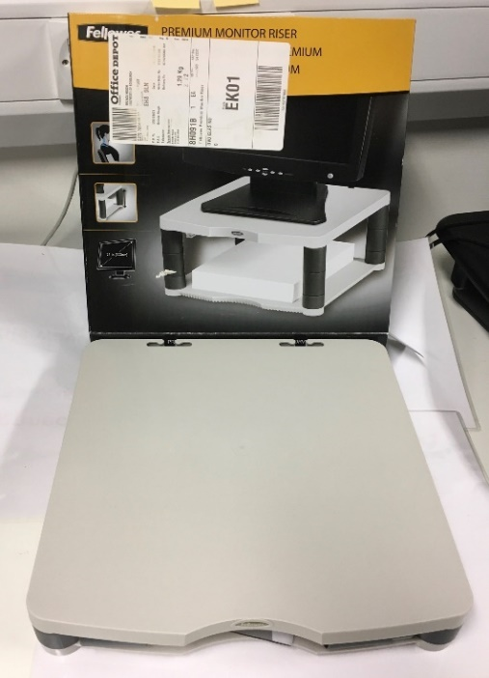 | Fellowes Monitor Riser | Adjustable height monitor riser | P/N=CRC91717
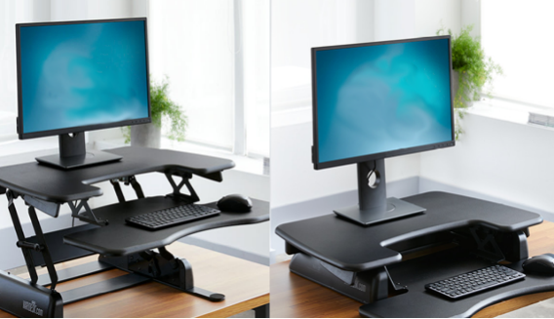 | Varidesk desktop adjustable height standing desk | Adjustable height Desk to allow for standing or sitting at workstation. | TBC
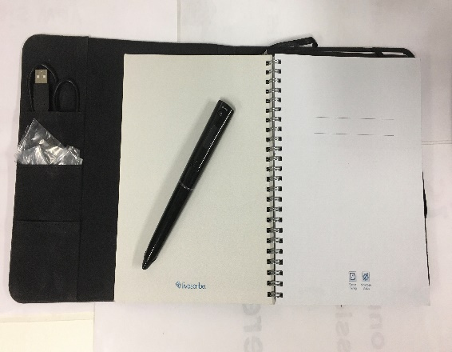 | Livescribe Echo kit 1  Note taking tool  Information on Livescribe | - Folio (carrying case)  - Livescribe Echo pen with cartridge and nib cover  - 1 x Livescribe notebook  - spare cartridge (in folio pocket)  - USB charging cable (in folio pocket)  - 1 x user manual  - 1 x headphone info leaflet (for reference only - headphones not included in kit)*  - 1 x software download leaflet | TBC
 | Livescribe Echo kit 2  Note taking tool  Information on Livescribe | - Folio (carrying case)  - Livescribe Echo pen with cartridge and nib cover  - 1 x Livescribe notebook  - spare cartridge (in folio pocket)  - USB charging cable (in folio pocket)  - 1 x user manual  - 1 x software download leaflet | TBC

