Assistive Technology loans for Staff – Mice

To request this document in an alternative format e.g. large print, Braille et. cetera please contact Jed Bajai via email at Jed.Bajai@ed.ac.uk

Mice | Make and Model | Equipment Description | Serial Number
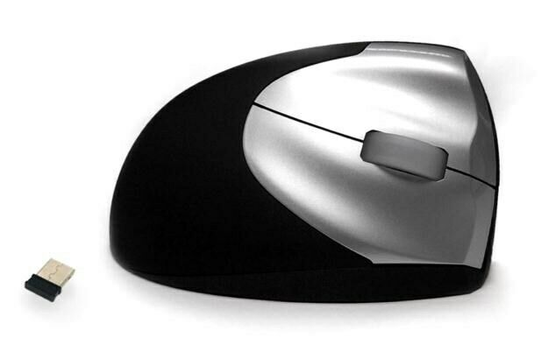 | Accuratus upright mouse 2 | USB ‘plug and play’ connection  Silver with soft black tactile rubberised surround  Special contoured upright design so that your hand is in a natural position  Sleek modern design with gloss silver buttons  Helps with prevention of RSI and Carpel Tunnel syndrome  Wireless - R/H | S/N - 161001147
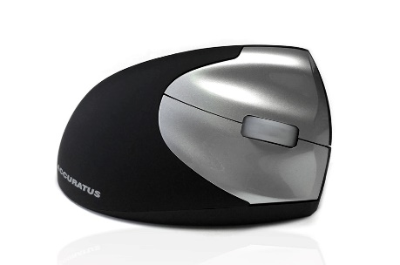 | Accuratus upright mouse 2 | USB ‘plug and play’ connection  Silver with soft black tactile rubberised surround  Special contoured upright design so that your hand is in a natural position  Sleek modern design with gloss silver buttons  Helps with prevention of RSI and Carpel Tunnel syndrome  Wireless - R/H | S/N - 180701123
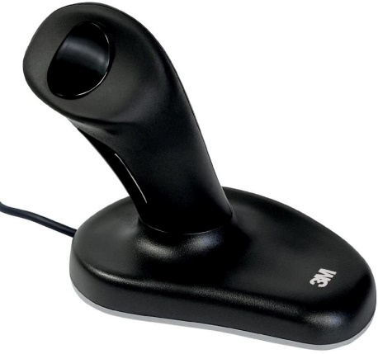 | 3M Ergonomic Joystick Mouse | large, right-handed  Can reduce muscle strain and discomfort  Vertical grip reduces pressure on the wrist's median nerve  Records optically for smoother and more accurate moussing  Optical sensor has no moving parts to wear out or to clean | S/N - EM500GPL
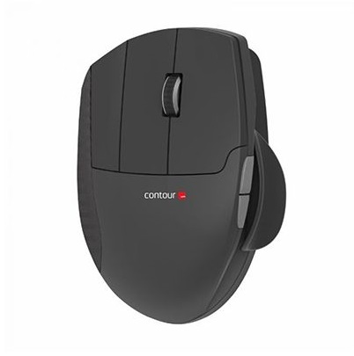 | Contour Unimouse | Wireless - Right Handed  Unimouse is an adjustable 'vertical' mouse designed with a unique articulated hinge. This clever hinge allows you to find your ideal hand position, from a gentle 35 degree slope, to a more upright 70 degrees. | S/N - 38094052
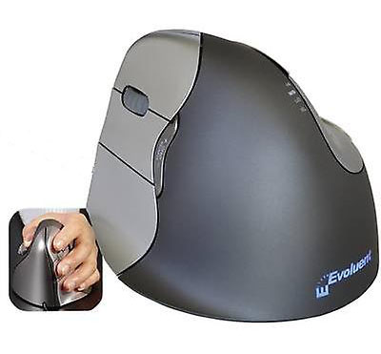 | Evoluent VerticalMouse 4 | one-size, left-handed  usb wired | S/N = 421202104695
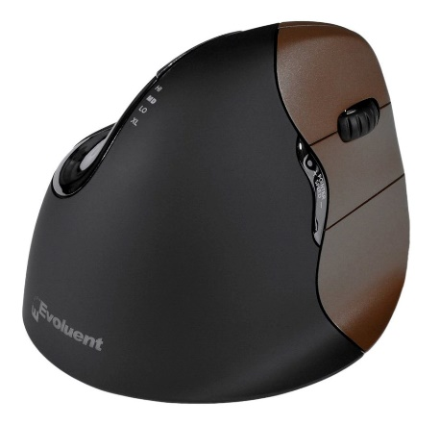 | Evoluent VerticalMouse 4 | one-size, right handed  usb wired | S/N = 411212120309
 | Evoluent VerticalMouse 4 | one-size, right-handed, wireless | S/N=8-52153-01441
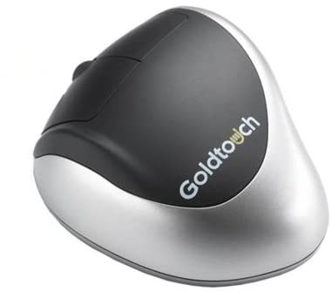 | Goldtouch Ergonomic Mouse | left-handed | S/N=36140847
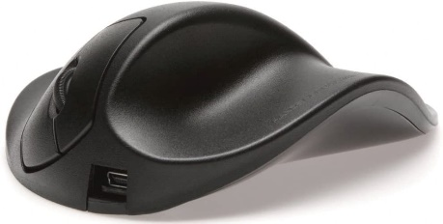 | HandShoe Mouse | large, right-handed, wireless  USB wireless adaptor and charger cable included | S/N = 1103001557
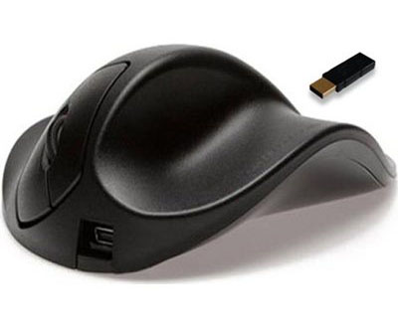 | HandShoe Mouse | small, right-handed, wireless | S/N=150700675
 | HandShoe Mouse | medium, right-handed wireless | S/N=130100370
 | HandShoe Mouse | medium, left-handed, wireless  USB wireless adaptor and charger cable included | S/N = 140200371
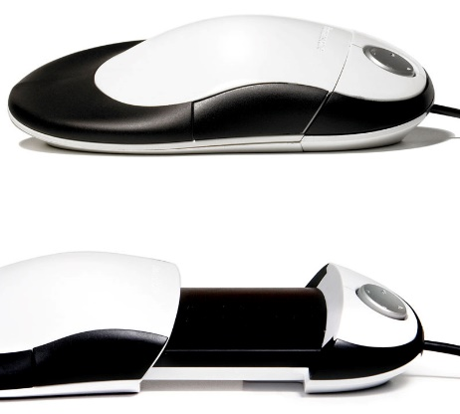 | Humanscale SwitchMouse | adjustable, right-handed | S/N=0701300001
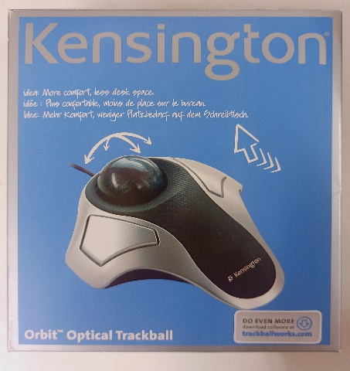 | Kensington Orbit Optical Trackball | one-size, ambidextrous, wired | S/N=K64327EU
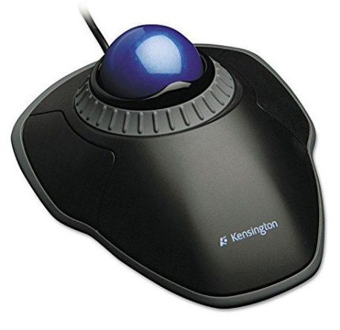 | Kensington Orbit Trackball with Scroll Ring | one-size, ambidextrous, wired | S/N=F1801B
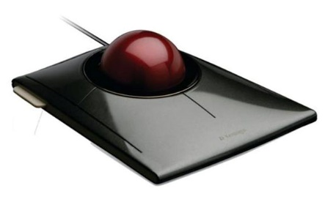 | Kensington SlimBlade Trackball Mouse | one-size, ambidextrous | S/N=K72327EU
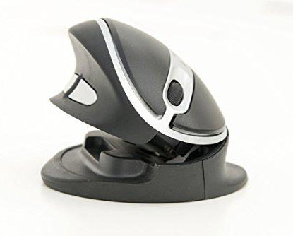 | Keytools Adjustable Oyster Mouse | Adjustable height and angle, ambidextrous | S/N=Art No. 5080
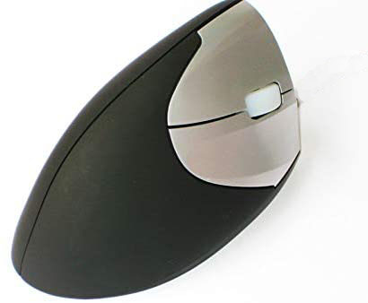 | Keytools vertical mouse | wireless, small, right handed | S/N=RH_SMALL
 | Keytools vertical mouse | wireless, small, right handed | S/N=RH_SMALL
 | Keytools vertical mouse | wireless, small, right handed | S/N=RH_SMALL2a
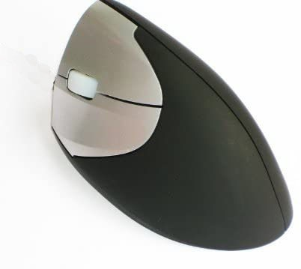 | Keytools vertical mouse | wireless, small, left handed | S/N=LH_SMALL
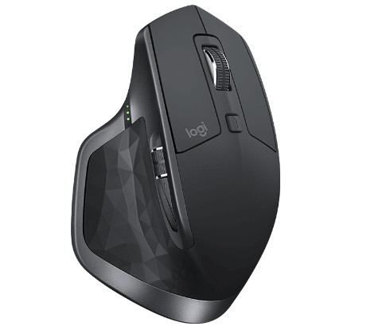 | Logitech Master 2S mouse (Mac & PC) | wireless or Bluetooth, right-handed | S/N=1740LZ0FBJV9
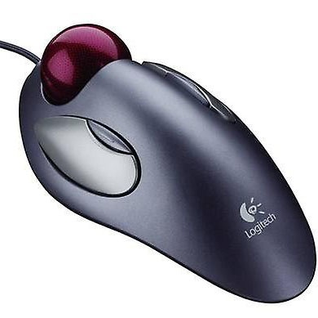 | Logitech TrackMan Marble roller mouse | one-size, ambidextrous  USB wired | S/N = 810-000767a
 | Logitech TrackMan Marble roller mouse | one-size, ambidextrous | S/N=810-000767b
 | Logitech TrackMan Marble roller mouse | one-size, ambidextrous | S/N=810-000767c
 | Logitech TrackMan Marble roller mouse | one-size, ambidextrous | S/N=810-000767d
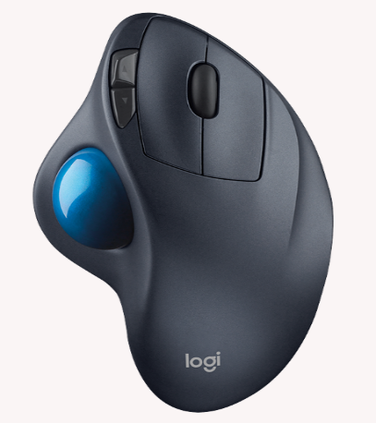 | Logitech Wireless Trackball M570 | right-handed | S/N = 910-001882a
 | Logitech Wireless Trackball M570 | right-handed | S/N= 910-001882b
 | Logitech Wireless Trackball M570 | right-handed | S/N= 910-001882c
 | Logitech Wireless Trackball M570 | right-handed | 910-001882d
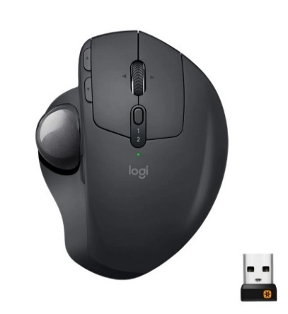 | Logitech Wireless MX Ergo | right handed | S/N=1802LZ00WNT9
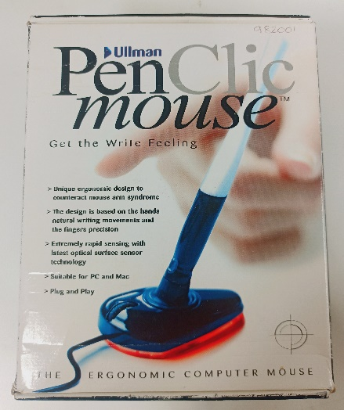 | Penclic Ergonomic Mouse | Ambidextrous, USB Wired | S/N=982001
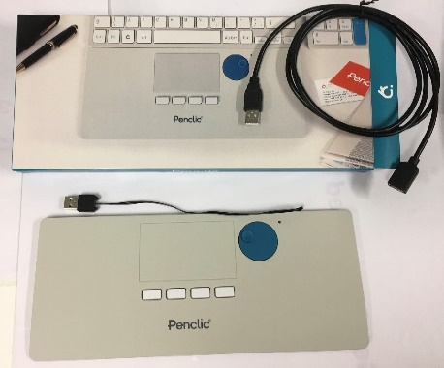 | Penclic Nicetouch Touchpad T2 white (ergonomic flat mouse) | ambidextrous | P/N=2037
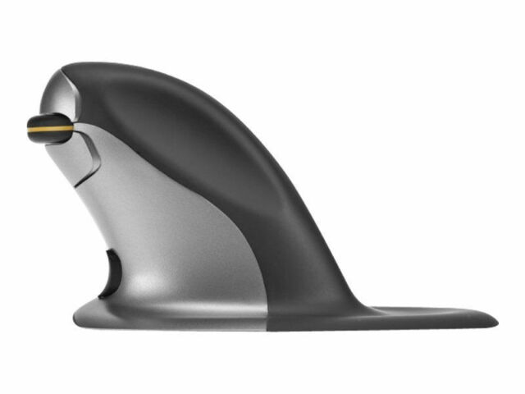 | Penguin Ambidextrous Mouse | small, wireless | S/N=SMWL131101577
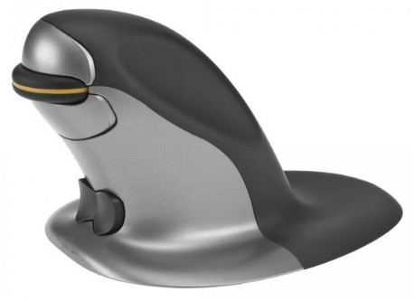 | Penguin Ambidextrous Mouse | medium, wireless | S/N = MD WL 160612544
 | Penguin Ambidextrous Mouse | medium, USB wired | MDWD220500938
 | Penguin Ambidextrous Mouse | medium, USB wired | MDWD220500830
 | Penguin Ambidextrous Mouse | medium, USB wired | MDWD220500831
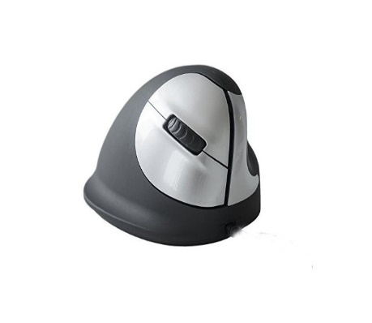 | R-Go HE vertical mouse | medium, right-handed, | Not in DCS Store
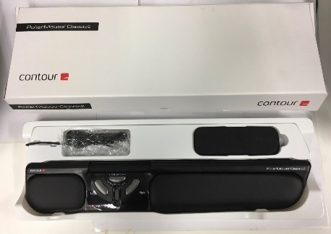 | RollerMouse Classic2 - Contour | N/A | S/N=50061606
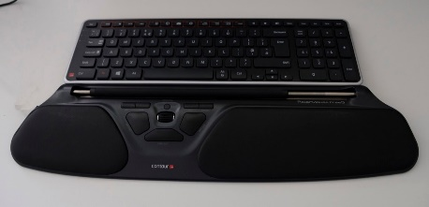 | RollerMouse Free3 - Contour | wireless | S/N=82003270

