Assistive Technology loans for Staff – Laptops & Tablet Devices

To request this document in an alternative format e.g. large print, Braille etcetera please contact Jed Bajai via email at Jed.Bajai@ed.ac.uk
Laptop | Make and Model | Equipment Description | Serial No:
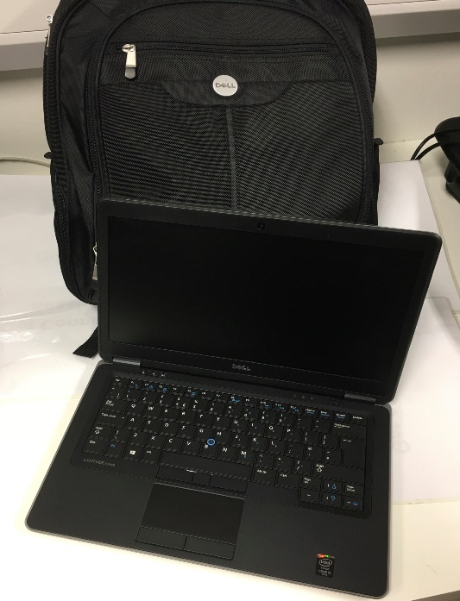 | Dell Latitude E7440,  2.60 GHz Intel Core 2 Duo,  4 Gb RAM | Windows 10 Pro  MS Office 2016  Dragon Naturally Speaking v.15  Zoomtext 11  TextHelp Read&Write 11 | S/N=3X8ZP12
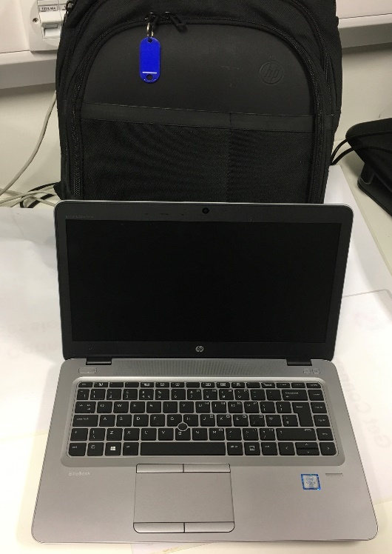 | HP EliteBook 840 G3 | Windows 10 Pro  MS Office 2016  Dragon Naturally Speaking v.15  Zoomtext 11  TextHelp Read&Write 11 | S/N=50G7434BD0

Tablet Devices | Make and Model | Equipment Description | Serial No
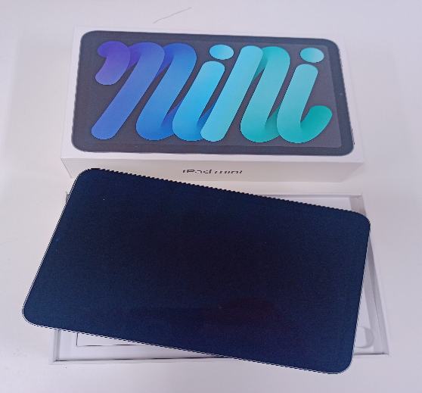 | Apple iPad | Apple iPad Mini - IOS  64Gb - 6th Generation  With USB-C Charger Cable + Power Adapter | K7TV664R60
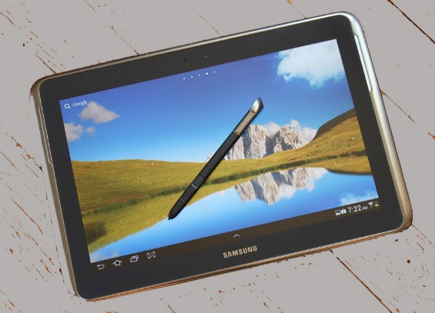 | Galaxy Note 10.1  32Gb |  | DMPKJ4ZZF184
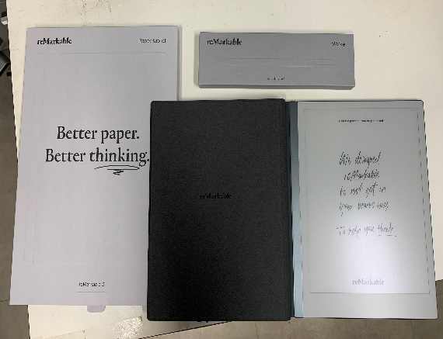 | Remarkable 2 Tablet  1.2 GHz dual core ARM  Codex OS  Information on Remarkable Tablet | Storage and RAM;  1 GB LPDDR3 SDRAM / 8 GB internal storage  Second-generation CANVAS display  10.3” monochrome digital paper display (no colors)  1872 x 1404 resolution (226 DPI)  Partially powered by E Ink Carta technology  Multi-point capacitive touch  Connectivity;  Wi-Fi 2.4GHz and 5GHz  USB-C / Accessory port

