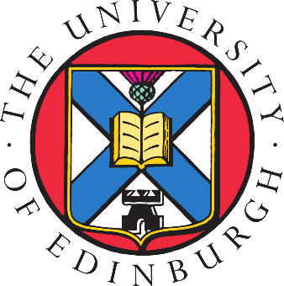

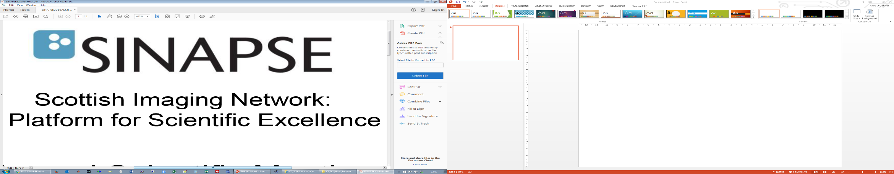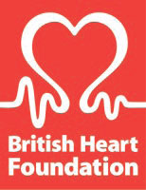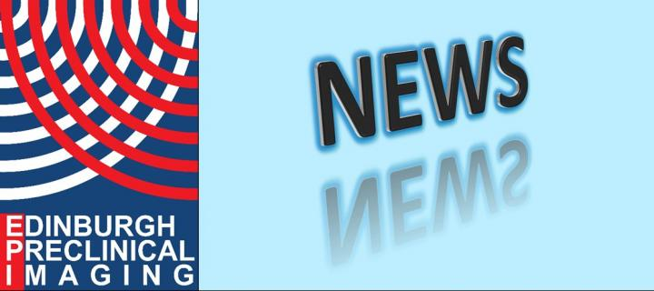

**PET is Wonderful**

**International Meeting**

**Monday, 6th August 2018, 14:00-17:00**

**Lecture Theatre T100**

**School of Chemistry, King’s Building**

**AGENDA**

**14:00 to 14:20**

Dr Tashfeen Walton (University of Edinburgh)

“PET Radiolabelling: An Overview”

14:20 to 14:30 – Q&A

**14:30 to 14:50**

Prof David O’Hagan (University of St. Andrews)

“The fluorinase: My PET project”

14:50 to 15:00 – Q&A

*Break*

**15:30 to 16:30**

Prof Henri Tochon-Danguy (Austin Health, Australia)

“Bringing PET Down Under”

16:30 to 16:40 – Q&A

