Adding alternative text to images in Learn
When you add images to Learn it is important to ensure you provide alternative (alt) text for images – written descriptions of the information contained in the images. This ensures that visually impaired students who use a screen reader (such as Jaws) or students on a bad internet connection (where images don’t fully load, for example) don’t miss vital information.

Guidance on how to write good alternative text
What information should your alternative text contain? If the image is purely for aesthetic purposes then having no alt text is fine – screen-readers will just ignore it. However, most images used in a VLE will have a purpose and will convey some information. You should ensure that alt text:
- Gives the same meaning as the content of the image
- Is short and to the point (if it’s very long/complicated, alt text may not be the solution)
- Is not repeating information that’s already given elsewhere on the page
- Doesn’t contain phrases such as ‘photo of…’, ‘image showing..’ – the user with a screen reader shouldn’t need to know that the text is provided as an alternative to an image.

How do you add alternative text to an image in Learn?
There are two ways to add an image to your course site in Learn. Both provide a field for supplying alt text.

Adding an image using the ‘Image’ option under ‘Build Content’
Under ‘Building Content’ menu, click on ‘Image’.
Fill in the form:
Name - name of the image that the students will see.
Find file – browse to find the image you will upload
Alt Text – add your image description into this box
If your alt text gets too long, consider filling in a Long Description instead, where the text will appear underneath the image within the tool. No formatting is possible in this field.
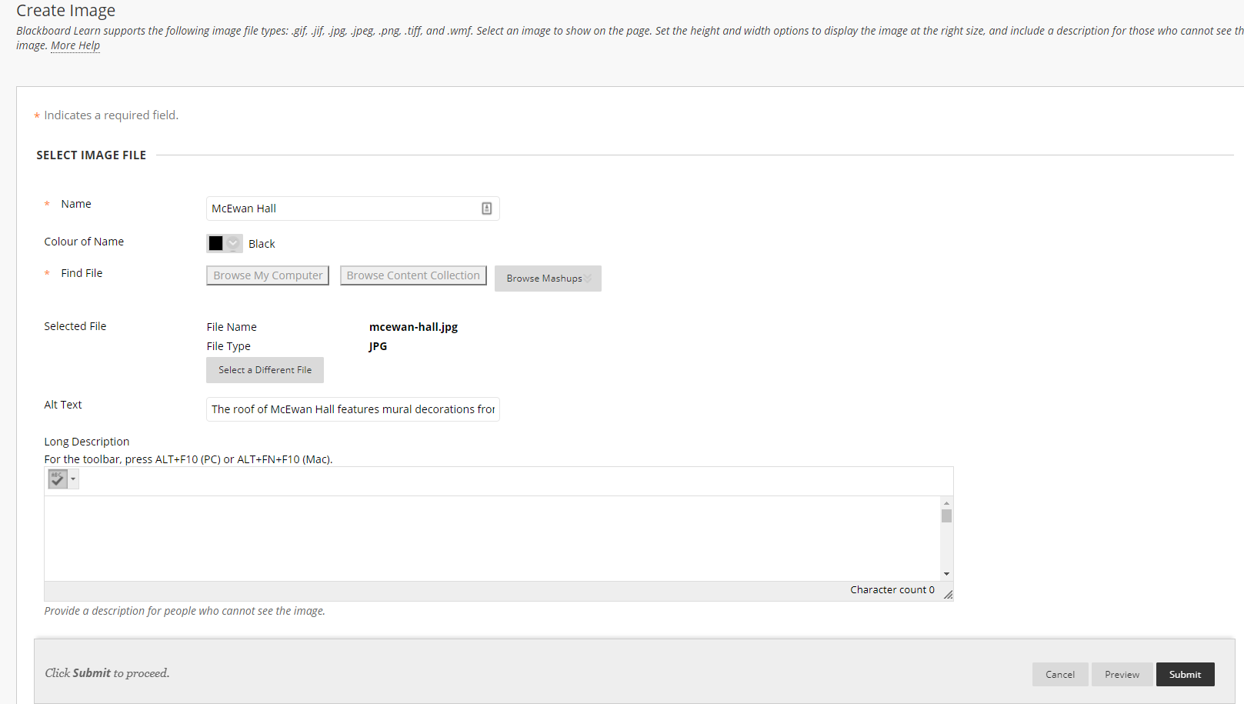

Adding an image to any content using the Learn text editor
Most content types in Learn can be edited with a standardised text editor (i.e folders, items etc). Images can be embedded anywhere within text using this editor.
To add an image with alt text, click on the ‘Insert image’ tool in the editor
In the form that pops up, Browse to find the image you wish to upload or link to. You should type your alt text into the Image Description field.
