PARTICIPANT EXTRA INFORMATION: AAMOS-00 Phase 2
“Mobile device monitoring to inform prediction of
asthma attacks: an observational study (AAMOS-00)”
This is a reference sheet designed to assist you with various areas you might be having trouble with. We do not expect you to read from start to finish, but to pick and choose the areas that might be of help.

Contents
Get Started with Mobistudy 2
Step 1: Downloading the app on your smartphone 2
Step 2: Registration 2
Step 3: Joining This Study 4
Step 4: Completing a questionnaire or task 6
More information about Mobistudy 7
Navigation Around Mobistudy 7
General Mobistudy Use 9
Forgot Password 10
Smart Inhaler FindAir ONE 11
Device Description and Device Care 11
Get Started with FindAir 12
Deleting Medication Usage 17
Adding Medication Usage Manually 18
Smart Peak Flow Meter SRP 19
Device Description and Device Care 19
Taking Measurement 19
Smartwatch Xiaomi Band 3 25
Device Description and Device Care 25
Navigation 26
Connecting with Mobistudy 27
First time 27
Not first time 28
Weather and Location Task 30

Get Started with Mobistudy

Step 1: Downloading the app on your smartphone
Mobistudy is a mobile app available on the Apple App Store and the Google Play Store. There are 2 methods of downloading Mobistudy.
Method 1: Search “Mobistudy” inside the app store or play store and look for the logo

After you have found the Mobistudy app, press “install” to download and install the app onto your phone. Please go to step 2.

Method 2: Follow the direct link below, depending on whether you have an iPhone or Android phone (such as Samsung, Google, LG, Huawei) respectively. Please click the link on your phone.
Apple https://apps.apple.com/us/app/id1462273500
Android https://play.google.com/store/apps/details?id=org.mobistudy.app

After you have found the Mobistudy app, press “install” to download and install the app onto your phone. Please go to step 2.

Step 2: Registration
After installing the Mobistudy app onto your phone, you will need to register an account with Mobistudy. The first time you enter Mobistudy, you will be greeted with the “Login” page. Please press the blue button with “REGISTER” at the bottom of the page to begin the registration process. If you do not see the button, please scroll down.
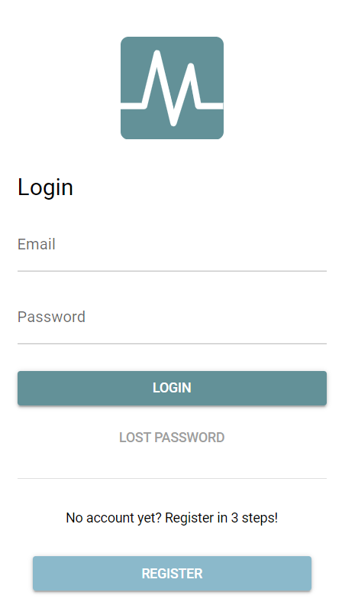

Please make sure you read and understand the terms and conditions and privacy policy of Mobistudy before pressing the “accept” button.
To create an account, you will need to provide an email address and make a password. We recommend you use one email address for all correspondence with this study. The password must have the following properties:
- A minimum of 8 characters
- At least 1 lowercase character
- At least 1 uppercase character
- At least 1 number
- At least 1 special character (e.g. !$%^&*)
- No obvious patterns like “abc” and “123456”
Then fill in the information for your profile:
- First name
- Surname
- Language selection, press the arrow on the right (▼) for a drop-down selection, English would be preferable
- Country, press the arrow on the right (▼) for a drop-down selection
- Sex, press the arrow on the right (▼) for a drop-down selection
- Date of Birth, press the calendar icon for a date selection, or you could type your date of birth in the format YYYY/MM/DD, the forward slashes will appear automatically
- Weight (kg)
- Height (cm
- Long term conditions, type “asthma” and select from the drop-down. Feel free to put any other conditions you may have. After selecting all your conditions, please touch anywhere outside the box on your screen to confirm your selection.
- Long term medication, type the name of the medications and select from the drop-down. After selecting all your conditions, please touch anywhere outside the box on your screen to confirm your selection.
After filling in all the information, please press “NEXT”
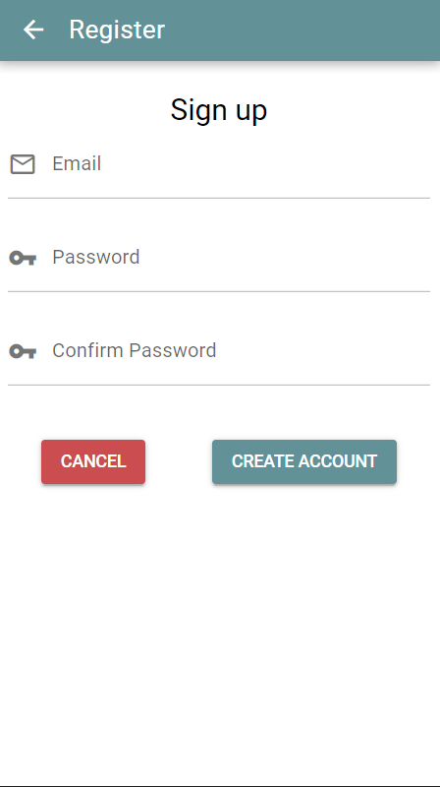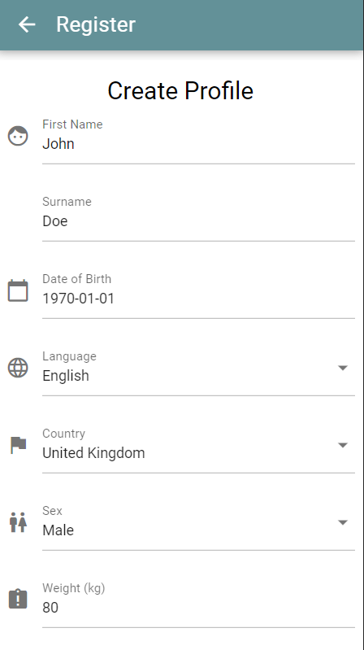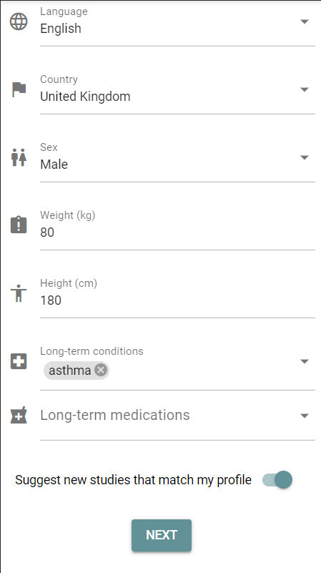

Please go to step 3.

Step 3: Joining This Study
After completing your profile, please use the navigation bar at the bottom of the screen and press the word “STUDIES” to see a plus button (+) in the bottom right. Press on the plus button and type the study invitation code in the pop-up prompt, the code will be provided by the research team. Pressing “OK” would bring up the study invitation with “You are invited to a new study”.
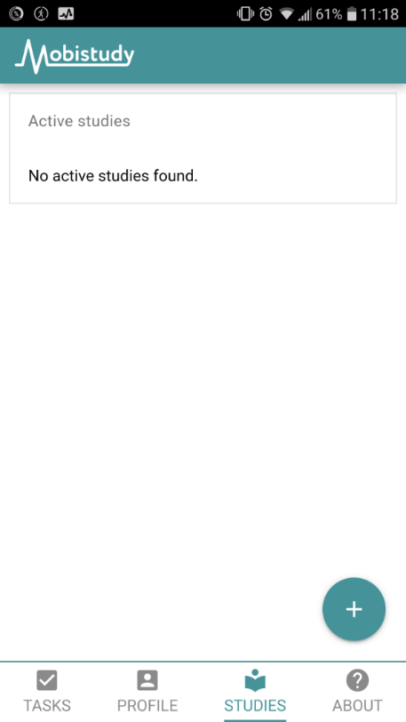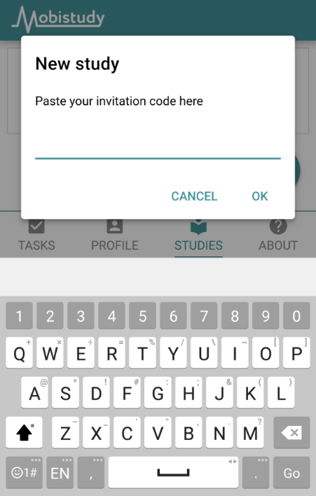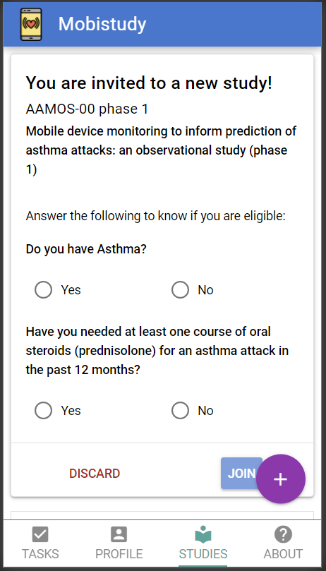
Once you can see the invitation, please press the “JOIN” button. This will take you through some information about the study. After reading through all the information and pressing “JOIN STUDY”, you will have joined this study within the Mobistudy app. Please go to step 4.

Step 4: Completing a questionnaire or task
After joining the study, the tasks for today are listed in “Task” page.
In phase 1, you should expect to see the daily questionnaire task every day, this will be 6 questions and take around 2 minutes to answer. The weekly questionnaire task should be completed every 7 days, a reminder inside the app will give the prompt when it has been 7 days.
In phase 2, there are 4 daily tasks: daily questionnaire, take peak flow measurements, send inhaler usage, and send smartwatch data. The weekly questionnaire will appear in the same way as in phase 1.
Click on any of the listed tasks to begin that task and follow the instructions within. For example, “Daily Questionnaire”
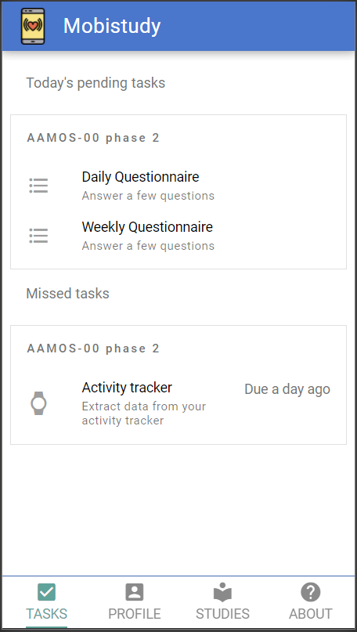

Once all the tasks are completed, the “TASKS” page will have no more pending tasks and should look like this.
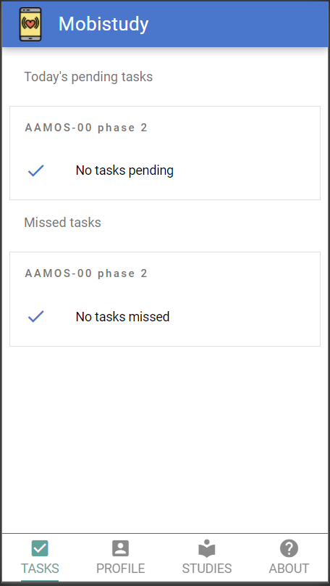

There is no need to logout after each session. Thank you for following the steps to get started with Mobistudy. Please open Mobistudy again tomorrow to answer the daily questionnaire, you should see the task mentioned in step 4 every day throughout the study period.

More information about Mobistudy

Navigation Around Mobistudy
There are 4 pages in Mobistudy:
- TASKS
- PROFILE
- STUDIES
- ABOUT
To navigate between any of these pages, use the icons at the bottom of the screen which list the pages. If the page is underlined, it means you are already on the page.
If at any time the bottom navigation bar disappears and you are looking for it, you may be in a task. To leave the task press the cross at the top right of the page to quit the task, but you will lose the progress up to that stage in the task.
TASKS
Under “TASKS” you will find all the tasks for the day. Click on any of the listed tasks to begin that task.

PROFILE
In the “PROFILE” page, you will find all the profile information you entered when you used Mobistudy for the first time, this information can be changed at any time by editing the information and pressing the green “UPDATE” button.
On this page, you will also find functions that are not generally needed, such as the reset password function, logout of Mobistudy function, and delete account function.
If you wish to delete your account, we would like you to contact the research team before using the function so that we can advise you on the appropriate method to leave this study.

STUDIES
The “STUDIES” page lists the studies you are currently involved and were involved. Also, this is where you would find the study invitations. You are under no obligation to join any other studies.

ABOUT
The “ABOUT” page contains information relating to Mobistudy.

General Mobistudy Use
Once registered and logged in, there is no need to logout of Mobistudy if you are completing the tasks on a personal smartphone. This will reduce the time required to complete a daily task.
Mobistudy Login
If you have logged out of Mobistudy or using Mobistudy on another phone, you will see the “Login” page when you open the app. You can enter your email address and password. It should take to the main page “Today’s tasks” and you should see the tasks for today. If you have forgotten your email or password, please follow the instructions below in “Forgot Password”.

Mobistudy Logout
If for any reason you wish to logout of Mobistudy, press “PROFILE” at the navigation bar at the bottom of the screen. Scroll to the bottom and press the yellow “Logout” button to logout.

Forgot Password
If you have forgotten your password for Mobistudy, your account can be recovered with the following steps. Firstly, press the “LOST PASSWORD” in the login page, this will direct you to enter your email which you have used to sign up to Mobistudy. Secondly, press the “RESET PASSWORD” to send an email with a token used to set the new password.
If you have forgotten what email address you have used to sign up to Mobistudy, please try all your email addresses, it will not save and send to any email addresses that are not registered with Mobistudy. If all the options are exhausted, please get in touch with the research team.
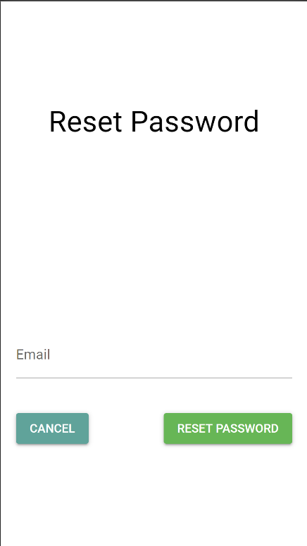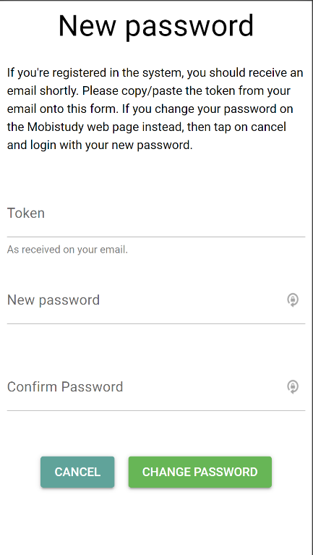

Smart Inhaler FindAir ONE

Device Description and Device Care
The FindAir ONE is a rubber button that attaches to your inhaler. It can be detached and reattached to another inhaler when you change inhalers. The smart inhaler will record every time you press the device to take a puff. The data is transferred when you connect it to your phone via Bluetooth.
The device is fully waterproof and robust, so please keep it attached to the relief inhaler you are using.
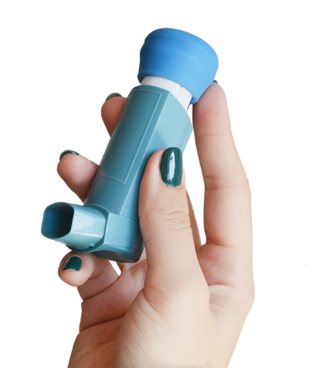

Charging
The FindAir ONE has a non-chargeable battery with a life of 12 months, so it will not require charging for the duration of the study. If you think it has ran out of battery, please get in touch with the research team.

Cleaning
The device may be cleaned with by wiping gently with a towel, sponge, or cotton swab dampened with water. Then wait for the device to dry.
Do not put the device under a stream of running water. Do not clean the unit under the water surface. Do not place the device in a dishwasher, washing machine, etc. Do not use chemical or detergents.

Attaching to Inhaler
The lower half of the FindAir ONE device can stretch and starts off smaller the average pMDI inhaler canister. Don’t worry about pressing the button when attaching the device. You may follow the instructions in the “Delete Medication Usage” section below if you think you have pressed the button.

Get Started with FindAir
Step 1: Downloading the FindAir app
FindAir is a mobile app available on the Apple App Store and the Google Play Store. There are 2 methods of downloading the FindAir app.
Methods 1: Search “FindAir – Asthma Diary” inside the app store or play store and look for the logo

After you have found the FindAir app, press “install” to download and install the app onto your phone. Please go to step 2.

Methods 2: Follow the direct link below, depending on whether you have an iPhone or Android phone (such as Samsung, Google, LG, Huawei) respectively. Please click the link on your phone.
Apple https://apps.apple.com/us/app/findair-asthma-diary/id1515944881
Android https://play.google.com/store/apps/details?id=eu.findair

After you have found the FindAir app, press “install” to download and install the app onto your phone. Please go to step 2.

Step 2: Registration with FindAir
After installing and opening the FindAir app, you will need to create an account with FindAir. This will require an email and a password (at least 6 characters long), we recommend you use the same email as signing up with Mobistudy and correspondence with this study.
The app will send you a confirmation code to your email address. Copy over that code into the app.
The following information is required:
- Name
- Sex
- Date of Birth dd/mm/yyyy
The following information is optional and will not be transferred to the research team. You can press “NEXT” to skip the questions:
- Known asthma irritants
- Main medication
- Regular medication
Please go to step 3.

Step 3: Connecting the FindAir ONE
Firstly, make sure you have your Bluetooth turned on. This is done on your phone’s settings. If you are on an Android phone, please also turn on your GPS, as this is required to connect to the device.
At the top left corner inside the app, please find the “gear” icon ( ). This brings up the “Settings”. Press the “Device” (the second option). Then press “Connect with device”. Please choose the blue FindAir ONE option.
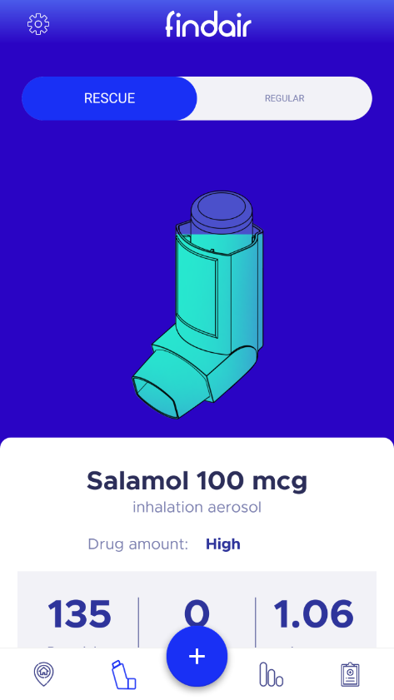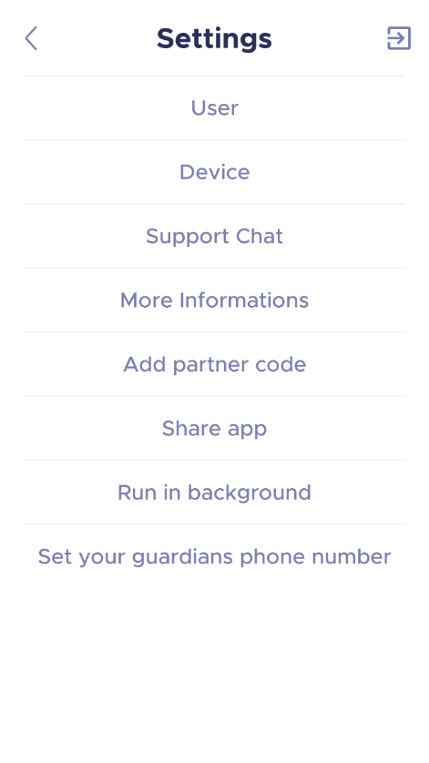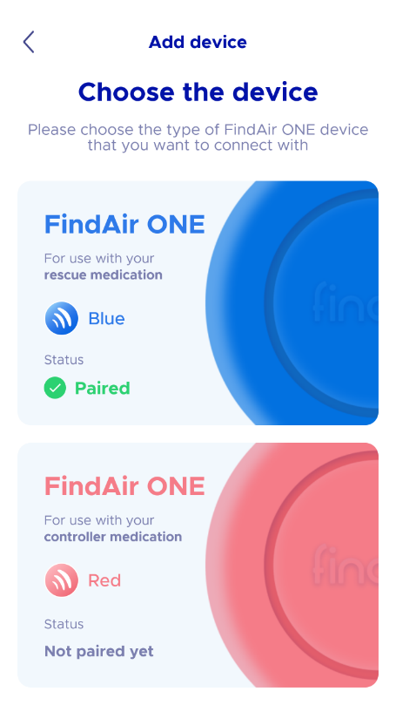
There is a search bar for you to type the inhaler you have. If you have multiple “blue puffers” please select the one you most often use and will attach the FindAir ONE.
Once selected, take the FindAir ONE smart inhaler device and press it once. Then place it in the middle of your screen and press “CONNECT”. Please go to step 4.
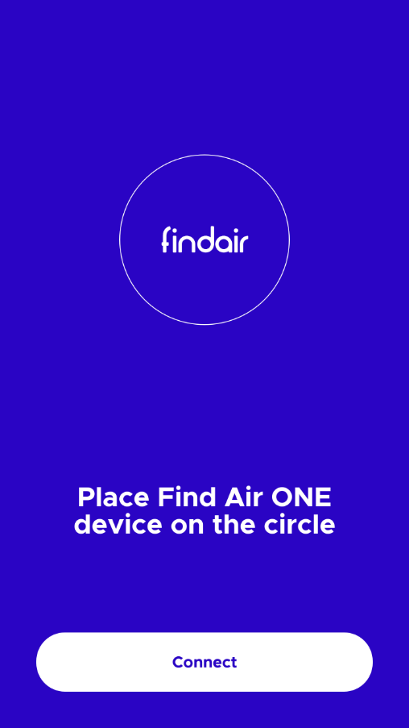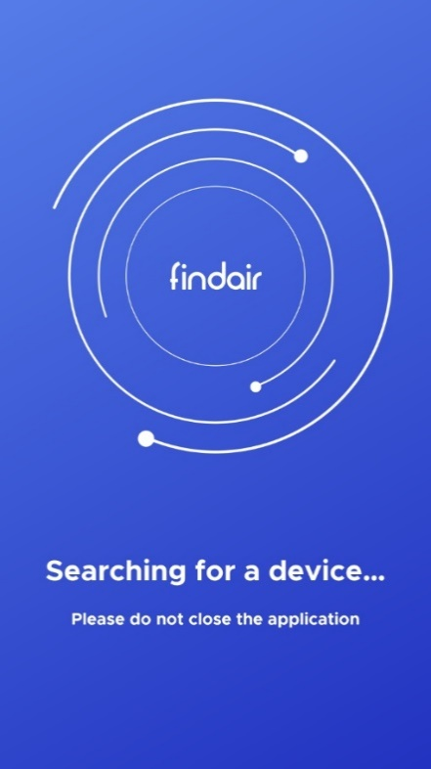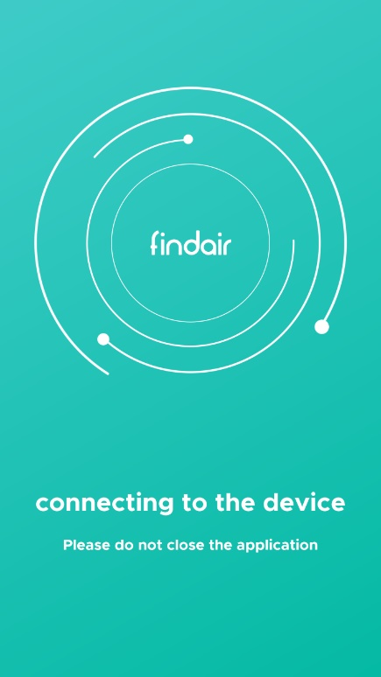
If you have accidentally selected the wrong medication, please press the back arrow ( < ) on the top left until you return to the main page and see the “gear” icon in the top left. At the bottom of the app is the navigation tool, please select the second icon, the inhaler icon. Scroll to the bottom of the page and press “MY DRUGS”. You should see the medication you had selected, press the “trash” icon ( ) then “OK” to remove the medication. Please repeat from the start of step 3 to connect the FindAir ONE.

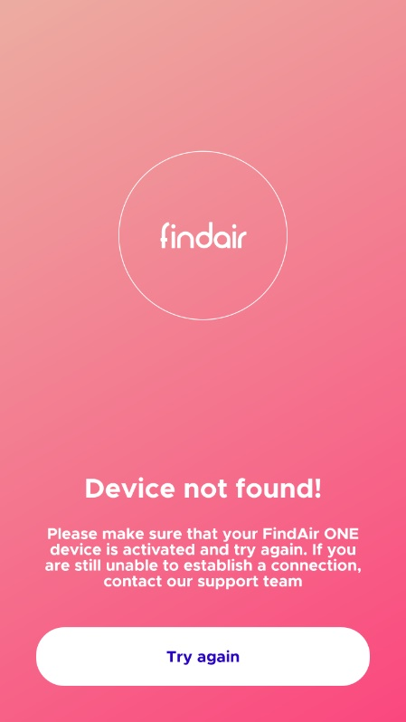
If you see the “Device not found!” screen, please check that you have your Bluetooth and location turned on, and click the button once. If the error remains, please do not hesitate to get in touch: k.c.h.tsang@sms.ed.ac.uk
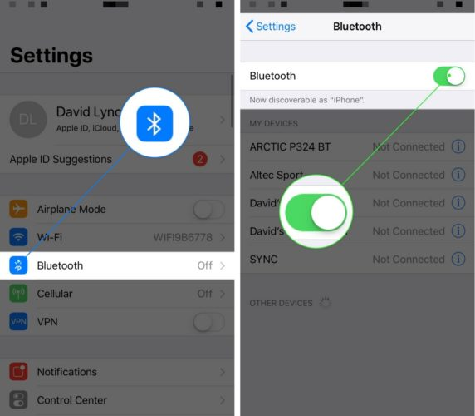

Step 4: Run FindAir in background
Unless you are changing medication, you would not need to open the FindAir app. For the FindAir ONE to talk to Mobistudy, the app will need to run in the background.
At the top left corner inside the app, please find the “gear” icon ( ). This brings up the “Settings”. Press the “Run in background” (the last option). This will bring up information about how to change your phone to allow the app to run in background. This step varies between every phone, but in general:
Apple
- Open your phone’s settings
- Find the “Background App Refresh” option either with the search function or look under “General”
- Press the background app refresh switch to enable the option
Android
- Open your phone’s settings
- Find the “Battery” settings
- Under “POWER SAVING”, press “Power saving exclusions”
- Find the “FindAir” app and choose “Turned off”

If you find that the FindAir app is draining your battery too much, feel free to not allow it run in background. Instead, please open the FindAir app regularly (around once a week) to allow the smart inhaler to transfer the data.

Step 5: Connecting with the study
At the top left corner inside the app, please find the “gear” icon ( ). This brings up the “Settings”. Press the “Add partner code” (the fifth option). Please enter the code provided to you by the study team.
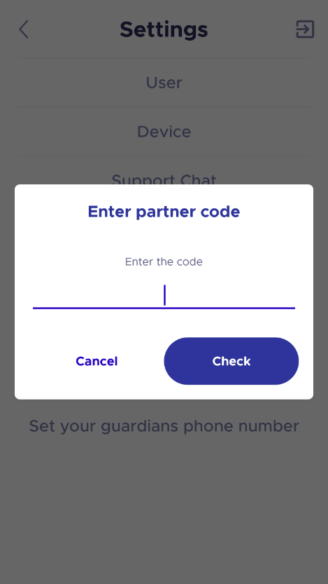
You will need to keep using your inhaler with the smart inhaler attached and update the medication information inside the FindAir app if you change the inhaler it is attached.

Deleting Medication Usage
You may want to delete medication usage if you have accidentally pressed the smart inhaler button without taking a puff or if you think the device recorded more.

Step 1
Open the FindAir app. Navigate to the statistics page (third page from the left) (fourth button from the left at the bottom of the page). Scroll down and click on the “See all usages” option.
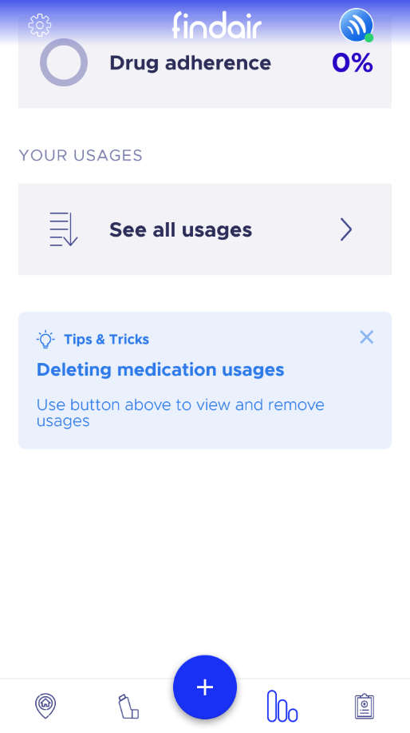

Step 2
On this “Your Usages” page, you will see all the usage stored on the app. You can change the date using the left and right arrows on either side of the date.
To remove an entry, click on the “trash” icon ( ). This brings up circles on the left of each entry. Click any where on the entry you would like to delete, this will give a tick in the circle. Click the “trash” icon again to delete the entry. Click “OK” to confirm.
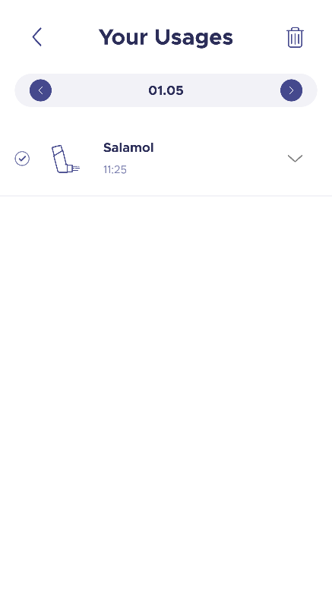

Adding Medication Usage Manually
If you have more than one relief inhaler or have accidentally deleted an entry, you may want to use the FindAir app to add medication usage manually.
Click the blue “plus” (+) button at the middle of the navigation bar at the bottom of the page. This will change the “plus” (+) to a “cross” (x) and show a button for the drug. Click on the button to add usage.
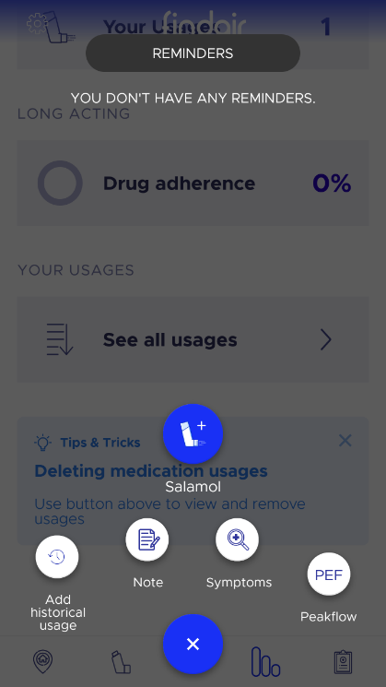

Smart Peak Flow Meter SRP

Device Description and Device Care
There are 4 items to the smart peak flow meter:
- Smart peak flow meter
- Reusable mouthpiece
- Bluetooth adapter
- Carry bag

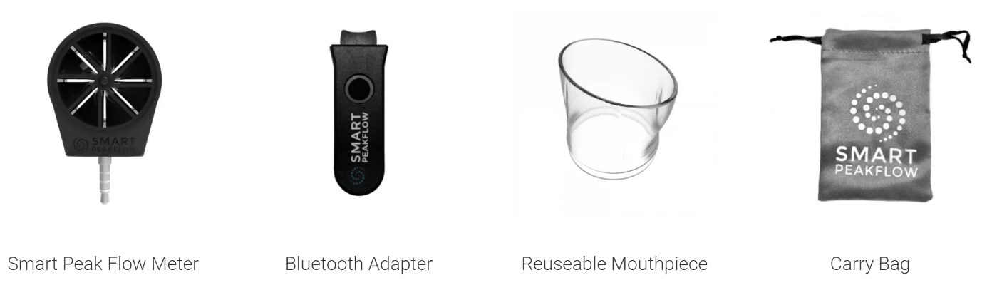
The smart peak flow meter has an audio jack/ headphone connection at the bottom and a small panel for light at the top. For the meter to function, it must be connected to your phone either with the headphone connection or using the Bluetooth adapter provided. The device can be washed under tap for hygiene, but do not submerge in water. The meter does not require any charging.
The reusable mouthpiece connects with meter by snapping on. Please wash with soap before first and after daily usage.
The Bluetooth adapter may be required if you do not choose or cannot connect the smart peak flow meter directly to your phone. The adapter small hole at the top for the meter audio jack to plug into. This adapter does not require cleaning and should not be in water. The Bluetooth adapter can be charged using the wire provided (micro USB to USB). The micro USB side plugs into the adapter the other to a socket with the same shape, this can be anywhere, for example a laptop/computer, the wall, or an extension lead.
For more information about the smart peak flow meter, you may refer to the company website https://smartpeakflow.co.uk/

Taking Measurement
Step 1: Connecting the smart peak flow meter to your phone
To take a measurement with the smart peak flow meter, please first connect the device to your phone either by pugging it into the audio jack or using the Bluetooth adapter. If you have plugged it into the audio, please go to step 2.
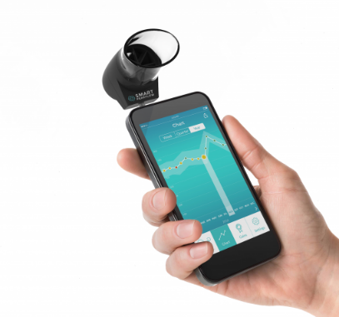

To use the Bluetooth adapter, first plug the meter into adapter. Then hold (around 5 seconds) the round button until it starts to blink blue and red, this means it is now searching for Bluetooth.
On your phone please turn on the Bluetooth.
On your phone please find the Bluetooth settings, under “available devices” you should see “SmartPeakFlow” as a possible device, this will be your Bluetooth adapter. Click on it to connect your phone with the meter. Once your phone and the peak flow meter are connected, the light will stop blinking and show a blue light. After you have connected the smart peak flow meter to your phone, the next time you turn on the adapter it should automatically connect to your phone. Please go to step 2.
If the adapter light is flashing and you do not see the device with your phone, try holding the button to turn off the device and repeat the instructions from the start of step 1.
If the light does not turn on after holding the button for 10 seconds, it might be out of battery and require charging. Please refer to the “Device Care” information above.
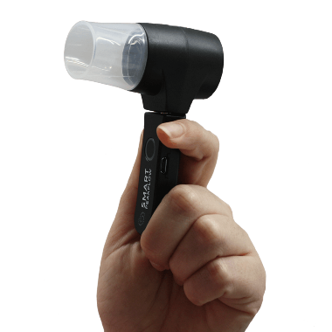

Step 2: Take measurement with Mobistudy – Set up
The mouthpiece needs to be attached the peak flow meter, either side is fine, whichever is more comfortable.
Now please open the Mobistudy app on your phone and login if you have not already done so. You should see the task “Peak Flow” available, click to begin the task. If you require extra assistance with Mobistudy, please first refer to the Mobistudy information above.
Information about the task is provided in the app. You may swipe right to read the next slide. You may press “START” at any time to leave the information page.
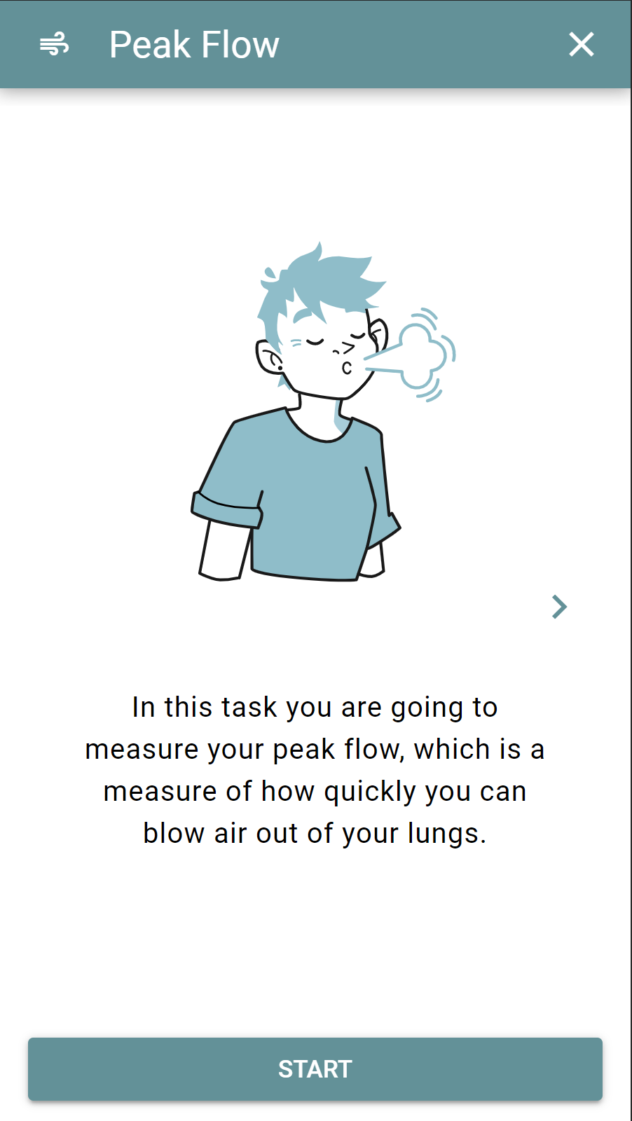
Press the “CALIBRATE SMART PEAK FLOW METER” button to calibrate the device, this should only take a few moments. If it does not calibrate, please check the following:
- The top of the device is not covered
- The connection between the peak flow meter and your phone/Bluetooth adapter is secure
- There is sufficient light above the peak flow meter
Once the device is calibrated, please press “Complete”. Please go to step 3.
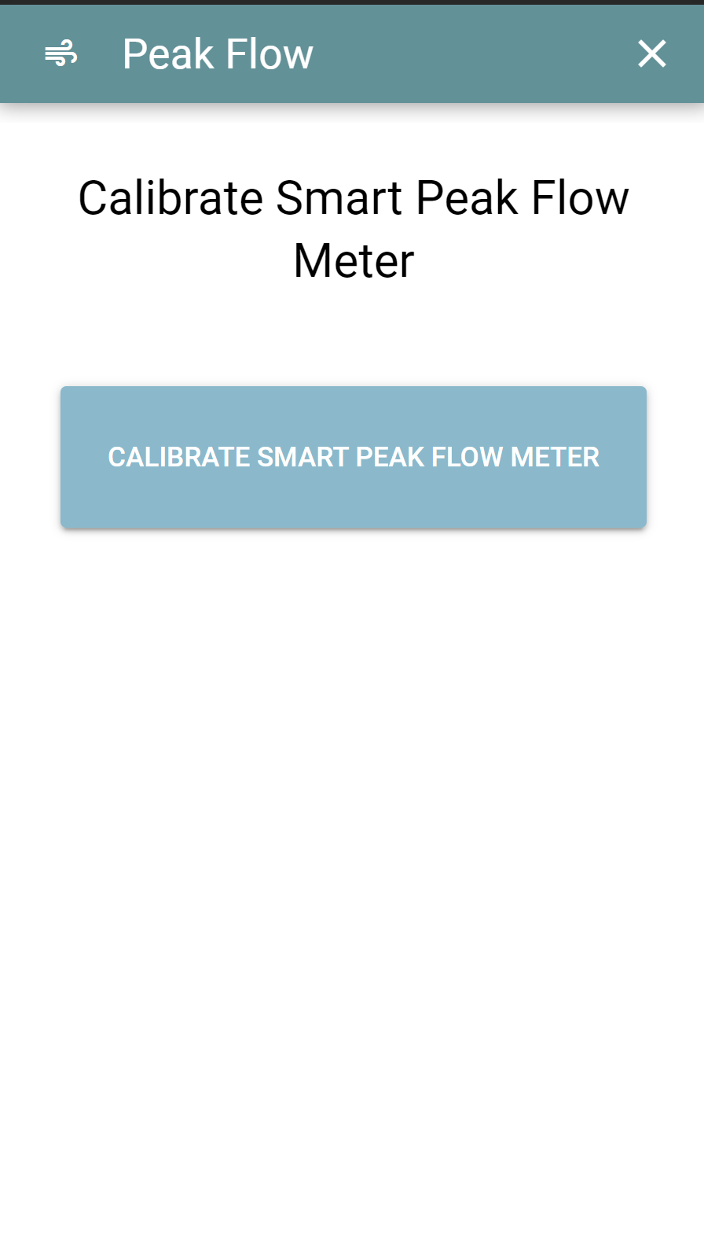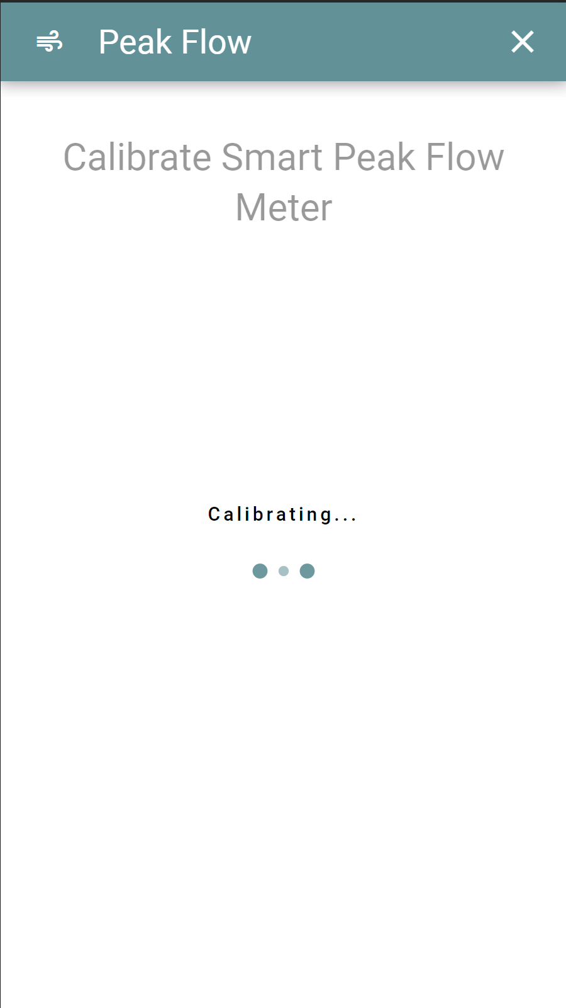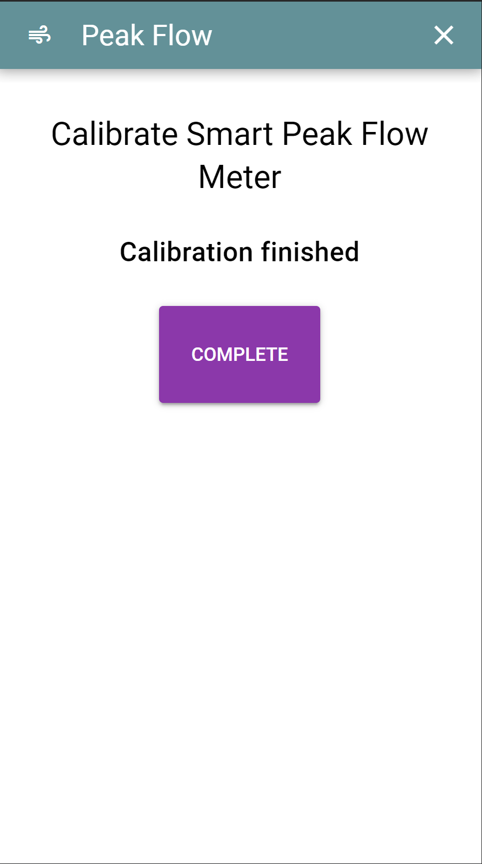
Step 3: Take measurement with Mobistudy – Recording
Now for the peak flow measurement. We ask for 3 measurements and the best peak flow will be recorded.
Please stand up and press “MEASURE”. Take a deep breath, make sure your mouth is tightly sealed around the mouthpiece. Then blow out as fast as you can. After a short break, please take two more peak flow measurements, three in total.
After taking 3 measurements, the “COMPLETE” button will show, please press “COMPLETE”. On the next screen, your best peak flow measurement is shown, please press “SEND” to save this recording.
Please go to step 4.
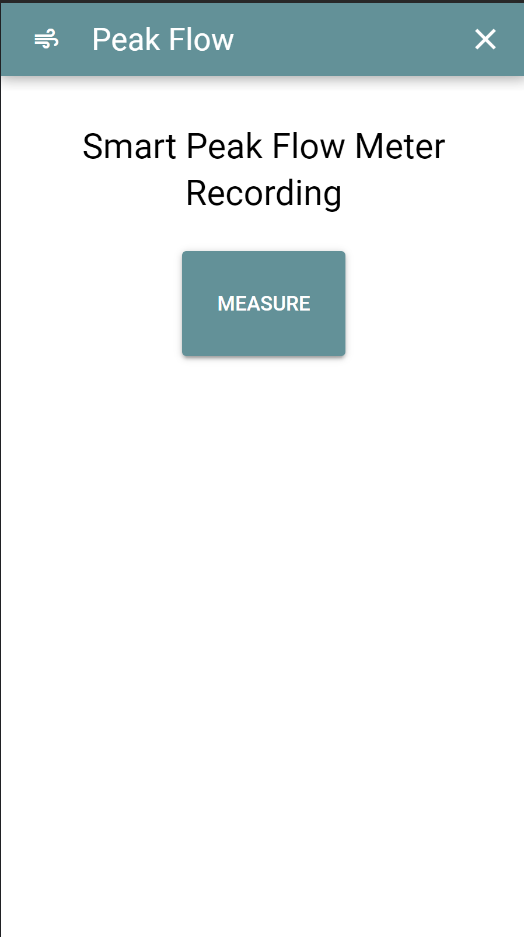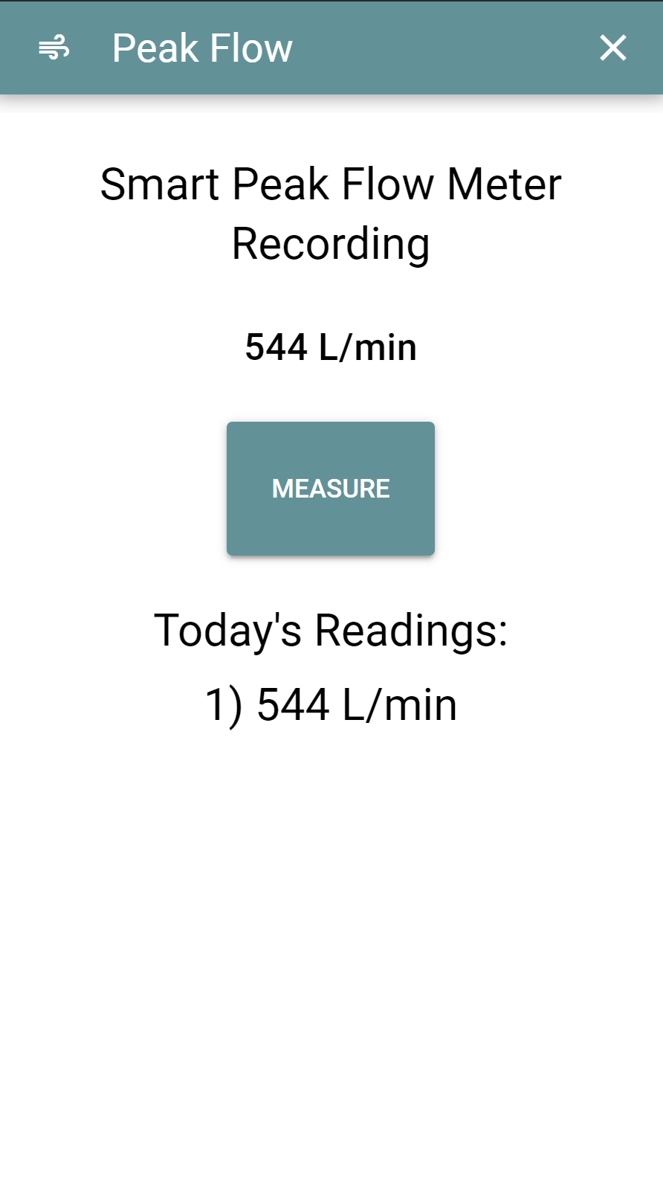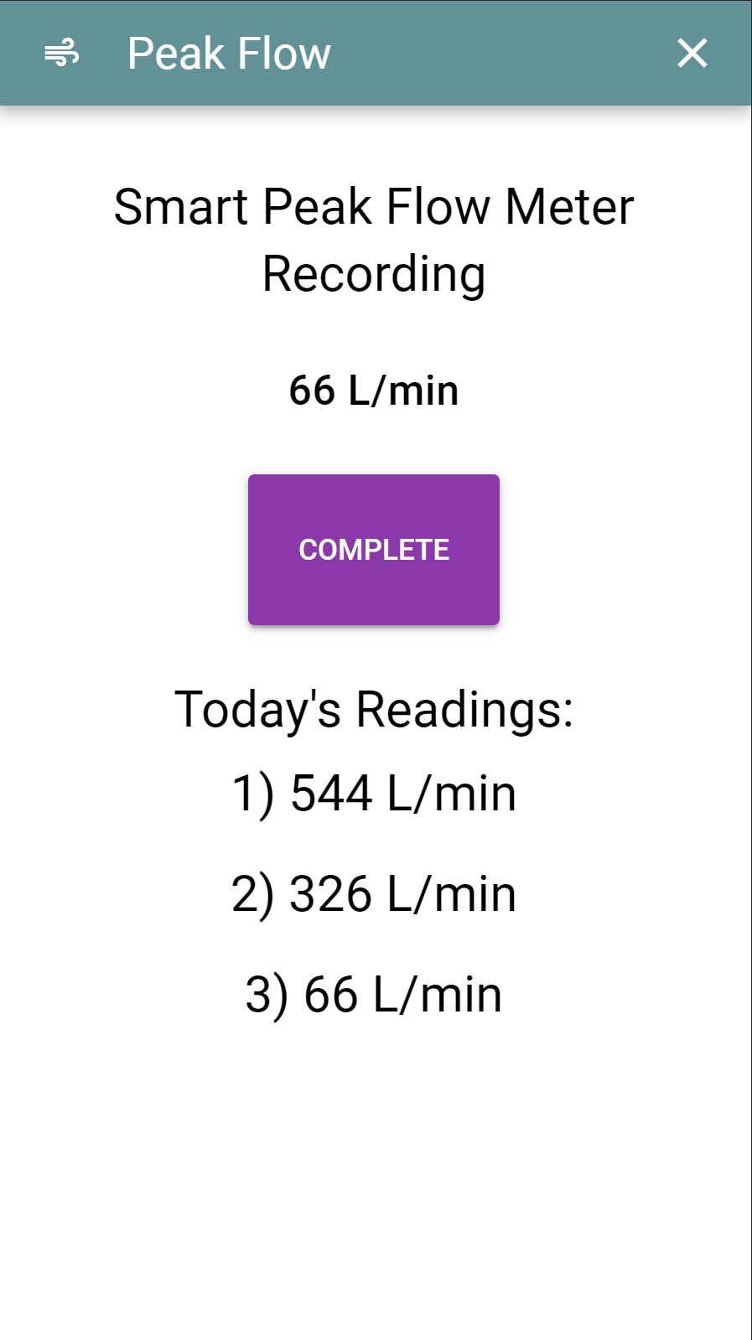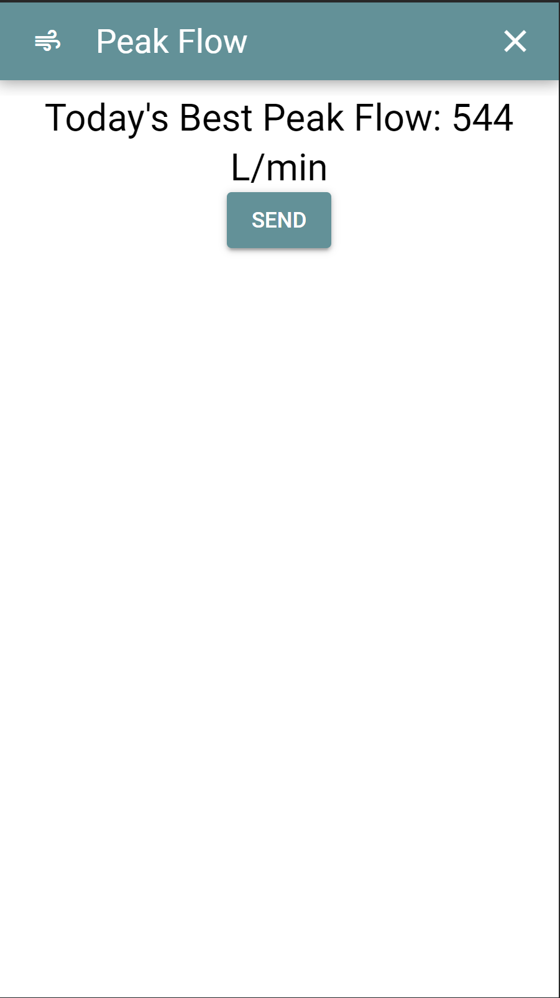

Step 4 (Optional): Review Readings
You may use this page to see previous peak flow readings. Press “COMPLETE” to close this screen. Please go to step 5.

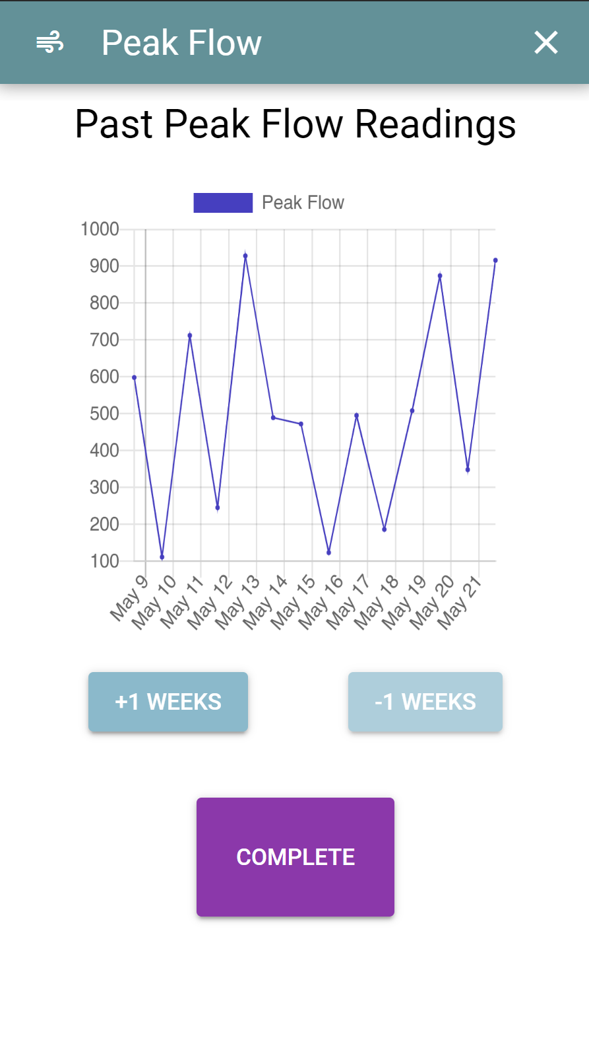
Step 5: End of task
You may now unplug the smart peak flow meter from your phone or disconnect the Bluetooth adapter. If there are other daily tasks to complete in Mobistudy, please continue with those.
To turn off the Bluetooth adapter, hold the button until it blinks red and turns off. It will also automatically turn off if unused for 2 minutes.

Smartwatch Xiaomi Band 3

Device Description and Device Care
There are 3 items relating to the Xiaomi Mi Band 3:
- Fitness Tracker
- Wristband
- Charging cable
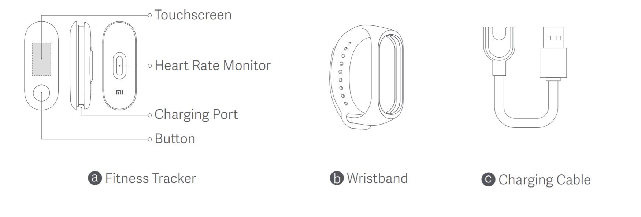
For more information about the Mi Band 3, you may refer to the company website https://www.mi.com/uk/mi-band-3/specs/

Charging
To charge the Mi Band 3, first detach the fitness tracker from the wristband. Stretch the wristband until a small gap appears. Use your finger to pop it from the wristband.
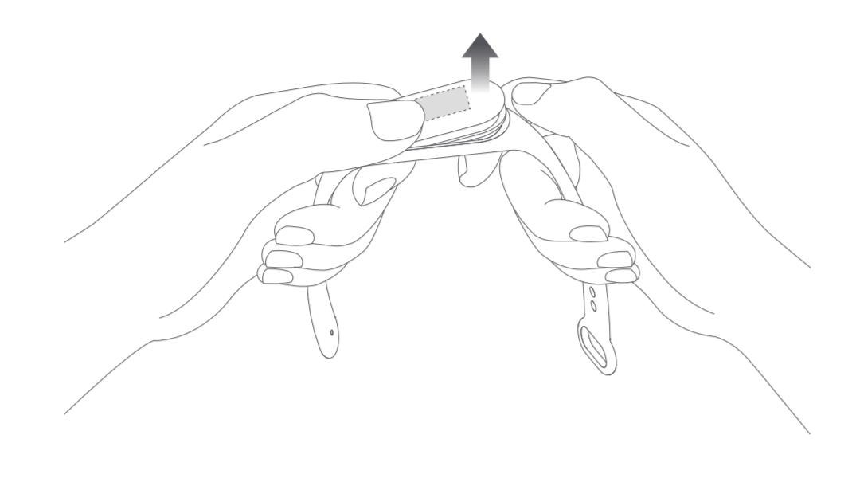
The Mi Band has a special charging cable, which connects via the pins to the wristband body. The other side needs to be plugged into a USB port.
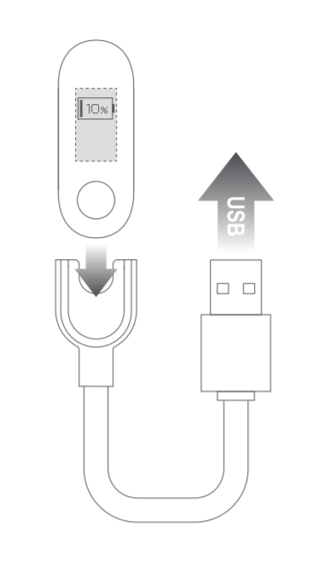
After charging, install the fitness tracker into the wristband. Slot one end of the fitness tracker into the wristband. Then press the other side down to slot the fitness tracker fully into the wristband.
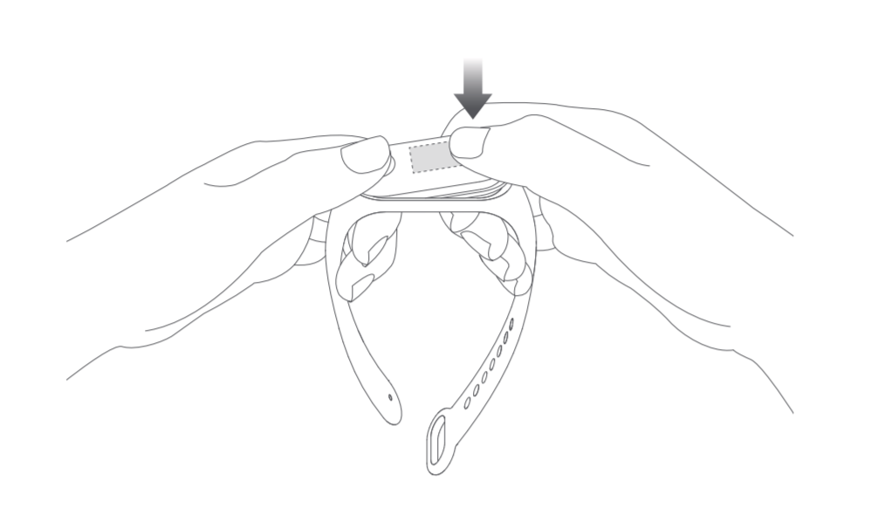

The smartwatch will require charging every week. It takes approximately 30 minutes to charge from zero to full.

Waterproof
Xiaomi Mi Band 3 has a water resistance rating of 5ATM. It can be worn in the shower, swimming pool, or while swimming near the shore. It cannot be used, however, while sitting in a sauna or diving in the ocean.

Navigation
There is a dipped circle which can be held to perform actions when prompted.
Navigation around the watch is done by swiping up, down, left, and right on the screen. Swiping up or down will cycle all the way around.
The clock is the main face, the sections are as follows.
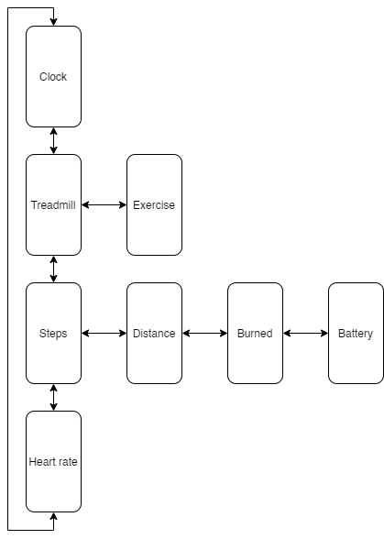
You may use the treadmill, exercise, and heart rate functions anytime. To start the function, navigate to the screen, then press and hold the button.

Connecting with Mobistudy
The smartwatch has a limited storage so would need to be transferred to your phone and Mobistudy for safe storage.

First time
Step 1
Firstly, on your phone please turn on the Bluetooth and GPS. Make sure your smartwatch is near and has been charged. You will know it has been charged if the screen lights up when you press it.
Step 2
Please go to the Mobistudy app. In the front page, you should see a task “Activity Tracker”. Click on the task.
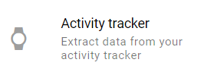
Step 3
Follow the instructions and press “start”. This will start searching for nearby Miband. Wait until “Tap the activity tracker!” shows up, then go to Step 4
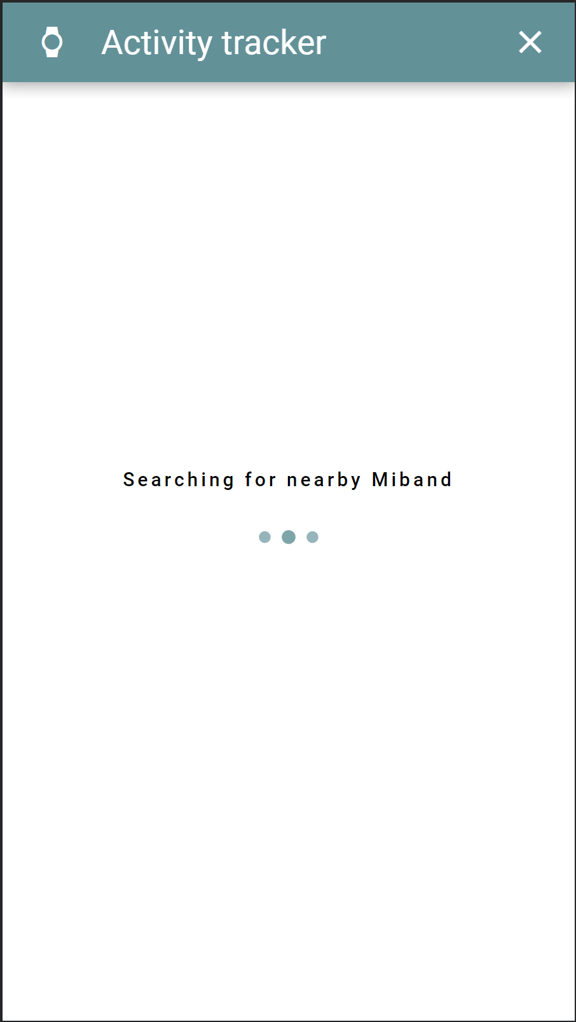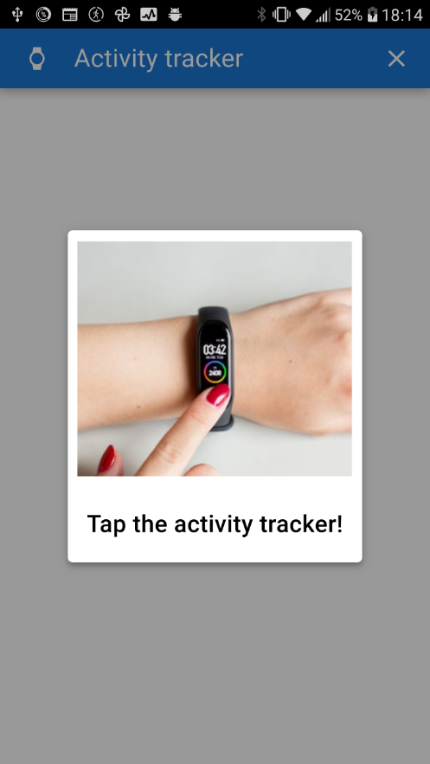
Step 4
Tap the button on the Miband to complete the connection process. A tick and “paired successfully” will be shown on the watch.
Step 5
After you have successfully connected the smartwatch, it will have no data. Please wait around 30 minutes for some data to be collected before attempting to send data. You may now quit the task with the cross at the top right corner.
Step 6
Once you have enough data, return to the “Activity tracker” task to send the data. Click on the “start” button to connect the smartwatch if it is not already connected. Scroll down and press the “Send” button. This completes the task.

Not first time
Step 1
Firstly, on your phone please turn on the Bluetooth and GPS.
Step 2
Please go to the Mobistudy app. In the front page, you should see a task “Activity Tracker”. Click on the task.
Step 3
Click on the “START” button to connect the smartwatch if it is not already connected. Scroll down and press the “SEND” button. This completes the task.
Pressing “DISCARD” will not send the data.
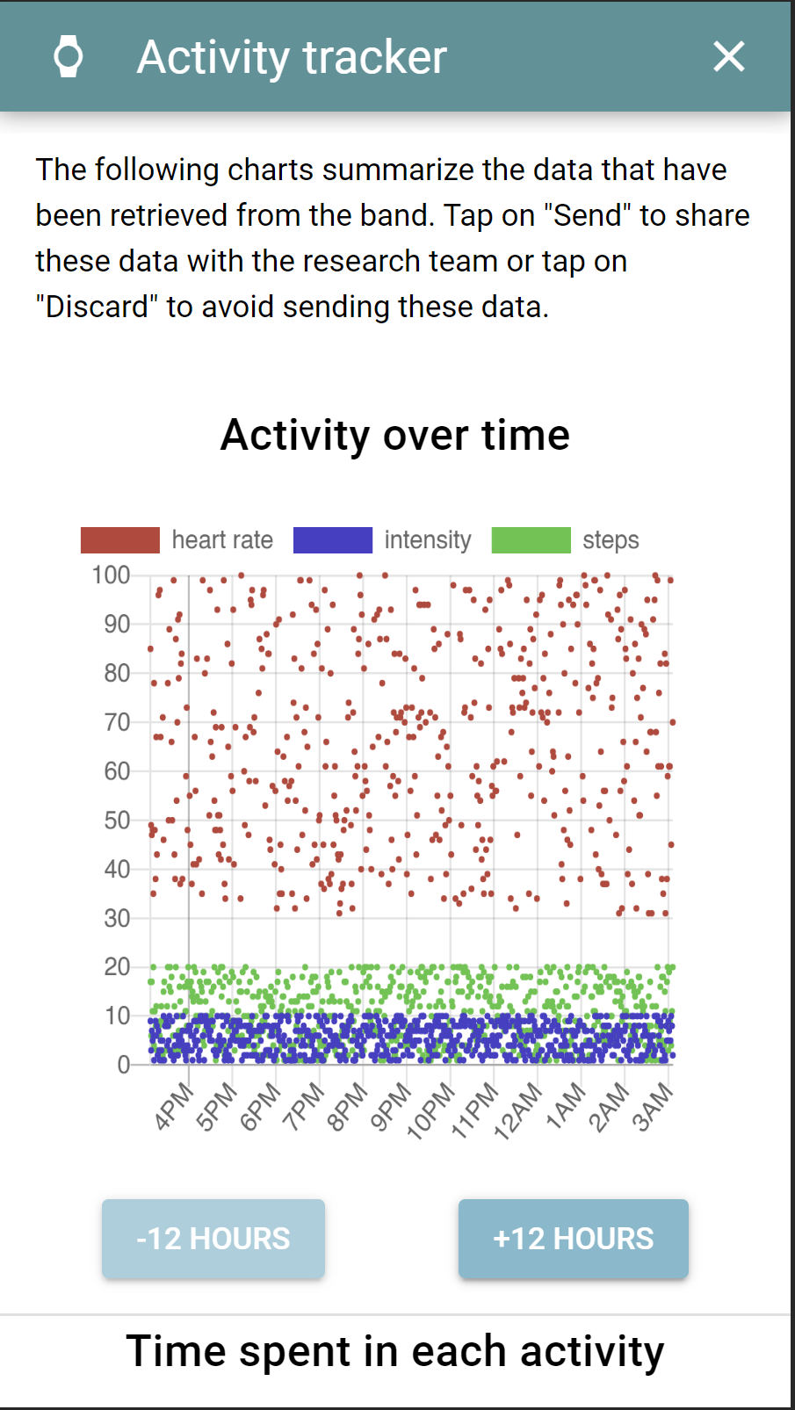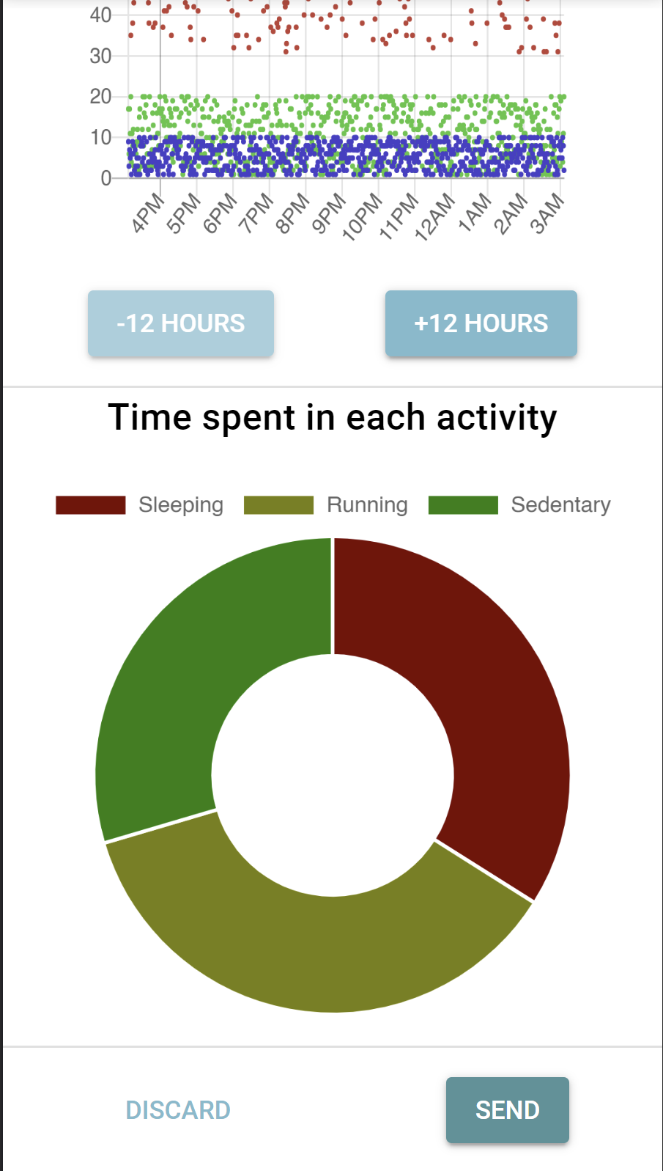

Weather and Location Task
Step 1
Firstly, on your phone please turn on the GPS and check you have internet access.
Step 2
Please go to the Mobistudy app. In the front page, you should see a task “Weather”. Click on the task.
Step 3
Press “START” and wait a moment for your local weather.
You may take you time reading the weather report. When you are ready, please press “COMPLETE”. Then on the next page press the “SEND” button. This completes the task.
