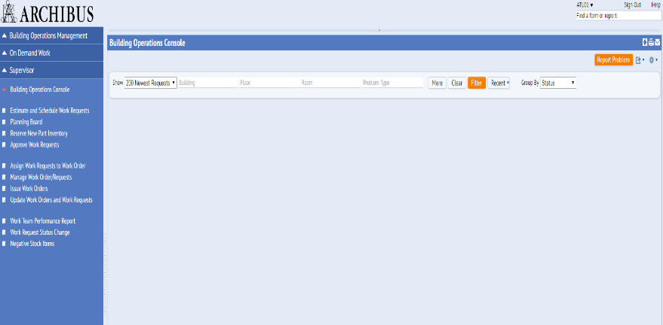



ARCHIBUS Web Central

Managing a Work Request & Report Problem Screen

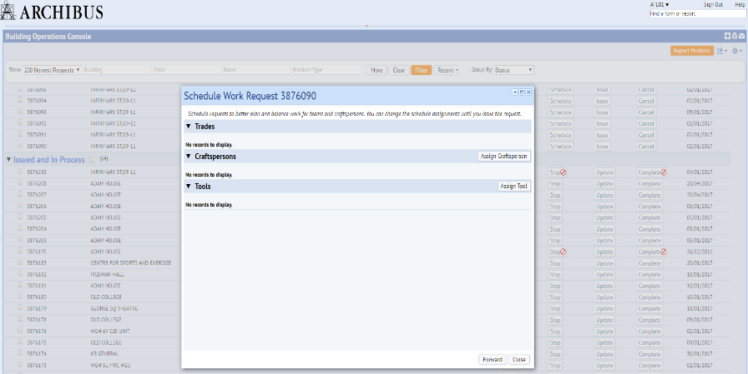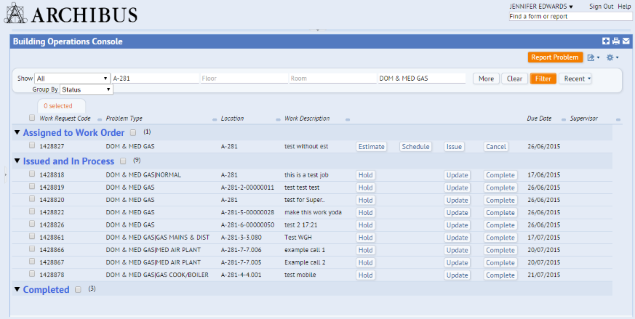

**Schedule** button

Allocate to a member of staff using the **Assign Craftsperson** button

Use the **Filter** button to view requests that have been assigned to you.

Select the

**Filter** button to retrieve your latest 200 requests

Collapse the Navigator by clicking on the dotted area

v

Use the **Forward** button to send the work request to another work team

Use **Forward** -> **Work Team Code** option to forward to another work team.

Use **Assign Craftsperson** -> **Craftperson Code** to allocate a work request to yourself or a member of your team.

All your new work will appear under the Status Step - *Assigned to Work Order.* To forward to another work team, or allocate this work to yourself or a member of your team, select the **Schedule** button.

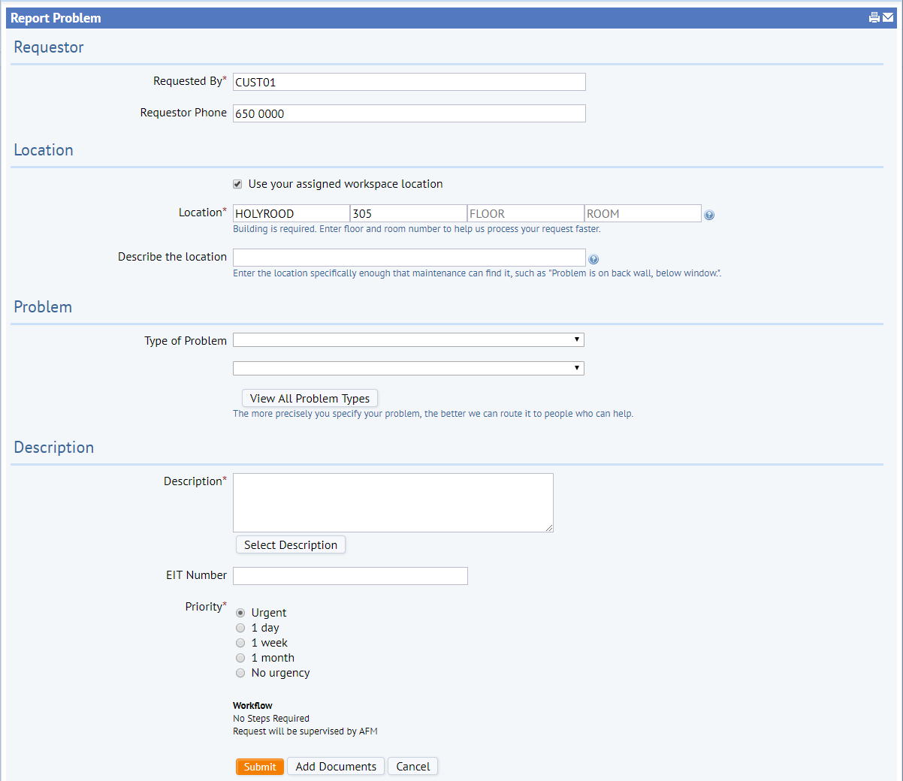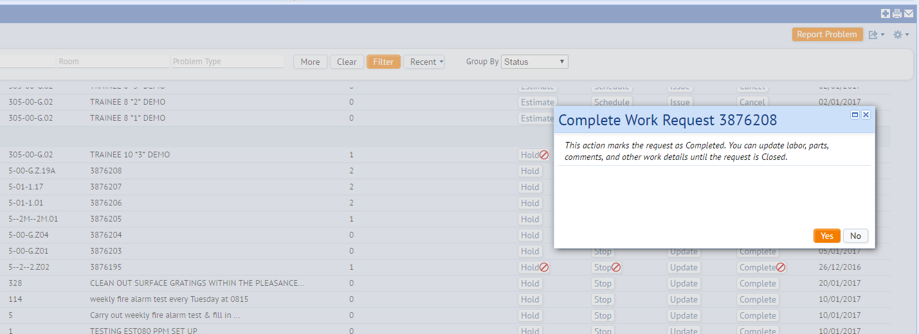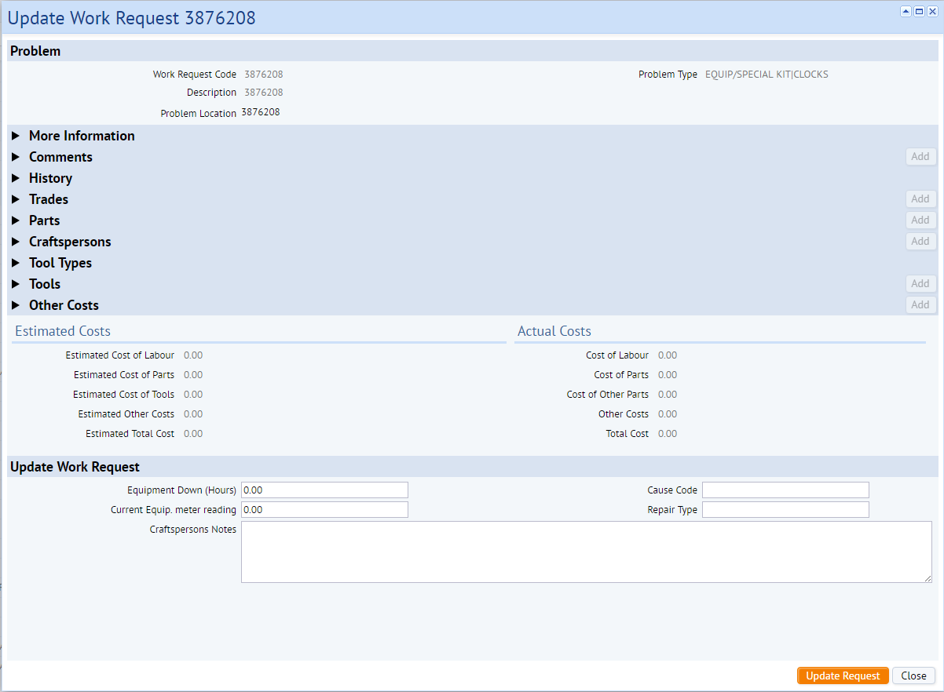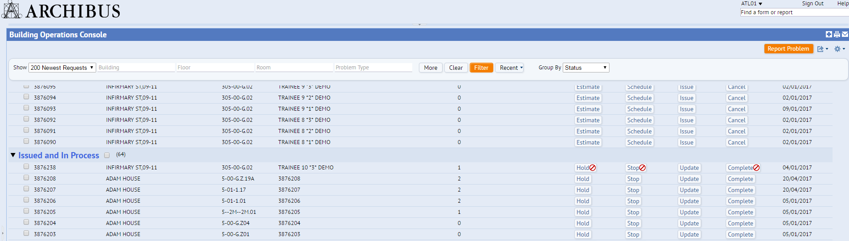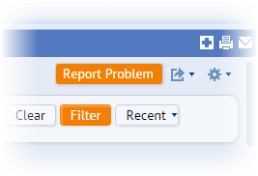

You can now add a document from the Report Problem screen

Enter a description of the issues. Enter the name /phone number of the requestor if they are not in the requested by menu

The problem type sets the SLA for the request

The location of the issue must be entered

Enter your name and contact number.

To complete a work request, select the **Complete** button.

v

v

v

Complete three fields -

1) Cause Code

2) Repair Type

3) Craftspersons Notes

v

v

On the Update screen there are three fields to be completed, the Cause Code, Repair Type, and Craftspersons Notes. Select the **Update Request** button once these have been updated.

Or you can use the **Hold** button to place the work request on hold.

v

The **Hold** button separates the work request into one of three status steps of On Hold for Parts/Labour/Access. The status step will be highlighted in red for ease of reference.

Once work has been completed use the **Update** button to record the outcome

v

Once the work request is ready to be completed, select the **Complete** button and confirm **Yes** in the pop up window.

Highlight escalated requests/ or select work request fields to amend console headings

**Report Problem**

Requestor

Location

Problem Type

Description

Submit