4-ACP Project

4 -Actions for Anticipatory Care Planning—Case Studies

Practice information and consent sheet
Thank you for your interest in in this research project. We are a team from the University of Edinburgh funded by Marie Curie looking to test an intervention around Anticipatory Care Planning (ACP) in a small number of GP practices across Scotland.
This document gives details of activities we ask practice teams to undertake and the funding and support available to them.
The 4-ACP project has 2 parts
- Intervention with four steps called: 4-Actions for Anticipatory Care Planning
- Research evaluation lasting 3-4 months to look at how the 4-ACP intervention works in GP practices, and its impact on primary care teams and your patients.

Intervention – 4-Actions for Anticipatory Care Planning
The 4-ACP intervention brings together current and new approaches to ACP in Scotland. It is based on the Healthcare Improvement Scotland Toolkit for ACP (https://ihub.scot/acp) and includes new public information available on NHS Inform (www.nhsinform.scot/acp). Your practice may have well-developed approaches to ACP and we are interested in how those could be shared.
In Scotland, ACP is seen as helping people plan for future changes in their health so they are better prepared. For professionals, ACP provides information/recommendations about what matters to a person and what we should know about them if they are seriously ill or unable to make health and care decisions. DNACPR and care at the end of life are not the sole focus of ACP.
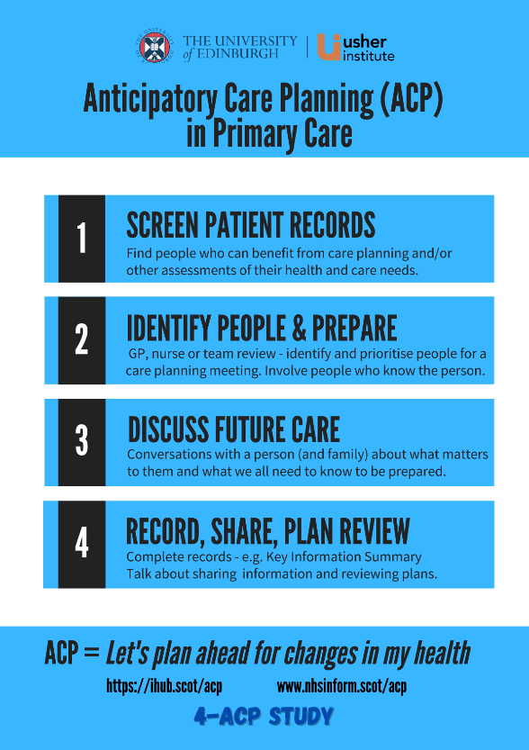
We provide GP practices with a toolkit to help them identify people for ACP and support in offering anticipatory care planning to people who can benefit the most. This consists of:
◊ AnticiPal – a GP practice record screening programme giving a “long list” of patients who might benefit from ACP.
◊ Tools and resources for professionals based on the RED-MAP framework for ACP conversations.
◊ Request to try using the new NHS Inform resources on ACP with your patients living at home or in a care home and their families/friends.
ACP plans generated during the project are recorded in your normal way and uploaded to the patient’s Key Information Summary (KIS)
MORE INFORMATION (4-ACP Project website):
https://www.ed.ac.uk/usher/primary-palliative-care/recent-grants/4acp-primary-care

The aim of the intervention is for you SCREEN your patient lists to find a cohort of people who may benefit from care planning, IDENTIFY patients for anticipatory care planning and offer them an opportunity to DISCUSS making an ACP that you will RECORD and share in on a KIS in the usual way.

What we are asking you to do to help with our research
Each case study will last 3-4 months. If you take part, we will ask you to do the following:
- Nominate a GP or nurse (or other key staff member) to become the Local Collaborator (LC). The LC will work with us to deliver the ACP intervention and evaluate it.
- Run the AnticiPal screening programme at the start of the project in your practice to generate a list of your patients who have AnticiPal indicators. This list of patients is your practice Cohort for the study.
- At the start of the project, provide us with a count how many of your patients have Key Information Summaries and how many you have on your palliative care register.
- The LC (or another nominated team member) takes part in a recorded “Thinking Aloud” interview with a researcher about identifying patients for ACP lasting a maximum of 60 minutes.
- Allow a project researcher to attend at least one meeting in which your team discusses anticipatory care planning or palliative care for patients registered at your practice.
- Use the Scottish ACP resources for professionals and patients during the intervention.
- Approach up to 4 patients who have had an ACP conversation with a member of the practice team, complete a “Consent to contact” form and send it to the project team. These patients will then be contacted by us to discuss the research and ask if they wish to take part in an interview about ACP.
- Agree to provide relevant clinical information to the research team from the medical records of the interviewed patients who consent to this.
- After 12 weeks, the LC and/or 1-2 other key staff take part in a short, reflective interview about the impact of 4-ACP and ACP more generally.
- After 12 weeks, run the AnticiPal search again and collate a summary of clinical contacts and care planning actions undertaken with your Cohort during the project.

Resources and funding for GP practices
If you take part in the intervention there will be a core reimbursement of £750. Depending on the number of staff who take part in an interview and the number of patients you approach about the study this reimbursement may increase up to £1,500.

What happens next
Once key personnel have understood the research process and are willing to take part, please ask a senior partner or your practice manager to sign and date this agreement on behalf of the practice.
On behalf of [Practice Name], I consent to take part in this project as listed above.

Name______________________________ Signature__________________________

Date______________
One copy to be kept by the practice
One copy to be returned to the 4ACP Project Lead Researcher
Dr Bruce Mason,
Project Researcher, University of Edinburgh, Teviot Place, Doorway 3, Edinburgh, EH8 9AG.
Phone: 0131 650 9237
Email: Bruce.Mason@ed.ac.uk

