How to Upload DNA data files

Upload Step 1
In the volunteer dashboard select Upload File to start.

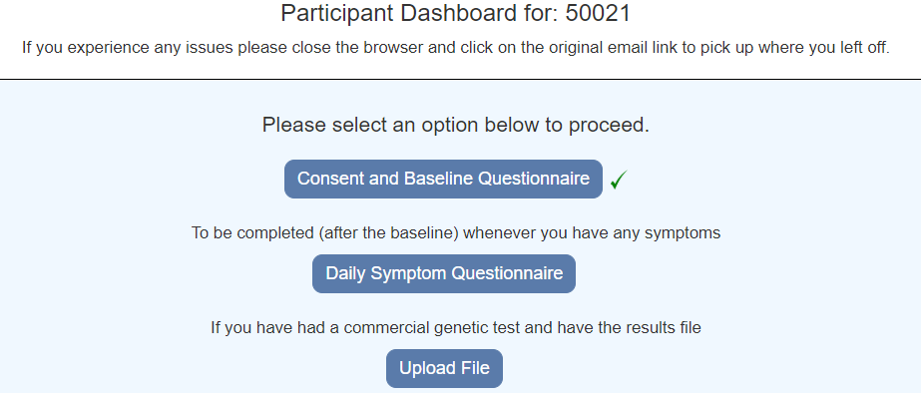

Upload Step 2

Choose a file and select Upload

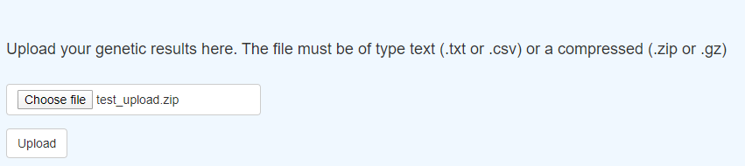

Upload Step 3

The message “File successfully uploaded” will be displayed

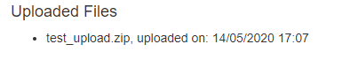
If there was an error, a message will be displayed. IF you have problems please contact the Coronagenes team. Please send us details of any errors you receive.

Upload Step 4

Select Back to Dashboard

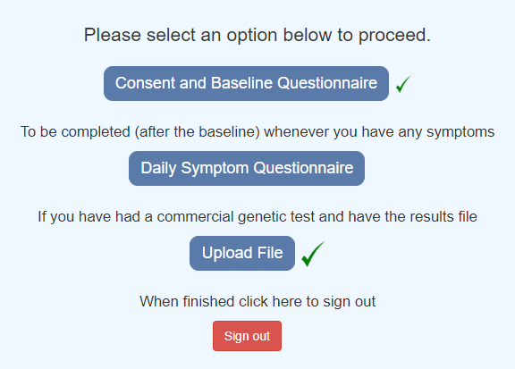

The Upload file will have a green tick.

Upload Step 6

Select Sign Out to complete the process.

