How to Download and Upload DNA data files

My Heritage

Download Instructions

Download Step 1
Sign on to your MyHeritage account.
Click on DNA on the upper toolbar.
The dropdown menu includes “Manage DNA Kits”
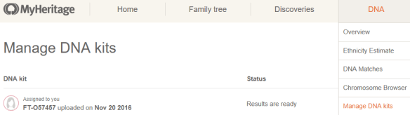

Download Step 2
At the right of the kit you wish to download, click on the three small buttons which will include an option for “Download.” This is shown in the graphics below from the MyHeritage blog article.

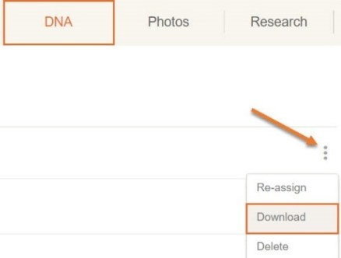
Download Step 3
You’ll be presented with a box titled “Learn more about DNA data files.” Click the purple “Continue” button.
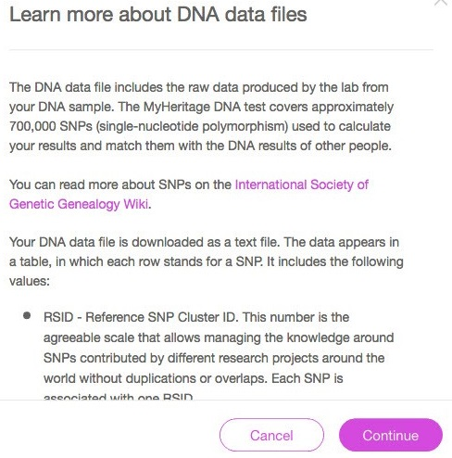

Download Step 4
You’ll need to confirm that you want to download your data and that you understand the download is outside of MyHeritage and their protection. Click the purple “Continue” button.
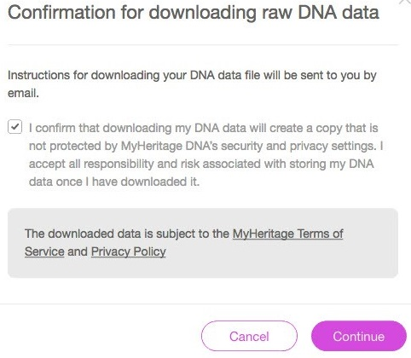

Download Step 5
You’ll receive a confirmation e-mail. Click on “Click here to continue with download.”
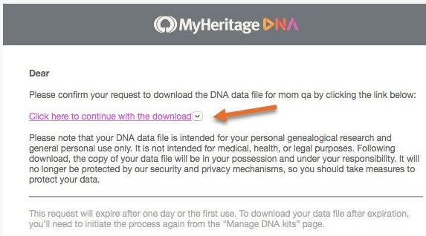

This e-mail link is only valid for 24 hours.
Download Step 6
Enter your password again, and click on the purple “Download” button.
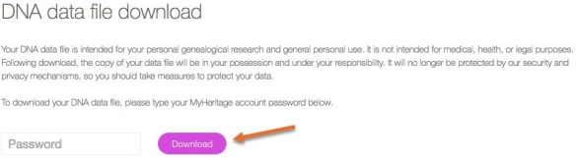

Download Step 7

Save the file as a recognizable file name on your computer.
Upload Instructions

Upload Step 1
In the volunteer dashboard select Upload File to start.

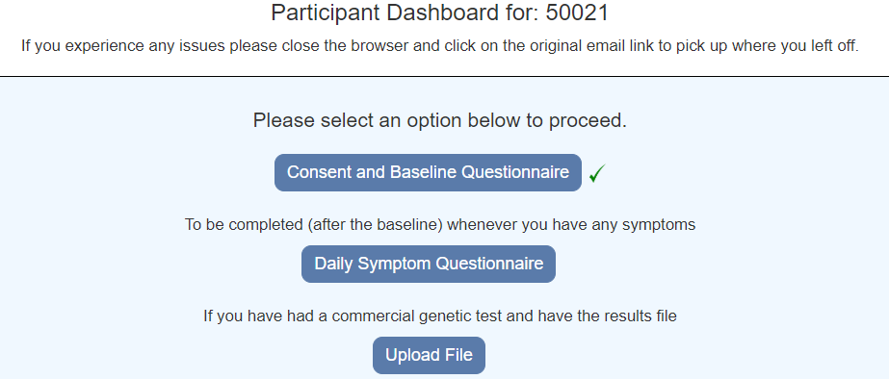

Upload Step 2

Choose a file and select Upload

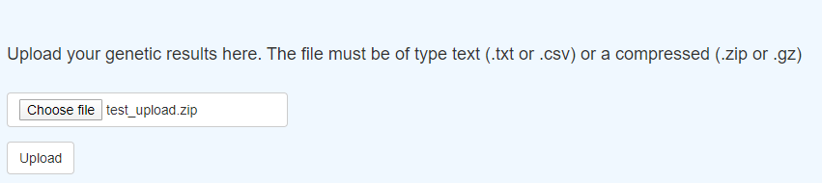

Upload Step 3

The message “File successfully uploaded” will be displayed

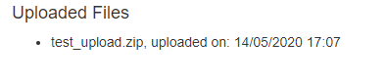
If there was an error, a message will be displayed. IF you have problems please contact the Coronagenes team. Please send us details of any errors you receive.

Upload Step 4

Select Back to Dashboard

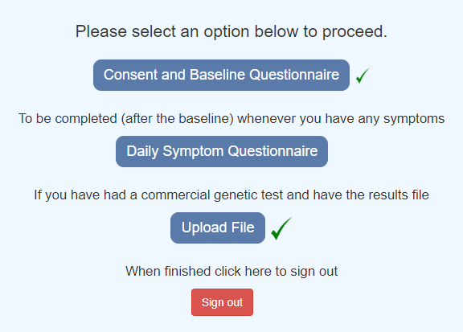

The Upload file will have a green tick.

Upload Step 6

Select Sign Out to complete the process.

