How to Download and Upload DNA data files

Family Tree DNA

Download Step 1
To download your raw autosomal DNA file from Family Tree DNA, click on the orange “Download Raw Data” link. It can be found at the bottom of the Family Finder section on your dashboard.

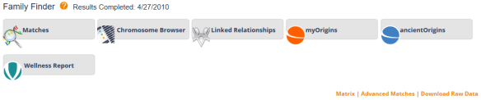

Alternatively, you can select the “Download Raw Data” option at the top of the page under myDNA, “Family Finder.”
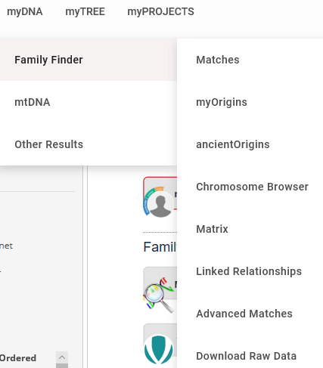

Step 2
You will be given the option of downloading your Build 36 and Build 37 raw data files.
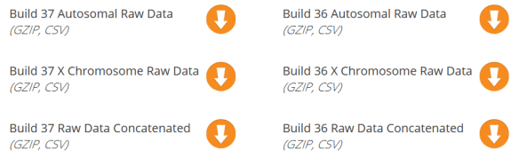

Click the arrow beside Build 37 Raw Data Concatenated.
Step 3
Save the file in a manner that you’ll recognize. The file name will be something like “37_R_Estes_Chrom_Autoso_20180818.gz”. We suggest appending the word FTDNA in front of the 37, so there is no question which vendor’s file this is. The last several digits are the date of download.
Upload Instructions
Upload Step 1
In the volunteer dashboard select Upload File to start.

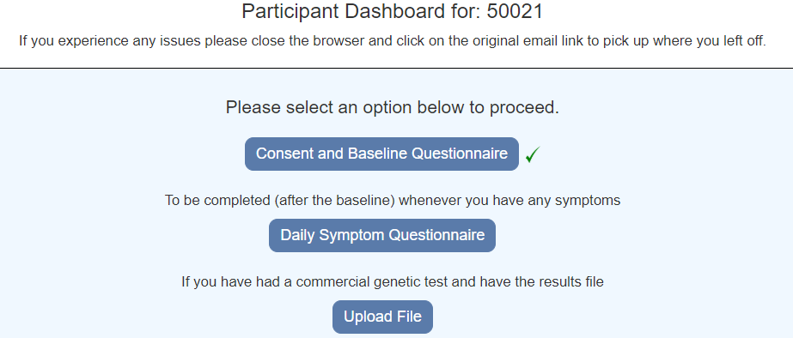

Upload Step 2

Choose a file and select Upload

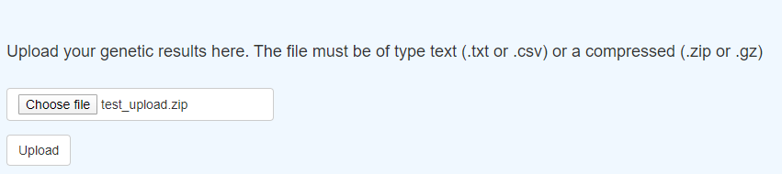

Upload Step 3

The message “File successfully uploaded” will be displayed

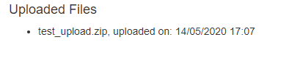
If there was an error, a message will be displayed. IF you have problems please contact the Coronagenes team. Please send us details of any errors you receive.

Upload Step 4

Select Back to Dashboard

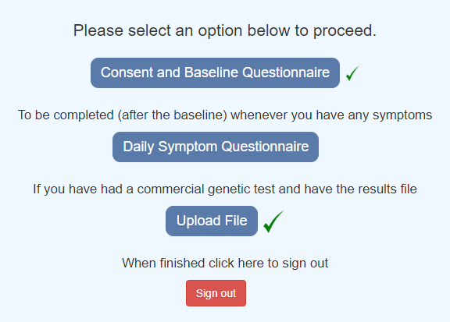

The Upload file will have a green tick.

Upload Step 6

Select Sign Out to complete the process.

