How to Download and Upload DNA data files

23 and Me

Download Instructions

In order to transfer your autosomal DNA file to Coronagenes, you’ll first need to download the file from 23andMe.
Download Step 1
Sign on to your account at 23andMe.
Your account can be found under your name at the upper right-hand corner of your page. Click on the little circle with your initials, you’ll see “Browse Raw Data.” Click there.
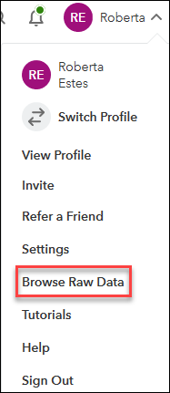
Download Step 2

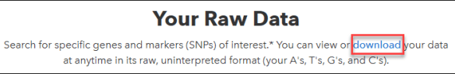
You’ll see “Your Raw Data.” Click on the blue download link.
Download Step 3
On the Download Raw Data page, scroll down towards the bottom until you see “Request your raw data download.”
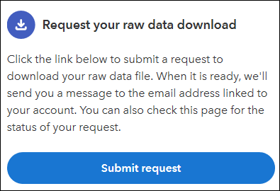
Click on Submit request.
Download Step 4
You’ll see the following message saying an e-mail will be sent to you.
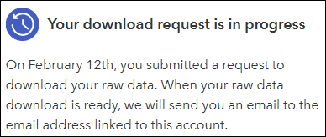
Download Step 5
A few minutes later, an e-mail will arrive that says:
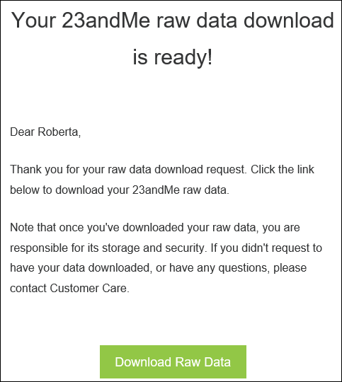
Click on the green button in the e-mail which will take you back to 23andMe to sign in.
Download Step 6
After you sign in, you’ll be immediately taken to the download page and will see the following.
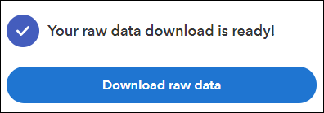
Your raw data file will be downloaded to your computer. You’ll need to store it in a location, under a name that you can find.
The file name will be something like “genome_Roberta_Estes_v2_v3_Full_xxxxxxxx.” The x’s are a long number. We recommend adding the word 23andMe to the front when you save the file on your system.
Upload Instructions
Upload Step 1
In the volunteer dashboard select Upload File to start.

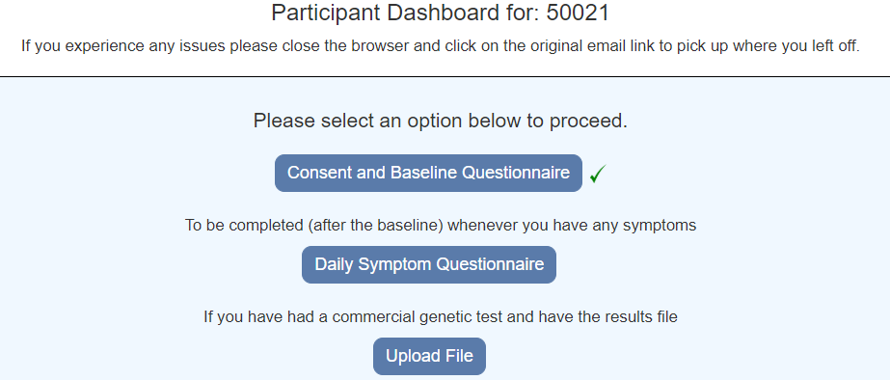

Upload Step 2

Choose a file and select Upload

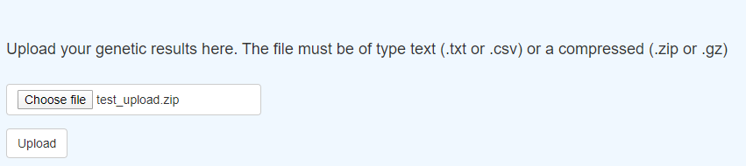

Upload Step 3

The message “File successfully uploaded” will be displayed

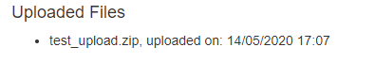
If there was an error, a message will be displayed. IF you have problems please contact the Coronagenes team. Please send us details of any errors you receive.

Upload Step 4

Select Back to Dashboard

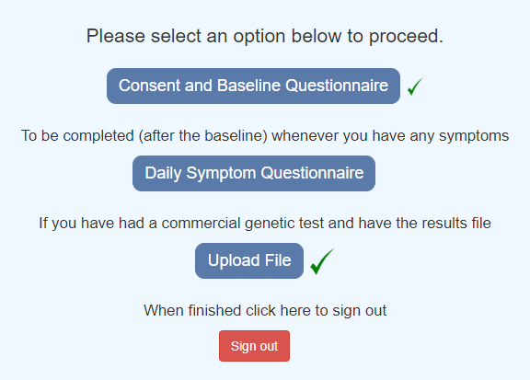

The Upload file will have a green tick.

Upload Step 6

Select Sign Out to complete the process.

