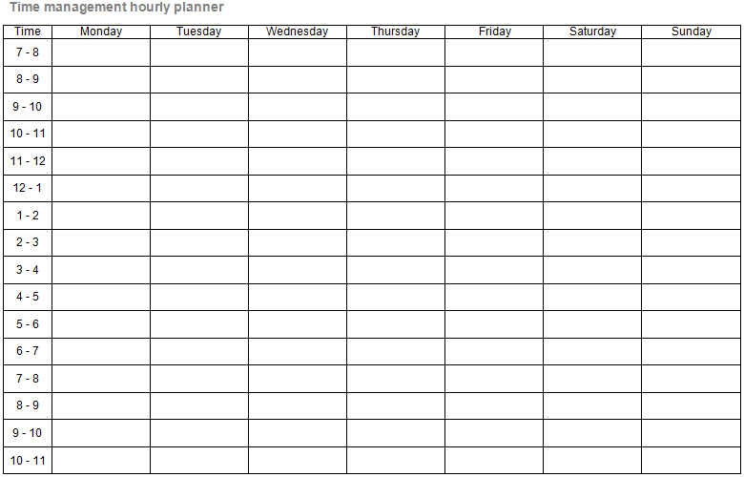
The time management sheet (find on the following page) can be used to organise your day, week or semester.

This planner has time slots broken down into hourly segments. These are a guide only and you do not need to complete every time slot. You may want to print several copies of the planner – this would allow you to plan forward.

Please do remember that to remain an effective student it is very important that you schedule time to relax.

Time | Monday | Tuesday | Wednesday | Thursday | Friday | Saturday | Sunday
7 - 8
8 - 9
9 - 10
10 - 11
11 - 12
12 - 1
1 - 2
2 - 3
3 - 4
4 - 5
5 - 6
6 - 7
7 - 8
8 - 9
9 - 10
10 - 11

