The time management sheet (find on the following page) can be used to organise your day, week or semester.

This planner has time slots broken down into morning, afternoon and evening segments. These are a guide only and you do not need to complete every time slot. You may want to print several copies of the planner – this would allow you to plan forward. You may keep it as a file on your computer/laptop/tablet or you may wish to print off and use it as a file or wall planner

Please do remember that to remain an effective student it is very important that you schedule time to relax.

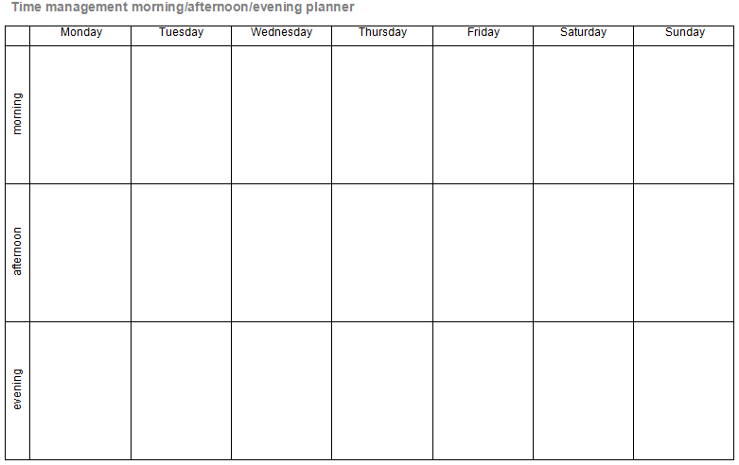

 | Monday | Tuesday | Wednesday | Thursday | Friday | Saturday | Sunday
morning
afternoon
evening

