Student Disability Service

Student Evaluation 2013/14

Contents
Background | 2
Methodology | 2
Objectives | 2
Demographic Overview | 2
Awareness and Usage of the Service | 3
Evaluation of Service | 7
Accessible and Inclusive Learning Policy (AILP) | 15
Summary and Recommendations | 16
Appendix 1: Demographics | 17
Appendix 2: The Questionnaire | 20

Background
- The Student Disability Service (SDS) has been undertaking an annual survey of users for 8 years
- The survey is administered by Communications and Marketing.
- The questionnaire has been adjusted from previous years; however, comparisons will continue to be drawn where possible
- Previous reports can be found on the Student Disability Service website http://www.ed.ac.uk/schools-departments/student-disability-service/about/feedback-evaluation

Methodology
- Sent to 2,737 people (208 people more than 2013)
- Received 593 responses (22% response rate – a 17% increase on 2013)

Objectives
- To monitor the satisfaction with the various services offered by the SDS
- To gauge the extent to which the SDS contributes positively to the educational experience
- To track trends over time
- To capture what SDS are doing right and identify what could be improved.

Demographic Overview
- The demographics of respondents remain relatively consistent across the years therefore allowing us to compare with some confidence.
- The demographics are also reflective of the wider SDS user profile so can be used to extrapolate to this audience.
- SDS respondents remain under represented (in terms of what we would expect) in three areas: non-UK, under 20yrs and males.
- See Appendix 2 for a full breakdown of the demographics

Awareness and Use of Service

Awareness of Service

How did you first find out about the Student Disability Service?
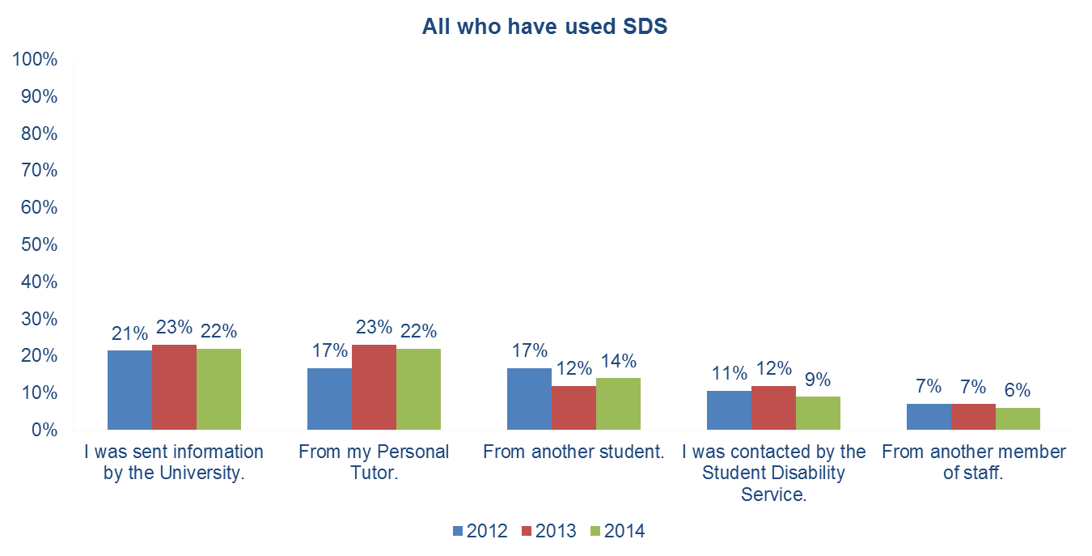

How first found out - other
134 people who said other and gave more information:
- 39 found it on the UoE website
- 9 people from their doctor
- 8 from a friend or colleague
- 6 from their previous institution

Awareness of Services
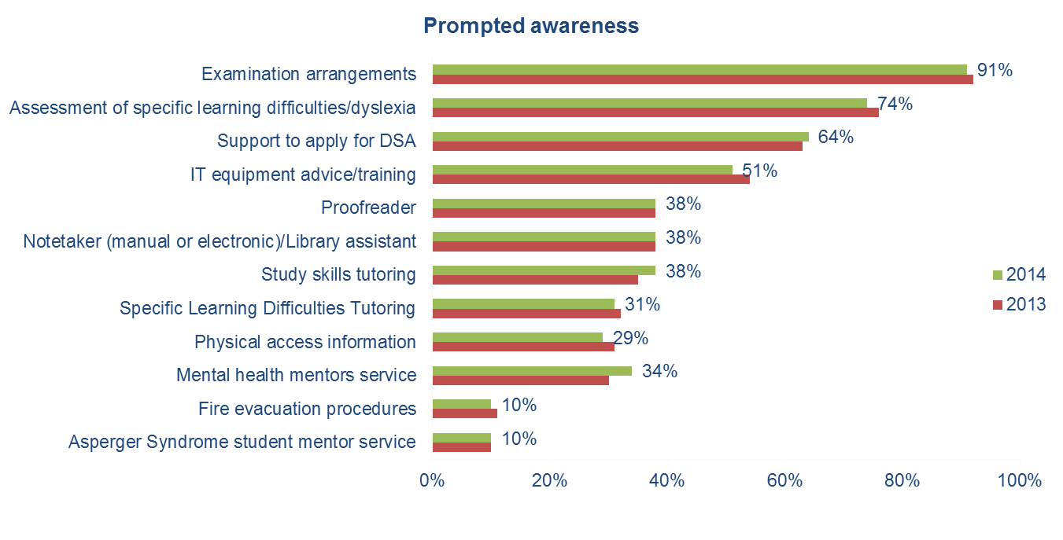
Use of Service

When was the last time you had contact with the Student Disability Service?
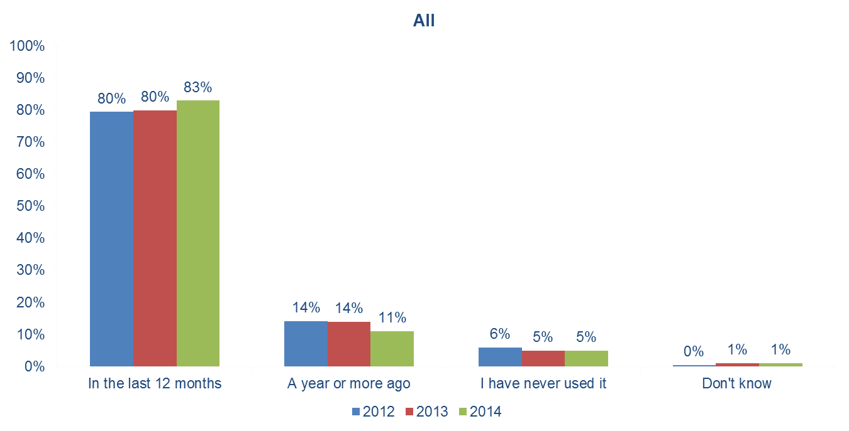

When do you use the Student Disability Service?
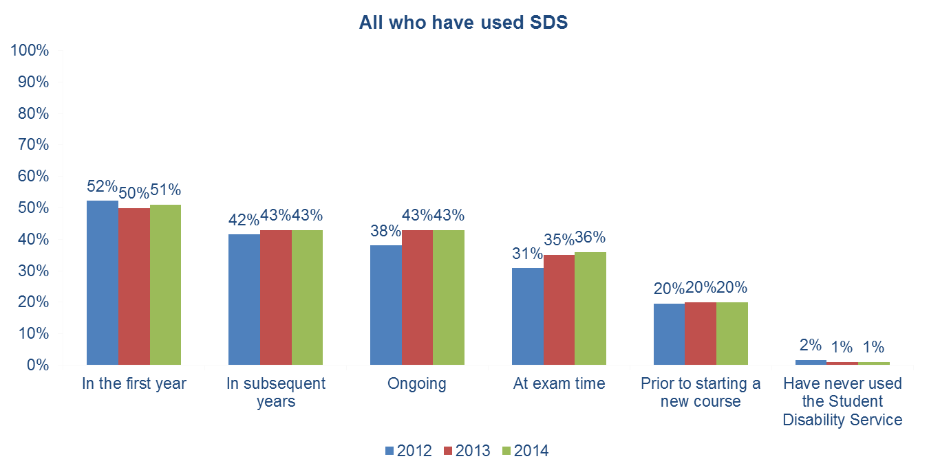

Services used in the last 12 months
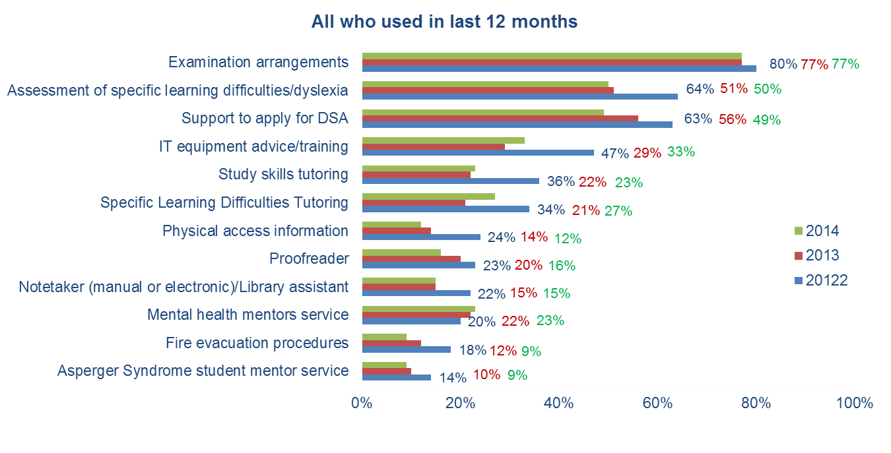

Awareness of services by usage
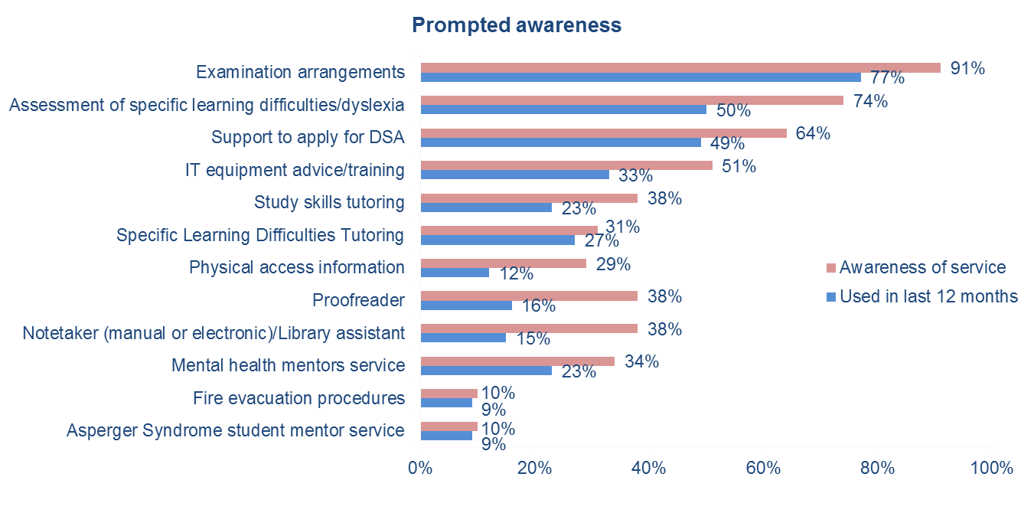

Why students haven’t used the SDS

Why haven’t used the SDS at all

- In 2014L 29 people responded
- 5 distance learners didn’t know if anything was provided for them
- Most felt that their disability had no negative impact on their learning experience and therefore did not need to contact SDS

- In 2013: 15 people responded
- Almost all cited the lack of need as the main reason for not using SDS.

- In 2012: 29 people responded
- 18 people said they hadn’t used the Student Disability Service because they didn’t need to
- The other responses relate to a lack of desire to expend any effort.

Reasons for not using SDS in last 12 months
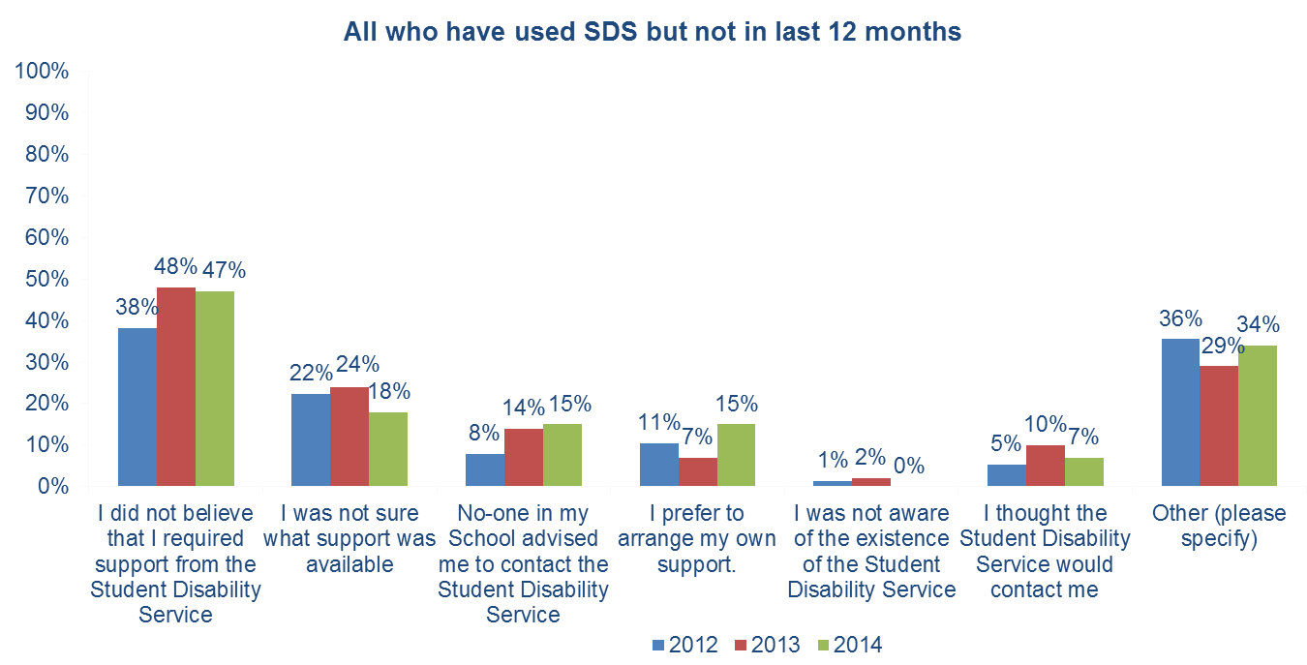

Open ended answers:
- 21 people answered
- 15 of whom said there was they didn’t need any help (either because the adjustments had rolled over from previous years or they didn’t need any adjustments).
- 5 people said they were unsure of the available help
- 4 people said previous negative experience had stopped them using the service

Evaluation of service
(all those who used in the last 12 months)

Level of satisfaction with specific staff types
 | Student Support Assistant (e.g. notetaker, IT tutor) | Management Team | Advisory Team | Frontline Reception Team
Very Satisfied | 16% | 22% | 50% | 65%
Satisfied | 9% | 12% | 24% | 24%
Neutral | 6% | 7% | 9% | 5%
Dissatisfied | 1% | 1% | 4% | 1%
Very Dissatisfied. | 0% | 1% | 2% | 0%
Had no contact | 69% | 56% | 12% | 6%

Rating of services by those who used them
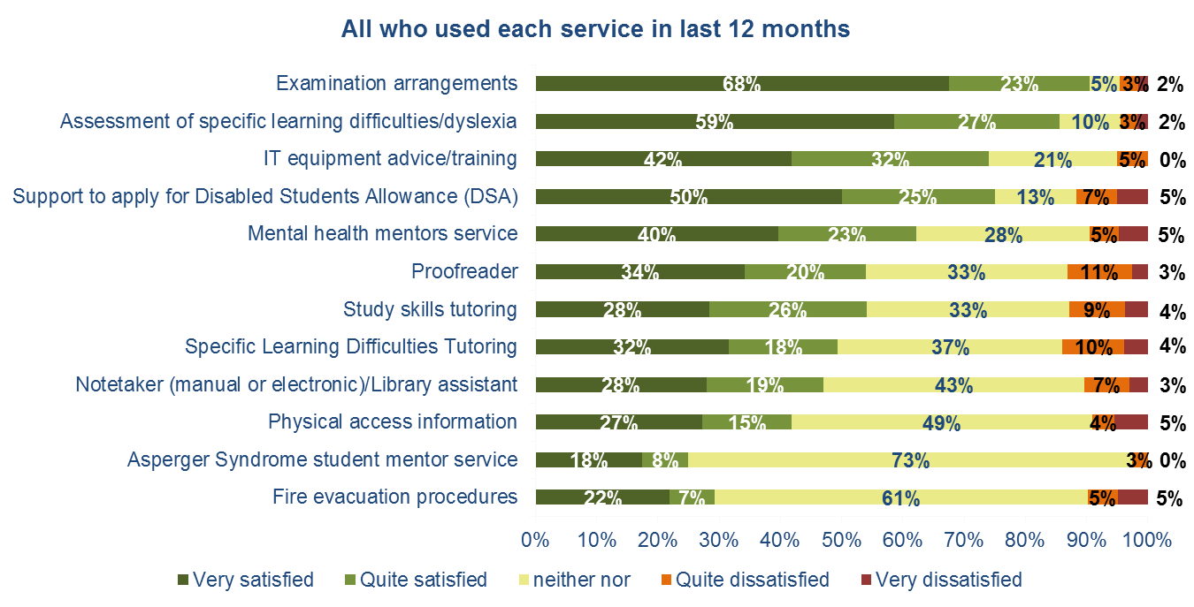

Average rating of services by those who used them in 2013/14
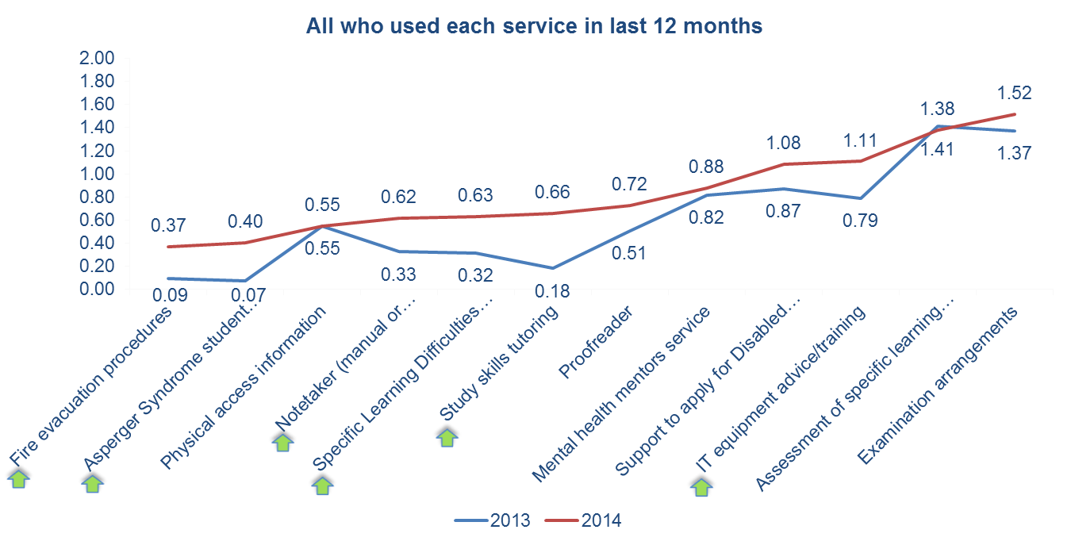
Ratings have significantly improved in 6 areas of service in 2014 ()

Learning Profile

Did you have a Learning Profile set up in the last 12 months?
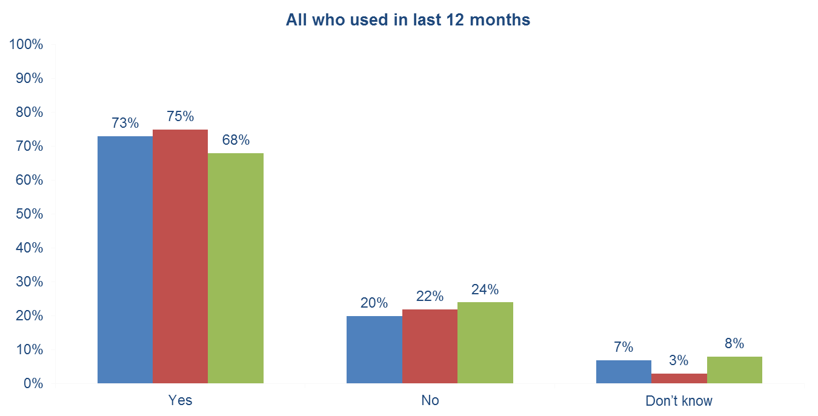

Did you receive the adjustments recommended in your Learning Profile
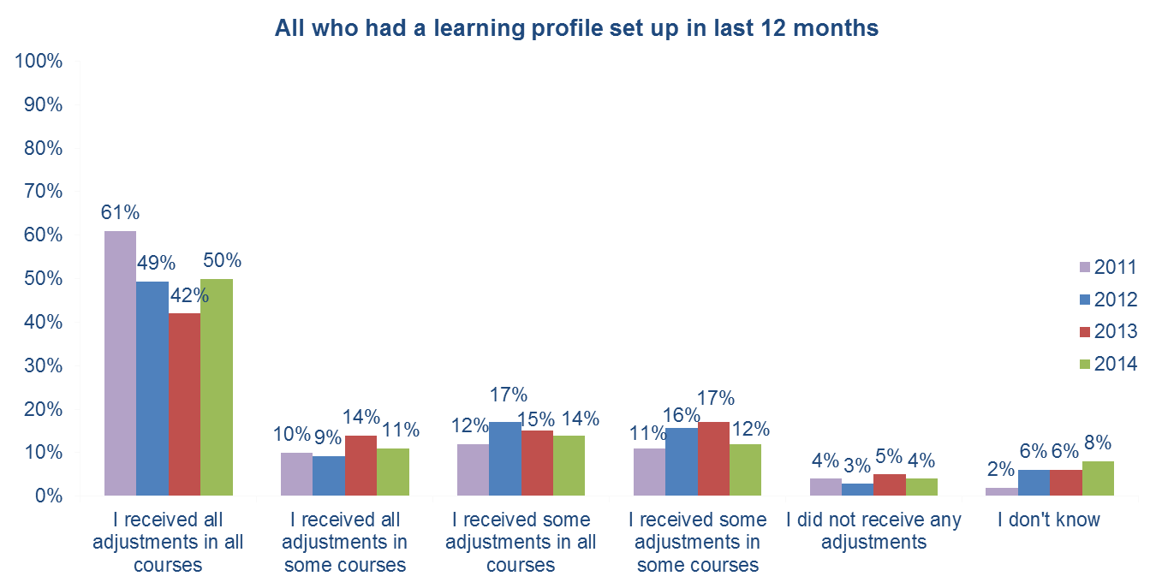

Adjustments received in Learning Profile by subject area – all with more than four responses shows average score
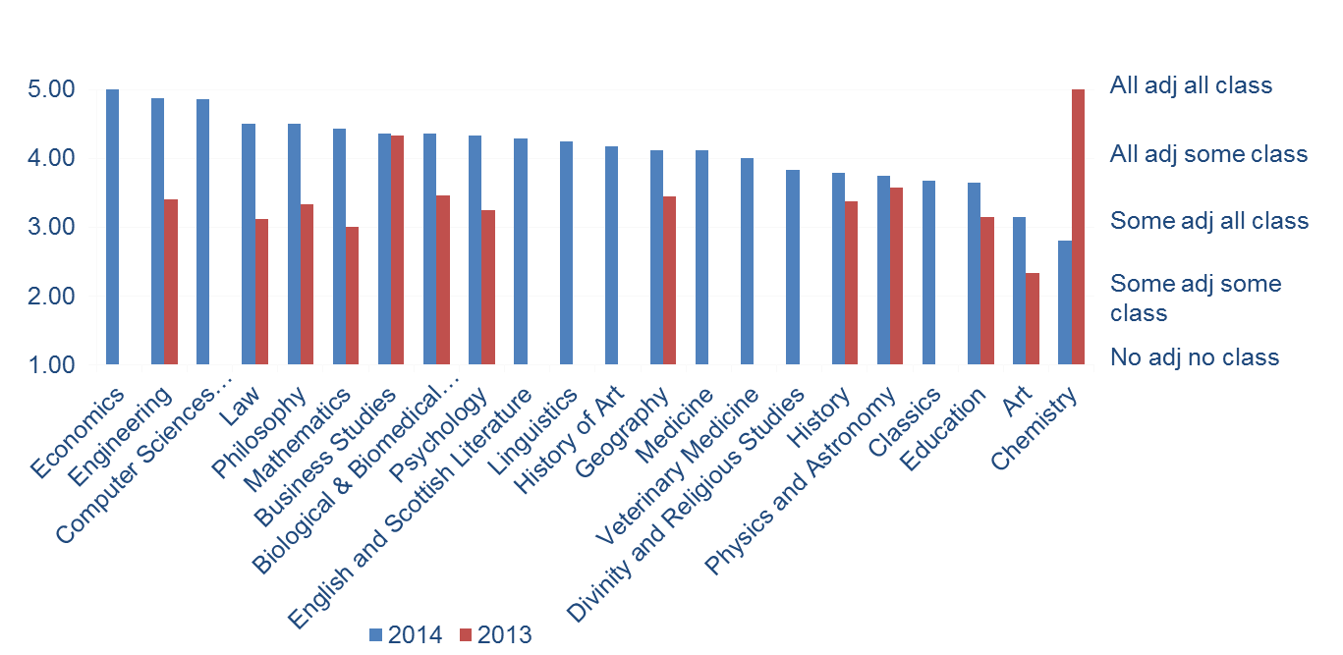

Satisfaction with Service
Best elements of the SDS

In 2014: 372 people answered, leaving 879 comments
Staff | 23%
The support/assistance provided | 15%
Help with exams | 7%
Accessibility of the Service | 6%
The assessment process | 5%

In 2013: 276 people answered, leaving 652 comments

Staff | 33% | 215 comments
The available support | 23% | 152 comments
Accessibility | 14% | 94 comments
That it works | 14% | 89 comments

In 2012: 318 people answered, leaving 752 comments

Staff | 35% | 264 comments
The available support | 14% | 106 comments
Accessibility | 10% | 77 comments
That it works | 10% | 73 comments

Elements of the SDS needing improvement

In 2014: 266 answered this, leaving 452 comments
- 15% related to the promotion of services and of SDS in general
- 14% to communications – mainly around setting expectation
- 10% with regards to the amount of time it takes to get something done
- 10% wanted some alternative help that wasn’t currently offered
- 8% thought the customer service could be improved
- 7% felt there could have been greater collaboration between SDS and the schools/colleges/academics
- 6% felt there could be more follow up

In 2013 210 people answered this question, leaving 357 comments:

Communications | 24% | 84 comments
Improvements to the Service | 24% | 67 comments
Promotion of the Service | 12% | 43 comments
Staff | 11% | 39 comments

In 2012 250 people answered this question, leaving 440 comments:

Communications | 15% | 64 comments
Staff | 13% | 56 comments
Improvements to the Service | 12% | 54 comments
More follow up is needed | 8% | 37 comments

If you had cause to complain were your complaints handled constructively?
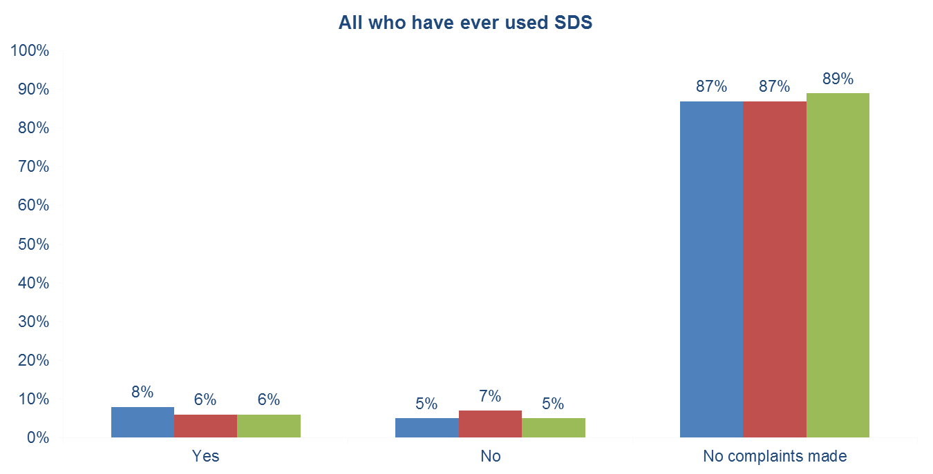

Complaints – open ended answers
142 people gave more detail on the nature of their complaint
- 42 of whom (30%) only said positive things
- 28 (20%) had interacted with SDS with regards to exam provision
- 17 (12%) due to adjustments that were (or weren’t) made
- 13 (9%) due to poor service
- 11 (8%) were unhappy at the lack of available slides prior to lectures

Overall Satisfaction
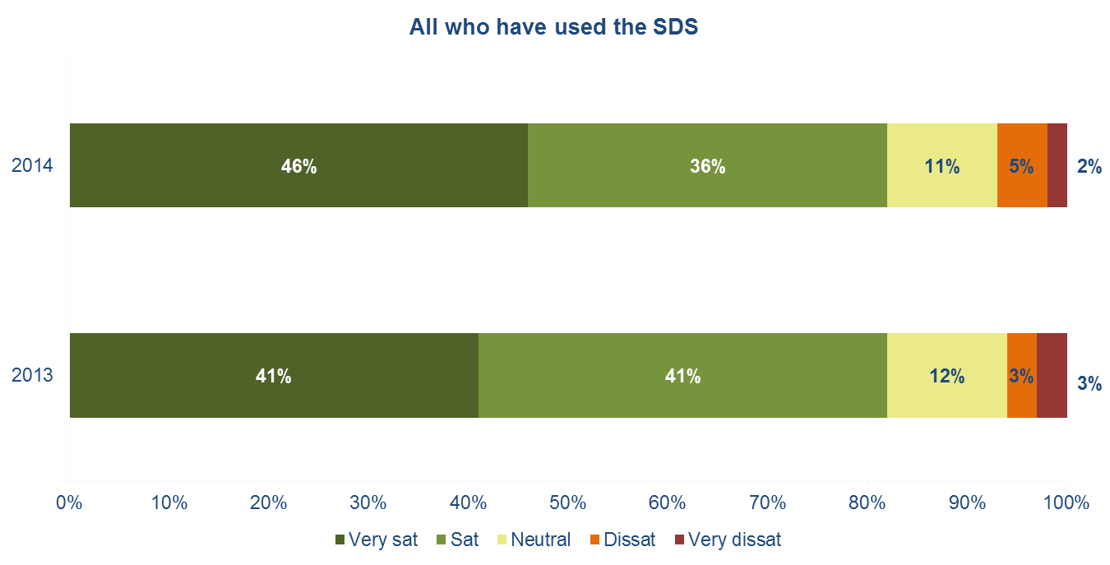

The work of the SDS has contributed positively to my educational experience at the University of Edinburgh
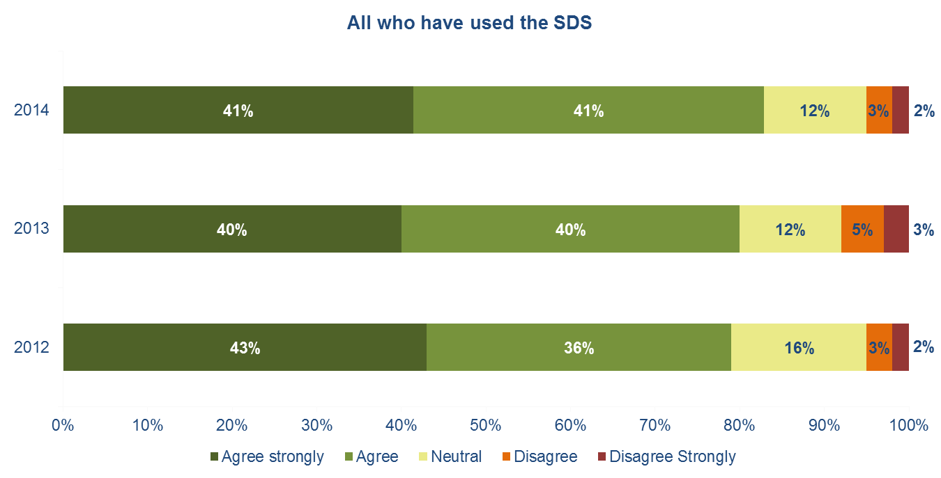

Accessible and Inclusive Learning Policy (AILP)

Awareness of the AILP
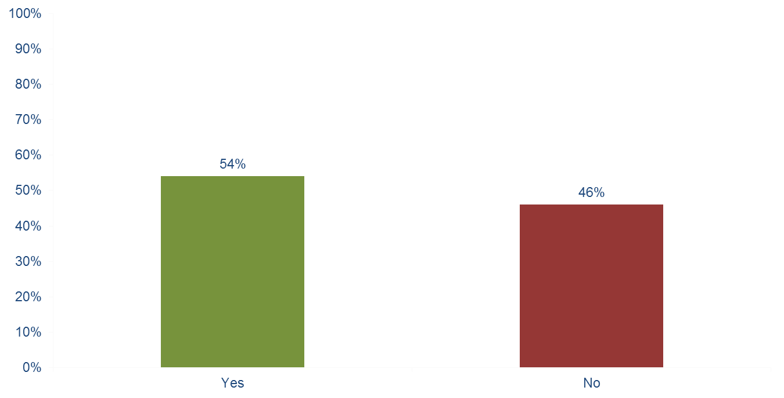

Impact of AILP on learning experience
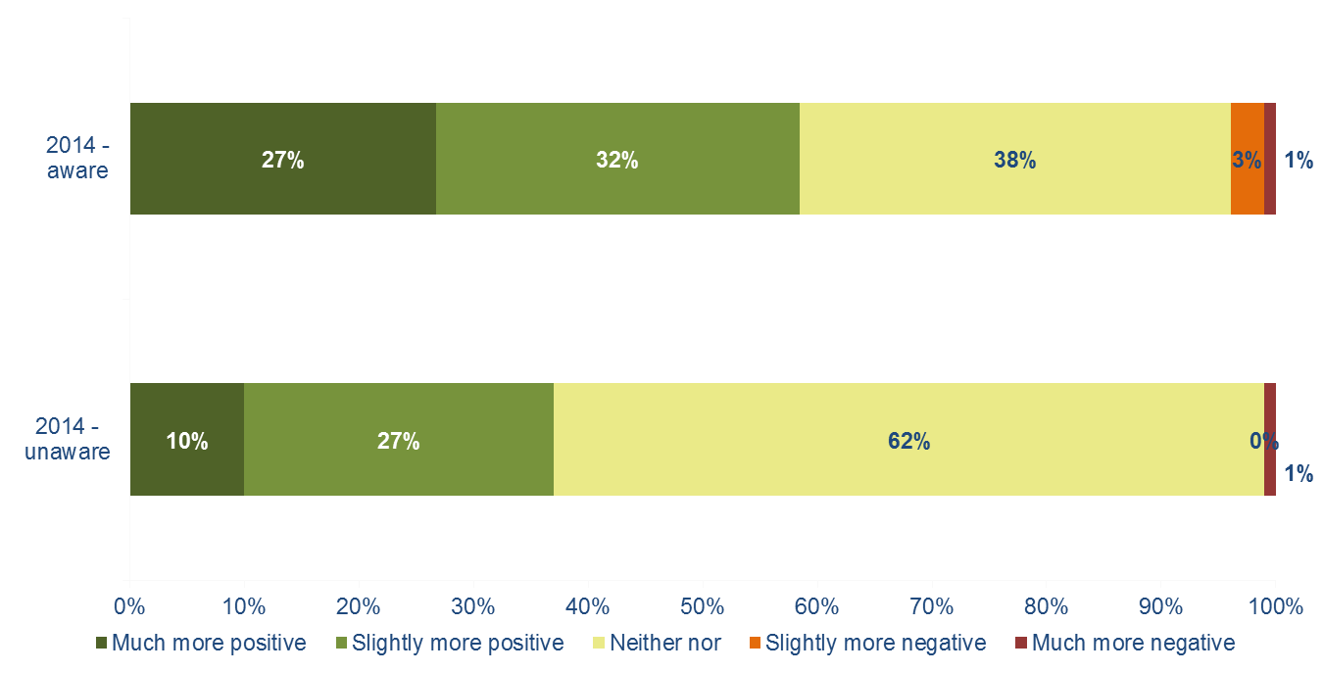

More details on impact of AILP
- 122 responses
- There are two major themes:

- The policy is helpful when followed
- The policy is not always followed
Summary and Recommendations

Summary - profile
- The respondents are broadly representative of those who are flagged as having a disability within the University
- However, compared to the University profile there may be slight under-representation in young people under 20yrs, males and students from outside the UK.

Summary - results
Overall
- 82% thought the SDS contributed positively to their life at UoE (no significant change from last year)
- However, only 50% had received all adjustments in all courses (8% increase from 2013, 1% increase from 2012)

Services
- Examination arrangement has the best awareness (91%) and is the most used (77%)
- Asperger's Syndrome student mentor service is the lowest awareness (10%) and is the least used service (9%)
- Slight dissatisfaction with study skills tutoring, support for applying for DSA, proofreading, and specific learning difficulties tutoring

Accessible and Inclusive Learning Policy (AILP)
- 54% had heard of it before
- 59% of those who had heard about it thought it had a positive impact on their learning experience (but only 37% of those who hadn’t)

Other
- Generally good satisfaction with staff
- Only few responses from those not using the service, but those who replied suggested communications could be improved and the offering to distance learners could be clearer

Recommendations
- Think about setting some performance indicators:
  - Number of people receiving all adjustments in all classes
  - Overall satisfaction
- Look at the provision for distance learners – is it enough / communicated well?
- Re-connect with schools to reinforce your service
- Send an email to all 1st telling them what you offer and to get in touch if they would like more information
- Promote the AILP wider
- Look at the verbatims and try and make some quick solutions to any problems arising

Appendix I: Demographics
Age
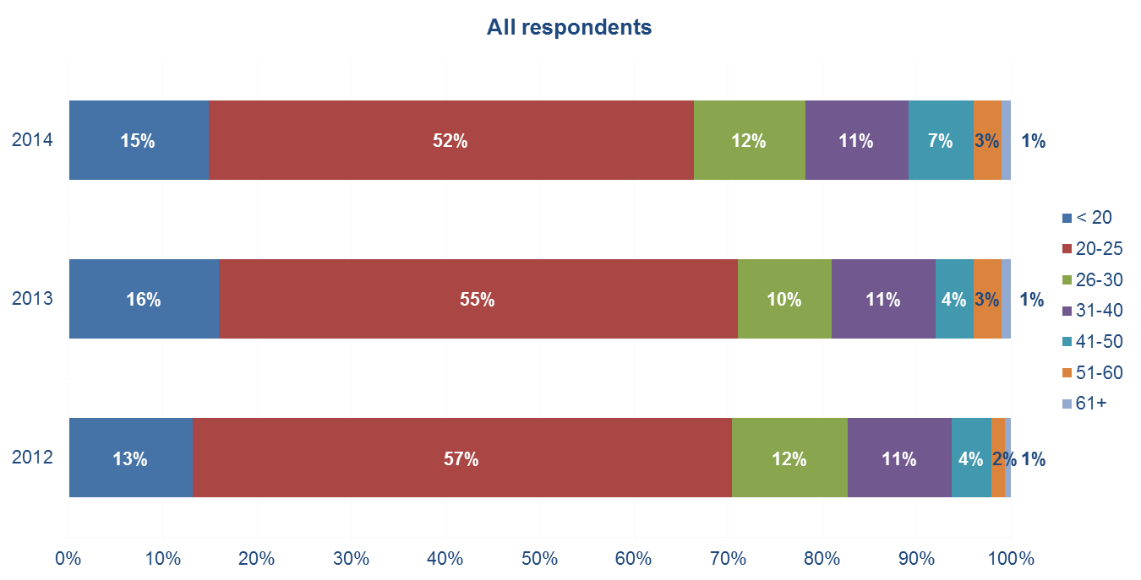
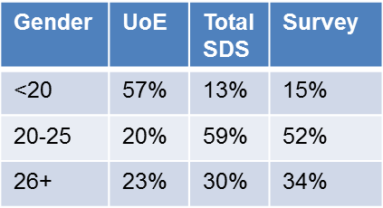
Gender split
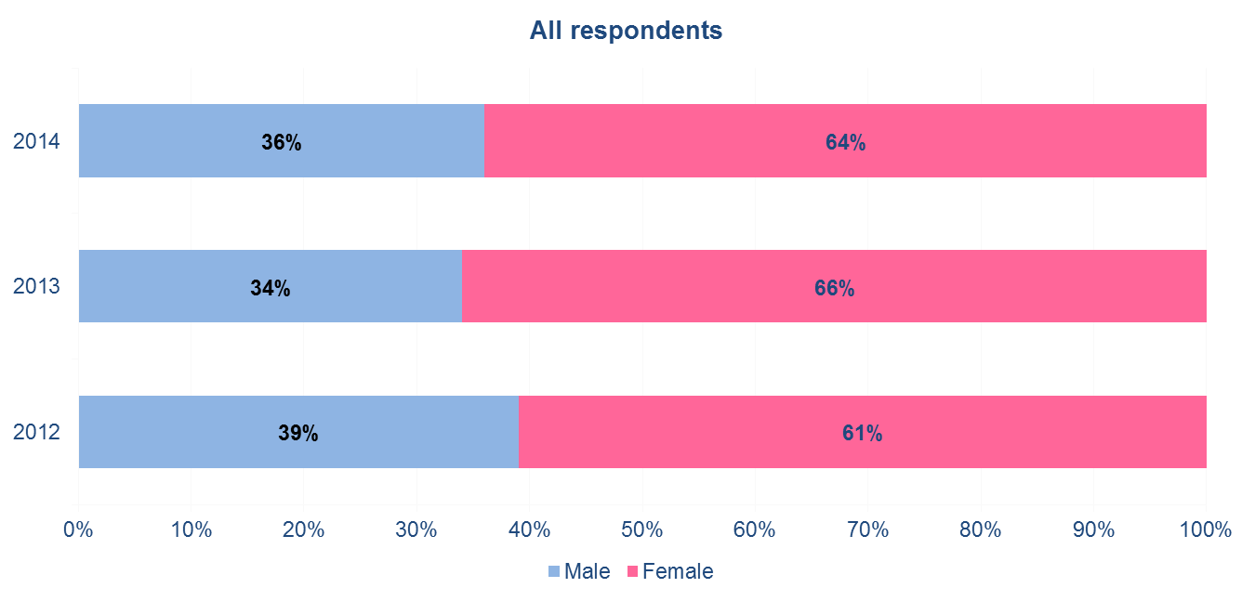
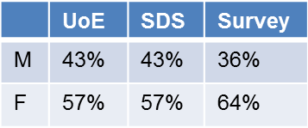
Nationality
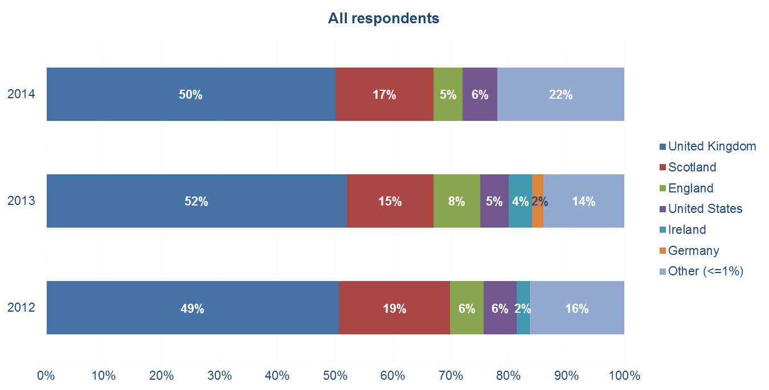
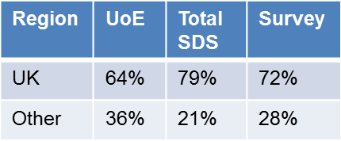

Subject area
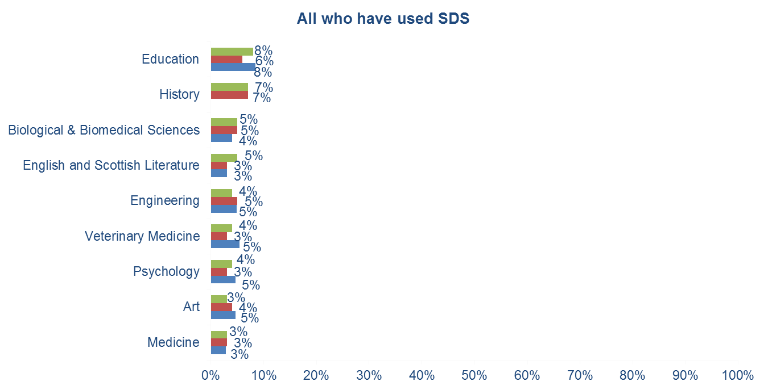
There are 35 other subject areas with =<2% and 6 with no representation

Degree level
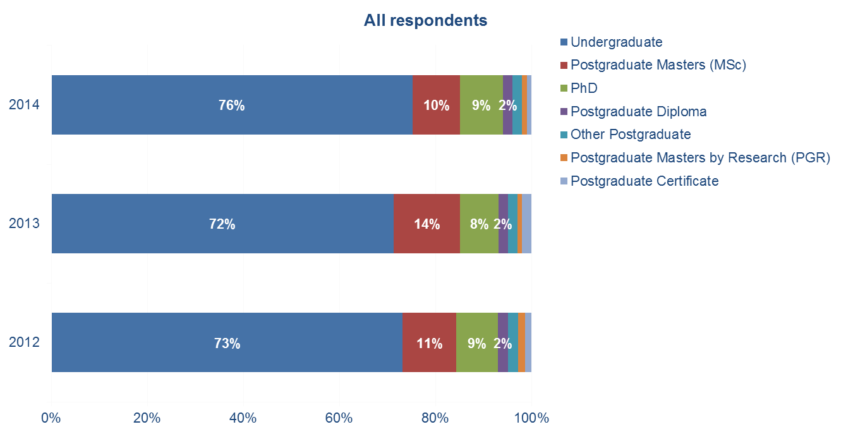
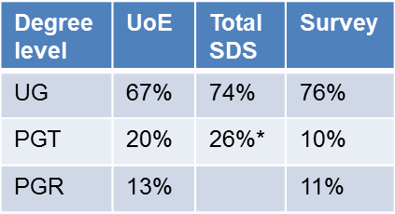
Year of Study
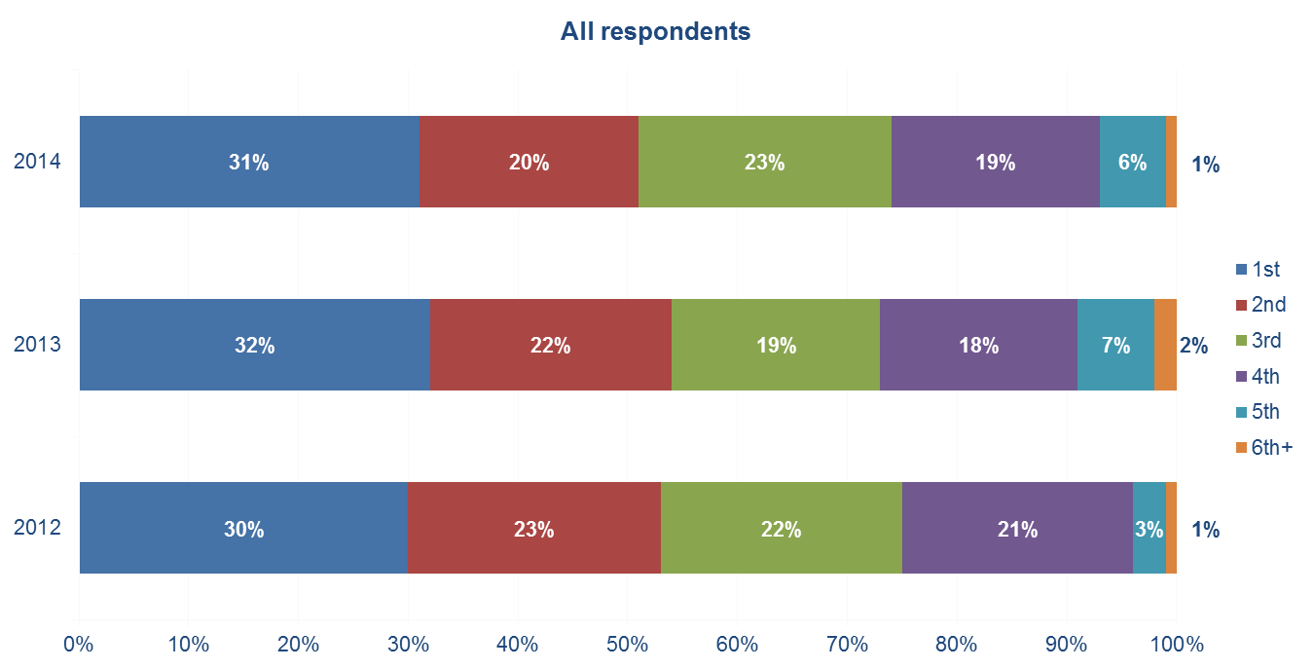

Appendix 2: The Questionnaire
