Knowledge, behaviours and attributes developed through a research degree

A guide to identifying knowledge, behaviours and personal attributes developed through a research degree.
The Researcher Development Framework (RDF), which articulates the knowledge, behaviours and attributes of researchers, provides a valuable tool to assist you to identify personal and professional development through your doctoral research.
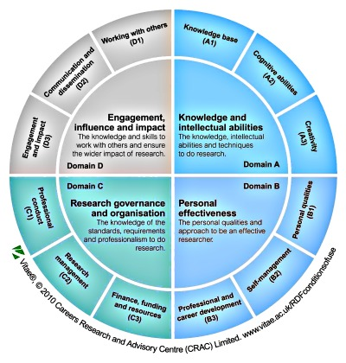
The RDF was developed by Vitae, a UK-wide organisation that supports career and professional development of researchers (www.vitae.ac.uk). It aims to assist researchers at all levels to evaluate and plan their own personal development. A personal development planner tool is available on the Vitae website by subscription to help identify strengths, action plan, review achievements and create a portfolio of evidence.
The knowledge, behaviours and attributes audit exercise for PhD students which follows, is based on an abbreviated RDF. This is designed to help you to recognise your strengths and to aid awareness of your development needs and goals. You can take stock of how you have been developing as a researcher by rating your confidence level for each of the descriptors provided. Space is provided to record specific evidence that illustrates your competence; this will be valuable when it comes to marketing yourself in your CV and at interviews.
Knowledge, behaviours and attributes audit exercise
- Rate yourself: Reflect honestly on your abilities and rate yourself from 1 – 4 (where 1= not at all confident I can do this and 4 = very confident I can do this).

- Highlight what you are good at: use a coloured font to highlight descriptors that you have rated at 3 or 4. This will help you to recognise your current strengths. It is worth also reflecting which of these gives you most satisfaction.

- Record evidence of your strengths: make a note of some specific examples which you could use to illustrate your competence in job applications and at interviews.

- Identify areas for development: review areas where you feel less confident and, if appropriate, consider steps you could take to develop your confidence e.g. by attending a related course, or discussion with your supervisor.

 | Rate Yourself  (1 low – 4 high) |  |  |  | Evidence
 | 1 | 2 | 3 | 4 | Record examples illustrating your strengths
Knowledge and intellectual abilities

Cognitive abilities

Can critically analyse and evaluate own findings and those of others
Sees connections between own research and previous studies
Critically synthesises complex information from diverse sources
Recognises a range of problems, and can formulate and apply solutions
Creativity

Willingness and ability to learn and acquire knowledge
Identifies and ask useful and challenging questions
Creates ideas and opportunities by investigating / seeking information
Exercises critical judgement to create new or imaginative ways of understanding
Structures arguments clearly and concisely, producing evidence in defence of ideas
Is willing to expose ideas to a critical audience and to critically appraise other research
Knowledge base

Understands own and related areas of research, the advances within them
Knowledge of appropriate research methodologies and ability to apply them appropriately
Can identify and access suitable sources of information, assessing reliability and relevance
Ability to record, manage and handle information / data using appropriate software
Can write in a style appropriate to purpose for specialist and non-specialist audience
Understands and applies any statistics used in research area
Personal effectiveness

Personal qualities

Able to stay motivated and enthusiastic even when work is mundane
Perseveres in face of obstacles and demonstrates resilience
Understands and demonstrates standards of good research practice, acting with professional integrity
Shows confidence in defending ideas in the face of challenge from others
Seeks and takes personal feedback on performance and acts on it
Takes responsibility for own project, demonstrating independence
Self-management

Prepares, plans and prioritises project to meet objectives
Shows dedication and determination in developing own research
Manages own time effectively to deliver projects on schedule
Demonstrates flexibility when dealing with the unexpected and adapts approach when necessary
Professional and career development

Seeks opportunities for professional and career development
Shows awareness of own skills and attributes, and identifies ways to improve employability
Develops and uses networks effectively for feedback and advice on work and to seek out opportunities
Research governance and organisation

Professional conduct

Understands, respects and applies appropriately policies relevant for own area of work, e.g. health and safety, ethics
Understands data ownership rules as they apply to research, ie. IPR and copyright
Research management

Has understanding of broader context of research in strategy of the institution and discipline area
Applies effective project management through setting research goals, defining milestones and prioritising activities
Can identify and manage risks associated with project
Finance, funding and resources

Understands the processes for funding and evaluation of research, and awareness of relevant funding sources
Knowledge of financial management systems and manages own grant
Engagement, influence and impact

Working with others

Gives and receives feedback appropriately
Recognises impact on others when working in a team and able to contribute to team success
Manages relationships with supervisor and peers, and negotiates to set clear expectations of them and others
Effectively supports learning and advises others when appropriate, for example through teaching or demonstrating
Demonstrates ability to influence and lead, by communicating confidently and convincingly
Can build collaborative relationships with colleagues and stakeholders to benefit research and to maximise impact
Communication and dissemination

Constructs coherent arguments and articulates ideas clearly to a range of audiences, formally and informally
Can persuade effectively, asking timely and appropriate questions
Can produce high quality academic writing
Engagement and impact

Engages with and shares research through research-informed and student-focused teaching
Contributes to increasing public awareness, engagement and understanding of research
Is enterprising, creates ideas and identifies opportunities for commercial exploitation of research
Recognises and understands the wider impact of research on society, and is keen to make a contribution

