VATA-ADL
Version for PATIENTS

Instructions to researchers:
This questionnaire for patients should be completed independently of the caregiver version, on the same day where possible. Patients and caregivers should not discuss their responses with each other before the end of the testing phase.
Place each item in front of the respondent. If necessary, point to the stimuli or rating scale when/where appropriate. For each item, read aloud the entire question or just the core action. Emphasize that the question is about their current difficulties and repeat it if necessary. Read the following instructions to the patient while the practice item is on view:

“You will be asked to tell me how well you can currently perform day to day activities. Each activity will be illustrated by a picture. I will read each question aloud and the question is also written at the top of the sheet. You will be asked to rate what you think is, or would be, your difficulty now in performing each activity. Below each picture there is a rating scale. Please state your difficulty by stating, or poiting to, a number from 0 (no problem, if you can perform this activity without any difficulty) to 3 (problem, if you would have serious difficulties with this activity and you would not be able to perform it). You can also provide the responses simply by pointing to the rating scale where appropriate. Let's try an example.”

Item scoring:
Examine the participant and caregiver scores for the four check items:
- Items 4 and 13: These scores should be 0 or 1. If any other scores are given, please disregard the questionnaire and note on the datasheet that this questionnaire could not be included because of failure to answer the check questions correctly.
- Items 9 and 19: These scores should be 2 or 3. If any other scores are given, please disregard the questionnaire and note on the datasheet that this questionnaire could not be included because of failure to answer the check questions correctly.

Sum the scores from the six experimental items for each subscale, patient and caregiver versions, and add to the participant data sheet:
- Self-care items ( 2, 3, 8, 14, 18, 21)
- Activities inside the home (6, 10, 12, 15, 20, 22)
- Activities outside the home (1, 5, 7, 11, 16, 17)

VATA-ADL scoring.
Sum the scores for all 18 experimental items (excluding the control questions) for the patient version and for the caregiver version. Total scores should be bewteen 0 and 54. Add these to the participant datasheet. Subtract the patient’s total score from the caregiver’s total score to provide a caregiver-patient discrepancy value. Add this score (raging form -54 to + 54) to the participant datasheet.

Discrepancy scores interepretation.
Discrepancy scores closer to 0 indicate general agreement between patient’s and caregiver’s evaluation. Negative discrepancy scores indicate patients’ underestimation of their abilities; positive discrepancy scores indicate patients’ overestimation of their abilties.
Discrepancy socres below -6.8 or over + 6.8 indicate pathological underestimaiton or overestimation of own abilities, respectively. Discrepacny score between the two cut-offs indicate a normal performance.
VATA-ADL

TEST MATERIAL FOR PATIENTS

Does/Would you have difficulty doing the washing up?

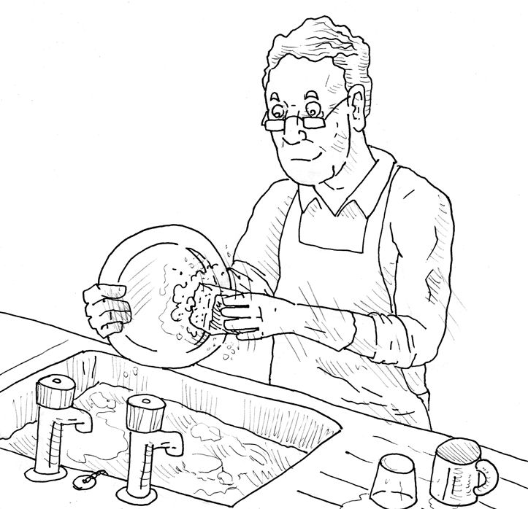

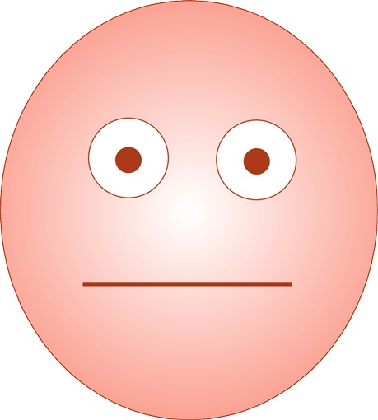
No Problem Problem

0 ---------- 1 ---------- 2 ---------- 3

Example Question

Do/Would you have difficulty getting in and out of the car?

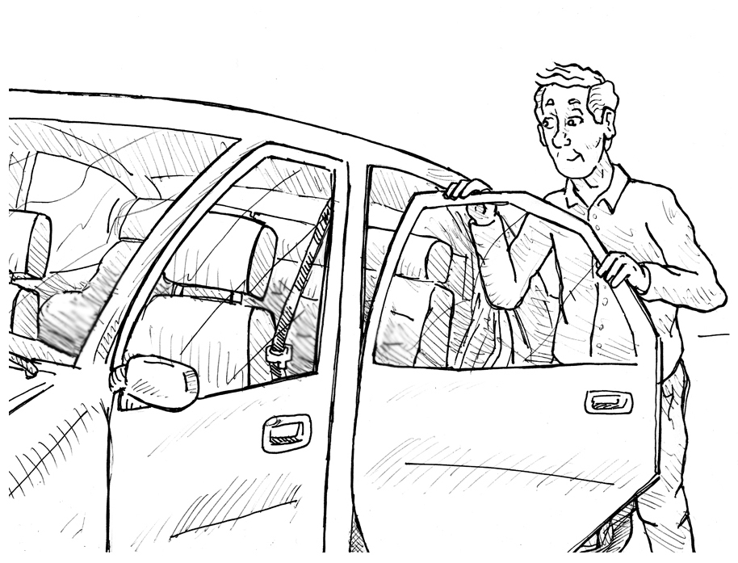

No Problem Problem

0 ---------- 1 ---------- 2 ---------- 3

Question 1

Do/Would you have difficulty feeding yourself?

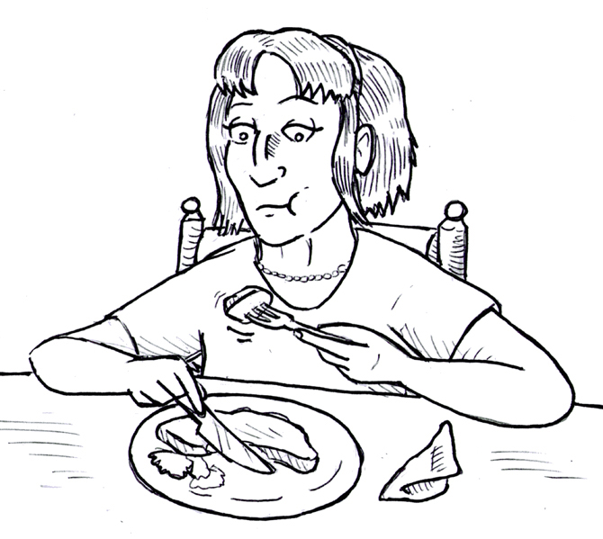

No Problem Problem

0 ---------- 1 ---------- 2 ---------- 3

Question 2

Do/Would you have difficulty washing your face?

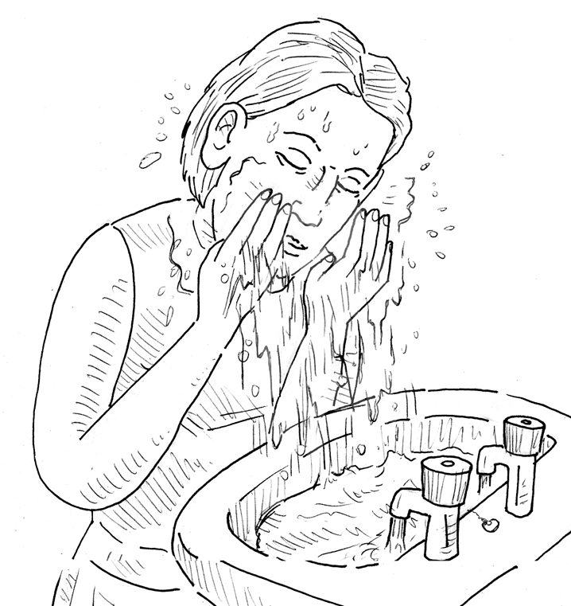

No Problem Problem

0 ---------- 1 ---------- 2 ---------- 3

Question 3

Do/Would you have difficulty hearing a loud speaker?

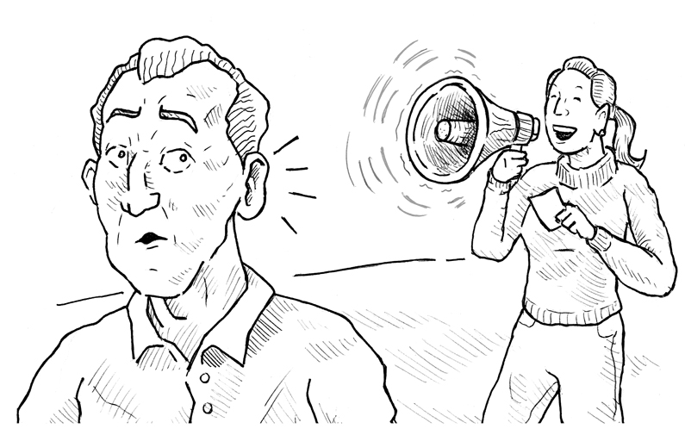

No Problem Problem

0 ---------- 1 ---------- 2 ---------- 3

Question 4

Do/Would you have difficulty managing money?

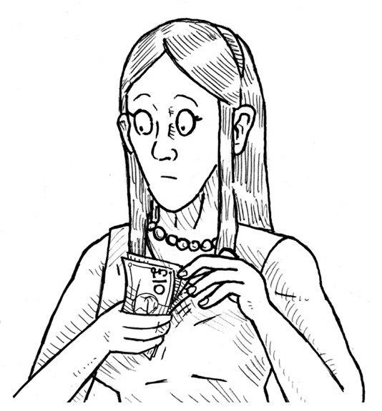

No Problem Problem

0 ---------- 1 ---------- 2 ---------- 3

Question 5

Do/Would you have difficulty writing letters?

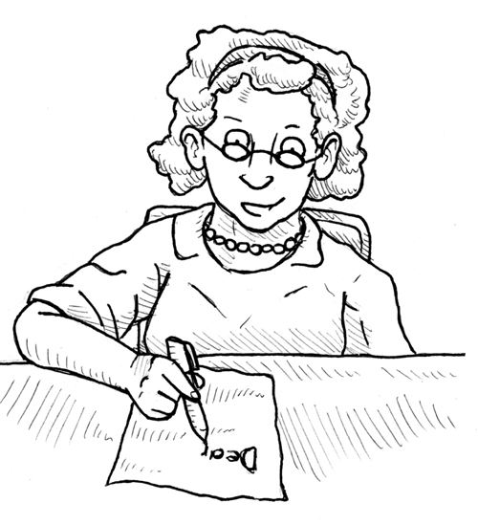

No Problem Problem

0 ---------- 1 ---------- 2 ---------- 3

Question 6

Do/Would you have difficulty crossing the road?

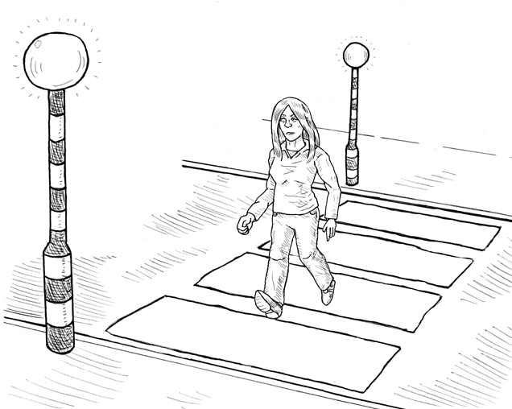

No Problem Problem

0 ---------- 1 ---------- 2 ---------- 3

Question 7

Do/Would you have difficulty taking a bath or shower?

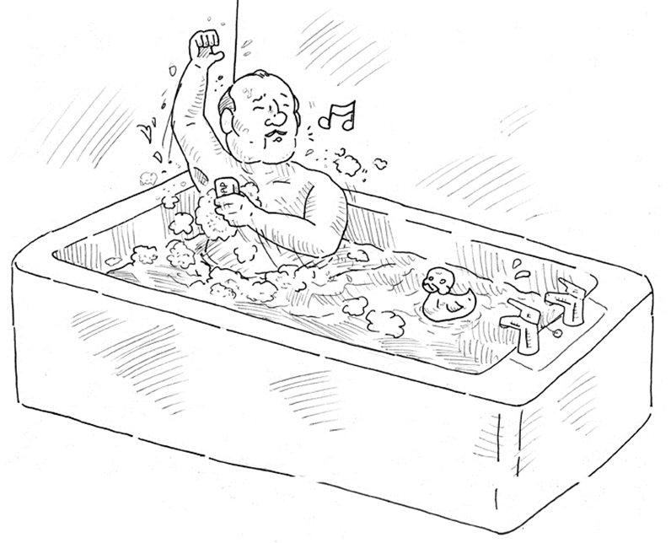

No Problem Problem

0 ---------- 1 ---------- 2 ---------- 3

Question 8

Do/Would you have difficulty pulling a lorry?

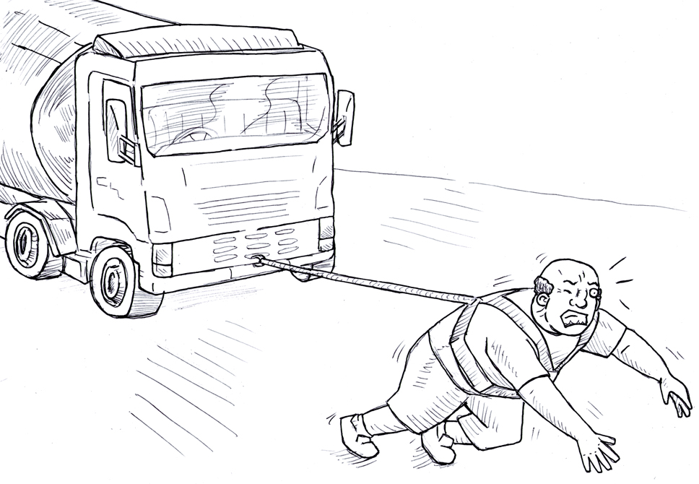
No Problem Problem

0 ---------- 1 ---------- 2 ---------- 3

Question 9

Do/Would you have difficulty making yourself hot drinks?

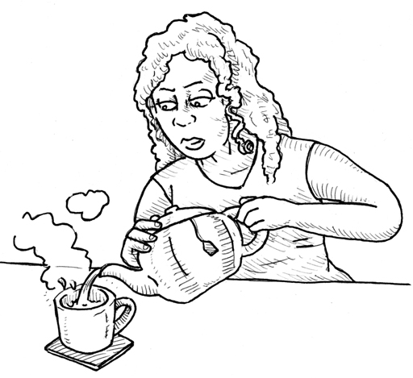

No Problem Problem

0 ---------- 1 ---------- 2 ---------- 3

Question 10

Do/Would you have difficulty travelling on public transport?

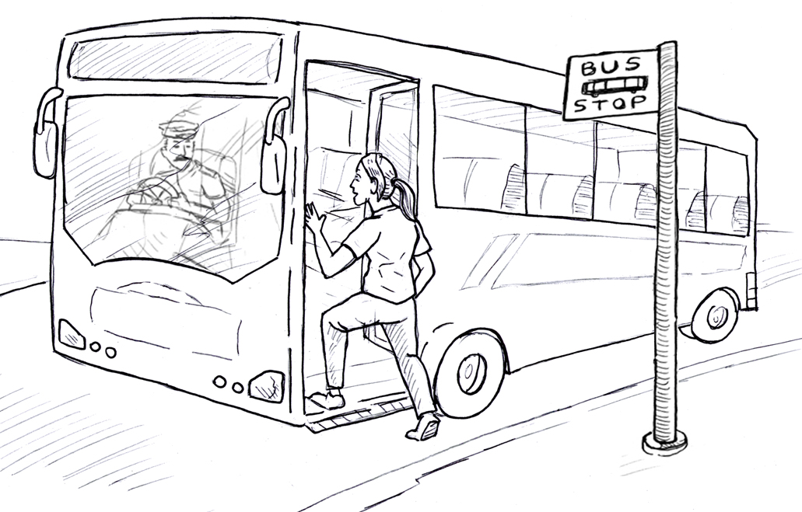

No Problem Problem

0 ---------- 1 ---------- 2 ---------- 3

Question 11

Do/Would you have difficulty using the telephone?

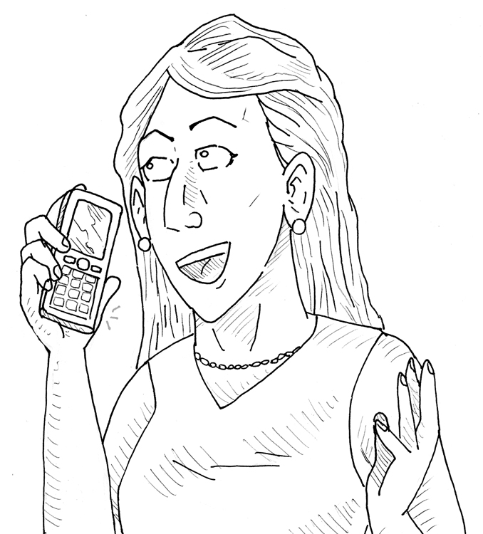

No Problem Problem

0 ---------- 1 ---------- 2 ---------- 3

Question 12

Do/Would you have difficulty recognising yourself in the mirror?

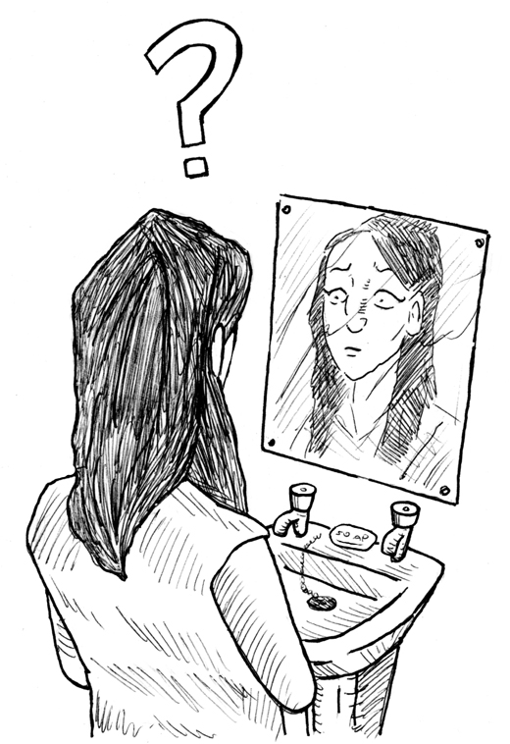

No Problem Problem

0 ---------- 1 ---------- 2 ---------- 3

Question 13

Do/Would you have difficulty getting dressed and undressed?

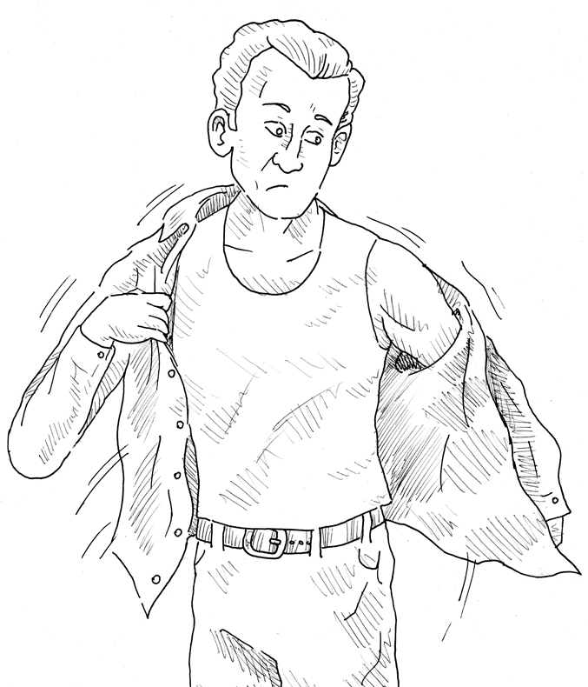

No Problem Problem

0 ---------- 1 ---------- 2 ---------- 3

Question 14

Do/Would you have difficulty making yourself a hot snack?

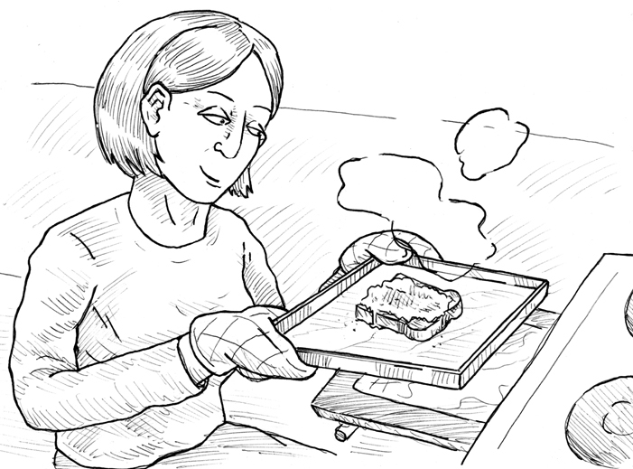

No Problem Problem

0 ---------- 1 ---------- 2 ---------- 3

Question 15

Do/Would you have difficulty doing your shopping?

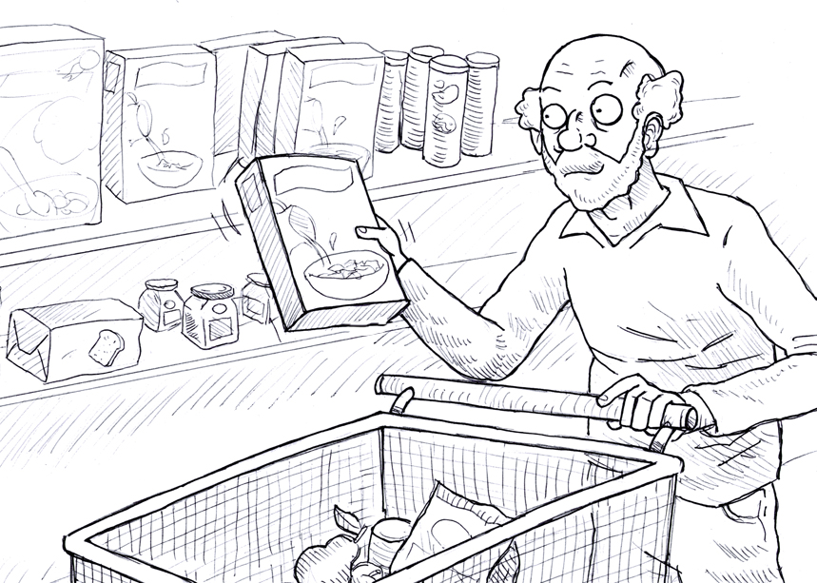

No Problem Problem

0 ---------- 1 ---------- 2 ---------- 3

Question 16

Do/Would you have difficulty going out socially?

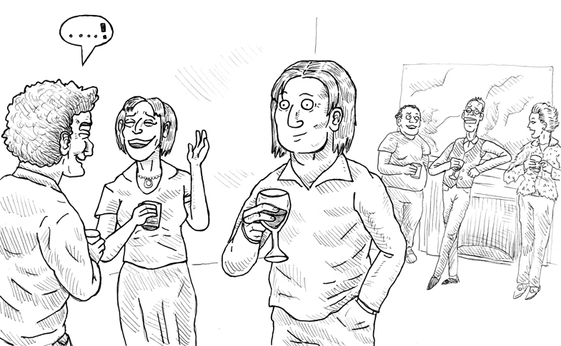

No Problem i Problem

0 ---------- 1 ---------- 2 ---------- 3

Question 17

Do/Would you have any problem combing your hair?

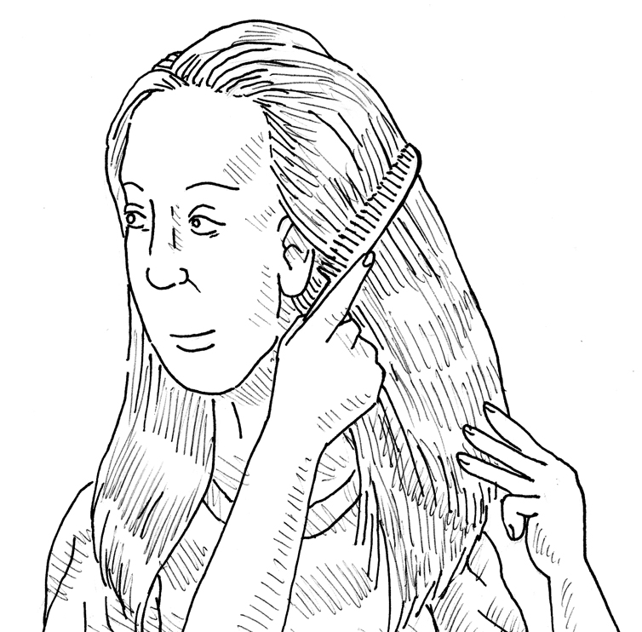

No Problem Problem

0 ---------- 1 ---------- 2 ---------- 3

Question 18

Do/Would you have difficulty swinging on a trapeze?

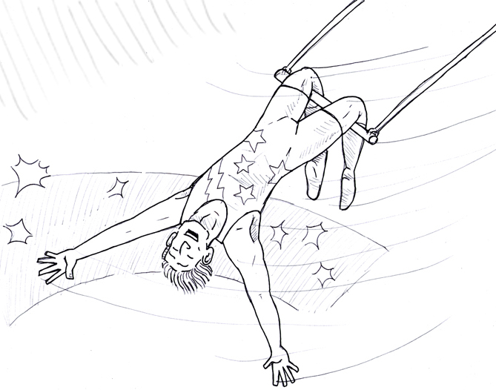
No Problem Problem

0 ---------- 1 ---------- 2 ---------- 3

Question 19

Do/Would you have difficulty watering plants?

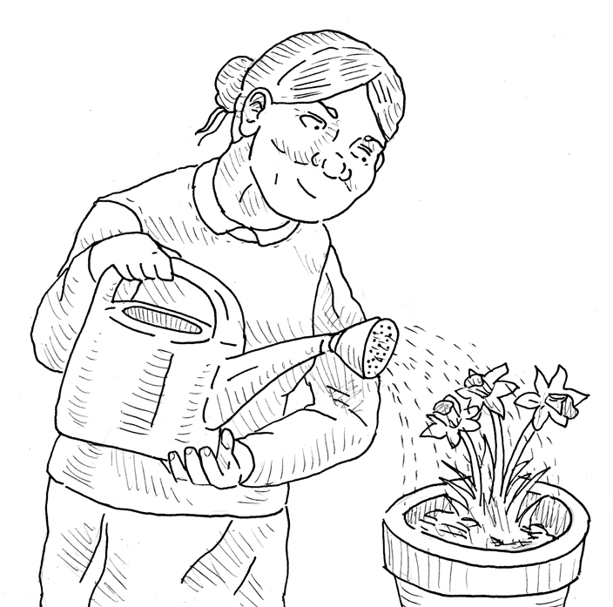

No Problem Problem

0 ---------- 1 ---------- 2 ---------- 3

Question 20
Do/Would you have difficulty taking your medication?

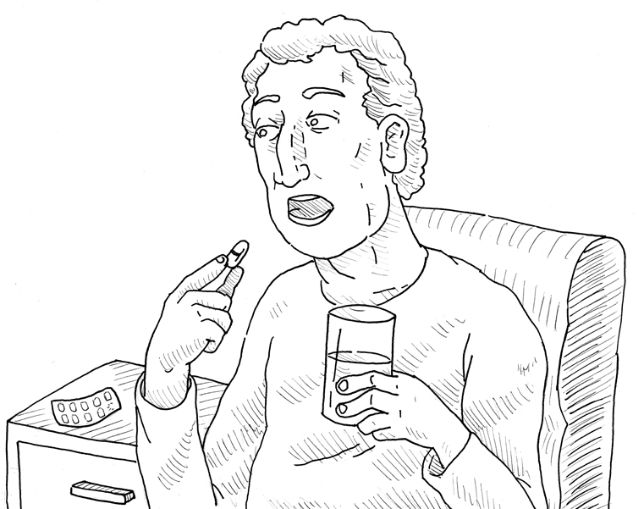

No Problem Problem

0 ---------- 1 ---------- 2 ---------- 3

Question 21

Do/Would you have difficulty reading the newspaper?

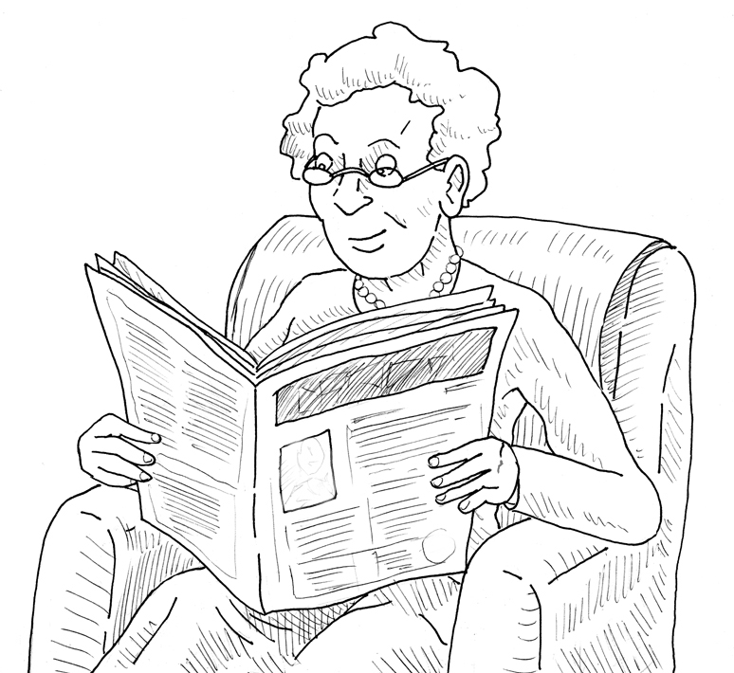

No Problem Problem

0 ---------- 1 ---------- 2 ---------- 3

Question 22

