VATA-ADL
Version for CAREGIVERS

Instructions to researchers:
This questionnaire for caregivers should be completed independently of the patient version, on the same day where possible. Patients and caregivers should not discuss their responses with each other before the end of the testing phase.
Caregivers can complete their version of the VATA-ADL without the researcher being present, provided they demonstrate understanding of the questionnaire. If there is doubt about their ability to follow the questionnaire instructions, please assist them as follows.
Place each item in front of the respondent. If necessary, point to the stimuli or rating scale when/where appropriate. For each item, read aloud the entire question or just the core action. Emphasize that the question is about the patient’s current difficulty and repeat it if necessary. Read the following instructions to the caregiver while the practice item is on view:

“You will be asked to tell me how well your family member or friend can currently perform day to day activities. Each activity will be illustrated by a picture. I will read each question aloud and the question is also written at the top of the sheet. You will be asked to rate what you think is, or would be, his or her ability now in performing each activity. Below each picture there is a rating scale. Please state his or her ability by stating a number from 0 (no problem, he or she can perform this activity without any difficulty) to 3 (he or she would have such serious difficulty with this activity that he or she would not be able to perform it). You can also provide the responses simply by pointing to the rating scale where appropriate. Let's try an example.”

Item scoring:
Examine the participant and caregiver scores for the four check items:
- Items 4 and 13: These scores should be 0 or 1. If any other scores are given, please disregard the questionnaire and note on the datasheet that this questionnaire could not be included because of failure to answer the check questions correctly.
- Items 9 and 19: These scores should be 2 or 3. If any other scores are given, please disregard the questionnaire and note on the datasheet that this questionnaire could not be included because of failure to answer the check questions correctly.

Sum the scores from the six experimental items for each subscale, patient and caregiver versions, and add to the participant data sheet:
- Self-care items ( 2, 3, 8, 14, 18, 21)
- Activities inside the home (6, 10, 12, 15, 20, 22)
- Activities outside the home (1, 5, 7, 11, 16, 17)

VATA-ADL scoring.
Sum the scores for all 18 experimental items (excluding the control questions) for the patient version and for the caregiver version. Total scores should be bewteen 0 and 54. Add these to the participant datasheet. Subtract the patient’s total score from the caregiver’s total score to provide a caregiver-patient discrepancy value. Add this score (raging form -54 to + 54) to the participant datasheet.

Discrepancy scores interepretation.
Discrepancy scores closer to 0 indicate general agreement between patient’s and caregiver’s evaluation. Negative discrepancy scores indicate patients’ underestimation of their abilities; positive discrepancy scores indicate patients’ overestimation of their abilties.
Discrepancy socres below -6.8 or over + 6.8 indicate pathological underestimaiton or overestimation of own abilities, respectively. Discrepacny score between the two cut-offs indicate a normal performance.
VATA-ADL

TEST MATERIAL FOR CAREGIVERS

Does/Would s/he have difficulty doing the washing up?

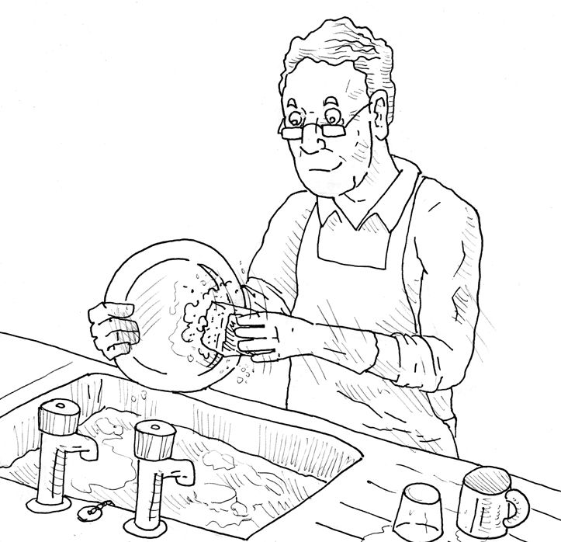

No Problem Problem

0 ---------- 1 ---------- 2 ---------- 3

Example Question

Does/Would s/he have difficulty getting in and out of the car?

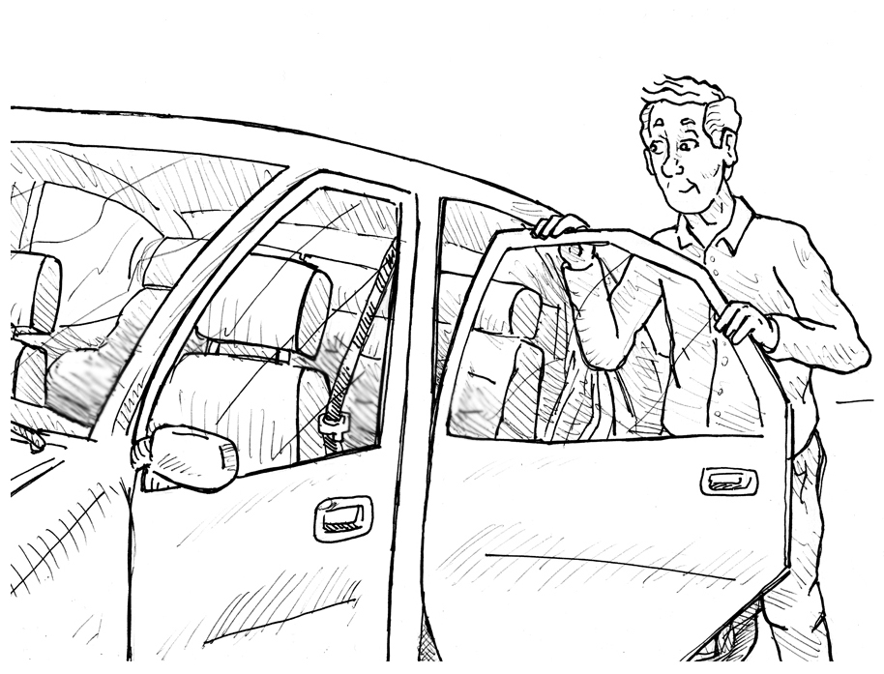

No Problem Problem

0 ---------- 1 ---------- 2 ---------- 3

Question 1

Does/Would s/he have difficulty feeding yourself?

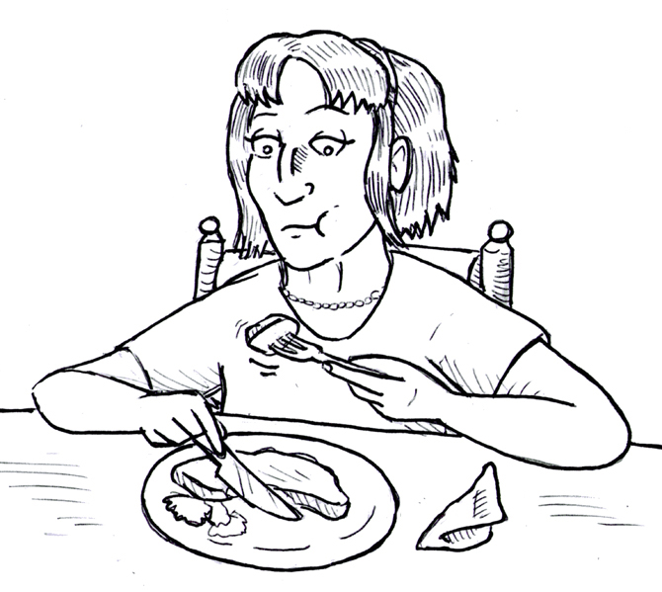

No Problem Problem

0 ---------- 1 ---------- 2 ---------- 3

Question 2

Does/Would s/he have difficulty washing your face?

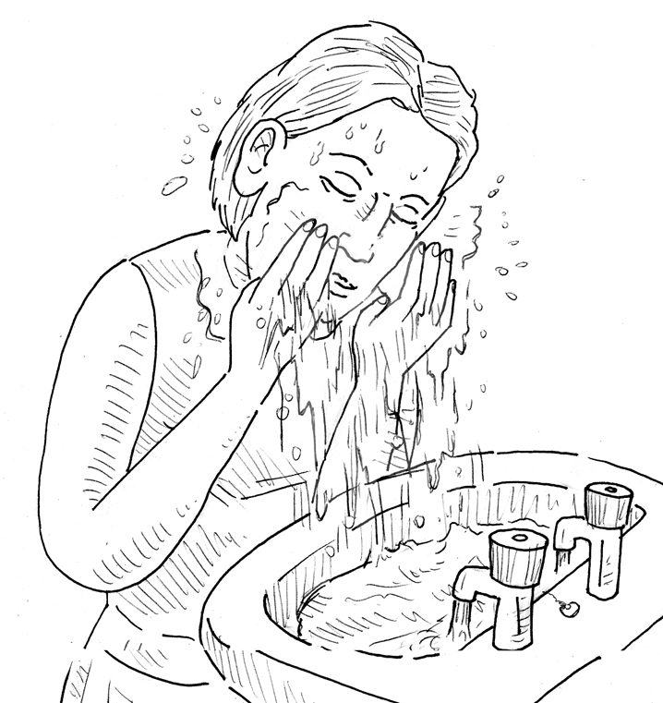

No Problem Problem

0 ---------- 1 ---------- 2 ---------- 3

Question 3

Does/Would s/he have difficulty hearing a loud speaker?

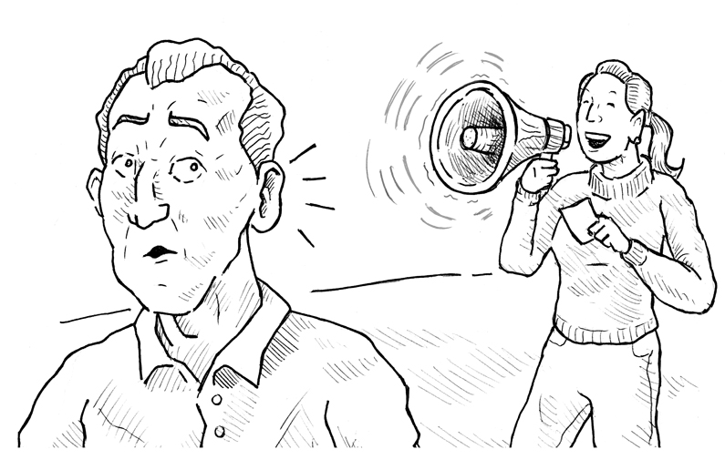

No Problem Problem

0 ---------- 1 ---------- 2 ---------- 3

Question 4

Does/Would s/he have difficulty managing money?

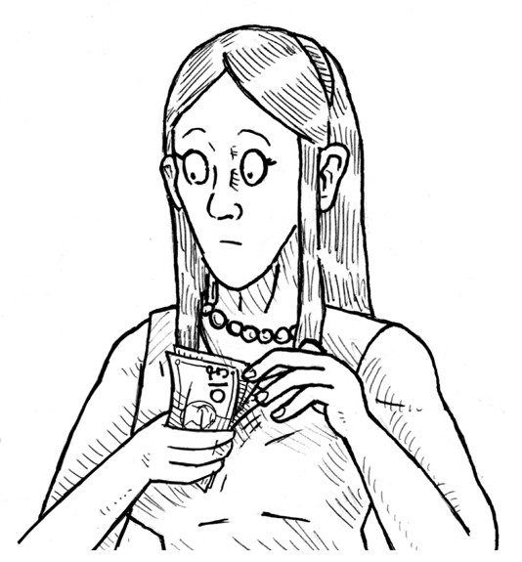

No Problem Problem

0 ---------- 1 ---------- 2 ---------- 3

Question 5

Does/Would s/he have difficulty writing letters?

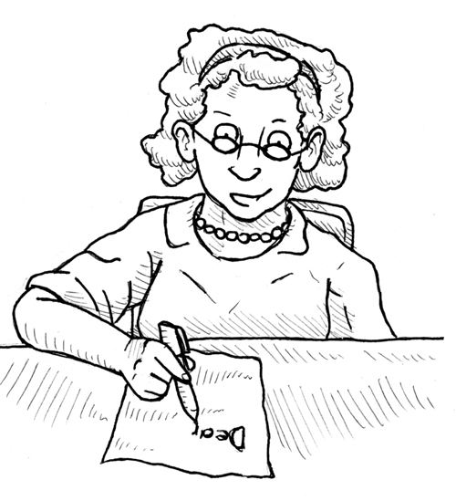

No Problem Problem

0 ---------- 1 ---------- 2 ---------- 3

Question 6

Does/Would s/he have difficulty crossing the road?

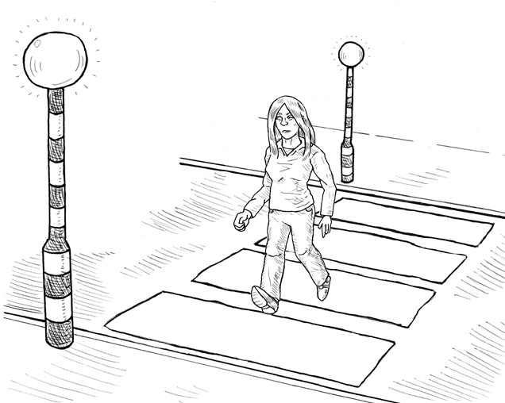

No Problem Problem

0 ---------- 1 ---------- 2 ---------- 3

Question 7

Does/Would s/he have difficulty taking a bath or shower?

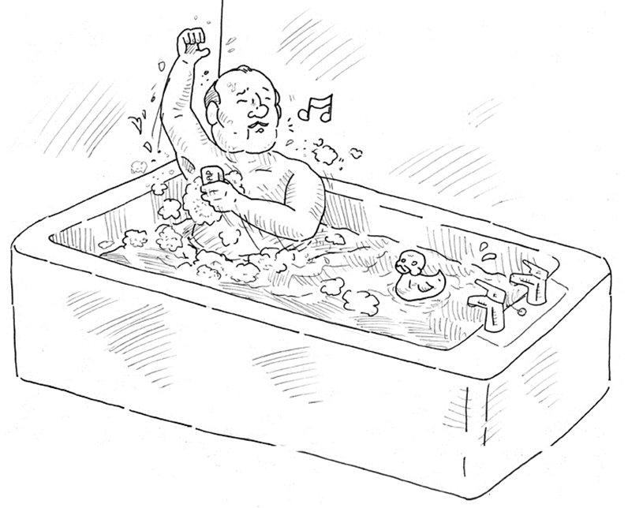

No Problem Problem

0 ---------- 1 ---------- 2 ---------- 3

Question 8

Does/Would s/he have difficulty pulling a lorry?

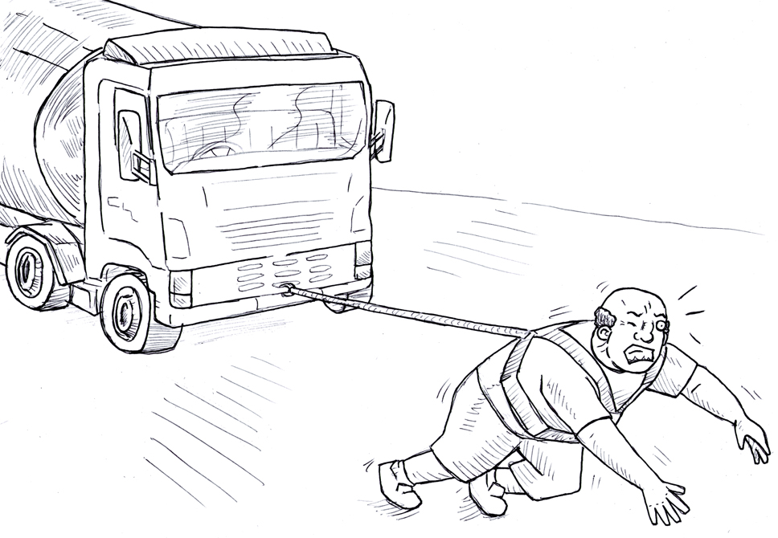
No Problem Problem

0 ---------- 1 ---------- 2 ---------- 3

Question 9

Does/Would s/he have difficulty making her/himself hot drinks?

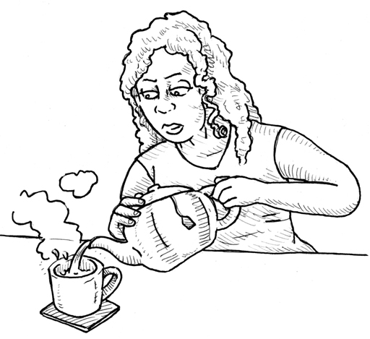

No Problem Problem

0 ---------- 1 ---------- 2 ---------- 3

Question 10

Does/Would s/he have difficulty travelling on public transport?

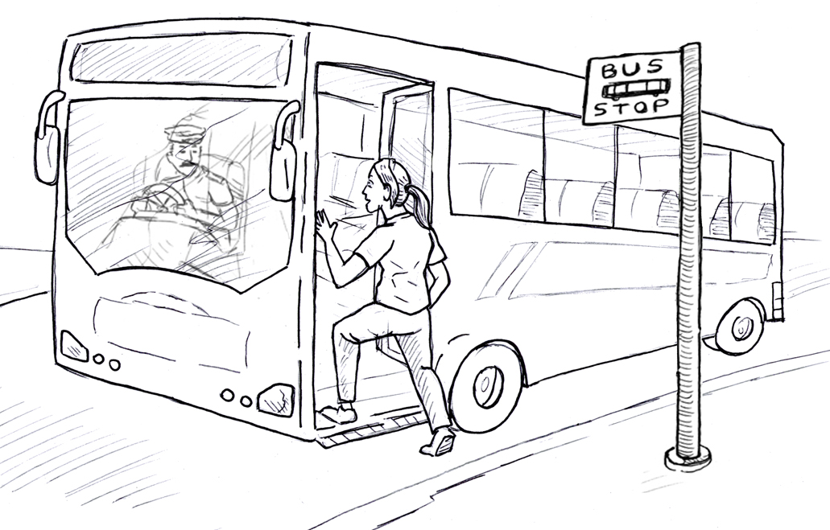

No Problem Problem

0 ---------- 1 ---------- 2 ---------- 3

Question 11

Does/Would s/he have difficulty using the telephone?

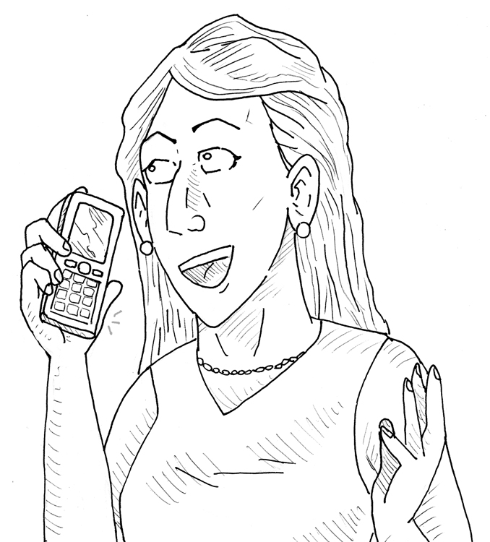

No Problem Problem

0 ---------- 1 ---------- 2 ---------- 3

Question 12

Does/Would s/he have difficulty recognising her/himself in the mirror?

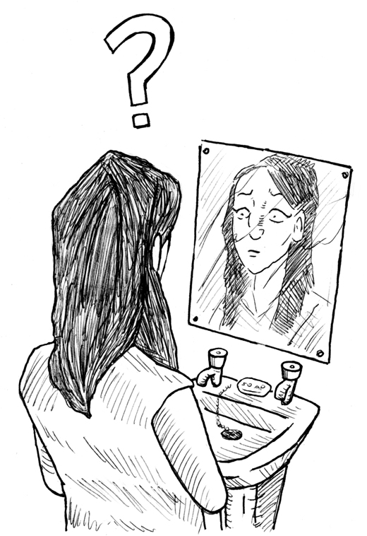

No Problem Problem

0 ---------- 1 ---------- 2 ---------- 3

Question 13

Does/Would s/he have difficulty getting dressed and undressed?

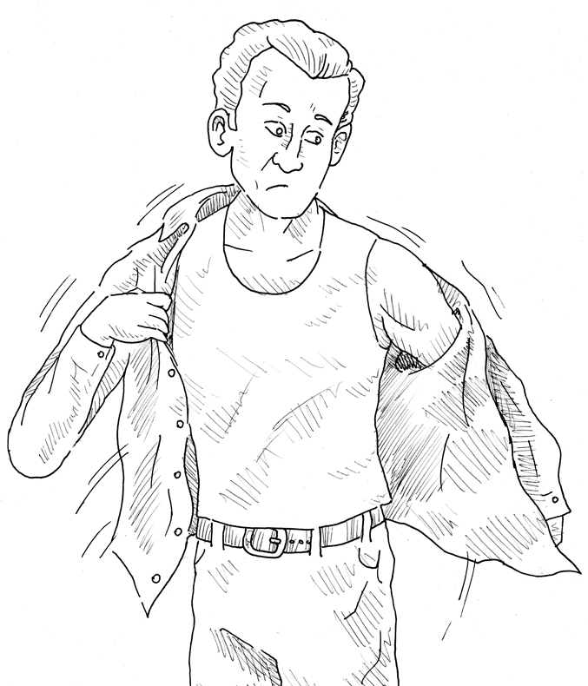

No Problem Problem

0 ---------- 1 ---------- 2 ---------- 3

Question 14

Does/Would s/he have difficulty making her/himself a hot snack?

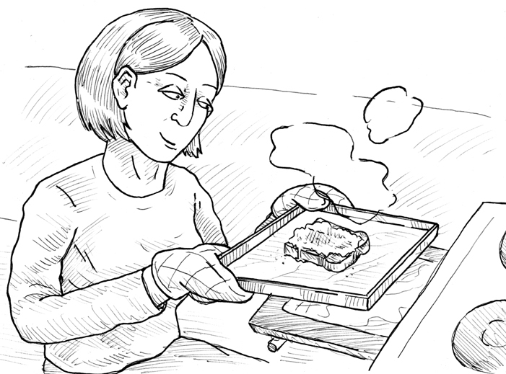

No Problem Problem

0 ---------- 1 ---------- 2 ---------- 3

Question 15

Does/Would s/he have difficulty doing their shopping?

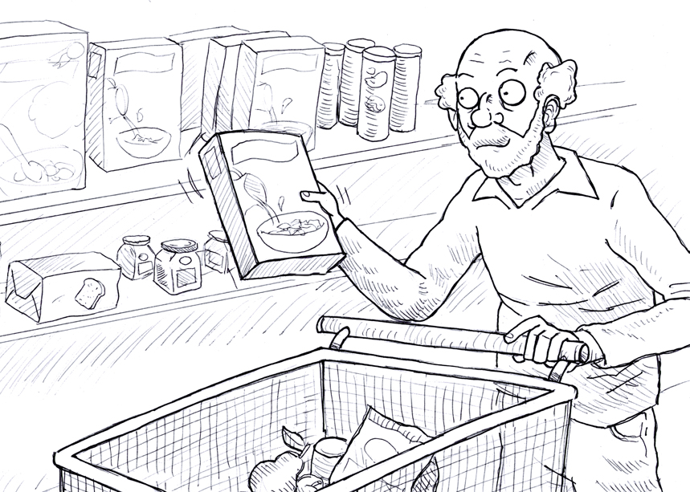

No Problem Problem

0 ---------- 1 ---------- 2 ---------- 3

Question 16

Does/Would s/he have difficulty going out socially?

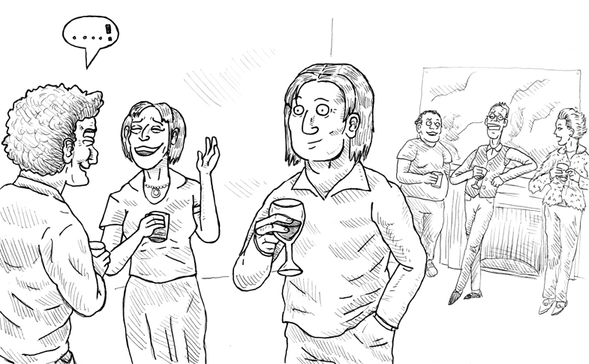

No Problem Problem

0 ---------- 1 ---------- 2 ---------- 3

Question 17

Does/Would s/he have any problem combing their hair?

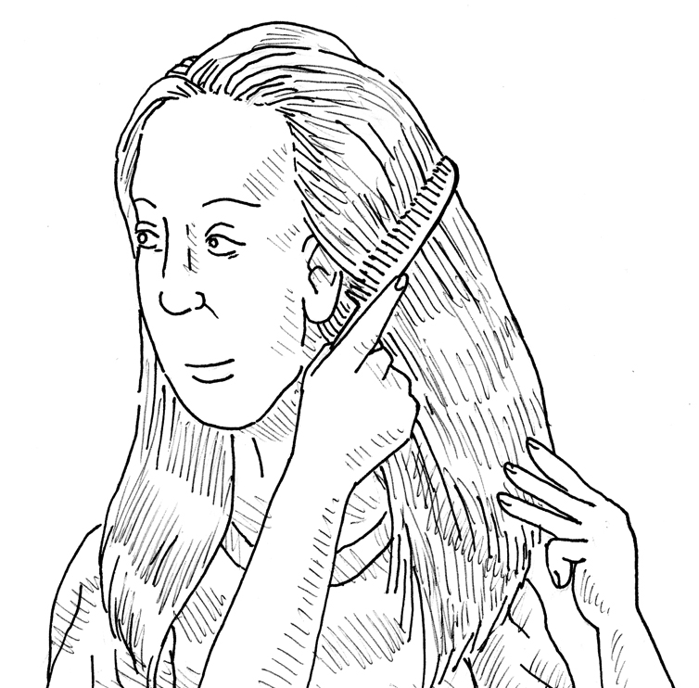

No Problem Problem

0 ---------- 1 ---------- 2 ---------- 3

Question 18

Does/Would s/he have difficulty swinging on a trapeze?

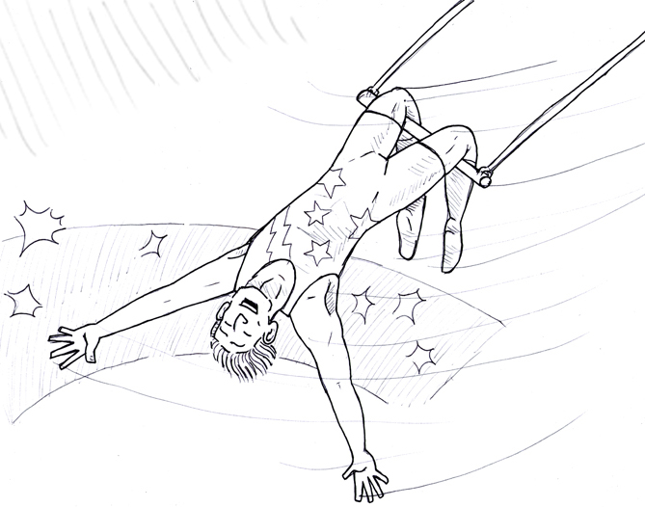
No Problem Problem

0 ---------- 1 ---------- 2 ---------- 3

Question 19

Does/Would s/he have difficulty watering plants?

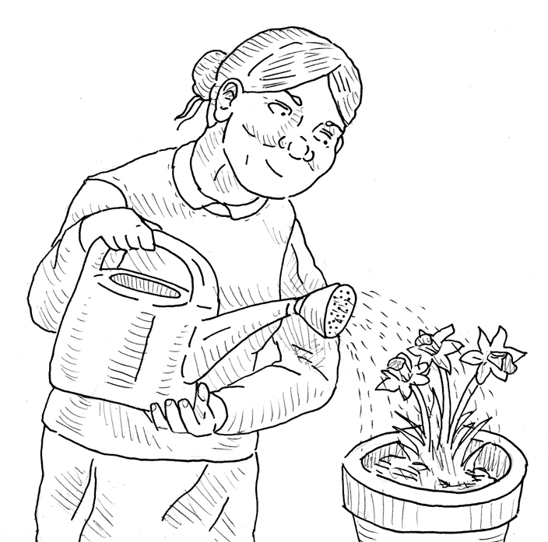

No Problem Problem

0 ---------- 1 ---------- 2 ---------- 3

Question 20
Does/Would s/he have difficulty taking their medication?

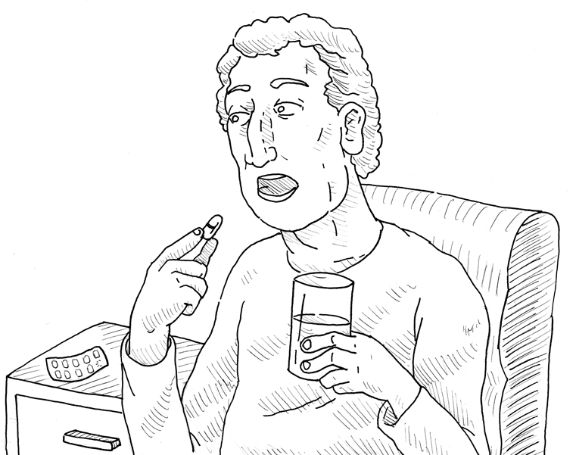

No Problem Problem

0 ---------- 1 ---------- 2 ---------- 3

Question 21

Does/Would s/he have difficulty reading the newspaper?

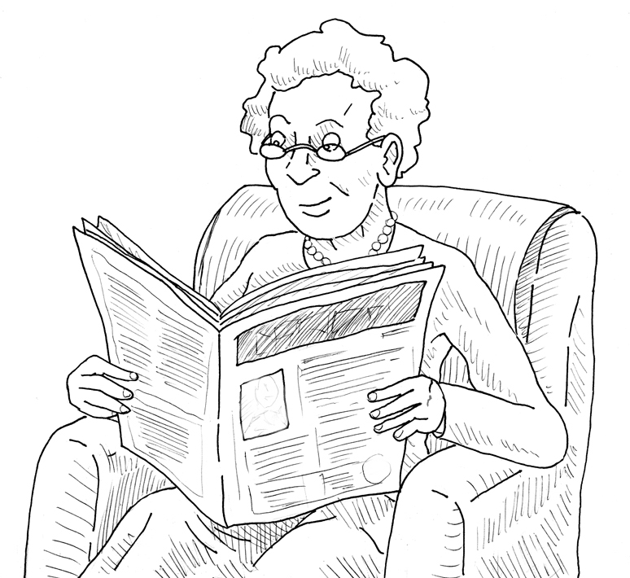

No Problem Problem

0 ---------- 1 ---------- 2 ---------- 3

Question 22

