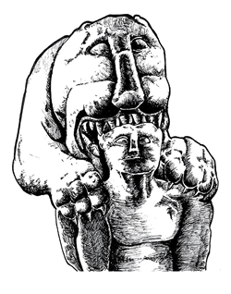
TRAC 2018 (Theoretical Roman Archaeology Conference)
Edinburgh, 12th -14th April 2018

CALL FOR PAPER FORM
Title of the Paper
Speaker Information | Name, affiliation and email of the speaker/s.
Session

Abstract
300 words max

Bibliography
Please provide recent relevant publications

Specific requirements
Please provide a description of your equipment or support needs

