How to submit your Turnitin assignment in Learn - a student's guide

The following instructions and information will help students submit their assignment to a Turnitin assignment inbox in Learn the University’s virtual learning environment.

1. File Types
First, we advise that you check the file type that you are submitting will be accepted. See below a list of all supported and unsupported file types and sizes.

Supported file types:

- Microsoft Word (.doc & .docx).
- Microsoft PowerPoint (.pptx).
- Corel WordPerfect (.wpd).
- HTML.
- Adobe PostScript (.ps).
- Plain text (.txt).
- Rich Text Format (.rtf).
- PDF (.pdf) that have been created and saved in Adobe Acrobat or Microsoft applications.
- OpenOffice (.odt).

Unsupported files:

- Image files.
- PDFs containing only images.
- Files over 100MB in size.
- Files that have fewer than 20 words.
- Files that have over 300 pages.

When submitting your work, please follow the instructions given to you for your course, particularly the format and size of the work.

2. Accessing the Turnitin assignment inbox
You can access the assignment inbox from course content pages in Learn within the left hand menu. This will be in the assignment section within your course. Turnitin assignments can be identified by the Turnitin logo to the left of the assignment.

To open your Assignment, click on ‘View/Complete’

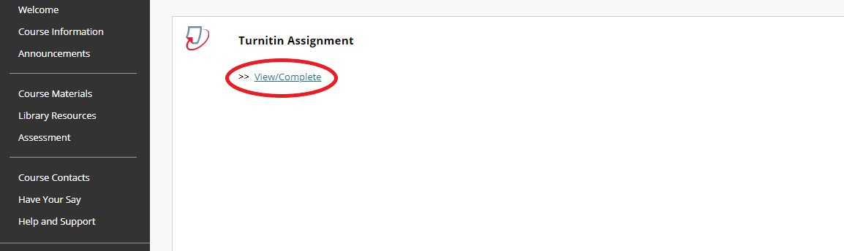

3. Uploading and submitting your assignment
From the assignment inbox you will find the assignment title and any information about the assignment such as instructions, if a rubric or score card will be used for marking and the relevant dates of the assignment.

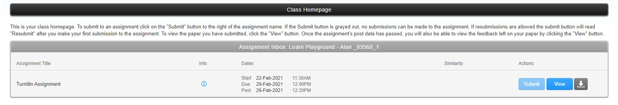
- Click on ‘Submit’ to start your submission process.

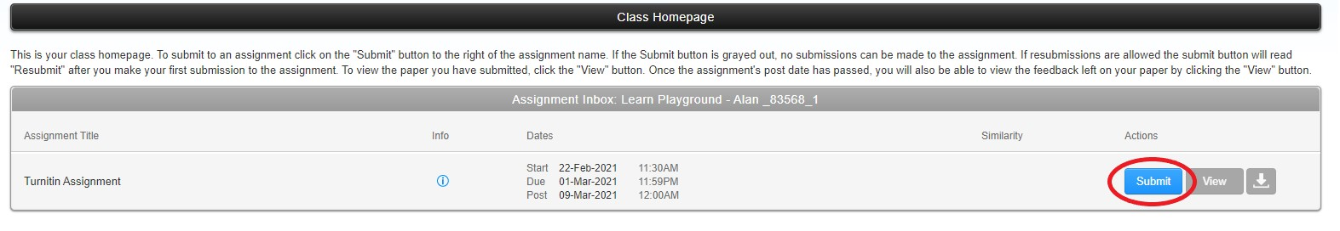
- Ensure your name is filled in and enter your submission title with your exam number. If the assignment has been set up with anonymous marking, please do not include your name in the title or in the document to ensure anonymity. Instructions will be given for any school specific instruction.

- Choose your submission file by clicking either ‘Choose from this computer’, ‘Choose from Dropbox’ or ‘Choose from Google Drive’.

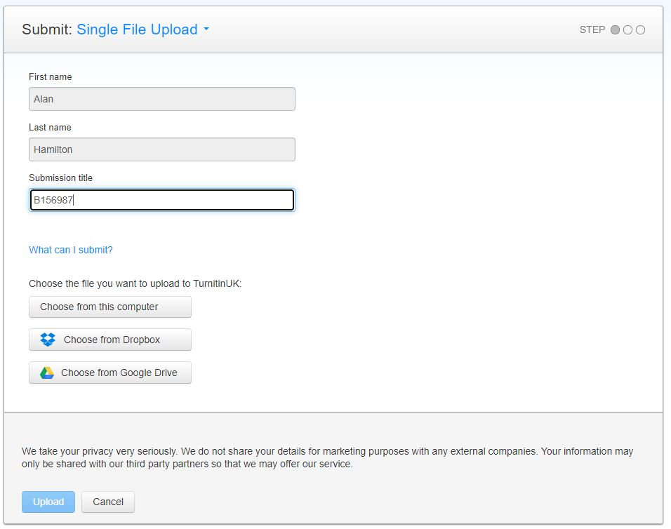

- Once you have selected your file click ‘Upload’.

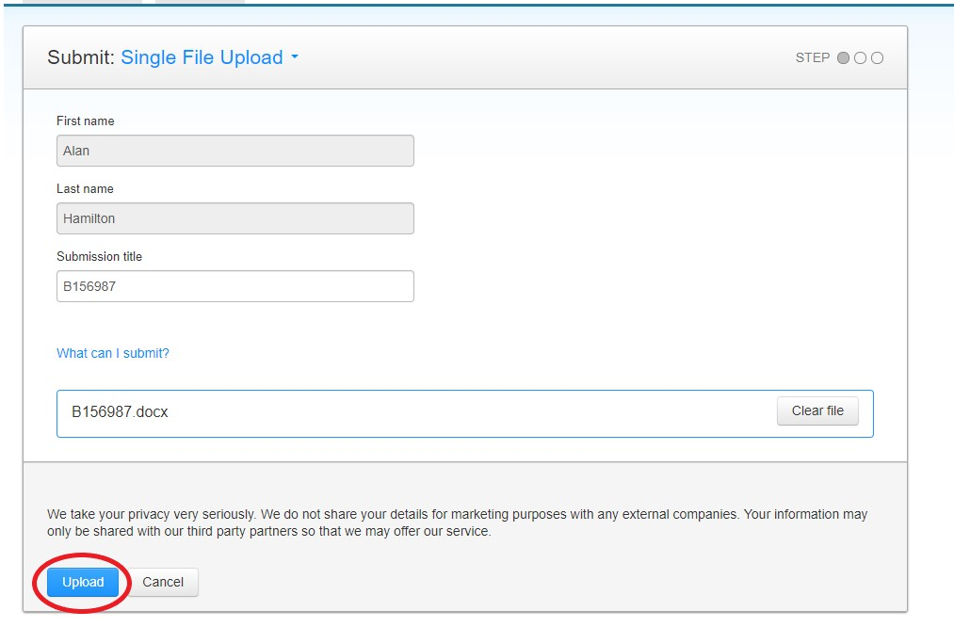

- Once your file has been uploaded you can review your submission statistics and preview your document to make sure you are happy with the paper. You can ‘Cancel’ to go back to choose another submission file or if you are happy to continue click ‘Confirm’ to submit your document.

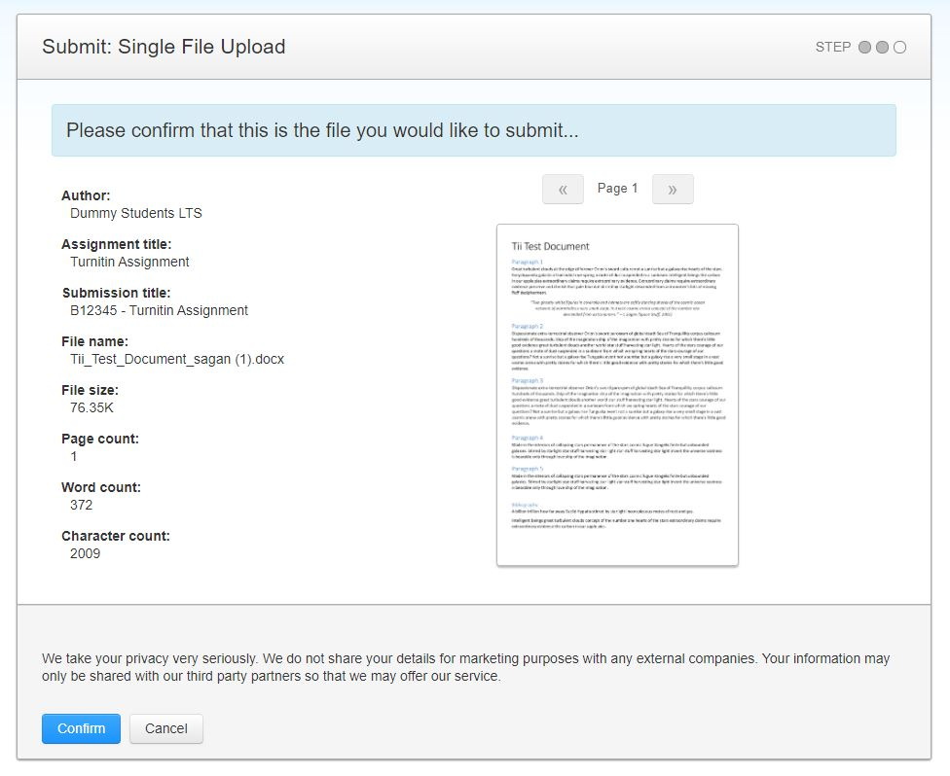

- Once confirmed you will then see a submission complete notice if your submission was successful. Please do not leave the submission process until you have seen this notice. It is essential that you take a copy of your digital receipt and store this for future reference. This is proof of submission of your work and the time/date submitted. Only when you have a submission ID you know your submission has been successful. Once finished click ‘Return to assignment list’.

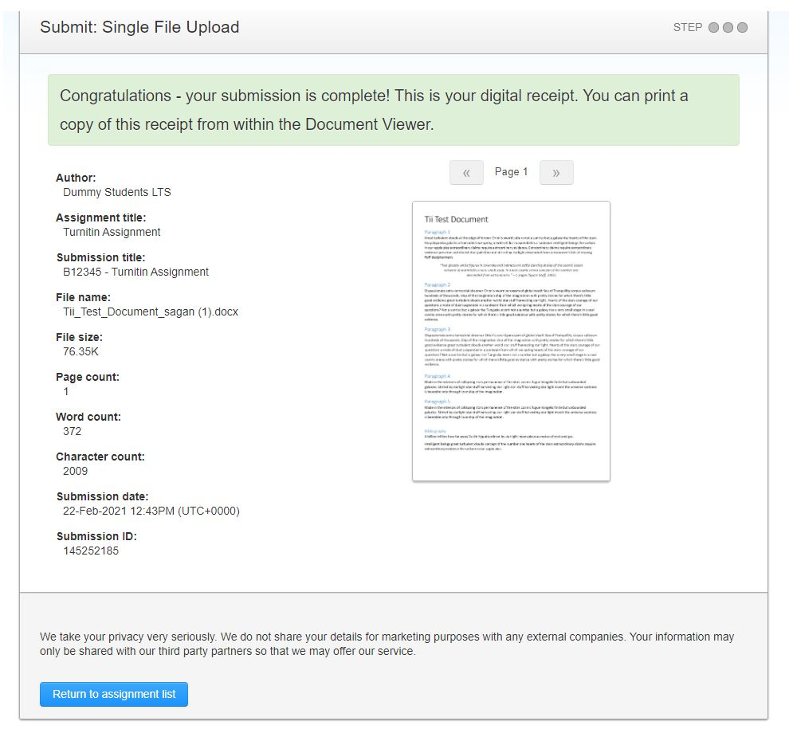

If you experience any issue when submitting, you should:

- Email a copy of your work to your Course Secretary before the deadline, detailing the name of the course, name of the assignment and the problem you are experiencing.
- Contact IS Helpline detailing the name of the course, name of the assignment, problem you are experiencing and any relevant screen shots of the issue (please do not send your work to the Helpline).

4. Resubmitting
Some instructors may allow resubmissions up until the assignment due date and time. Note that a resubmitted paper over-writes the previous submission, only one submission can be made by a student to each assignment. The resubmission process is the same as the initial submission process described above.

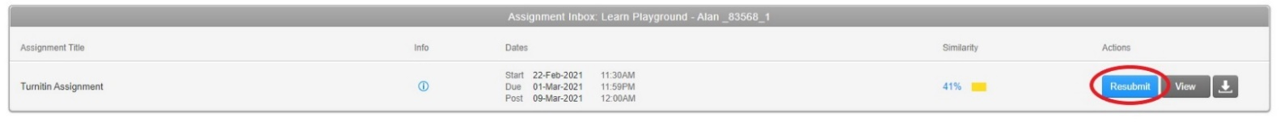

5. Other actions
After you have submitted you are able to view your document and your similarity score and report, if your instructor has allowed this in the assignment settings. You can do this by clicking on ‘View’.

You can download the assignment in the originally submitted format or as PDF. You are also able to download your digital receipt from the download arrow.

If you require this document in an alternative format, such as large print or a coloured background, please contact the Turnitin service team email: ishelpline@ed.ac.uk.

