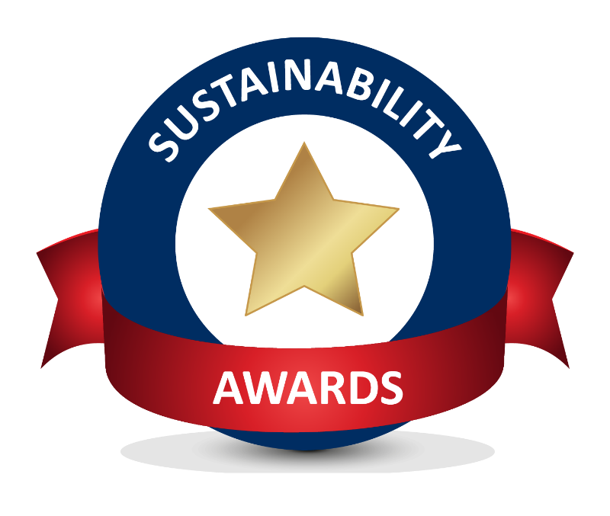

Student Award Report Template
2017/18

Final report – template
Student societies and groups applying to the Sustainability Student Award are invited to use this template for their final report. Please submit the report and relevant evidence by the end of Friday 23rd February 2018. Please email matthew.lawson@ed.ac.uk with the email subject line ‘Application Sustainability Student Award 2017-18, Project Name’.
Project name:

Name of student society or group:

Project description (no more than 500 words):
- Background
- Project management/meetings
- Objectives
- Relevance to SRS issues
- Intended outputs
- Intended outcomes
- Audience / stakeholders
- Timeline

Project impact (no more than 300 words):
- Changes delivered
- Intended outputs and outcomes
- Secondary (or unintended) outputs and outcomes
- Metrics

Project outreach (no more than 300 words):
- Audience and stakeholders
- Communication methods
- Participation levels in project

Project evaluation and next steps (no more than 300 words):
- Lessons learnt from project
- Future of project

Links to further information:
- Website link

