School of Biological Sciences Personal Tutoring Statement 2020 – 2021

Dear Student,

Your Personal Tutor and the Biology Teaching Organisation (BTO) Student Support Team are here to guide and support you throughout your time at Edinburgh. You can access this support throughout your Biology degree for both academic and pastoral matters. There is also a Peer-Assisted Learning (PAL) system provided by students in the School, which can provide help based on topics in your courses and the university experience.

Take a look at how the Personal Tutoring system and Student Support systems in your School are organised:

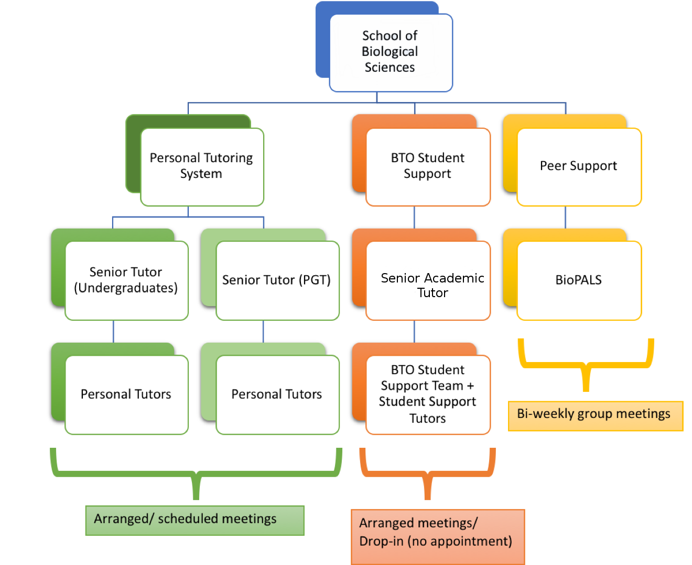

The following pages will explain how these support systems work, and how you can access them e.g. how to arrange meetings.

We hope that you have a successful and happy time with us!

Personal Tutoring System for Undergraduate Students

During your early years at the University you will have several scheduled meetings with your Personal Tutor (PT) to enable you to settle in and build a rapport with them. Contact will gradually become less formal in the later years of study, with the intention that you schedule meetings as you require with your Personal Tutor throughout your time at the University.

In year 1 of your programme you should have a minimum of two meetings per semester including one meeting at the beginning of each semester. In years 2, 3 and 4, there will be a minimum of 3, 1 and 1 meetings respectively.

The BTO and/or your personal tutor will prompt you to arrange these meetings and you should respond via your University of Edinburgh e-mail account. You can also request additional meetings with your PT at any time using your university email (there are some examples below of times when you might want to schedule an additional meeting with your PT).

Due to the restrictions imposed by Covid-19, it is likely that meetings with your PT this year will take place digitally, using platforms such as Microsoft Teams, Zoom or Skype. For new entrants, we will try to offer in person meetings, but only in cases where both parties are willing and where there is suitable office or other meeting space available. No one will be obliged to meet in person if they are not comfortable with it.

Personal Tutoring System for Postgraduate Taught Students

Most taught postgraduate courses in the school are of one year duration, although we have some two-year part-time courses, and online distance learning courses can take place over a longer period. While a student at the University you will have several scheduled meetings with your Personal Tutor to enable you to settle in and build a rapport with them.

In your programme you should have at least 1 personal meeting with your PT per semester. Your PT will meet you at the beginning of first semester to discuss the course structure with you, and discuss which optional courses are appropriate for you. A follow up meeting after 3-4 weeks will focus on student support, Extensions and Special Circumstances applications. Another meeting will be held early in Semester 2 (or equivalent in part time or distance learning courses) to discuss progress in semester 1, and any possible changes to semester 2 options.

Meetings of your tutor group will also be held, however since many of the PGT personal tutors are teachers on the compulsory courses of your degree, you will also see them on a regular basis via these activities. During the summer period (May-July) you will be working on your project/dissertation and during that time three group meetings will be scheduled to help you stay in contact with your personal tutor.

Your personal tutor will contact you to schedule the second and subsequent meetings; the date of your first meeting is normally fixed as this is part of your induction week.

Due to the restrictions imposed by Covid-19, all meetings with your PT this year will take place digitally, using platforms such as Microsoft Teams, Zoom or Skype.

Your Personal Tutor

When you arrive, the BTO will allocate you a Personal Tutor. Your Personal Tutor will be a member of staff familiar with your general area of study and the expectations of academic work in your discipline. He or she will have a clear understanding of their role in supporting your studies, both academically and pastorally, and, if necessary, how to direct you to any other support you might need during your time at the University

The main responsibilities of your Personal Tutor are to:
- Provide academic guidance, advising and supporting your studies, and following your progress.
- Guide you in your choice of courses, confirming course choice and where appropriate enrolling you on courses.
- Direct you towards additional information, support and guidance as and when appropriate, by liaison with the BTO Student Support Team and referring you to central services and other specialist sources.
- Respond promptly to a request for a meeting (usually within 3 working days) and where this is not feasible, arrange for another Personal Tutor to be contacted in their place (this information may be contained in an ‘out of office’ email).
- Advise and support you in, for example, special circumstances, disciplinary or appeal matters (in conjunction with the BTO Student Support Team).

Your Personal Tutor will help you to:
- Review your academic progress and performance regularly;
- Think about your learning, how it contributes to your future development, prepares you for your time at university and your career;
- Become a confident, active member of a community of learners;
- Deal with any concerns or problems - personal as well as academic - that might affect your studies and refer you to other staff in the School and support services as appropriate.

Senior Tutors

There is a dedicated Senior Tutor for both Undergraduate students and Postgraduate taught students (PGT). Each is in charge of the Undergraduate/PGT PT system and any comments on these systems should be brought to their attention. They will also provide support on special academic and pastoral situations. For example, they can advise on applying for an Interruption of Studies and progression problems. The Senior Tutors in Biological Sciences are:

Biological Sciences Undergraduate Senior Tutor: | Biological Sciences Postgraduate Taught Senior Tutor:
Professor Justin Goodrich | Professor Andrew Leigh Brown
Institute of Molecular Plant Sciences  Daniel Rutherford Building  Phone: 0131 650 7032  Email: Justin.Goodrich@ed.ac.uk | Institute of Evolutionary Biology  Ashworth Laboratories  Phone: 0131 650 5523  Email: A.Leigh-Brown@ed.ac.uk  Emai

BTO Student Support Team

The School of Biological Sciences has a Student Support Team that provides additional academic and pastoral support to students in conjunction with Personal Tutors. The BTO Student Support Team is coordinated by the Senior Academic Tutor:

Dr Nadia Tuzi
Biology Teaching Organisation
JCMB 2105
King’s Buildings
Email: Nadia.Tuzi@ed.ac.uk

There are four Student Support Tutors in the School of Biological Sciences, who will primarily be working from home, although on request it may be possible to arrange an in person meeting at King’s Buildings:

Student Support Tutor
Dr John Curtis
Dr Hazel Cruickshanks
Dr David Radford
Dr Abigail Cabrelli

The student support team offer a readily accessible point of contact and can support you if your Personal Tutor is unavailable or if you’d prefer to talk to someone else. The student support tutors hold drop-in sessions where no appointment is necessary, during the Covid pandemic these will be held digitially. To get in touch, please send an email to btostudentsupport@ed.ac.uk and ask to speak to a member of the team (09:00-17:00, Monday-Friday) they can arrange a meeting over MS Teams or Skype for Business. See their web page (https://edin.ac/btosst) for details).

Meetings and how to request them

You can request a meeting with your PT at any time through your University email. You can similarly request a meeting at any time with a member of the BTO Support Team by email (btostudentsupport@ed.ac.uk). When such a request is made a reply should be received within 3 working days. PTs and the BTO Student Support Team will make records of meetings on EUCLID via the Notes/Meetings tab and you too can make them there.

Why might you want to schedule a meeting with your PT?
Academic: If you want to discuss or change your course choices, are thinking of applying for an internship, or are concerned about your progress.
Personal: If something has come up that may affect your studies, or you feel like you are not fulfilling your personal potential e.g. because you are very stressed or anxious, and you would like to get additional support or to apply for Special Circumstances.

Why might you want to schedule a meeting with the BTO Student Support Team?
Meetings arranged with the BTO Support Team can enable more routine tasks to be dealt without involving your Personal Tutor directly. However, in some cases, you may be referred to your Personal Tutor or the Senior Tutor.

You can also come to drop-in sessions with members of the BTO Student Support Team, where no appointment is necessary, see their webpage https://edin.ac/btosst.

Responding to your Request:
- If your Personal Tutor is unavailable they will arrange for another Personal Tutor to deal with your queries. Information on who to contact may be contained in an ‘out of office’ email and you should follow these instructions.
- If you do not receive a response from your PT within 3 working days you should contact the BTO Support Team via email (btostudentsupport@ed.ac.uk)
- Bookable appointments are also available with members of the BTO Student Support Team. You can request one of these by emailing btostudentsupport@ed.ac.uk

Change of Personal Tutor
Any requests to change Personal Tutor should be made to the BTO Academic Administrator, Dr. Ann Haley (ann.haley@ed.ac.uk) who will send you a form to fill in which will be handled in the strictest confidence.

Other sources of support

Peer Support

Peer Support activities are also available and we’d encourage you to get involved with these as they’re a great way to engage with other students:

- Information about Edinburgh University Student Association (EUSA) Peer Support activities across the University can be found at the following link: https://www.eusa.ed.ac.uk/support_and_advice/peer_learning_and_support/

- There are several Biology-specific student-run societies available for you to join, see:https://www.ed.ac.uk/biology/current-students/biology-teaching-organisation/new-students/biology-societies

- BioPALS: this is a Peer-Assisted Learning (PAL) scheme set up by students for students in the School of Biological Sciences. It aims to help students make the most of their degree by creating a friendly and informal environment for cross-year interaction and support. Structured group meetings, based around a theme relevant to the course and university experience are led by trained student facilitators every week or two weeks, see
https://www.facebook.com/uoebiopals/

Other useful sources of information and support

The University’s student ‘Academic Life’ support portal contains many useful links to services you may require (http://www.ed.ac.uk/students/academic-life)

The School of Biological Sciences Undergraduate students’ intranet (https://www.wiki.ed.ac.uk/display/SBSUndergraduateIntranet/) similarly shows many useful documents and links tailored to biologist’s needs, in particular BTO Student Support (https://edin.ac/btosst).

Justin Goodrich & Andrew Leigh Brown
Senior Tutors (Undergraduate and Postgraduate Taught)
26/08/2020

